Satellite Products and Services Review Board

**Algorithm Theoretical**

**Basis Document**

**Global Mosaic of Geostationary Satellite Imagery**

*Ken Pryor, NOAA/NESDIS/STAR*

*Xu Li, NOAA/NESDIS/STAR*

*Vladimir Kondratovich, NOAA/NESDIS/STAR*

Version 2.0

30 October 2015



**Version 2.0**

**October 2015**

**___________________________________**

Title: Global Mosaic of Geostationary Satellite Imagery

AUTHORS:

Ken Pryor (STAR)

Xu Li (STAR)

Vladimir Kondratovich (STAR)

**DOCUMENT HISTORY**

**DOCUMENT REVISION LOG**

|  |  |  |  |
| --- | --- | --- | --- |
| **DOCUMENT TITLE: Algorithm Theoretical Basis Document Template** | | | |
| **DOCUMENT CHANGE HISTORY** | | | |
| **Revision No.** | **Date** | **Revision Originator Project Group** | **CCR Approval # and Date** |
| 1.0 | July 2014 | STAR |  |
| 2.0 | October 2015 | STAR |  |
|  |  |  |  |
|  |  |  |  |
|  |  |  |  |
|  |  |  |  |
|  |  |  |  |

**LIST OF CHANGES**

|  |  |  |  |  |  |
| --- | --- | --- | --- | --- | --- |
| **DOCUMENT TITLE: Algorithm Theoretical Basis Document Template** | | | | | |
| **LIST OF CHANGE-AFFECTED PAGES/SECTIONS/APPENDICES** | | | | | |
| **Version Number** | **Date** | **Changed By** | **Page** | **Section** | **Description of Change(s)** |
|  |  |  |  |  |  |
|  |  |  |  |  |  |
|  |  |  |  |  |  |
|  |  |  |  |  |  |
|  |  |  |  |  |  |
|  |  |  |  |  |  |
|  |  |  |  |  |  |
|  |  |  |  |  |  |
|  |  |  |  |  |  |
|  |  |  |  |  |  |
|  |  |  |  |  |  |
|  |  |  |  |  |  |
|  |  |  |  |  |  |
|  |  |  |  |  |  |

**TABLE OF CONTENTS**

Page

LIST OF TABLES AND FIGURES 6

1. INTRODUCTION 7

1.1. Product Overview 7

1.1.1. Product Description 7

1.1.2. Product Requirements 7

1.2. Satellite Instrument Description 8

2. ALGORITHM DESCRIPTION 9

2.1. Processing Outline 9

2.2. Algorithm Input 14

2.3. Theoretical Description 15

2.3.1. Physical Description 15

2.4. Algorithm Output 16

2.5. Performance Estimates 17

2.6. Practical Considerations 18

2.6.1. Numerical Computation Considerations 18

2.6.2. Programming and Procedural Considerations 18

2.7. Validation 19

3. ASSUMPTIONS AND LIMITATIONS 21

3.1. Performance Assumptions 21

3.2. Potential Improvements 21

4. REFERENCES 22

# LIST OF TABLES AND FIGURES

Page

Table 2-1 – The ADDE datasets used to generate the composite image**.**

Figure 2-1 – IT system architecture for global geostationary satellite image composite generation.

Figure 2-2 – Flowchart detailing the global composite image generation process.

Figure 2-3 – Flowchart describing the IMGCOMP command.

Figure 2-4 – Global image mosaic of Geostationary Operational Environmental Satellite (GOES), Meteosat SEVIRI, and MTSAT sensor source image at 1800 UTC 24 September 2015.

Figure 2-5 – Global image mosaic of Geostationary Operational Environmental Satellite (GOES), Meteosat SEVIRI, and MTSAT longwave infrared imagery at 1800 UTC 24 September 2015 with satellite sensor source marked by white partitions.

Figure 2-6 – Sample NWS/EMC GCIP product image at 1800 UTC 4 September 2015.

Figure 2-7 – NWS/EMC GCIP product validation example.

# INTRODUCTION

OSPO currently generates global geostationary infrared (IR) composites image at 8 km spatial resolution every 30 minutes. Shortwave (SW) IR and longwave (LW) IR geostationary full disk image datasets currently cover most of the northern hemisphere to 60°N latitude and the southern hemisphere to 45°S latitude. In the generation of the current suite of global geostationary composite images, GOES, METEOSAT, and MTSAT datasets are remapped and concatenated using standard McIDAS image commands (i.e. IMGREMAP, IMGOPER) to generate an image dataset in AREA file format. A new global composite dataset, as requested by the National Weather Service (NWS) Environmental Modeling Center (EMC), will be composed of full disk image datasets, and add a visible channel composite and expand coverage to 60°S latitude. Generation of the new composite image suite will entail the following steps: 1) generation of 8-band image data files, 2) generation of image files containing brightness values, 3) generation of new remapped images with 8-km resolution, 4) generate image files containing the distance to nadir for each respective satellite, 5) merge the four images with the same projection into a composite image. Product validation will consist of visual inspection: over continental US, the user will quantitatively compare the composite datasets to GOES data in GINI format. EMC will use the global composite datasets for development of new global icing analysis products. EMC will use an NCO IBM Unix supercomputer to process the datasets and generate icing analysis products.

## Product Overview

### Product Description

This new global mosaic image will consist of full disk images from GOES, METEOSAT, and MTSAT, generated every three hours.

### Product Requirements

Global Mosaic of Geostationary Satellite Imagery (GMGSI) data that includes visible channel, shortwave infrared channel (3.9 micron) and longwave infrared channel, with resolution of 8km or finer, with coverage as poleward as possible (to 60°). In addition, provide with each satellite image dataset, a dataset that includes coverage boundaries of each satellite.

## Satellite Instrument Description

The global geostationary image composites will be generated from full disk datasets originating from GOES-East and GOES-West imagers, MTSAT-2, and METEOSAT-10 SEVERI.

GOES-East (N/13), located over the equator at longitude 75°W, and GOES-W (P/15) at longitude 135°W, generate full disk imagery every three hours. The visible channel (1) has a nominal square IGFOV at nadir of 1km while the shortwave (2) and longwave infrared (4) channels have IGFOVs of 4km. The infrared channels have a system absolute accuracy of < 1K. The visible channel has an accuracy of ±5% of maximum scene radiance.

The MTSAT-2 imager, located over the equator at longitude 140-145°E, generates full disk imagery hourly. The visible channel (1) has a sub-satellite point spatial resolution at nadir of 1km while the shortwave (4) and longwave infrared (2) channels have resolutions of 4km.

The METEOSAT-10 SEVERI, located over the equator at longitude 0°, generates full disk imagery every 15 minutes. The visible channel (1) has a sub-satellite point spatial resolution of 1 km, while the shortwave (4) and longwave infrared (9) channels have resolutions of 3km.

# ALGORITHM DESCRIPTION

## Processing Outline

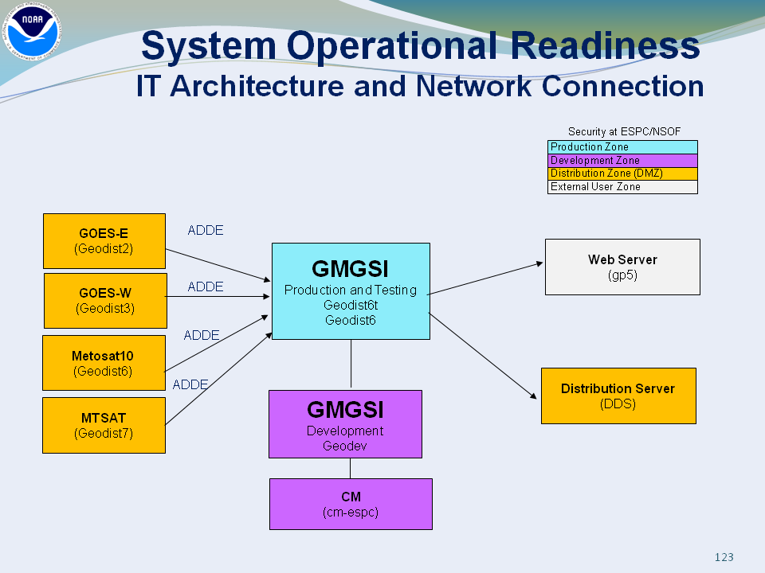

Figure 2-1. IT system architecture for global geostationary satellite image composite generation.

Geostationary full disk image datasets are remapped and concatenated using standard McIDAS image commands to generate a composite image dataset in AREA file format. This process capitalizes on an algorithm developed at University of Wisconsin/Space Science and Engineering Center (SSEC) (Kohrs et al. 2014) that employs satellite sub-point distance to greatly reduce satellite overlap and the geographical region covered by co-located pixels. Figure 2-1 illustrates the IT system architecture required for composite image generation.

The composite is generated by utilities in McIDAS-X and McIDAS-XRD:

IMGPARM, IMGCOPY, IMGCHA, MAKNAV, REMAP2, IMGCOMP

With the generation of the LW IR composite as the example, the procedure is as follows:

1. Create a local image file with IMGCOPY: AREA0301

imgcopy.k GER/GEFDSK04I4 LOC/AREA.0301 SIZE=ALL

Note: The above image copied is done differently for GOES-E and GOES-W visible image to handle the large size as the follows (with the example of GOES-E):

imgcopy.k GER/GEFDSK01V LOC/AREA.0101 SIZE=2500 5000 MAG = -6

1. Create an image AREA file with 8 bands: AREA3001

imgparm.k LOC/AREA.0301 LOC/AREA.3001

The 8 bands represent the following variable respectively:

Band 1: Brightness values

Band 2: Time difference from specified BASE values in seconds

Band 3: Distance from satellite subpoint (km)

Band 4: Pixel area (km*km)

Band 5: Satellite Sensor (SS)

Band 6: Wavelength

Band 7: Parallax distance (km*10)

Band 8: Parallax direction (degrees)

1. Create an image area file containing brightness value with 2500 lines by 5000 elements: AREA3011

imgcopy.k LOC/AREA.3001 LOC/AREA.3011 SIZE=2500 5000 BAND=1

1. Change the Directory block of AREA3011 and AREA3015

imgcha.k LOC/AREA.3011 RES=1 1 LIN=1 ELE=1

1. Make Navigation block of the destination AREA file (AREA3011):

maknav.k 3011 RECT=1 90 1 180 0.072 0.072

maknav.k 3011 MERC=2500 5000 0 110 8

1. Remap to get a new image with 8km resolution: AREA3011

remap2.k 3001 3011 BAND=1

1. Generate an AREA file containing the distance to the nadir with 2500 lines by 5000 elements: AREA3015 but for BAND=3
2. Apply steps (4), (5) and (6) to AREA3015 to get a new image with 8km resolution: AREA3015
3. Repeat step (1) to (8) to get the 8km resolution images of brightness and distance for other three satellites: AREA3012, AREA3013 and AREA3014; AREA3016, AREA3017 and AREA3018
4. Merge the four images with the same projection into a composite image for brightness with the help of 4 images of distance: AREA3010. The overlap area is handled to choose the one with the shorter distance to the nadir.

imgcomp,k LOC/AREA LOC/AREA.3010 3011 3014 BAND=1:

1. Remap the composite image to Mercator projection

imgremap.k LOC/AREA.3010 LOC/AREA.3030 RES=8 SIZE=2500 5000

The same procedure is applied to generate a composite image of SS with BAND=5. The composite image generation process is summarized graphically in the flowcharts shown in Figures 2-2 and 2-3.

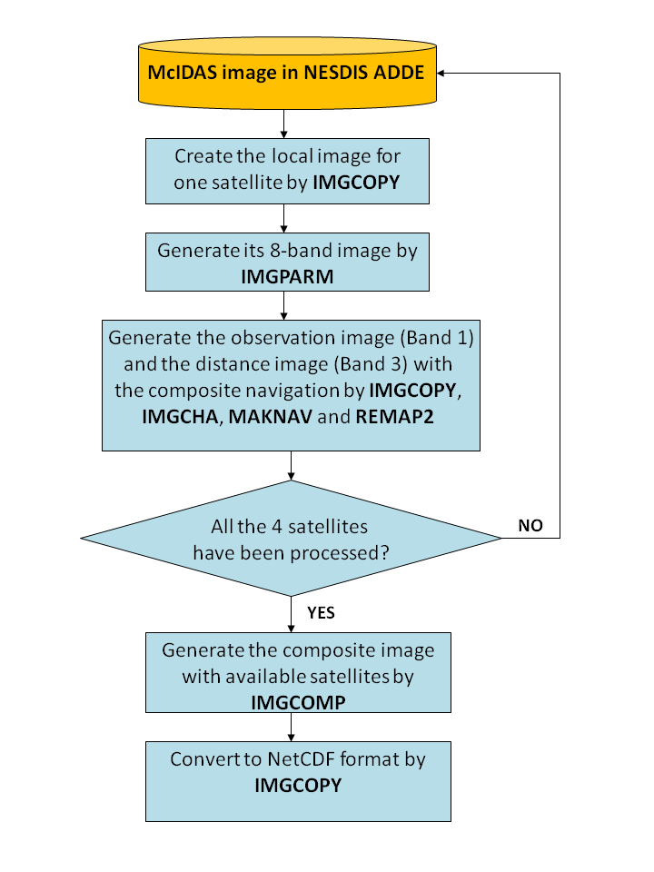

Figure 2-2. Flowchart detailing the global composite image generation process.

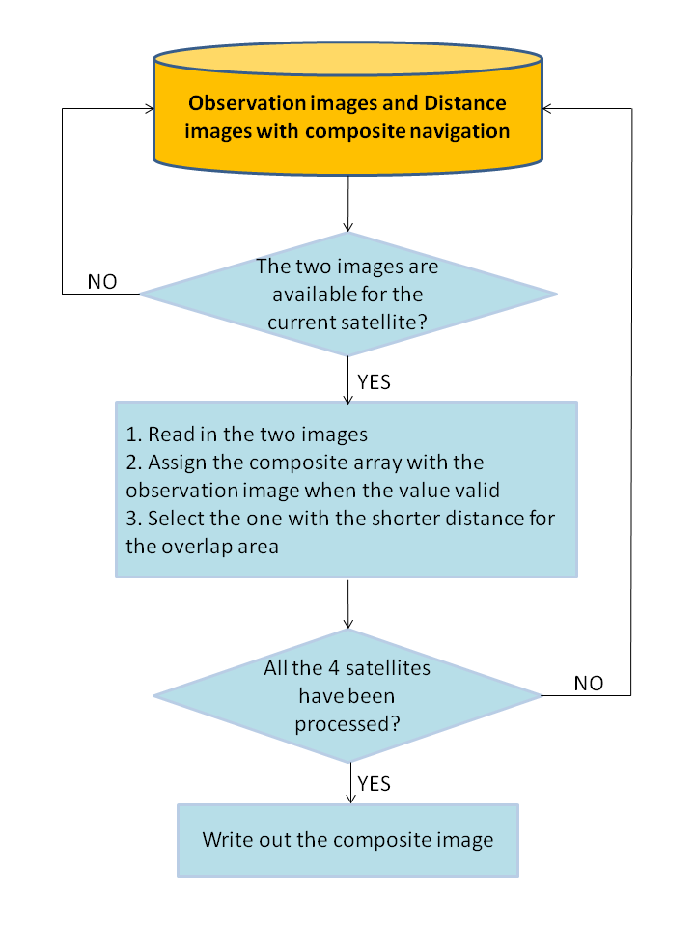

Figure 2-3. Flowchart describing the IMGCOMP command.

## Algorithm Input

The full-disk geostationary satellite image datasets are housed on the NESDIS ADDE server in McIDAS image (AREA file) format. Details are provided in Table 2-1.

Table 2-1. The ADDE datasets used to generate the composite image.

|  |  |  |  |  |  |
| --- | --- | --- | --- | --- | --- |
| Satellite Image | ADDE Group | Image  Size | Channel  Number | Wave  Length | Sensor ID |
| GOES-E (VIS) | GER/GEFDSK01V | 10820 by 20832  (453 MB) | 1 | 0.63 µm | 180 |
| GOES-E (SW IR) | GER/GEFDSK04I2 | 2705 by 5208  (29 MB) | 2 | 3.90 µm | 180 |
| GOES-E (LW IR) | GER/GEFDSK04I4 | 2705 by 5208  (29 MB) | 4 | 10.7 µm | 180 |
| GOES-W (VIS) | GWR/GWFDSK01V | 10820 by 20832  (453 MB) | 1 | 0.63 µm | 184 |
| GOES-W (SW IR) | GWR/GWFDSK04I2 | 2705 by 5208  (29 MB) | 2 | 3.90 µm | 184 |
| GOES-W (LW IR) | GWR/GWFDSK04I4 | 2705 by 5208  (29 MB) | 4 | 10.7 µm | 184 |
| MTSAT (VIS) | MTS/MTGLOB01V | 11000 by 11000  (242 MB) | 1 | 0.73 µm | 84 |
| MTSAT (SW IR) | MTS/MTGLOB04I5 | 2750 by 2752  (15 MB) | 5 | 3.75 µm | 84 |
| MTSAT (LW IR) | MTS/MTGLOB04I2 | 2750 by 2752  (15 MB) | 2 | 10.8 µm | 84 |
| Meteosat-10 (VIS) | MSG/MSGLOB01V | 3712 by 3712  (28 MB) | 1 | 0.60 µm | 53 |
| Meteosat-10 (SW IR) | MSG/MSGGLOB04I | 3712 by 3712  (28 MB) | 4 | 3.90 µm | 53 |
| Meteosat-10 (LW IR) | MSG/MSGGLOB09I | 3712 by 3712  (28 MB) | 9 | 10.8 µm | 53 |

## Theoretical Description

### Physical Description

The GOES N-P Imager instrument, GFE manufactured by ITT Industries, Inc., is a five channel (one visible, four infrared) imaging radiometer designed to sense radiant and

solar reflected energy from sampled areas of the earth. By means of a servo-driven, two axis gimbaled mirror scan system in conjunction with a Cassegrain telescope, the imager’s multispectral channels can simultaneously sweep an 8 km north-to-south swath along an east-to-west/west-to-east path at a rate of 20° (optical) per second.

The GOES Imager optimizes the maximum signal flow of the optical, detection, and electronic subsystems in order to preserve the quality and accuracy of the sensed information. The scene radiance, collected by the Imager’s optical system, is separated into appropriate spectral channels by beam splitters that also route the spectral energy to various visible and infrared (IR) detector sets where it is imaged onto the respective detectors for each channel. Each detector converts the scene radiance into an electrical signal that is amplified, filtered, and digitized; the resulting digital signal is routed to a sensor data transmitter for downlinking to a ground station.

The MTSAT imager functions similarly to the GOES imager: scans the earth by moving an internal scan mirror in an east-west and north-south direction. The light reflected by the mirror is converted into a beam and channeled through a system of lenses and filters, and is separated into one visible and four infrared channels. The beam intensities are converted to electric signals by visible and infrared detectors, and these signals are transmitted to the Meteorological Satellite Center's Command and Data Acquisition Station (CDAS).

For METEOSAT SEVIRI, the imaging is performed by combining satellite spin and rotation (stepping) of the scan mirror. The images are taken from south to north and east to west. The E–W scan is achieved through the rotation of the satellite with a nominal spin rate of 100 revolutions min−1. The spin axis is nominally parallel to the north–south axis of the earth. The scan from south to north is achieved through a scan mirror covering the earth’s disk with about 1250 scan lines; this provides 3750 image lines for channels 1–11 ) since three detectors for each channel are used for the imaging. For the HRV (channel 12) nine detectors sweep the earth for one line scan. A complete image, that is, the full disk of the earth, consists of nominally 3712 × 3712 pixels for channels 1–11. The HRV channel covers only half the full disk in the E–W direction and therefore a complete image consists of 11 136 × 5568 pixels. A nominal repeat cycle is a full-disk imaging of about 12 min, followed by the calibration of thermal IR channels with an onboard blackbody that is inserted into the optical path of the instrument.

## Algorithm Output

The suite of global geostationary composite image datasets will consist of full-disk visible (0.60-0.73 µm wavelength), shortwave infrared (3.75 – 3.90 µm wavelength), longwave infrared (10.7-10.8 µm wavelength), and sensor source (SS) image data on a Mercator projection at 8 km resolution.

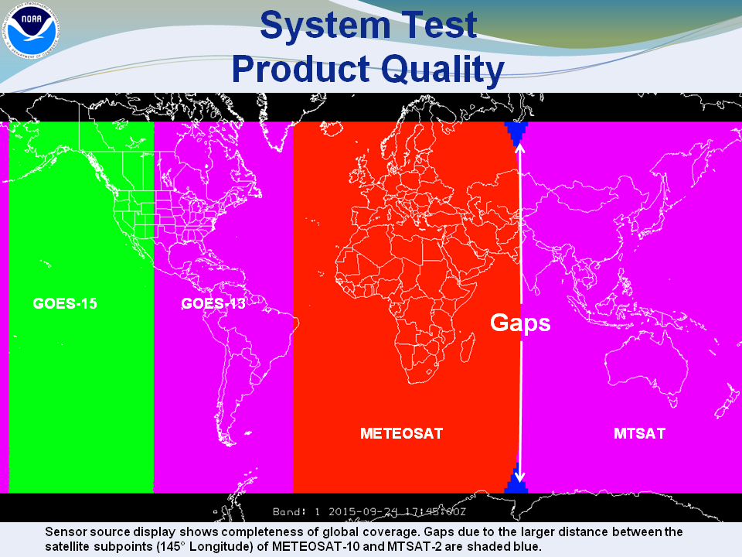

Figure 2-4. Global image mosaic of Geostationary Operational Environmental Satellite (GOES), Meteosat SEVIRI, and MTSAT sensor source image at 1800 UTC 24 September 2015.

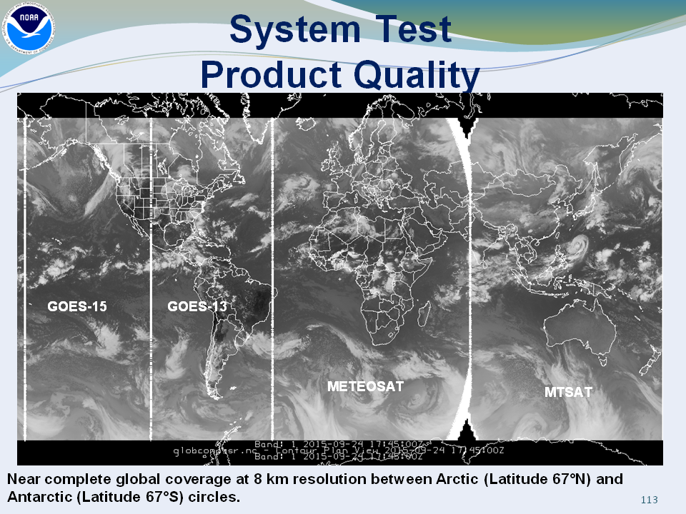

Figure 2-5. Global image mosaic of Geostationary Operational Environmental Satellite (GOES), Meteosat SEVIRI, and MTSAT longwave infrared imagery at 1800 UTC 24 September 2015 with satellite sensor source marked by white partitions.

Figures 2-4 and 2-5 show sample global mosaics of Geostationary Operational Environmental Satellite (GOES), Meteosat SEVIRI, and MTSAT imagery on 24 September 2015. Comparison of Figures 2-4 and 2-5 with Figure 13 of Kohrs et al. (2014) demonstrates the ability of the GMGSI algorithm to nearly eliminate overlap between satellite sectors. Real-time GMGSI datasets are available via FTP:

<ftp://satepsanone.nesdis.noaa.gov/2day/gmosaic/>

## Performance Estimates

The product is regular 8-km gridded image with Mercator projection, which is generated with full disk images with higher resolution. The error of the generated image, compared with the original one, just comes from the collocation, interpolation and projection transformation. In the areas overlapped by two satellites, the one with the closer distance to its own nadir, which has the higher resolution of FOV and less distortion, is selected to generate the composite.

Another error comes from the time difference, up to 15 minutes, among the four original images.

## Practical Considerations

### Numerical Computation Considerations

The composite algorithm is implemented by applying a series of McIDAS commands in a single script, which manipulates the images to do necessary collocation, interpolation, projection transformation, navigation generation, image merging.

The development has been done on NESDIS server rhw9101, which is Dual Intel(R) Xeon(R) CPU X5670@ 2.93GHz, 10GB RAM. It takes about 2 minutes to process the LW IR composite.

Sometimes, it takes longer than usual time for IMDPARM to finish.

The memory usage to run the composite: 78168 KB or 78.168 MB.

### Programming and Procedural Considerations

The current operational composite is generated with three McIDAS-X commands, IMGCOPY, IMGOPER and REMAP.

Since the Sensor Source (SS) information in the new composite is requested by the user, additionally, two McIDAS –XRD utilities, IMGPARM and REMAP2, and one user developed McIDAS utility, IMGCOMP, are required.

IMGPARM can generate an 8-band image:

Band 1: Brightness values (or other units)

Band 2: Time difference from specified BASE values in seconds

Band 3: Distance from satellite subpoint (km)

Band 4: Pixel area (km*km)

Band 5: Satellite Sensor (SS)

Band 6: Wavelength

Band 7: Parallax distance (km*10)

Band 8: Parallax direction (degrees)

The Band 1, 3 and 5 are used to generate the four composite images, including Visible (VIS), Short-wave Infra-red (SW IR), Long-wave Infra-red (LW IR), and SS. The procedure can be seen in the flow chart.

IMGCOMP merges the four satellite images into a composite image. In the overlap area, the pixel with shorter distance to the nadir is selected.

### Quality Assessment and Diagnostics

The product coverage is up to latitude 67 degrees and the quality is location dependent, the closer to the nadir, the higher the quality is. There are gaps between MTSAT and Meteosat at high latitude area. The product will be validated with the GOES data in GINI format.

## Validation

Product quality is assessed by NESDIS/OSPO and NWS/EMC.  To validate the composite, visual inspection is the first step. Over continental US, the user, NWS/EMC, quantitatively compares the composite and GOES data in GINI format. Direct comparison of brightness values between the new composite image data and existing GINI data serves as the primary means of product validation. In addition, NWS/EMC compares the Global Current Icing Potential (GCIP) product output using global mosaic data, GCIP product output without satellite data, and the reference Current Icing Potential (CIP) product over CONUS.

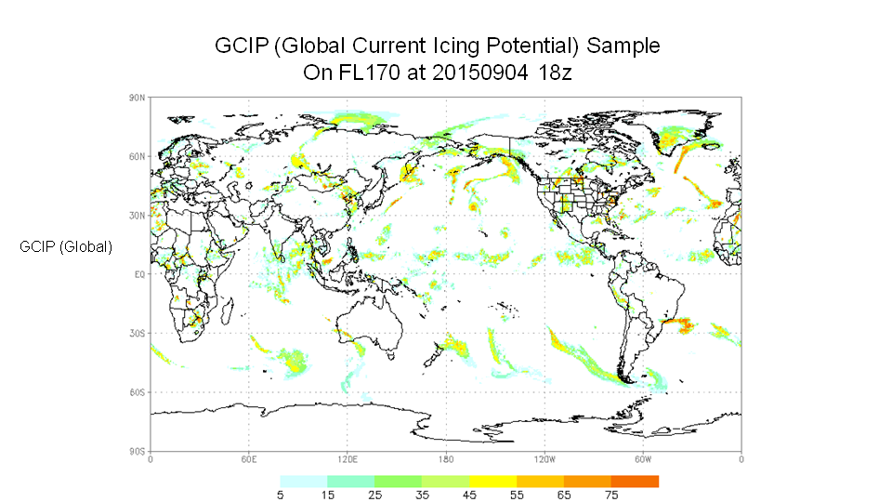

Figure 2-6. Sample NWS/EMC GCIP product image at 1800 UTC 4 September 2015.

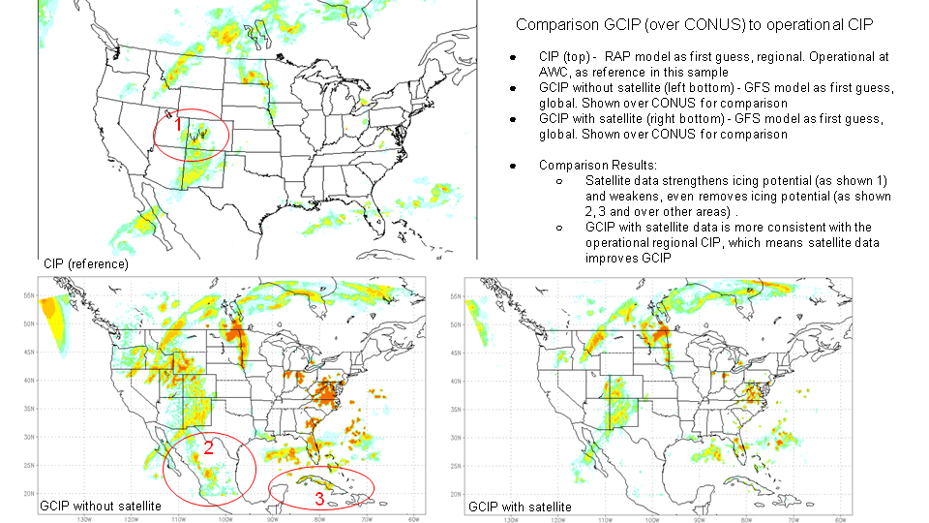

Figure 2-7. NWS/EMC GCIP product validation example.

Figures 2-6 and 2-7 show favorable validation results as noted by EMC. Most importantly, the product comparison demonstrates added value from the inclusion of global mosaic datasets in the icing potential calculation. Global mosaic satellite data allows for improved indication of icing potential, especially in the vicinity of icing PIREPS (pilot reports). GCIP derived from satellite mosaic data is more consistent with the operational regional CIP, which shows that satellite data improves GCIP.

# ASSUMPTIONS AND LIMITATIONS

## Performance Assumptions

Composite generation software is designed to execute and complete production with the satellite images available at the production time. Any number of the available original images can be handled to generate the composite image. The information on the image availability will be documented in a log file at the composite step.

## Potential Improvements

The product can be improved by applying cross satellite calibration with the help of additional satellite data, especially for the visible channel. The operational implementation of Himawari-8 that will replace MTSAT-2 is expected to be completed by December 2015. The location of the subpoint of Himawari-8, 4.3° west of the subpoint of MTSAT-2, should serve to reduce the gap in coverage near longitude 70° E.

# REFERENCES

McIDAS-X Users’ Guide: <https://www.ssec.wisc.edu/mcidas/doc/users_guide/2014.1/>

McIDAS-XRD: <https://www.ssec.wisc.edu/mcidas/software/xrd/>

Boeing, Inc., 2006: GOES-N Data Book.

Kohrs R., M. Lazzara, D. Santek, N. Bearson, S. Knuth, and J. Robiadek, 2014. Global Satellite Composites – 20 Years of Evolution, Atmospheric Research 135-136, 8-24.    
<http://dx.doi.org/10.1016/j.atmosres.2013.07.023>

Schmetz, J., Pili, P., Tjemkes, S., Just, D., Kerkmann, J. , Rota, S., and A. Ratier, 2002: An Introduction to Meteosat Second Generation (MSG). *Bull. Amer. Meteor. Soc.*, **83**, 977–992.

END OF DOCUMENT