Final Project Report

**Global Statistics Of COVID-19 Disease**

Version 1.0

Revision History

|  |  |  |  |
| --- | --- | --- | --- |
| **Date** | **Version** | **Description** | **Author** |
| 4/06/2020 | 1.0 | Global Statistics Of COVID-19 Disease | Đỗ Thu Hương |

Table of Contents

1. Introduction 2

1.1 Purpose 2

1.2 Scope 2

1.3 Definitions, Acronyms, and Abbreviations 2

1.4 References 2

1.5 Overview 2

2. Quality Objectives 2

3. Management 2

3.1 Organization 2

3.2 Tasks and Responsibilities 2

4. Documentation 2

5. Standards and Guidelines 2

6. Metrics 2

7. Review and Audit Plan 2

8. Evaluation and Test 2

9. Problem Resolution and Corrective Action 2

10. Tools, Techniques, and Methodologies 2

11. Configuration Management 2

12. Supplier and Subcontractor Controls 2

13. Quality Records 2

14. Training 2

15. Risk Management 2

Final Project Report

# Introduction

## Purpose

The purpose of this final project report is giving the overall information in terms of the process developing a Java web application to manage the global statistics of COVID-19 disease.

## Scope

The scope of this final project report including analyzing the requirements, develop architecture design which is Activity Diagram, ER Diagram, Class Diagram,

## Definitions, Acronyms, and Abbreviations

# Team Member Role

|  |  |  |  |
| --- | --- | --- | --- |
| No. | Name | Work Detail | Estimated Contribution Level |
| 1 | Phạm Quang Sáng |  |  |
| 2 | Bùi Tùng Anh |  |  |
| 3 | Đỗ Thị Nhung |  |  |
| 4 | Đỗ Thu Hương |  |  |

# Architecture Design

## ER Diagram

## Use Case DiagramC:\Users\MyPC\AppData\Local\Microsoft\Windows\INetCache\Content.Word\ERdiagram.png

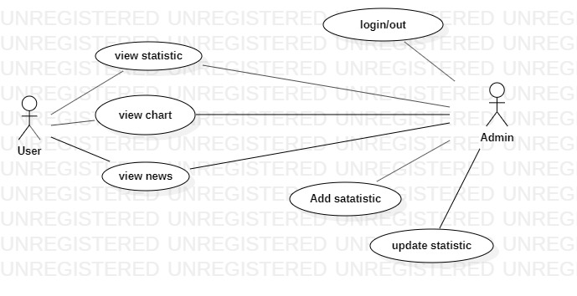

## Class Diagram

**Login Function**

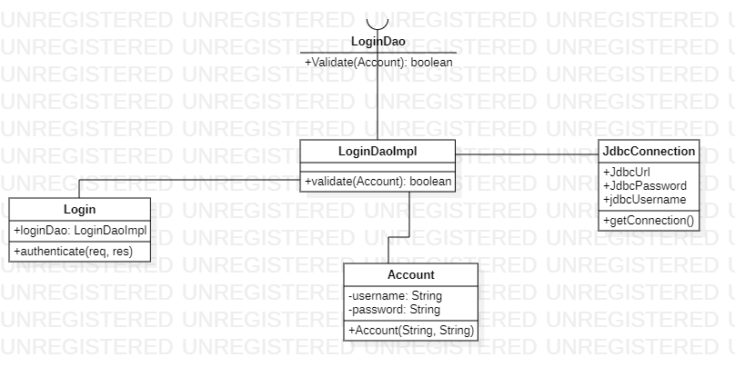

**Show News In VNExpress**

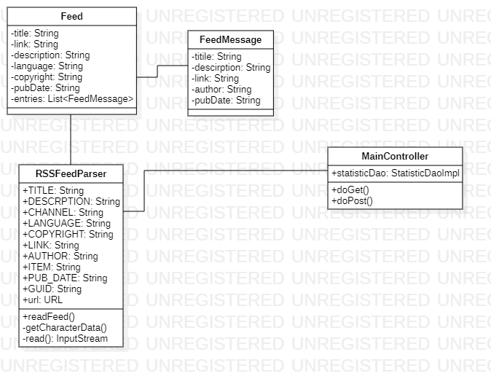

**Show Statistics**

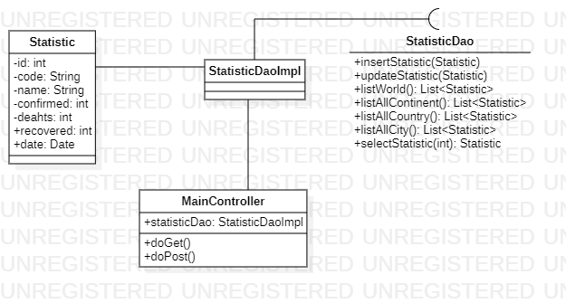

**Update & Add Statistic Function**

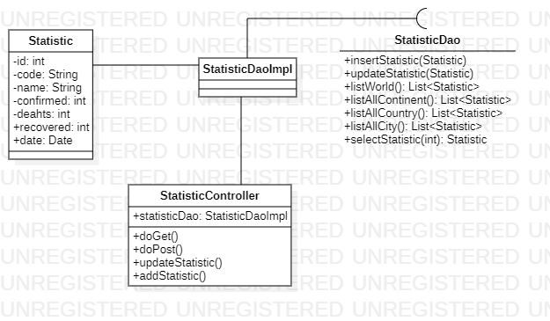

## Sequence Diagram

# Implementation

# Testing

# Evaluation