Step 1: We're on the Case:
- In this step I familiarized myself with the capabilities of Catalyst. Catalyst is capable of threat hunting, alerts that a generated by security monitoring, open tasks that are assigned to team members and represent actions that need to be performed during incident response, and forensic investigations.
- 1.1: Creating an incident:
In this step I created a incident using the criteria in the downloadable file.
- 1.2: Breaking it down: This step broke down the pieces of information that were viewable in incidents reports. The pieces of information are observables (IP addressees, file hashes, and email addresses), tasks (steps or actions taken by cybersecurity analysts), and TTP (Tactics, Techniques, and Procedures that represent the behavior patterns and methods of threat actors).
Step 2: The Investigation Begins:
- 2.1: Add a simple Artifact:
In this step I added an artifact that was included in the original downloadable file. This artifact was an IP address. I also learned that [.] is the sterilization of IP addresses to prevent accidental exposure to malware.
- 2.2: Investigate IoCs using external resources:
In this step I searched the IP address added from the simple artifact to identify any malicious activity connected to the IP address using VirusTotal. This showed 8/34 malicious flags for the IP address.
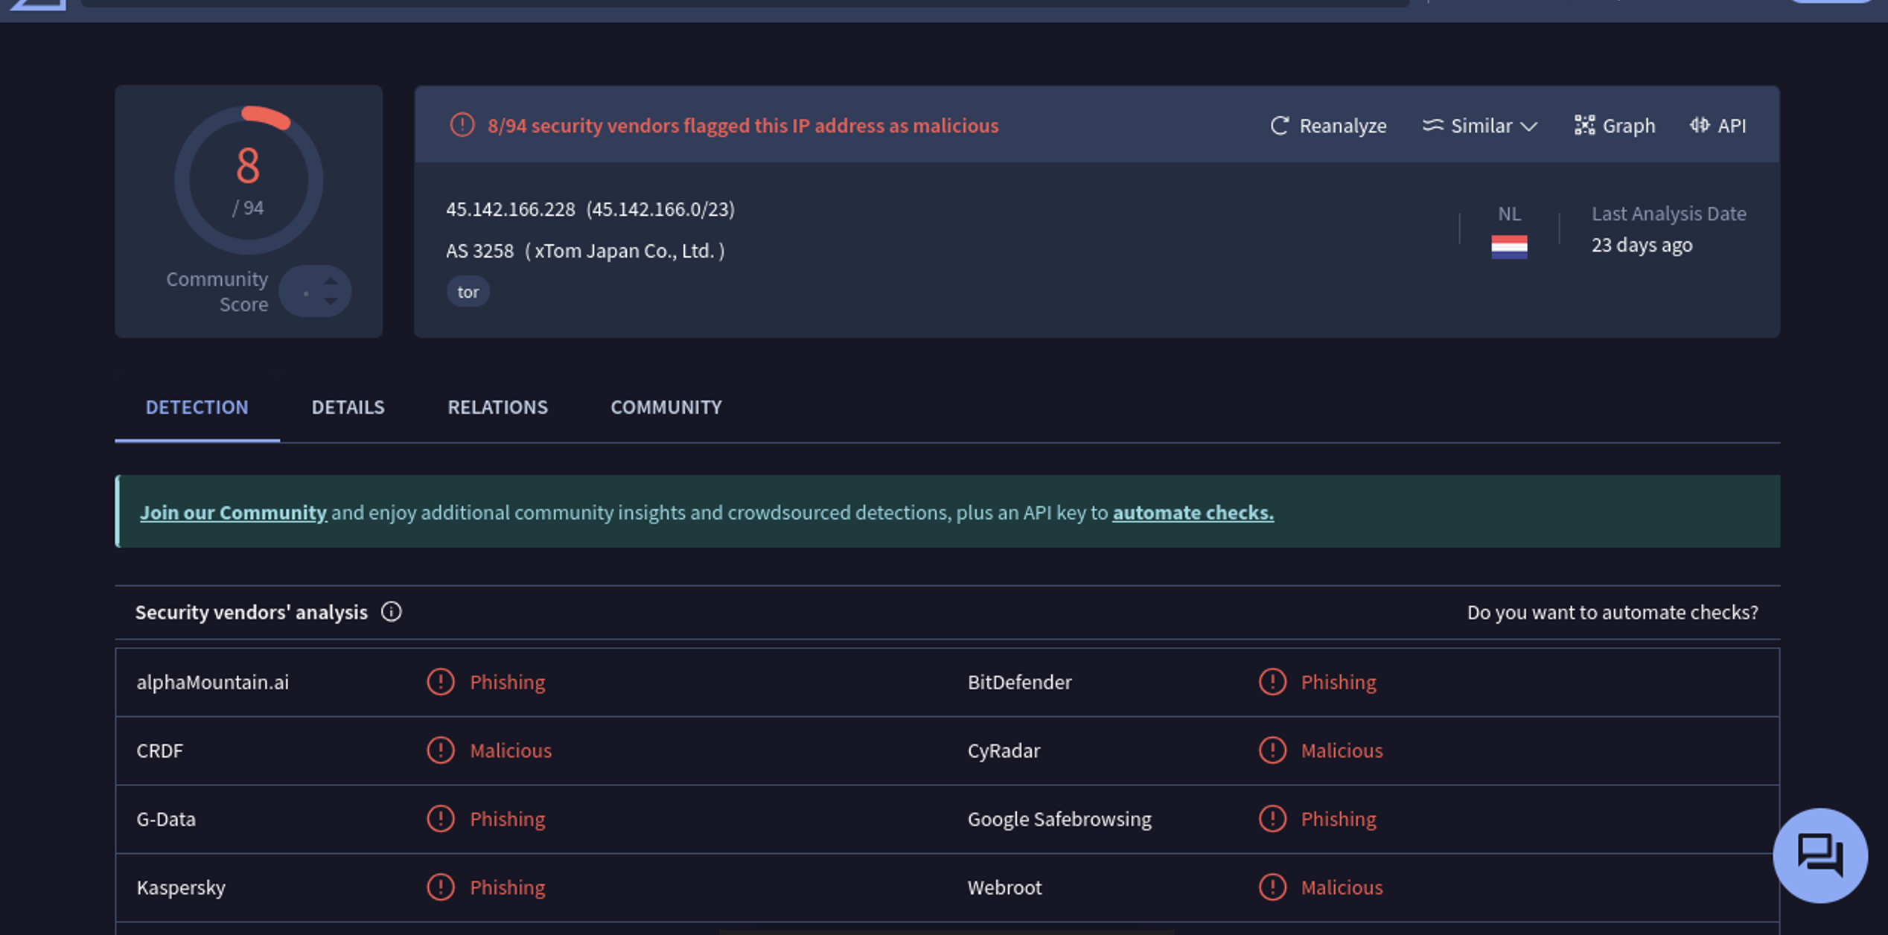
Using AbuseIPDE, I found different observations.
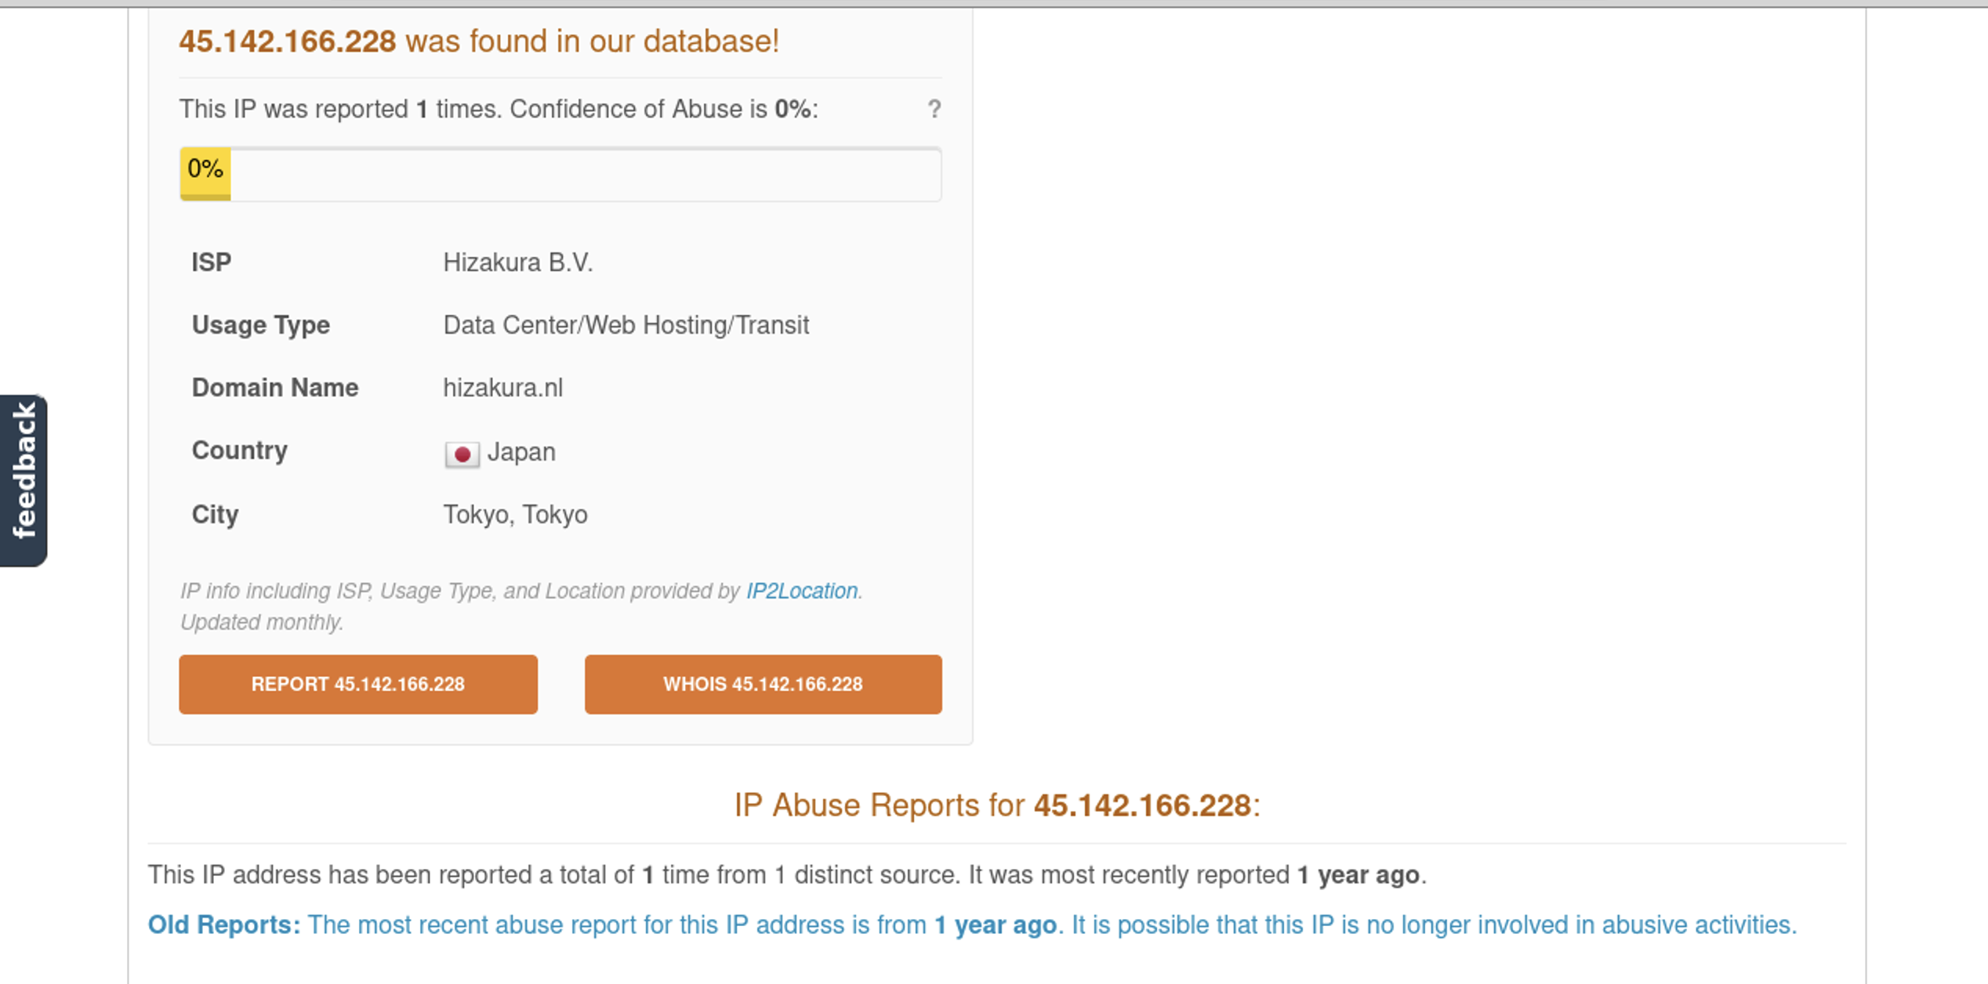
Step 3: Closing the Case:
After documenting tasks, observables, and TTPs I closed the case.
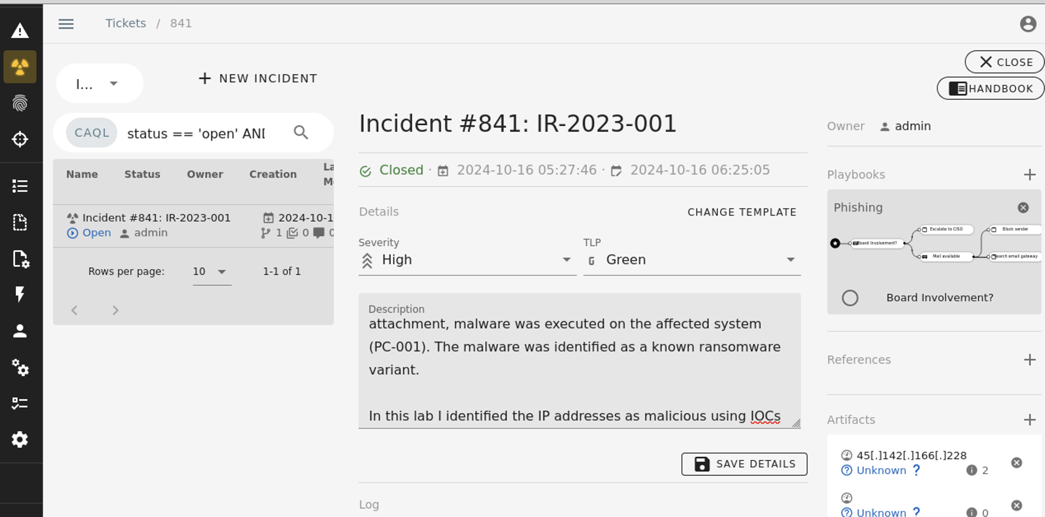

Step 4: Lessons Learned:
Incident Summary: A phishing email was received by the user, Jane Smith, containing a malicious attachment. Upon opening the attachment, malware was executed on the affected system (PC-001). The malware was identified as a known ransomware variant.

Tactics, Techniques, and Procedures (TTPs): A threat actor sent a phishing email to a user on the system that contained a malicious attachment. Once opened this attacked unleashed ransomware onto the system.

Response Effectiveness: 1. Implement email filtering to block malicious emails and attachments.
2. Provide cybersecurity awareness training for employees to help them recognize phishing attempts.
3. Regularly back up critical systems and data, ensuring that backups are stored offline and tested periodically.
Improvement Areas: No improvement steps.
Future Changes: Refer to response effectiveness steps 1 and 2.

Conclusion:
In this lab I learned what Catalyst is and how to effectively use it. I had problems starting it up on my system however, once I was able to get it operating everything was pretty much self-explanatory.

