Lab #7: Splunking for Threats

Step 1: Let's feed ourselves:
  - Initiate the Upload:
- In this step I added data to Splunk for data analysis.

  - Select Your Data:
- This is where the file was selected and uploaded.
  - Configure the Data Settings:
- I chose to let Splunk do autodetection.
  - Input Settings:
- In this step I altered the input settings to the standards below.
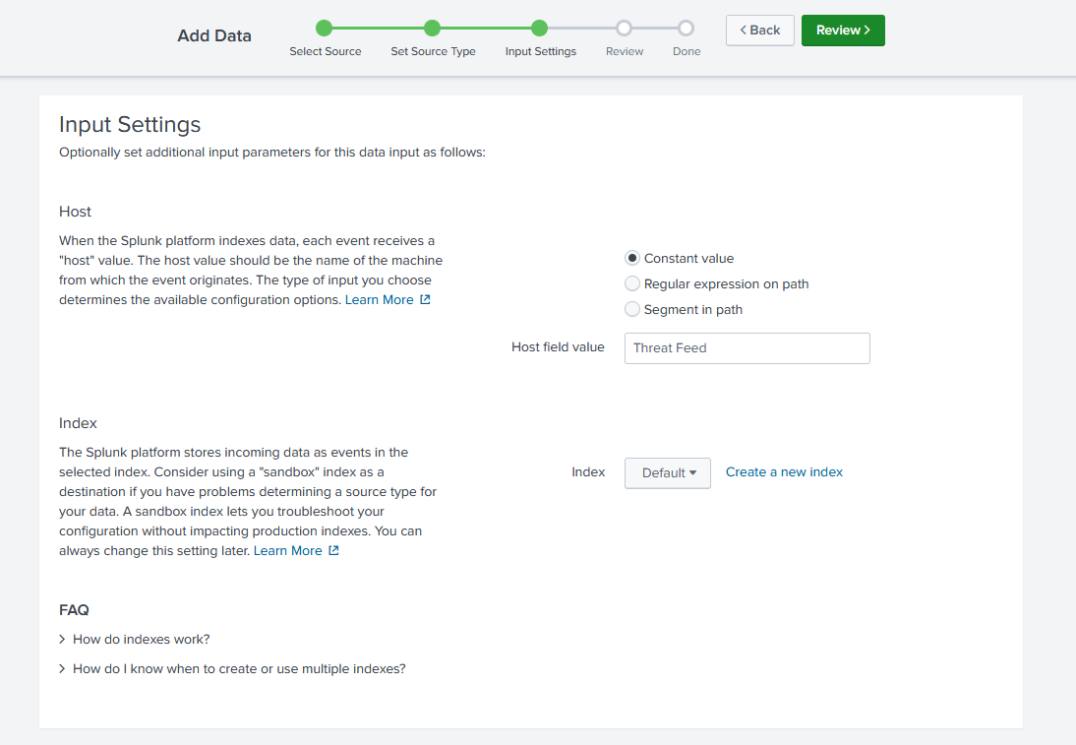
  - Review and Complete:
- In this step I reviewed and completed the upload.

Step 2: Analyzing Threat Intelligence Data:
With your data now in Splunk, it's time to turn this information into insight. You're the proverbial detective, combing through clues to find patterns that reveal a criminal's plan.

2.1. Start Exploring:
- This step gave instruction on how to determine what was missing from the Search and Reporting. The file hash seemed to be missing.

2.2. New Data:
- In this file I added new data. This purpose of this was to determine if any of the usrs were using TOR network.

2.3. By Their Powers Combined:
- I used a combined command search that searched both sources we've imported and see if any of the IP addresses show up more than once in both sources.
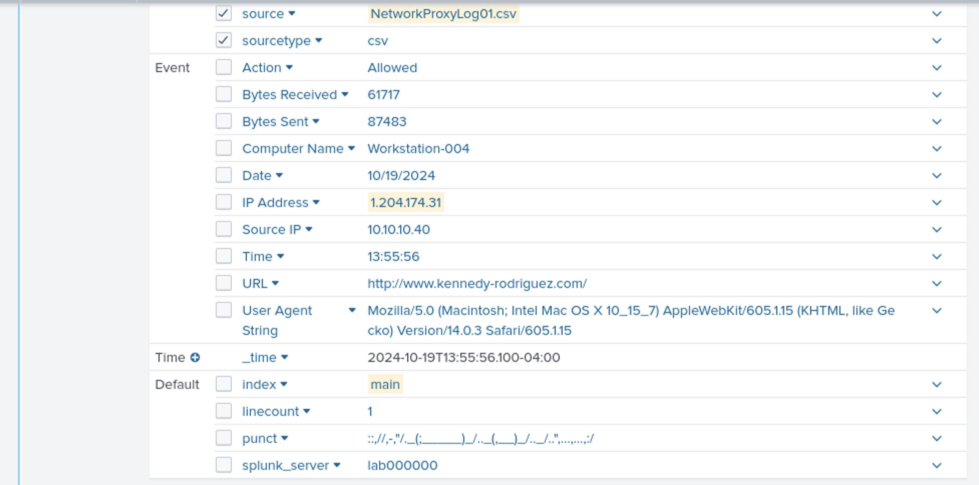

Step 3: Visualizing the Data with a Dashboard

3.1. Creating a New Dashboard:
- I navigated to the Dashboards section in Splunk and created a new dashboard titled "Threat Intelligence Monitoring".

3.2. Adding a Panel:
- I added a panel that uses the search query in the search from above. This panel displayed all instances where known TOR network IP addresses have accessed the network.

3.3. Adjust the visualization:
- I adjusted the data to show up as a Statistics table.

3.4. Edit the search
- I clicked the Magnifying Glass to edit the search and set the Auto Refresh Delay to 1 minute and the Time Range to All.
- I then replaced the search with advanced options that are beyond the scope of this course.

3.5. Let's save this:
- The above adjustments altered the search to one field therefore I saved it.

Step 4: Creating a Report from Your Dashboard:

4.1. Generating a Report:
- I clicked the magnifying glass to edit your search and selected "Convert to Report"

4.2 Name your report:
- I renamed the report and viewed it in the reports tab.

Conclusion:
Through these steps, I demonstrated how Splunk can be used to not only detect threats but also visualize and report on critical cybersecurity metrics, enabling informed decision-making and security postures.

