Exercise 0: Tracking Network Communication:
- First I updated all my packages using “sudo apt-get update.” Next I downloaded the docker using various “sudo” commands, after I ensured that the image was installed correct using the command “sudo docker images.” That is shown in the image below.

Step 1: Generating attacks with pytbull-ng
- After opening a new tab is used the command “sudo docker run --rm -it efigo/pytbull-ng -m victim” to generate traffic to my Host IP: 172.17.0.2/16.
- 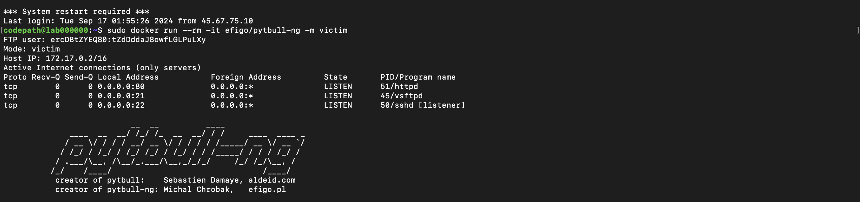Then I sent test attack directly to the IP using the command “sudo docker run --rm -it efigo/pytbull-ng -m attacker -t <172.17.0.2/16>.”

Exercise 1: Writing a Snort Rule to Block Google.com:

Step 0: How to Write Snort Rules:
- I edited the files “ethtool.service, local.rules, and snort.lua” using the command “sudo vi.” I created the folders and files that the Snort required using several commands. I set Snort to the detection mode that printed to the terminal. Then I set a ping to google.com in a new terminal, that ping was shown in the first terminal. 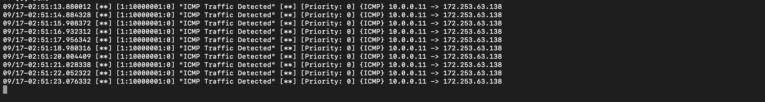
- Then I edited the Snort.lua file. In this file I edited the pulledpork rules using the command “enable_builtin_rules=true” and “include = RULE_PATH .. "/local.rules",.” I ran the snort using “sudo snort -c /usr/local/etc/snort/snort.lua -i eth0 -A alert_fast -s 65535 -k none”

Step 2: Update the Rule to Block HTTPS traffic to Google:
- I used “sudo vi /usr/local/etc/rules/local.rules” to replace the current rule with “alert tcp any any -> any 443 (msg:"Blocking HTTPS traffic to google.com"; sid:1000001; rev:1;).” In another terminal I ran the Snort detection mode using the command “sudo snort -c /usr/local/etc/snort/snort.lua -i eth0 -A alert_fast -s 65535 -k none.” This activated the block to google.com from Firefox, it is shown in the screenshot below that Google was pinged and blocked.
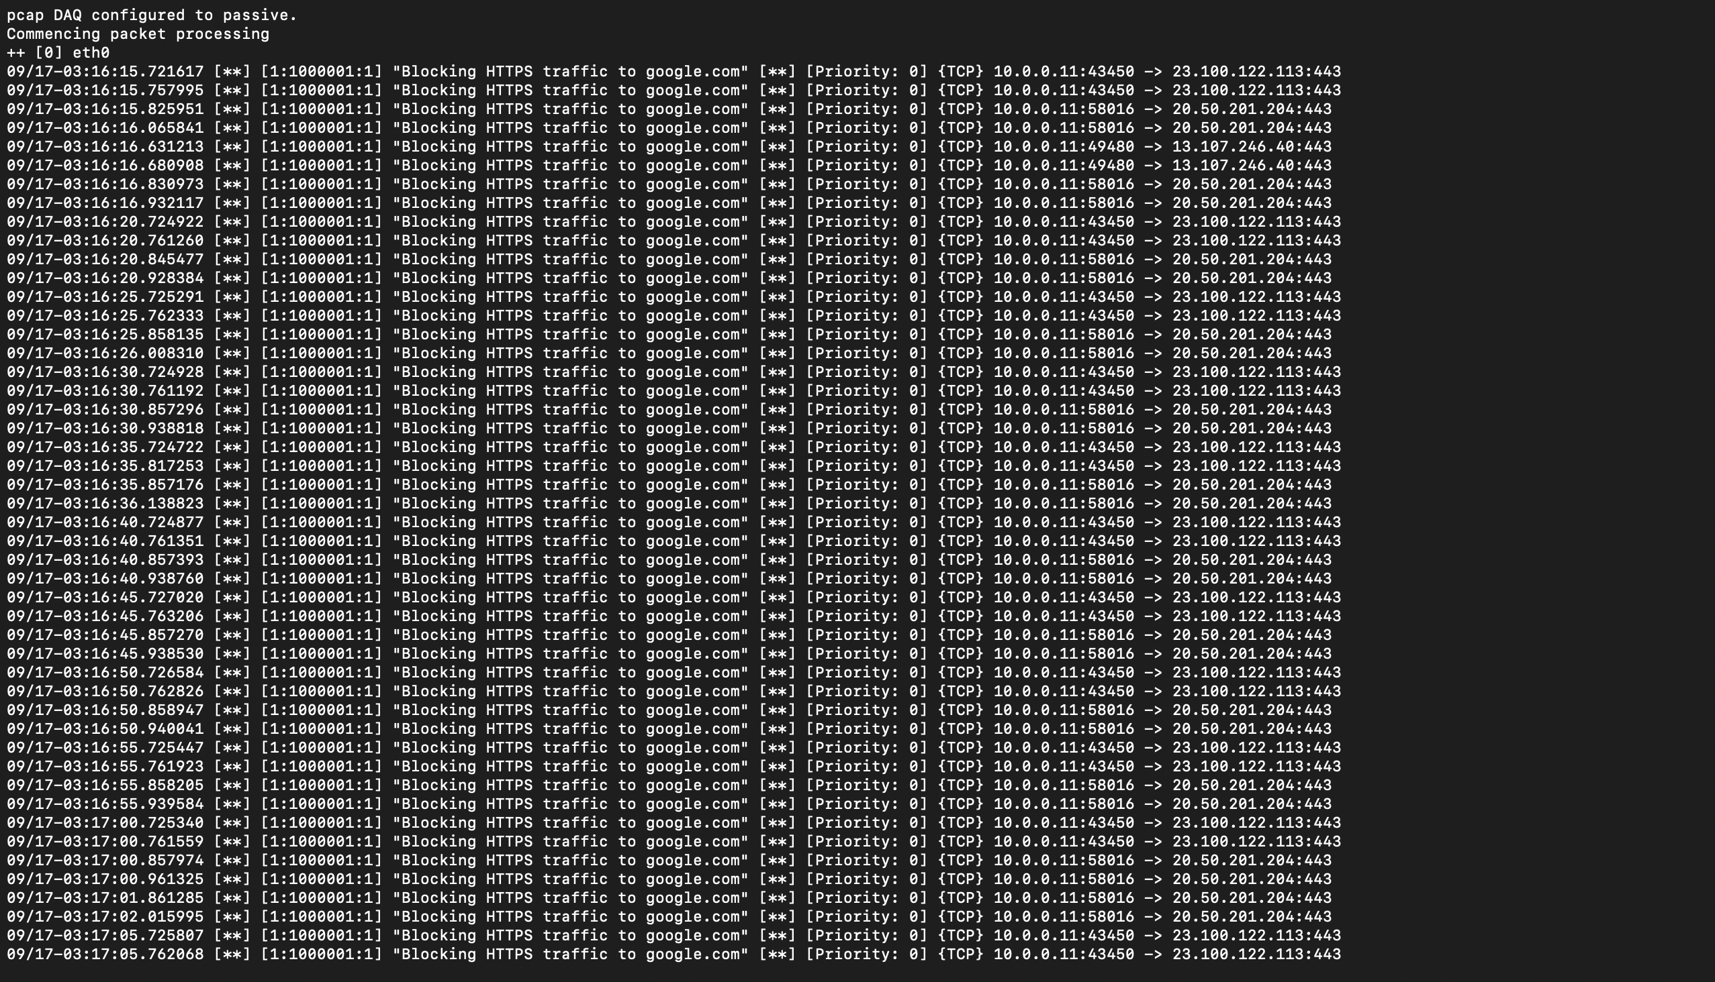

Conclusion: In this lab, I used network monitoring of the Host I.P. to detect incoming attacks. Using the Open-Source Intrusion Prevention System called Snort. I used several “sudo” commands to require the rules to block google.com. It can be seen in terminal, that this was blocked after trying to access the blocked website.

