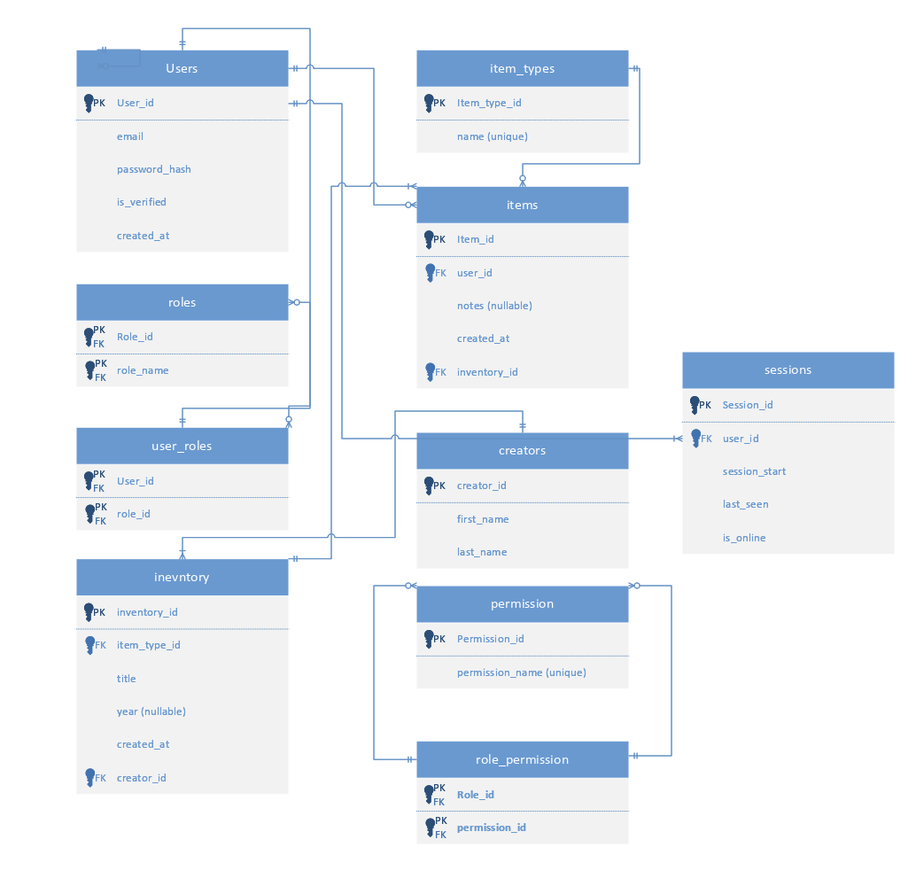

Task | Start | Duration | Finish | Predecessor
Planning: ERD | 1/20/26, 8:00 AM | 7 days | 1/28/26, 5:00 PM
Planning: Flowchart | 1/29/26, 8:00 AM | 2 days | 1/30/26, 5:00 PM | 7
Planning: Use Case Diagram | 2/2/26, 8:00 AM | 1 day | 2/2/26, 5:00 PM | 8
Planning: Logical Dataflow Diagram | 2/3/26, 8:00 AM | 1 day | 2/3/26, 5:00 PM | 9
Planning: Physical Dataflow Diagram | 2/4/26, 8:00 AM | 2 days | 2/5/26, 5:00 PM | 10
Planning: Review Document | 2/6/26, 8:00 AM | 1 day | 2/6/26, 5:00 PM | 11
Planning: Risk Analysis | 2/9/26, 8:00 AM | 2 days | 2/10/26, 5:00 PM | 12
Impl: Backend - Architecture | 2/11/26, 8:00 AM | 1 day | 2/11/26, 5:00 PM | 13
Impl: Backend - Architecture | 2/12/26, 8:00 AM | 1 day | 2/12/26, 5:00 PM
Impl: Backend - Models.py | 2/13/26, 8:00 AM | 3 days | 2/17/26, 5:00 PM | 15
Impl: Backend -Views.py (GET) | 2/18/26, 8:00 AM | 3 days | 2/20/26, 5:00 PM | 16
Impl: Backend - Urls.py (GET) | 2/23/26, 8:00 AM | 2 days | 2/24/26, 5:00 PM | 17
Impl: Backend - Flask serialize (GET) | 2/18/26, 8:00 AM | 2 days | 2/19/26, 5:00 PM | 16
Impl: Backend - Flask RESTful API (GET) | 2/20/26, 8:00 AM | 1 day | 2/20/26, 5:00 PM | 19
Impl: Frontend - Architecture | 1/19/26, 8:00 AM | 25 days | 2/20/26, 5:00 PM
Impl: Frontend -Home.js | 2/20/26, 5:00 PM | 0 days | 2/20/26, 5:00 PM | 20
Impl: Frontend - Main.js | 2/23/26, 8:00 AM | 0 days | 2/23/26, 8:00 AM | 22
Impl: Frontend - Card.js | 2/23/26, 8:00 AM | 0 days | 2/23/26, 8:00 AM | 22
mpl: Frontend - Auth Modal | 2/23/26, 8:00 AM | 0 days | 2/23/26, 8:00 AM | 22
mpl: Frontend - Search.js | 2/23/26, 8:00 AM | 0 days | 2/23/26, 8:00 AM | 25
implL: Frontend - Footer.js | 2/23/26, 8:00 AM | 0 days | 2/23/26, 8:00 AM | 22
Impl2: Backend -Views.py (POST) | 2/18/26, 8:00 AM | 3 days | 2/20/26, 5:00 PM | 16
Impl2: Backend - Urls.py (POST) | 2/23/26, 8:00 AM | 2 days | 2/24/26, 5:00 PM | 28
Impl2: Backend - Flask serialize (POST) | 2/18/26, 8:00 AM | 2 days | 2/19/26, 5:00 PM | 16
Impl2: Frontend - Create Model | 2/23/26, 8:00 AM | 1 day | 2/23/26, 5:00 PM | 24
Impl2: Backend - Flask RESTful API (POST) | 2/20/26, 8:00 AM | 1 day | 2/20/26, 5:00 PM | 30
Impl2: Frontend - Create Model | 2/23/26, 8:00 AM | 1 day | 2/23/26, 5:00 PM | 24
Impl2: Frontend - Create Model | 2/23/26, 8:00 AM | 1 day | 2/23/26, 5:00 PM | 24
Impl2: Frontend - Update Modal | 2/23/26, 8:00 AM | 1 day | 2/23/26, 5:00 PM | 24
Impl2: Backend: Auth/JWT | 2/24/26, 8:00 AM | 1 day? | 2/24/26, 5:00 PM | 35
Impl2: Fontend: Auth/JWT | 2/25/26, 8:00 AM | 1 day? | 2/25/26, 5:00 PM | 36
Impl2: Backend RBAC Admin GET/POST | 2/26/26, 8:00 AM | 1 day? | 2/26/26, 5:00 PM | 37
mpl2: Frontend Admin GET/POST | 2/27/26, 8:00 AM | 1 day | 2/27/26, 5:00 PM | 38
Impl2: Risk Analysis | 2/25/26, 8:00 AM | 1 day | 2/25/26, 5:00 PM | 39
Impl2: Review | 2/26/26, 8:00 AM | 1 day | 2/26/26, 5:00 PM | 40
Impl2: Deliverable - Product | 2/26/26, 8:00 AM | 2 days | 2/27/26, 5:00 PM | 41
Test: Unit Testing | 1/19/26, 8:00 AM | 3 days | 3/5/26, 5:00 PM
Test: Integration Testing | 2/26/26, 8:00 AM | 2 days | 3/9/26, 5:00 PM
Test: Systems Testing | 2/26/26, 8:00 AM | 2 days | 3/12/26, 5:00 PM | 44
Test: Acceptance Testing | 2/26/26, 8:00 AM | 12 days | 3/15/26, 5:00 PM | 45

