HR - 0014 | FINAL WRITTEN WARNING

NAME | {{employee_name}} | DATE HIRED | {{date_hired}}
POSITION | {{position}} | DEPARTMENT | {{department}}
COMPANY | {{company}} | DATE | {{memo_date}}

INCIDENT REPORT
Subject Matter | {{rule_text}} | Date of Incident | {{incident_date}}
 |  | Time of Incident | {{incident_time}}

This memo is being issued due to your continued violation of the Company’s policies, specifically {{rule_text}}
{{prior_warning_note}}
Please refer to the attached Attendance Record / Incident Report for details.
{{incident_narrative}}
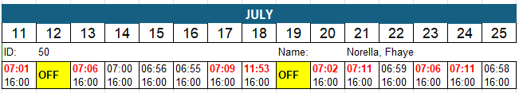

Your attendance behavior negatively affects operational efficiency, team productivity, and workplace discipline. Employees are expected to report to work on time, observe their assigned schedules, and promptly notify their immediate supervisor of any legitimate absence or tardiness in accordance with Company policy.
After careful review of your attendance record, Management has decided to issue you this FINAL WRITTEN WARNING. You are directed to immediately improve your attendance and strictly comply with all Company policies moving forward.
Please be advised that any further attendance violation or similar offense may result in more severe disciplinary action, including suspension or termination of your employment, subject to due process and in accordance with the Labor Code of the Philippines.
We trust that you will treat this matter with the seriousness it deserves and demonstrate immediate and sustained improvement.
For your strict compliance.

Conformed by:
{{employee_name}}
__________________________________
Signature over Printed name
Date: _____________________________
HUMAN RESOURCES DEPT.
Received by:
________________________________
Signature over Printed name
Date:____________________________

