HR - 0014 | WRITTEN WARNING

NAME | {{employee_name}} | DATE HIRED | {{date_hired}}
POSITION | {{position}} | DEPARTMENT | {{department}}
COMPANY | {{company}} | DATE | {{memo_date}}

INCIDENT REPORT
Subject Matter | {{rule_text}} | Date of Incident | {{incident_date}}
 |  | Time of Incident | {{incident_time}}

This memo is being issued to you in connection with a documented violation of the Company’s policies, specifically {{rule_text}}
The Company strictly enforces its policies to ensure business continuity, operational efficiency, and fairness among all employees. Any violation of the above-cited rule constitutes a breach of both company policy and, where applicable, statutory labor standards.
{{incident_narrative}}
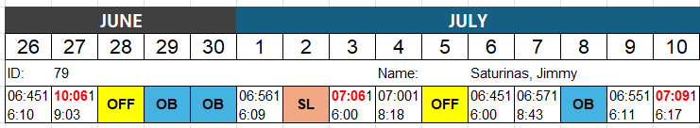

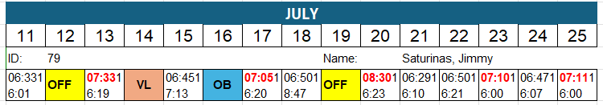
Your attendance violation(s) directly impact team productivity, workplace discipline, and the Company’s ability to deliver consistent service. Repeated or unaddressed attendance infractions disrupt operational schedules and are unfair to colleagues who comply with the established working hours. The Company emphasizes that all employees are expected to adhere to their designated schedules, including any overtime arrangements agreed upon in advance with management.
You are required to acknowledge receipt of this memo and are strongly advised to immediately correct your attendance behaviour going forward
You are expected to:
- Report to work on time and as scheduled.
- Notify your manager in advance in case of any legitimate absence or tardiness.
- Show immediate and sustained improvement in your attendance record.
Please be advised that continued violations may lead to further disciplinary action, up to and including suspension or termination of employment.
Performance Strategy: Make sure to inform your immediate manager for any UNSCHEDULED OUT or TARDINESS prior proceeding. As you know, we are maintaining a specific standard, and we need you to abide by these procedures.
After careful assessment of the complaint, please be advised that management has decided to issue you WRITTEN WARNING. We expect you to diligently observe our company's rules and regulations, as this is essential for providing excellent service. We trust that you will treat this matter with the seriousness it deserves and take this opportunity to reflect on your actions.
For your strict compliance

Conformed by:
{{employee_name}}
__________________________________
Signature over Printed name
Date: _____________________________
HUMAN RESOURCES DEPT.
Received by:
________________________________
Signature over Printed name

