Network Assessment Analyses and Tools Documentation

Michael Rizzo
OAQPS/AQAD/AQAG
Introduction

The analyses and tools developed to aid in the network assessments attempt to answer two relevant questions. The first is “Which sites are redundant and could possibly be either removed or relocated?” The second is “Where is more information needed to better characterize air quality and could, therefore, use a new site?” It is envisioned that these analyses and tools will provide the State and Local agencies with a weight of evidence in deciding whether or not to keep a site or possibly establish a new site. It is understood that each State and Local agency has its own unique needs and priorities and to attempt to generalize those priorities across the entire country is not feasible. There will probably be sites which a State knows it cannot decommission or relocate no matter how strongly the evidence suggests that it can be done. It is recognized that there are regulatory and public needs in addition to the requirements from USEPA that each State is obligated to meet. These analyses, therefore, are not prescriptive nor should they be construed as such.

It is recognized that each State will probably have three types of sites. The first type includes those sites that simply cannot be decommissioned because they are high concentration sites used for NAAQS determination or are used for public relations purposes to inform the public about air quality in their area. Likewise, there are sites which are known to have little value and can easily be determined as redundant. These sites measure concentrations well below the level of the NAAQS or are very close to other sites which measure very similar concentrations. The analyses will help provide clear evidence for removing those types of sites. The third type of site is characterized as a site where the State does not have enough data to determine whether or it can be moved or decommissioned. These analyses will aid in that determination by providing a weight of evidence for either keeping or removing the site from the network.

Limitations

There are certain limitations which need to be kept in mind when using the tools and analyses. First, none of the tools listed take into account topography unless it is inherently captured in the measurement. For example, two sites separated by mountainous terrain when compared to each other will most likely exhibit traits that demonstrate they are unique to one another.

The data collected by the Census Bureau is only fully updated at each decennial census. The Census Bureau does update a very limited amount of census tract information through the use of special surveys, but those are only conducted for a limited amount of areas and not done every year in the same area between decennial censuses.

At this point in the tool development, there is no option for the user to input his or her data. In order to provide these tools in the most timely and consistent means possible, static data sets have been created that the user can draw from to analyze a set of sites in relation to other nearby sites across dense monitoring networks. Because of this, most of the tools are limited to ozone, PM2.5 (both the FRM/FEM and continuous FRM-like networks) and PM10. The PM10 analyses have not been done yet, but will be added to the results when they are complete. Each analysis and tool is described below and further details the limitations associated with each.

Data

Ozone data were polled from AQS for 2005 through 2008. Maximum 8-hour concentrations were used to represent each day from May through September for each year. Individual days were considered complete if the day contained at least 18 valid 8-hour averages or the maximum 8-hour average was greater than 0.075 ppm. A site was considered to have complete data if it had at least 75% or 115 days out of the 153 measured between May and September.

PM2.5 data were divided into two groups: FRM/FEM and other continuous measurements. FRM/FEM data were polled from AQS for 2005 through 2008 and split into two categories based on the established sampling frequencies associated with fine particulate matter. Analyses and the associated interactive tools were completed for both 3-day and 6-day sampling schedules, and data completeness was calculated for each category. A site was considered complete for a year if it measured 75% of the samples required for either a 3-day or a 6-day schedule across all four quarters of a year, and then had four complete calendar quarters. In total, 92 days for a 3-day schedule and 46 days for a 6-day schedule were required. Only sites that collected on a 3-day schedule would be eligible for analyses involving data collected on a 3-day schedule, while the data from those particular sites could also be used in the 6-day analysis since they collected data along with the 6-day sites.

The continuous PM2.5 data were polled from AQS using parameter code 88502 which represents continuous fine particulate measurements deemed “FRM-like” by the States. These data were supplemented by data collected by AIRNOW to replace missing values in the AQS record for 2005 through 2008. The midnight to midnight block average was used to represent the concentration for a day where at least 18 hours had to be present or the average was greater than 35.5 ug/m3 for a day to be considered complete. As with the FRM/FEM data, a site was considered complete for a year if it had at least 75% of the expected observations within a calendar quarter which depending on the quarter was either 68 or 69 days and also had four complete quarters.

Tools

Population Animation
The population animation tool is a Google Earth display that shows the change in population over 19 years relative to the 1990 population at the census tract level. Accompanying the population changes are the monitoring network changes from 1990 to 2008. To start the tool, open the popanim9008.kmz in Google Earth. Because the population frames are PNG files, each one has to be loaded in as the animation progresses and may take several cycles of the animation to do. Once the animation is operating appropriately, the population will start off as all white in 1990 which is the base year and then turn either shades of blue or red to represent decreasing or increasing population, respectively. The monitoring sites for all of the criteria pollutants can be viewed by clicking on the appropriate box next to the pollutant’s name. The sites will be displayed as either black circles or gray triangles representing active and inactive sites, respectively. Clicking on a site gives details of the sites start and end year. The animation serves as clear example of how populations have changed within the country over the past 19 years and how the monitoring networks have evolved to serve those shifting populations. In many cases around urban areas, the population has shifted away from the urbanized core to the suburbs and the monitoring networks have not evolved to take into account this change.

Correlation Matrix Tool
The correlation matrix tool is a static analysis and interactive tool which shows the correlation, relative difference, and distance between pairs of sites within a CBSA or a user selected region. For the static analyses, each CBSA is provided with a graphical matrix for ozone, PM2.5 FRM/FEM, and continuous “FRM-like” sites as well as comma separated values (CSV) file which has the summary information corresponding to the graphical display contained within it. Figure 1 shows an example of one of the matrices which shows all of the possible pairings of 2008 ozone sites for the Chicago, IL metropolitan area. The shape of the ellipses represents the Pearson squared correlation between sites with circles representing zero correlation and a straight diagonal line representing a perfect correlation. The color of the ellipses represents the average relative difference between sites where the relative difference is defined as

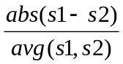

where s1 and s2 represent the ozone concentrations at sites one and two in the pairing, abs is the absolute difference between the two sites and avg is the average of the two site concentrations. The numbers in the middle of the ellipses is the distance between the pair of in kilometers. The accompanying CSV file provides information about the individual site pairings including the summary statistics for the relative difference calculations, the R2 correlation value and the distance between the sites.

The purpose of this particular analysis/tool is to provide a means of determining possible redundant sites that could be removed. Possible redundant sites would exhibit fairly high correlations of 0.6 consistently across all of their pairings and would have low average relative difference despite the distance. Usually, it is expected that correlation between sites will decrease as distance increases. However, for a regional air pollutant such as ozone, sites in the same air shed can have very similar concentrations and be highly correlated. More unique sites would exhibit the opposite characteristics. They would not be very well correlated with other sites and their relative difference would be higher than other site to site pairs. For Chicago, site 171971011 has these characteristics. It has the lowest correlations of the site pairs for Chicago and the highest average relative differences. This site is in fact designated as the background site for the Chicago metropolitan area. 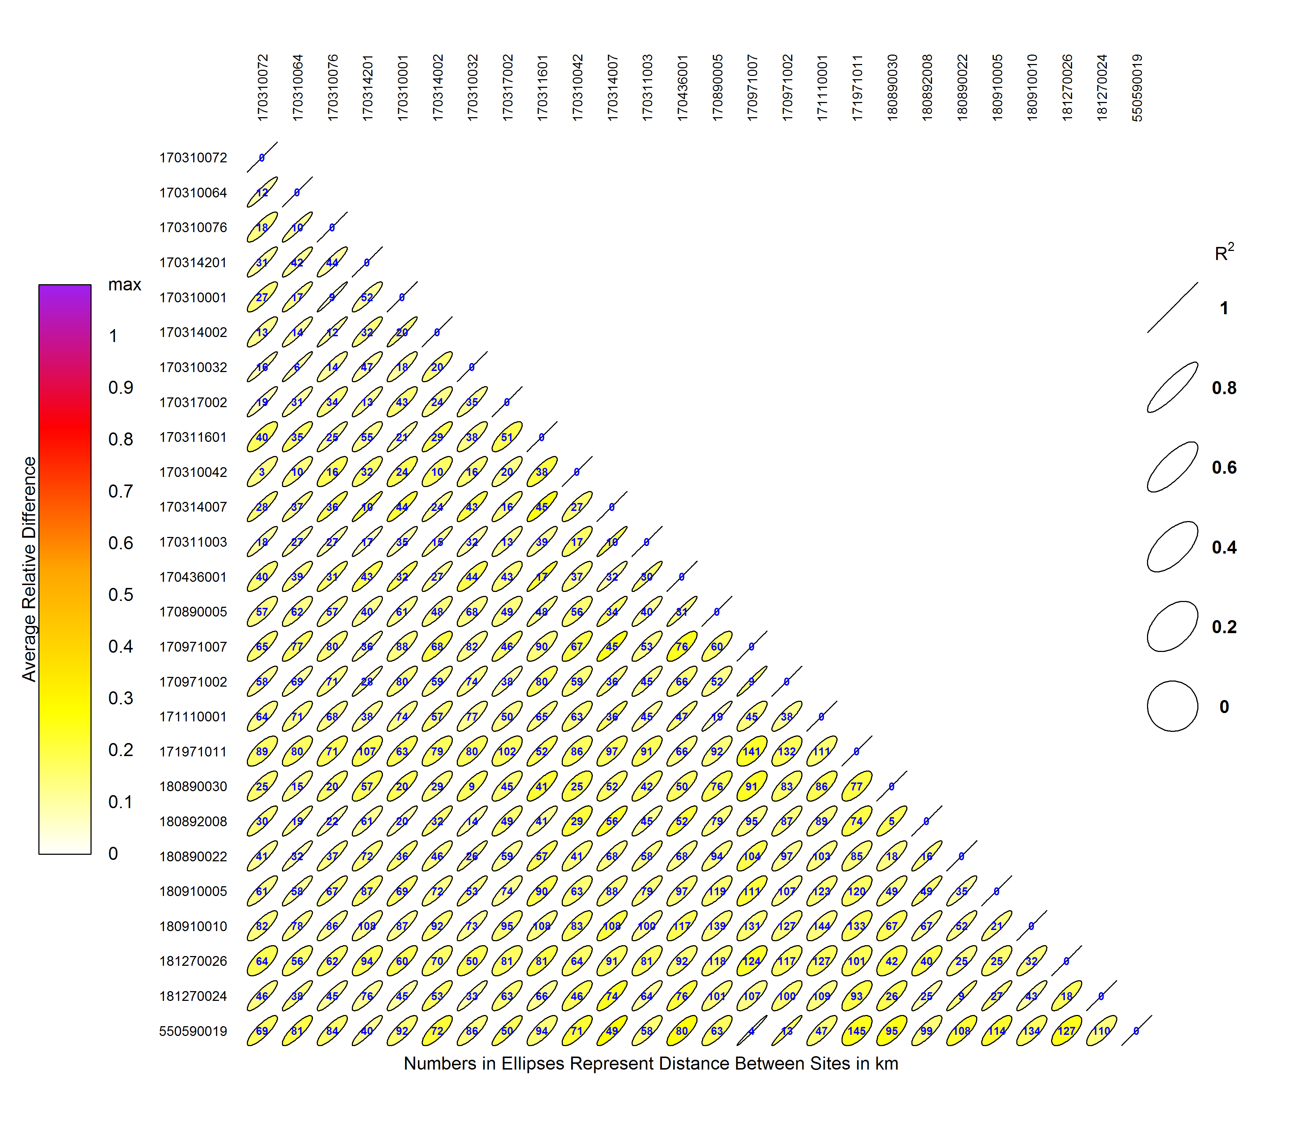
Figure 1. Example of a Correlation Matrix for Chicago, IL

Some sites show a mixture of redundancy and uniqueness such as site 550590019. It has some higher correlations with sites that are over 50 km away and also lower relative differences. This particular site is located in Racine, WI just over the border from Illinois and directly downwind of the Chicago metropolitan area. It has very high correlations with not only with sites 170971002 and 170971007 which are located due south of the Racine in Lake County, IL, but also with site 170314002 which is located further south in Northbrook, IL. The Northbrook site is considered to be both within the urban mix of emissions and downwind of major sources within the Chicago area. The results seen at the Racine, WI are consistent with the current knowledge of the effect ozone transport has on concentrations downwind from a major urban area like Chicago.

Removal Bias Tool
The removal bias tool consists of a series of static analyses and an interactive tool meant to aid in determining redundant sites and act as a means of validating a network after sites have been chosen for removal. The static analyses use the nearest neighbors to each site to estimate the concentration at the location of the site if the site had never existed. This is done using the Voronoi Neighborhood Averaging algorithm with inverse distance weighting. The weighting scheme used was 1/distance2 which allows for higher weighting on concentrations at sites located closer to the site being examined. The bias was calculated for each day at each site by taking the difference between the predicted value from the interpolation and the measured concentration, and the average bias was compared using a students-t distribution to determine whether or not it was statistically different from zero at a 95% probability. A positive average bias would mean that if the site being examined was removed, the neighboring sites would indicate that the estimated concentration would be larger than the measured concentration. Likewise, a negative average bias would suggest that the estimated concentration at the location of the site is smaller than the actual measured concentration.

The results from the static removal bias analyses are given in the form of Google Earth files, ARCGIS shape files and CSV files. All three types contain the same information. The AQS site ID, the address and “nickname” of the site from AQS, the 2005-2007 and 2006-2008 design values including the percentage each is of the corresponding NAAQS, the average bias and average relative bias which is the average of the daily bias divided by the measured concentration at the site, and a frequency table of all the neighboring sites used in the interpolation estimate across the time span. For ozone, the time span was the 153 days per year across the summer months, while for PM2.5 it depended on the number of days associated with a 3-day and 6-day sampling schedules or the entire year if continuous PM2.5 data were analyzed. In Google Earth, statistically insignificant sites are shown as solid dots while other sites are color coded according to the magnitude of their average bias and displayed as rings. Clicking on a site in Google Earth will provide all of the information listed above. The static analyses were done for 2005 through 2008 since meteorology plays such a large role in pollutant concentrations. A example from the Google Earth product is shown in Figure 2 for an ozone site near Huntsville, AL. For that particular site, the removal bias over the four years shows a consistently negative bias which would mean that the Huntsville site measures consistently higher than its neighbors. All of the four years are statistically significant. Contrast this with a site located in Birmingham, AL where three of the four years are showing no real difference with its neighbors and the remaining year has a small negative bias of 0.001 ppm (Figure 3). This particular site is exceeding the ozone standard, but there is another site approximately 3 miles to the northeast the similarly is not statistically different from its neighbors and has a similar design value. In this case, one of these sites could possibly be marked for removal if there were no other extenuating circumstances requiring keeping both.
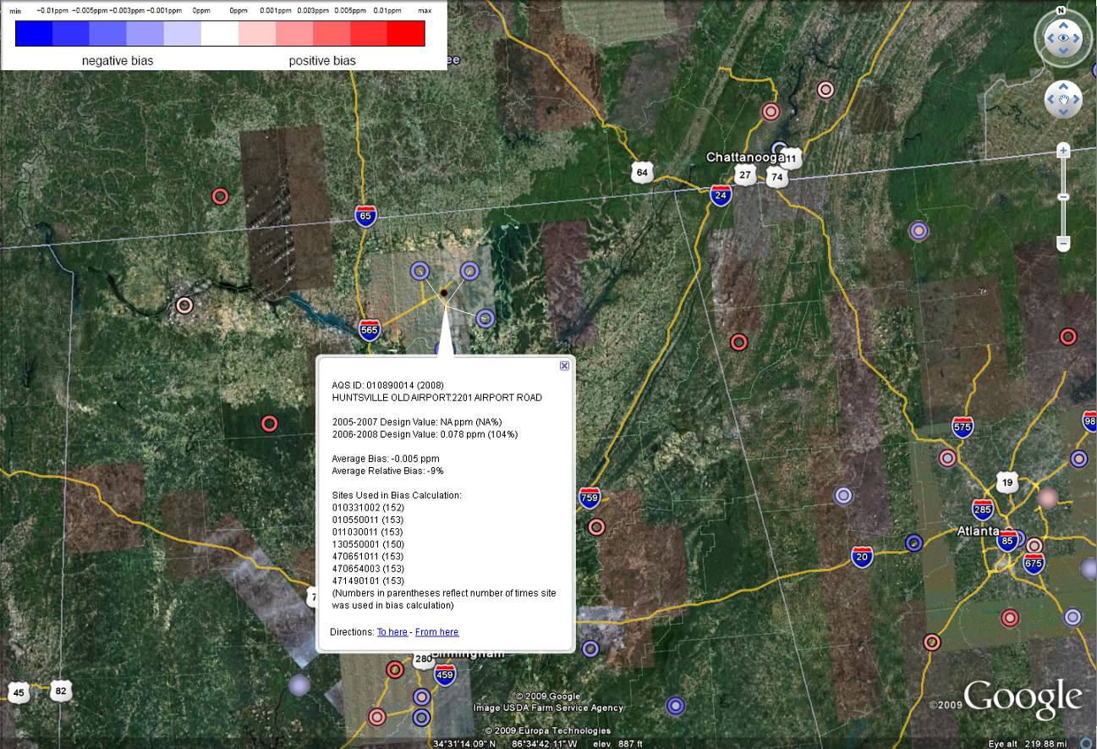
Figure 2. Example of the information provided in the Google Earth product for the removal bias analysis.
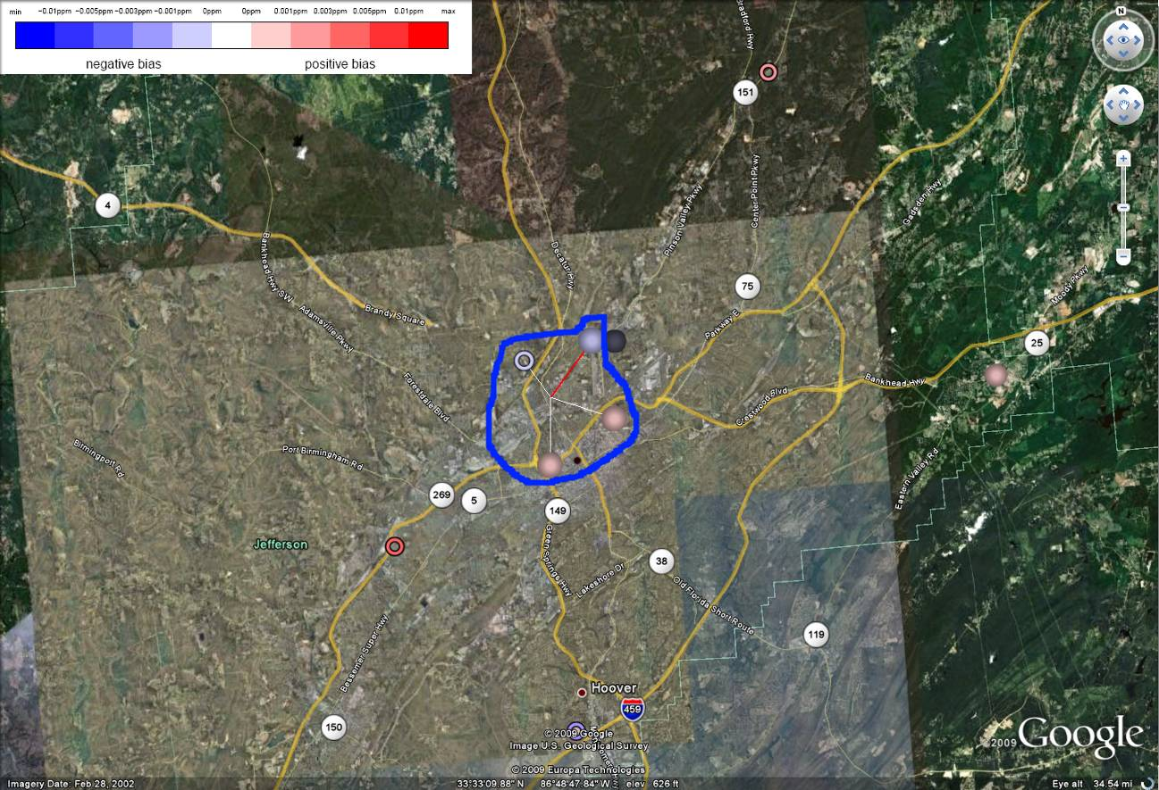
Figure 3. Example of an ozone site in Birmingham, AL (location highlighted in blue) that is consistently similar to it’s neighboring sites over several years
New Sites Tool
The new sites tool provides a way to determine areas where new sites could provide more information to characterize air quality. This is done using a series of criteria between neighboring sites to filter out those site pairs which meet the criteria for placing a “new” site. These criteria include the squared Pearson correlation between sites, the distance between sites, and the average difference between the sites. Additionally, in order to relate the positioning of potentially new sites back to the NAAQS, a final criterion related to the potential of exceeding 85% of the NAAQS is also accounted for. The 85% of the NAAQS value is stated in 40 CFR Part 58 Appendix D as a benchmark for siting the minimum number of sites within an urban area. However, it can also serve as a measure for areas that would benefit from potential additional sites.

The probability was calculated by interpolating the 2006-2008 design values for each pollutant across a 12 km by 12 km grid across the continental United States. The design values for all the pollutants except the continuous PM2.5 data were taken from http://www.epa.gov/airtrends/values.html. The continuous FRM-like PM2.5 design values were computed using the procedures in 40 CFR Part 50 Appendix K. Because of the completeness criteria for the PM2.5 NAAQS, many continuous sites did not have a valid design value. The probabilities of exceeding 85% of the NAAQS for the continuous sites are, therefore, less reliable than their FRM/FEM counterparts. It was assumed that the final design values had an error of 10%, and through error propagation, a standard deviation for each grid cell was calculated and used to estimate the probability for a grid cell to exceed 85% of the NAAQS. When the tool is launched, it defaults to ozone and the 8-hour standard, a correlation between site pairs of 0.5, a minimum distance of 100 km, and a difference between sites of zero. When nearest neighbor site pairs meet these criteria, a possible “new” site is drawn half way between the two sites. The possible “new” sites are further reduced by the probability of having them in an area that exceeds 85% of the NAAQS with the default probability being 80%. The “new” sites in the tool are shown as blue triangles, while the existing sites are shown as either black circles if they meet the above criteria or gray circles if they do not (Figure 4). Only sites within the 2008 network have been used for this tool since that year has the most recent complete data in AQS and reflects the most current monitoring networks for the NAAQS. It should be noted that the tool will show more new sites are needed than is feasible to deploy. As the variables listed above are manipulated, certain areas will more likely retain sites than others. Usually “corridors” of “new” sites are seen and consideration should be given to whether or not at least one new site could be placed within the general area. This tool does not take into account topography so “new” sites may be placed between existing sites separated by mountainous terrain. This tool will output the map to a PDF file as well as a Google Earth file. The satellite imagery will be useful in determining if “new” sites are located in areas that are dominated by mountainous terrain.
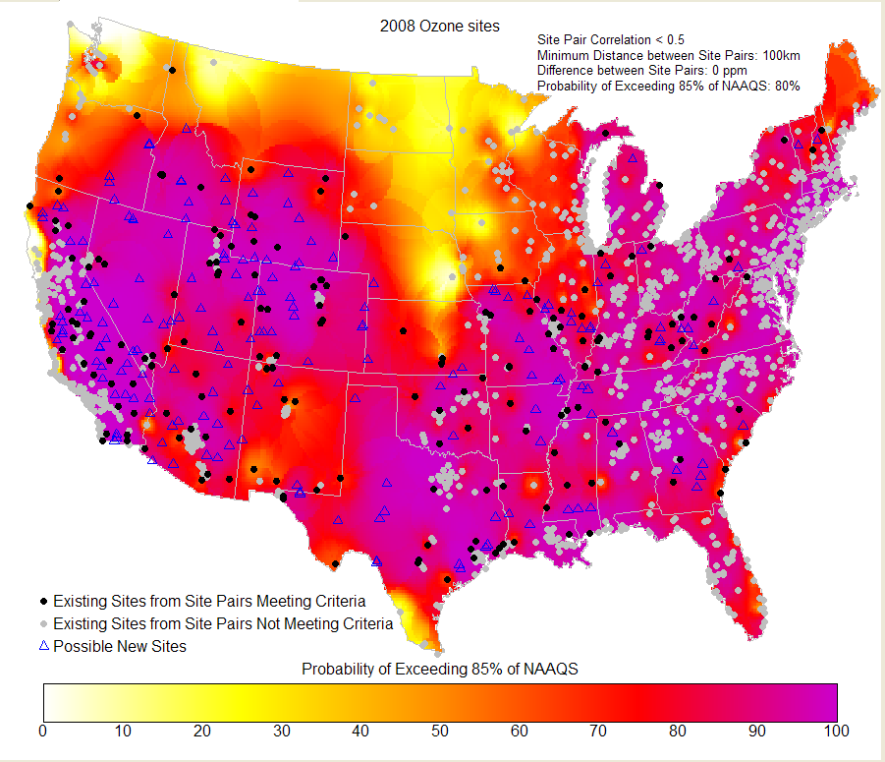
Figure 4. Example of the map produced for ozone from the new sites tool

As stated earlier, the probabilities of exceeding 85% of the NAAQS for the continuous FRM-like PM2.5 network may be somewhat unreliable since there are fewer sites and the completeness criteria used for the FRM/FEM data were used. However, the annual standard maps for the FRM/FEM and continuous FRM-like are very similar. The larger difference is seen in the comparison of the maps for the daily PM2.5 standard. There may be several reasons for this difference including the location of the sites since many continuous monitoring sites are not co-located with their FRM/FEM counterparts. Another explanation is that the number and density of continuous sites across the country is smaller than the FRM/FEM network. Yet another reason for the difference is the sampling schedules imposed on the FRM network. The continuous PM2.5 network is measuring anywhere from three to six times as many more days as the FRM network and could possibly have a different concentration distribution than the FRM network. Also, different monitoring methodologies also play a major role in the concentration distributions between the two networks (Figure 5). The dots on each map in Figure 5 represent the sites used for each interpolation.
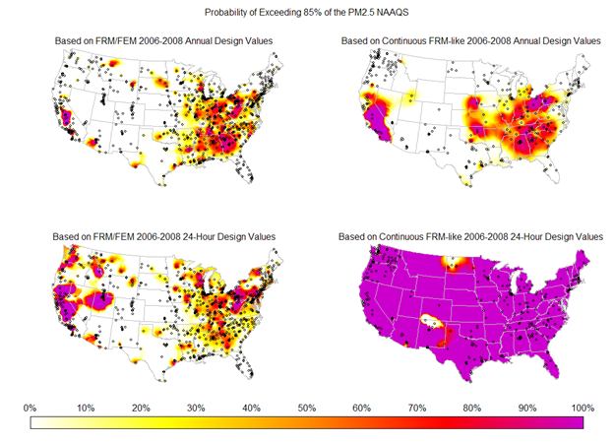
Figure 5. Comparison of the probability of exceeding 85% of the NAAQS for the PM2.5 FRM/FEM network (top) and the PM2.5 “FRM-like” continuous network (bottom)

Area Served Tool
The area served tool uses a spatial analysis technique known as Voronoi or Thiessen polygons to show the area represented by a monitoring site. The shape and size of each polygon is dependent on the proximity of the nearest neighbors to a particular site. Data from the 2000 Decennial Census were used to determine which census tract centroids were within each polygon. The total tract area represented by the polygon was calculated as well as the total population and population density. These statistics were tabulated for each year for 2005 through 2008. An individual population estimate was created for each tract and for each year by using the 2000 census’ individual tract composition within a county. This composition was assumed to remain constant and the census county level estimates for 2005 through 2008 were used to estimate the tract populations. The static tool displays each polygon along with the location of the monitor within it. In Google Earth, the user can click on the site or within the polygon containing the site and get the total area served, the total population and population densities for 2000 and the year represented by the network as well as the individual census tract IDs so that the user can refer to the census data to determine the sensitive populations served by the monitor. Those census data can be accessed at http://factfinder.census.gov/.

Since census tract centroids were used to assign whole tracts to a particular Voronoi polygon, some polygons which do not have a tract centroid within them will not have population information. In these cases, information will have to be gleaned from the statistics of surrounding sites.

