Network Assessment Tools Installation Instructions

Michael Rizzo
OAQPS/AQAD/AQAG
A new version of R was released near the end of October. Please uninstall any version of R older than R 2.10.0. There have been a series of changes to the libraries used by the network assessment package and the updated versions need to be installed along with the new version of R.

Installing R and network assessment tools

- Download and run the R 2.10.0 installation file for Windows from:
http://cran.r-project.org/bin/windows/base/R-2.10.0-win32.exe
- Follow the instructions on the screen and install a shortcut on the desktop.
- Save the netassess.zip and runthisfirst.r files to a user specified directory.
- Open R by clicking on the R 2.10.0 icon on the Desktop, click on “File” and click on “Source R Code…”.
- Go to the directory in which runthisfirst.r is saved, click on it and click “Open”.
- Another window will immediately open asking for a file with a zip extension. Find the netassess.zip file, click on it and click “Open”.
- The netassess package will then start to install. Once the zip file has been installed, R will begin downloading from the Internet other libraries it needs to run the network assessment tools. A series of “popup” windows will appear showing the progress that is being made in the download.
- Once everything is installed, R will shut down automatically.
- The “runthisfirst.r” script creates four “.bat” files on the Windows Desktop (area.served.bat, rembias.bat, cormat.bat and newsites.bat). Double clicking on any of these files will open the individual tool. No further knowledge of the use of R is needed.

Using network assessment tools in R
- There are four tools: cormat.bat, newsites.bat, rembias.bat and area.served.bat. When clicking each tool, a DOS window will open. Minimize that window since it may hide the window the tool pops up in. All tools use a series of static data sets currently representing ozone, PM2.5 (FRM/FEM) and continuous PM2.5 data. The data have been processed so that only those sites which meet the completeness criteria as given in 40 CFR Part 50 are used for the various analyses. This may cause some sites to be dropped due to the completeness criteria. For the PM2.5 (FRM/FEM) data set, there are two choices of either using data collected on an every 3-day or every 6-day schedule. This means that any data collected on the established monitoring schedules will be used. For example, if the every 6-day schedule is chosen, data from sites that collect air measurements from the every 3-day network will also be included if the completeness criteria are met.
- The cormat tool examines the correlations and compares concentrations between site pairs for an area chosen from the map. To start cormat, double click on “cormat.bat” on the Desktop.
- The following window opens after the data sets are loaded. A window will show the progress of the data sets being loaded by the tool. Be patient. It could take around a minute to load all of the data sets.
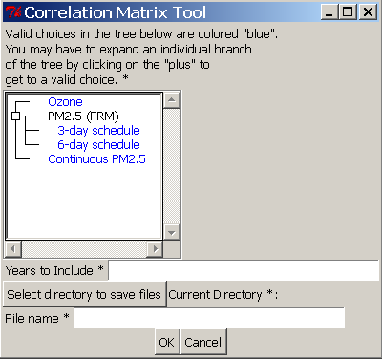

- Fields marked by “*” are mandatory and need to be filled in. For this tool, these fields are the pollutant, years to include, directory to save files to, and the file name. Valid choices for the pollutant can be made from the options colored “blue” on the tree. Simply select one of them with the mouse. The user may have to hit the “plus” symbol to expand the tree to get to a valid choice.
To include a series of years, separate the start and end year by a semicolon (“:”). For example, to include data from 2005 through 2007, the user would type “2005:2007” in the “Years to Include” field. Once everything is inputted, hit “OK”. If any of the information denoted by a “*” is missing, a window will pop up requesting the user to enter the missing information before proceeding to the next step.
- The next step is to select the geographic area of interest. A window with a map will pop up.
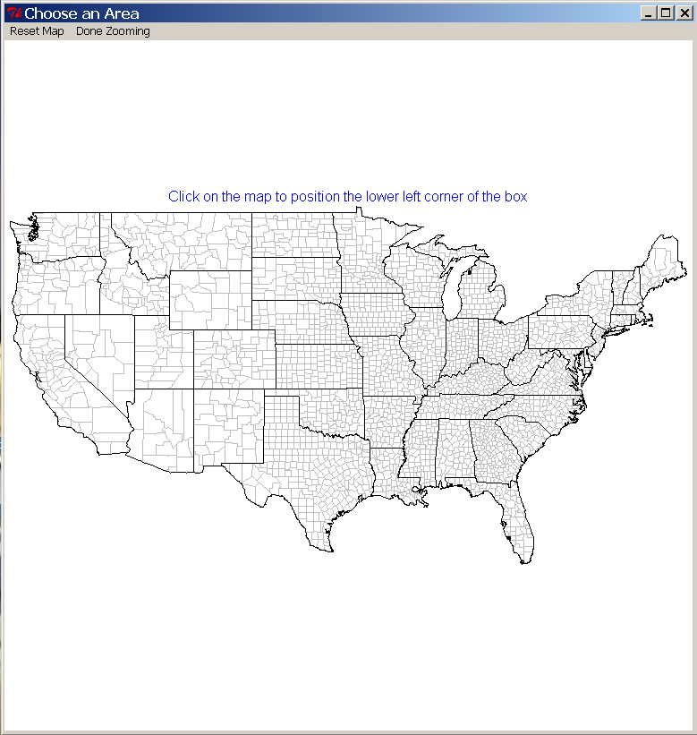
The user can zoom in on a particular area by first positioning the mouse cursor at the lower left corner of the area of interest. A blue square will appear at the chosen location. The user then clicks to the upper right of the area and the map will zoom in to the selected area. The area can further be zoomed into by repeating the previous steps. Once zooming is completed, click on “Done Zooming” at the top of the window. If a mistake was made and the area needs to be re-selected, click on “Reset Map” and the full map will be shown again.

- Once the map is selected, the analysis will run. A status bar will pop up showing the progress of the calculation. A PDF of the correlation matrix between sites will be created in the specified directory as well a CSV file giving the quantifiable information used to the make the correlation matrix plot. After the files are saved, the following window will pop up.
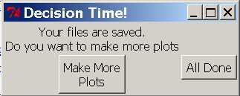
- If the user wants to run the tool again, hit the “Make More Plots” button. Hitting the “All Done” button will close the tool.

- The tool for examining the possible placement of new sites for the larger networks can be accessed by double clicking on “newsites.bat” on the Desktop. This tool has had the most changes made since the time it was shown at the National Monitoring Conference. A feature has been added showing the probability of exceeding 85% of the NAAQS for a particular area of the country. This was produced by interpolating the design values for each of the standards across a 12km grid and assuming an error in the design value of 10%. The error from the neighboring sites was propagated to the predicted value for a particular grid cell and a probability of that cell exceeding 85% of the NAAQS was calculated. The 85% of the NAAQS criterion was taken from 40 CFR Part 58 which uses that particular level as a benchmark for requiring sites. Utilizing the design value data allows the user to associate possible new sites with the air quality standards. The following window will pop up after the data required by the tool have been loaded.

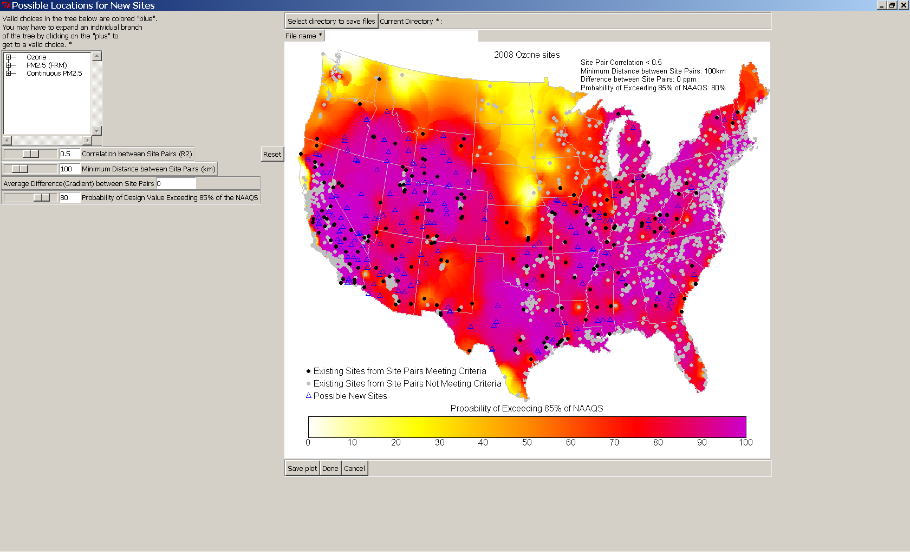

- The user can choose which pollutant to analyze by selecting a choice from the tree. The pollutant tree needs to be expanded by clicking on the “plus” next to each branch until a valid choice is indicated in “blue”. For the PM options, the user will be able to choose either the annual or daily standard. Making a selection from the tree will redraw the map for that particular pollutant and its associated standard. The correlation and distance between site pairs can be adjusted using the sliders or can be entered directly in to the box to the right of slider. Likewise, the probability of exceeding 85% of the NAAQS can also be adjusted. The average distance between sites pairs is entered directly. The “Reset” button resets the inputs to the defaults which is a correlation (R2) of 0.5, a minimum distance of 100 km, a difference of zero and an 80% probability of exceeding 85% of the NAAQS. Adjusting the inputs will automatically produce a new map displaying which site pairs met the first three criteria (“black” dots) and which ones did not (“gray” dots) as well as possible new sites based on that criteria (“blue” triangles). The possible new sites are further filtered out by the probability criterion where possible new sites are only placed in areas which have a probability of exceeding 85% of the NAAQS greater than value chosen. Any time the pollutant or criteria are changed, the map will update also. To save the map, enter a directory and filename to save the plot to and hit “Save Plot”. The plot will be saved as a PDF and KMZ file for Google Earth.

- The third interactive tool is for evaluating the area and population served by existing and new sites. It is accessed by double clicking the “area.served.bat” icon on the Desktop. The following window will pop up. 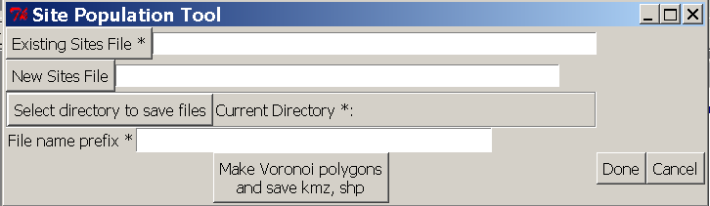

The user needs to enter at least an existing sites comma separated values (CSV) text file a directory and filename to save the output. The input file structure for both the existing and new sites should be 3 columns representing the siteid, longitude and latitude of the site in that order with a header line of “siteid,longitude,latitude”. Once the site files and output information have been inputted, click on the “Make Voronoi polygons and save kmz, shp” button. A progress bar will appear showing the progress of the calculations and a window will pop up when the files have been saved. The window can be closed by either clicking on “Done” or “Cancel”. The tool’s results now include a listing of the census tract centroids that are included in each polygon represented by a single monitor. This will allow users to use the census data from 2000 to look up statistics for sensitive populations and aggregate it to the area served by the monitor.

- The fourth tool is a removal bias tool and is accessed by double clicking on “rembias.bat” on the Desktop. The following window will pop up.

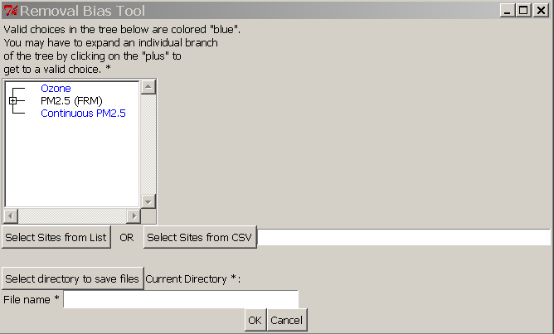
- This tool will allow the user to remove sites from the 2008 networks to see what the resulting bias would be. An interpolation will be computed across the year to determine the average bias. The user will start by selecting the pollutant from the tree and then either click on “Select Sites from List” or “Select Sites from CSV” to choose sites to leave out for the bias calculation. Clicking on “Select Sites from List” will open another window with the listing of sites associated with the pollutant selected. The user can use the “control” or “shift” keys on the keyboard to select multiple sites. If a comma separated values (CSV) file is supplied, the AQS IDs of sites for removal are given in a single line with each ID separated by a comma.
- After entering the directory and file name to save the output to, click “OK”. A window will display the progress of calculating the bias. Once it is done, a window will pop up asking the user if he or she wants to run the tool again.
- The tool will save the results to Google Earth, ARCGIS and CSV files.

