**VM_selenium**

**编辑Docker-compose.yml**

**mkdir /data/selenium**

**cd /data/selenium**

**vim Docker-compose.yml**

|  |
| --- |
| selenium-hub:  restart: always  image: selenium/hub:latest  ports:  - "4444:4444"  #selenium-chrome  selenium-chrome:  restart: always  image: selenium/node-chrome-debug  stdin_open: true  environment:  NODE_MAX_SESSION : 7  NODE_MAX_INSTANCES : 7  links:  - selenium-hub:hub  #se-fire  selenium-firefox:  restart: always  image: selenium/node-firefox-debug  environment:  NODE_MAX_SESSION : 7  NODE_MAX_INSTANCES : 7  links:  - selenium-hub:hub |

**docker-compose up -d**

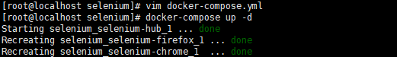

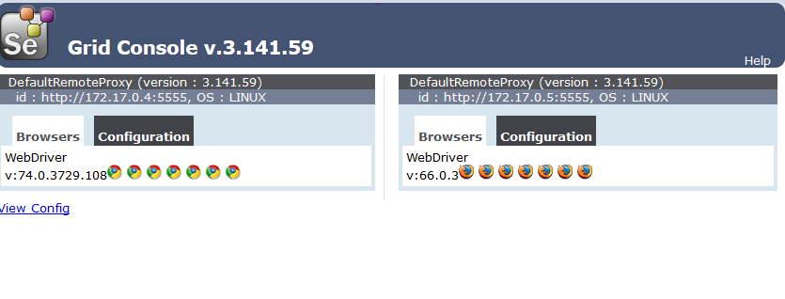

**如果需要多个remote node:**

**docker-compose scale selenium-chrome=3 selenium-firefox=3**

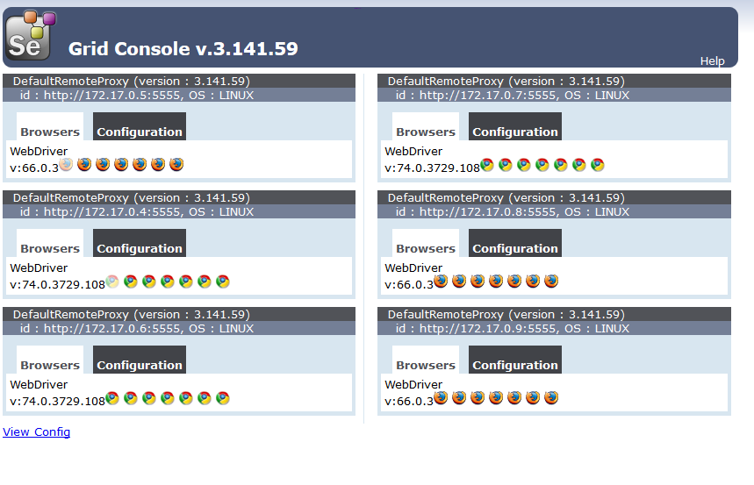

**测试selenium server 于python脚本**

|  |
| --- |
| **from selenium import webdriver**  **lists = ['chrome', 'firefox']**  **# 通过不同的浏览器执行脚本**  **for browser in lists:**  **driver = webdriver.Remote(command_executor='http://10.0.29.58:4444/wd/hub',**  **desired_capabilities={'platform': 'ANY',**  **'browserName': browser,**  **'version': '',**  **'javascriptEnabled': True})**  **html_url = 'http://ip138.com/ips138.asp?ip=' + '8.8.8.8'**  **driver.get(html_url)**  **data_table = driver.find_elements_by_xpath('/html/body/table/tbody/tr[3]/td/ul')**  **results = ''**  **for i in data_table:**  **results += i.text**  **print (results)**  **driver.quit()** |

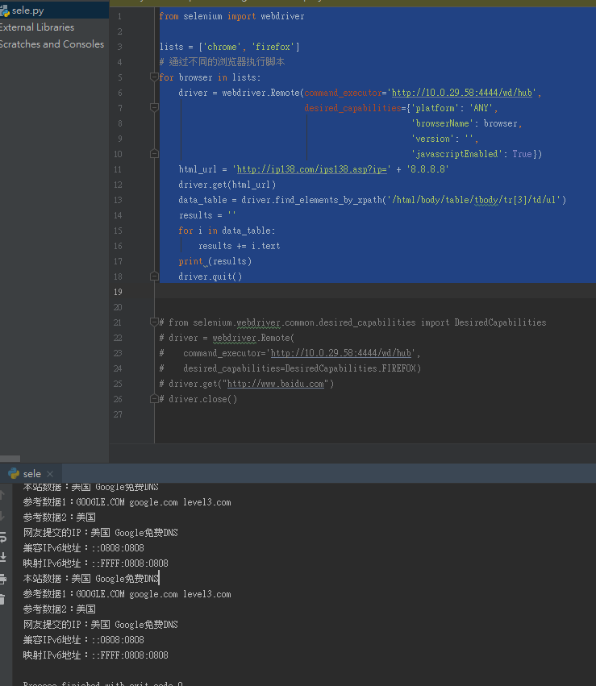

**执行中的node会显示半透明**

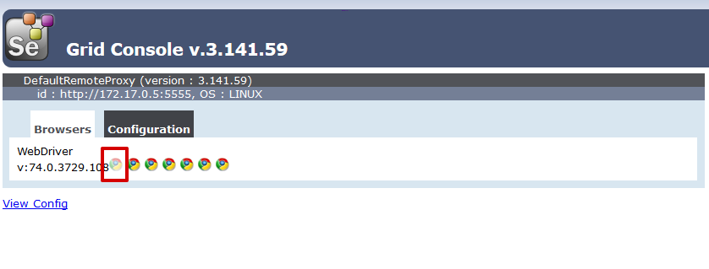

**最后脚本要记得driver.quit() 才算正常关闭**

