Predicting Secondary-School Academic Risk Using Machine Learning
The contribution of academic, demographic and social variables

MSc AI and Sustainable Development
School of Government
University of Birmingham

Ken Choi Kan Suen
Dissertation submitted for the MSc AI and Sustainable Development
September 2026

Abstract
This study examines how accurately machine-learning models can identify secondary-school students at risk of failing Mathematics using academic, demographic, family and social information. It uses a publicly available dataset containing 395 students from two Portuguese public schools. Academic risk is defined as receiving a final Mathematics grade below 10 on a scale from 0 to 20.
Three models are compared: Logistic Regression, Decision Tree and Random Forest. The models are tested using three sets of predictors: one containing both earlier Mathematics grades, one containing only the first-period grade and one excluding both earlier grades. To reduce the risk of overly optimistic results, model settings and data preparation are selected using only the training data, while separate unseen data are used to assess final performance.
When both earlier grades are included, the models perform strongly. Random Forest correctly classifies approximately 91–92% of students and identifies more than 93% of those who later fail. However, a simple rule based on the second-period grade performs similarly, suggesting that the machine-learning models add little information beyond grades already available to teachers. When both earlier grades are removed, performance declines substantially. The models identify only around half of the students who fail and also produce many false warnings. Random Forest achieves 68.4% overall accuracy, only slightly higher than the 67.1% obtained by simply predicting that every student will pass. Previous class failures provide the strongest remaining signal, but the other academic, demographic and social variables contribute limited and unstable predictive information.
The findings show that machine learning can predict final Mathematics failure reasonably well once earlier grades are known, but it is much less reliable without them. These models may support low-stakes professional review, but they should not be used to label students automatically, allocate support without human judgement or claim reliable prediction at the beginning of the school year.
Keywords: academic risk; student performance; machine learning; educational data mining; secondary education; sustainable development.

Contents
1. Introduction 3
2. Literature Review 4
2.1 Defining academic risk 4
2.2 Academic predictors of risk 4
2.3 Demographic and family predictors 5
2.4 Social, behavioural and school-context predictors 6
2.5 Machine learning and educational prediction 6
2.6 Prior grades, prediction timing and early warning 7
2.7 Critical framework for responsible interpretation 7
2.8 Research gap and contribution 8
3. Methodology 9
4. Findings/Results 12
5. Discussion 18
6. Conclusion 21
References 22
Appendices 25

List of Tables
Table 1. Selected characteristics of the Mathematics sample 12
Table 2. Nested cross-validation performance 13
Table 3. Out-of-fold confusion matrices 15
Table 4. Comparison with Cortez and Silva (2008) 15
Table 5. Hyperparameters selected across outer folds 17

List of Figures
Figure 1. Class distribution in the Mathematics dataset 12
Figure 2. Balanced accuracy across feature configurations 13
Figure 3. Recall for failing students across feature configurations 14
Figure 4. Random Forest permutation importance with prior grades 16
Figure 5. Random Forest permutation importance without prior grades 17

1. Introduction
Academic failure in secondary education is a sustainable-development concern because it can restrict later educational opportunities, reinforce social disadvantage and reduce the efficiency of limited school resources. Schools collect grades and attendance records, while some research datasets also contain background and questionnaire information. Machine-learning methods can combine these variables to estimate whether a student is likely to experience a poor outcome. In principle, such estimates could help teachers decide which records warrant closer professional review. Yet usefulness depends on more than a high overall accuracy score. The model must identify students who actually fail, be evaluated on genuinely unseen data, rely on information available at the intended time of use and be interpreted within the educational context.
This dissertation studies the Student Performance dataset developed by Cortez and Silva (2008). The data were collected during the 2005–2006 school year from two Portuguese public secondary schools by linking school reports with student questionnaires. The Mathematics dataset contains 395 students and variables relating to academic history, demographics, family circumstances, study behaviour, school support and social life. Students received first-period, second-period and final grades on a 0–20 scale. Academic risk is operationalised as a final Mathematics grade below 10, corresponding to failure in the original binary task. This is a clear target but a narrower measure than the wider construct of academic risk.
The main research question is: “To what extent can machine-learning models predict academic risk among secondary-school students using existing academic, demographic and social variables?” A secondary analytical question asks how performance changes when the first- and second-period grades are excluded. The second comparison tests whether the other variables add information beyond recent grades. It supports an early-warning interpretation only if the remaining predictors were available before those grades were awarded, which the dataset does not document precisely.
Logistic Regression, Decision Tree and Random Forest are compared with the original study’s naive baselines. The analysis improves on the earlier assignment replication by defining failure as the positive class, reporting class-sensitive measures and using nested stratified cross-validation. Preprocessing and hyperparameter selection occur only inside the outer training data, while untouched outer folds provide the reported test performance. A supplementary first-period-only configuration permits closer comparison with the three input setups in the original paper.
The report applies four module concepts: prediction versus intervention, target–construct mismatch, distribution shift and disparate performance. Chapter 2 reviews the literature, Chapter 3 explains the methods, Chapter 4 reports the findings, Chapter 5 discusses their implications and Chapter 6 concludes.

2. Literature Review
This chapter uses a structured narrative synthesis rather than claiming to be a formal systematic review. It prioritises meta-analyses, systematic reviews, longitudinal secondary-school research and educational-data-mining reviews, then uses supporting studies to examine the academic, demographic, family, behavioural and school-related factors represented in the dataset. The aim is to identify areas of agreement, disagreement and context dependence, rather than to summarise one study at a time.

2.1 Defining academic risk
Academic risk is not a single universally measured outcome. Education research uses the term to describe low grades, course failure, grade repetition, chronic absenteeism, disengagement, school transfer and dropout. These outcomes are related but not interchangeable. Dropout is an institutional exit, whereas failing Mathematics is a subject-level outcome that may occur while a student remains enrolled. De Witte et al. (2013) therefore caution that dropout research must define the point of exit and the minimum educational credential clearly. Gubbels, van der Put and Assink (2019) similarly distinguish the risk domains associated with absenteeism from those associated with permanent dropout, while Hammond et al. (2007) group dropout risk factors across individual, family, school and community domains.
This study defines academic risk as a final Mathematics grade below 10, matching Cortez and Silva’s (2008) binary task and providing an observable target. The definition nevertheless creates target–construct mismatch: subject failure captures one sign of difficulty but not disengagement, wellbeing, problems in other subjects or dropout. Broader educational-risk research is therefore used to interpret the predictors without claiming that Mathematics failure represents the complete construct.
Failure and dropout are generally treated as cumulative processes. Finn’s (1989) participation–identification model links low participation, weaker achievement and withdrawal, while Fredricks, Blumenfeld and Paris (2004) distinguish behavioural, emotional and cognitive engagement. Longitudinal studies similarly connect early academic and behavioural experiences with later outcomes (Alexander, Entwisle and Horsey, 1997; Ladd and Dinella, 2009). These perspectives support combining academic and contextual information, but a one-time dataset cannot identify each student’s causal pathway.

2.2 Academic predictors of risk
The strongest and most consistent predictors of later academic outcomes are usually previous academic outcomes. Prior grades summarise accumulated knowledge, assessment performance, attendance, effort and earlier support. In the Chicago public-school system, Allensworth and Easton (2007) showed that first-year course performance and failures were highly predictive of graduation. Balfanz, Herzog and Mac Iver (2007) found that course failure, poor attendance and behavioural problems in the middle grades identified a large proportion of later non-graduates. Earlier longitudinal work likewise demonstrated that low achievement and grade retention were central pathways to dropout (Alexander, Entwisle and Horsey, 1997; Battin-Pearson et al., 2000). Gubbels, van der Put and Assink’s (2019) meta-analysis found large dropout-risk effects for low academic achievement, learning difficulties and a history of grade retention.
Earlier grades are interim measures of the outcome process rather than ordinary background characteristics, so strong prediction from a recent grade in the same subject is expected. Cortez and Silva (2008) found that Mathematics accuracy declined when G1 and G2 were removed, while Kotsiantis, Pierrakeas and Pintelas (2004) found earlier performance more informative than demographic variables. Reviews likewise identify prior achievement, cumulative grades and assignment marks as dominant predictors (Shahiri, Husain and Rashid, 2015; Alyahyan and Düştegör, 2020; Albreiki, Zaki and Alashwal, 2021).
Attendance and absence are also consistently associated with outcomes. Absence reduces exposure to instruction and may indicate illness, family responsibilities, disengagement or barriers to participation. Credé, Roch and Kieszczynka’s (2010) meta-analysis in higher education found a strong relationship between attendance and grades, while Kearney (2008) documents the multiple psychological, family and school factors behind absenteeism among young people. Balfanz, Herzog and Mac Iver (2007) treat attendance as an early warning signal, and Gubbels, van der Put and Assink (2019) show that negative school attitudes and several behavioural or psychological factors have substantial associations with absenteeism. Nevertheless, the timing of absence counts matters. A cumulative absence variable measured near the end of the school year may contain more information than would have been available at the beginning.
Study time, participation and previous failures capture related aspects of engagement. Engagement trajectories predict achievement and dropout (Ladd and Dinella, 2009; Archambault et al., 2009a), supporting their inclusion alongside attendance. However, self-reported study time is noisy and may reflect either commitment or difficulty. Any model importance therefore represents predictive association, not evidence that changing the variable would improve achievement.

2.3 Demographic and family predictors
Socioeconomic and family background influence educational opportunity through access to material resources, parental knowledge, expectations, neighbourhood conditions and the capacity to provide academic support. Sirin’s (2005) meta-analysis found a consistent association between socioeconomic status and academic achievement, although effect sizes varied with how socioeconomic status and achievement were measured. Parental education is often used as a more stable and interpretable indicator than a broad socioeconomic index. In the Student Performance dataset, mother’s and father’s education and occupations therefore provide plausible contextual predictors, but they remain incomplete proxies for family resources.
Parental involvement is generally associated with achievement, but its form matters. Meta-analyses identify parental expectations and academic socialisation as more consistently beneficial than direct homework control (Fan and Chen, 2001; Jeynes, 2007; Hill and Tyson, 2009; Erdem and Kaya, 2020). A binary family-support variable therefore captures only a small part of the underlying process.
Family structure, guardian status and family size may correlate with outcomes, but their predictive value is context-specific and mediated by resources and relationships. Dropout develops through interacting individual, family, school and community influences (Rumberger and Lim, 2008; De Witte et al., 2013). Demographic variables may aid prediction but should not be treated as direct explanations of individual failure.
Age and sex may also be associated with academic outcomes. Older age within a grade can indicate previous retention, while sex differences depend on subject, school system and cohort. A model can exploit these correlations without revealing their mechanisms. Moreover, using protected or sensitive characteristics in a decision system can create normative concerns even when they improve statistical accuracy. The dissertation therefore treats demographic variables as contextual predictors, reports their contribution cautiously and does not frame group membership as a cause of failure. Any subgroup comparison is exploratory because the sample is small, particularly for the second school.

2.4 Social, behavioural and school-context predictors
Students’ relationships with parents, teachers and peers shape motivation, participation and belonging. Wentzel (1998) found that support from parents, teachers and peers related to different aspects of motivation among middle-school students. Wang and Eccles (2012) showed longitudinal relationships between social support and behavioural, emotional and cognitive engagement from middle to high school. Roorda et al.’s (2011) meta-analysis found that affective teacher–student relationships were associated with both engagement and achievement, while Eccles and Roeser (2011) describe schools as developmental contexts in which classroom practices, institutional organisation and policy interact with adolescent development.
Peer groups shape motivation and achievement-related behaviour (Ryan, 2001), but variables such as free time and going out are ambiguous. Social activity can support belonging or compete with study, and a simple ordinal item cannot distinguish those mechanisms. The same caution applies to romantic relationships and extracurricular activities.
Behaviour and wellbeing can affect attendance and concentration; substance use and psychological difficulties are among absenteeism risk domains (Gubbels, van der Put and Assink, 2019). Yet the dataset uses self-reported alcohol and health items that may be affected by under-reporting and cultural context. Any predictive signal should not become a basis for punitive action.
School support and paid tutoring may also have complex interpretations. Support can reduce risk, but it may be allocated in response to an existing difficulty. This produces a form of selection: students receiving school support may have lower outcomes because they were already struggling, not because support caused the difficulty. The same problem appears in many observational educational datasets. Predictive models can use these variables, but causal conclusions require designs that address why the support was provided. This reinforces the distinction between prediction and intervention: a variable associated with risk does not automatically identify an effective policy response.

2.5 Machine learning and educational prediction
Educational data mining and learning analytics use statistical and computational methods to identify patterns in student data. Papamitsiou and Economides (2014) found that the empirical literature covered prediction, assessment, feedback and the identification of at-risk learners, but also noted variation in datasets and evaluation practice. Romero and Ventura (2020) describe a rapidly expanding field spanning administrative records, learning-management systems and classroom data. Reviews focused on performance prediction report frequent use of Decision Trees, Random Forests, Logistic Regression, support-vector machines and neural networks (Shahiri, Husain and Rashid, 2015; Albreiki, Zaki and Alashwal, 2021; Balaji et al., 2021). Grimmer, Roberts and Stewart (2021) further argue that machine-learning methods in social-science applications should be judged against the specific research task and suitable benchmarks rather than adopted because of their complexity alone.
Decision Trees offer understandable rules and capture non-linearity, but are unstable across samples. Random Forest reduces this variance by aggregating many trees. Logistic Regression is less flexible but provides a comparatively transparent linear baseline. In small tabular social-science datasets, complex models may offer little advantage over simpler alternatives (Morucci and Spirling, 2024; Kapoor and Narayanan, 2023).
Comparing published models is difficult because targets, feature timing, institutions and class balance differ. Prediction often improves as later academic data become available (Márquez-Vera et al., 2016; Berens et al., 2019), while algorithm rankings remain context-specific (Yağcı, 2022). Reviews therefore recommend explicit targets and prediction dates, meaningful baselines, out-of-sample validation and transparent reporting of preprocessing and metrics (Alyahyan and Düştegör, 2020; Albreiki, Zaki and Alashwal, 2021).
The original Cortez and Silva (2008) study is particularly relevant because it introduced the present dataset. It compared Decision Tree, Random Forest, Neural Network and Support Vector Machine models under three input setups. For binary Mathematics classification, Random Forest achieved about 91% accuracy with both prior grades and about 71% without either prior grade. The authors used repeated 10-fold cross-validation and found that past evaluations dominated prediction, although absences, family variables, parental education and alcohol consumption appeared in explanatory analyses. The present dissertation retains the focus on tree-based models, adds Logistic Regression, treats failure as the positive class and gives greater attention to balanced and class-specific performance.

2.6 Prior grades, prediction timing and early warning
The distinction between models with and without prior grades is not merely technical. It changes the educational question. A model including the second-period grade asks whether information available after much of the school year can predict the final result. This may help organise end-of-year support, but it is close to forecasting a later assessment from an earlier assessment in the same subject. A model excluding prior grades asks whether background, previous failures, study behaviour, support and social variables can discriminate risk without the strongest interim outcome measures.
Early-warning research shows that timely indicators can be valuable when they are linked to a response system. Balfanz, Herzog and Mac Iver (2007) used attendance, behaviour and course performance to identify students on a path towards non-graduation. Allensworth and Easton (2007) demonstrated the practical value of an on-track indicator based on credits and failures. These systems depend on the indicator being available early enough, updated reliably and combined with professional follow-up. Prediction alone does not produce improvement.
In the present dataset, the timing of questionnaire variables is insufficiently documented for a strong early-warning claim. Stable background characteristics such as parental education would normally be known at the beginning of the year. In contrast, absences, study time, going out, support and alcohol consumption may have been measured at different points or may describe behaviour over the school year. Excluding G1 and G2 therefore tests dependence on prior grades and the predictive value of the remaining variables, but it cannot prove that the resulting model could have been deployed before the first grading period. This limitation is built into the interpretation of the secondary analysis.

2.7 Critical framework for responsible interpretation
Four concepts from the module provide a framework for interpreting model performance. First, prediction versus intervention distinguishes forecasting an outcome from identifying what should be done. Kleinberg et al. (2015) argue that prediction can be valuable in policy problems, but Wang et al. (2024) show that predictive optimisation often assumes too quickly that an accurate prediction leads to a beneficial decision. A student-risk score does not reveal whether tutoring, counselling, financial support, attendance work or another action will improve the student’s outcome. Intervention effectiveness requires causal evidence and knowledge of individual circumstances.
Second, target–construct mismatch arises when a measurable label does not represent the broader concept. Obermeyer et al. (2019) show how predicting healthcare cost rather than health need produced serious bias despite accurate target prediction. Here, Mathematics failure is defensible but partial: students may face disengagement or problems elsewhere while passing Mathematics, or fail for reasons absent from the dataset.
Third, distribution shift concerns differences between the training environment and a later use environment. The data come from two Portuguese schools in 2005–2006. Grading practices, curricula, student populations, support services and the relationships among variables may differ across countries, schools and periods. A model that generalises across cross-validation folds from the same dataset has demonstrated internal out-of-sample performance, not external validity.
Fourth, disparate performance means that average accuracy can conceal errors concentrated in a class or group. If passing students are the majority, a model can appear satisfactory while missing many failing students. Precision, recall, F1-score, balanced accuracy and confusion matrices are therefore required. Subgroup disparities may also arise through representation, measurement or historical bias across the machine-learning lifecycle (Suresh and Guttag, 2021). The present sample is too small for strong fairness claims, but the report avoids equating overall accuracy with equitable performance.

2.8 Research gap and contribution
The literature establishes that prior academic performance, course failure, attendance and engagement are central indicators of educational risk, while family, demographic, social and school variables make more context-dependent contributions. Machine-learning studies demonstrate that these variables can support prediction, but many reported results are difficult to compare because of differing targets, feature timing, small institutional samples, imbalanced outcomes and incomplete reporting of validation or preprocessing.
The dissertation contributes by synthesising education research to interpret the dataset, comparing three models with simple baselines, applying leakage-controlled nested validation and distinguishing prediction with grades from the separate no-grade analysis. Its contribution is not a deployable universal risk system, but a transparent assessment of predictive capacity and its limits in a widely used secondary-school dataset.

3. Methodology

3.1 Research design, data and outcome
The study adopts a quantitative, observational and predictive design using secondary data. It estimates out-of-sample classification performance rather than causal effects. The Mathematics dataset contains 395 students from Gabriel Pereira and Mousinho da Silveira, two public schools in Portugal. Cortez and Silva (2008) merged school reports with a questionnaire. Grades and absences came from school records, whereas variables such as family relationships, social activity, alcohol consumption and support were questionnaire measures. The analysis therefore refers to existing school-report and questionnaire variables rather than assuming that every predictor would be routinely available in an operational school system.
Students with a final Mathematics grade (G3) below 10 are coded 1, indicating academic risk or failure, and students with G3 of 10 or above are coded 0. Failure is the positive class so that precision, recall and F1 refer directly to the students the study aims to identify. The sample contains 130 failing students (32.9%) and 265 passing students (67.1%). The dataset contains no missing values, although imputation remains inside the pipeline so that the workflow is robust to missing values in future data.
Three feature configurations are evaluated. Configuration A includes all predictors except G3, including G1 and G2. Configuration B excludes G2 but retains G1 and is included as a supplementary comparison with the original study. Configuration C excludes both G1 and G2 and is the principal secondary analysis. Configuration C tests dependence on prior grades; it is not presented as definitive start-of-year prediction because the exact collection dates of several questionnaire variables are unclear.

3.2 Model selection and baselines
Logistic Regression, Decision Tree and Random Forest represent increasing flexibility while remaining suitable for a small tabular dataset. Logistic Regression produces a classification score through a regularised linear decision function and provides a comparatively transparent baseline. Decision Tree captures non-linearities and interactions through sequential splitting rules but can be unstable. Random Forest averages many trees to reduce the variance of a single tree. The comparison tests whether additional complexity produces a meaningful out-of-sample advantage; simple models can remain competitive in small social-science datasets (Grimmer, Roberts and Stewart, 2021; Morucci and Spirling, 2024).
The original-study naive baselines are also reproduced. In Configuration A, the baseline classifies failure directly from G2 using the same pass threshold of 10. In Configuration B, it uses G1. In Configuration C, where no period grade is available, it predicts the majority class, pass, for every student. These baselines are important because a complex model has limited value if it does not outperform the most recent grade or the majority-class rule.

3.3 Training, validation, testing and hyperparameter design
Nested stratified five-fold cross-validation is the primary design. In each outer iteration, four folds form the development data and the fifth remains untouched for testing. Within the outer training data, three inner stratified folds compare hyperparameters using balanced accuracy. The selected pipeline is then refitted on all outer training observations and evaluated once on the test fold. After all five iterations, every student has one out-of-fold prediction.
Outer test folds do not fit preprocessing, select predictors or hyperparameters, compare thresholds or choose the preferred model. Model parameters are learned from inner training observations, hyperparameters from inner validation performance, and final metrics only from outer test observations. This separation prevents validation or test information from influencing model development.
The limited inner grids reduce overfitting in a sample of 395 students. Logistic Regression tests C ∈ {0.1, 1, 10}; both tree models test depths of 3, 5 or unlimited and leaf sizes of 3 or 5, with Random Forest fixed at 100 trees and square-root feature sampling. Balanced class weights are used, and the 0.5 threshold is not tuned on outer tests. Full grids and selections are reported, following Arnold et al. (2024).

3.4 Preprocessing and information-leakage controls
Categorical variables are one-hot encoded. Numerical variables are standardised only for Logistic Regression; tree-based models receive unscaled numerical values. Median and most-frequent imputation are included for numerical and categorical variables respectively, although the current dataset has no missing values. Every preprocessing operation is contained in a scikit-learn Pipeline and ColumnTransformer.
Within every cross-validation split, the encoder, imputer and scaler are fitted only on the training data and then applied to the held-out validation or test data. G3 is used only to construct the outcome and is never a predictor. No feature selection, resampling, permutation ranking or threshold adjustment is conducted on the full data before evaluation. In nested cross-validation, inner validation results select hyperparameters while outer test folds remain untouched. These controls address information leakage, which can create spurious relationships and overoptimistic performance estimates (Kapoor and Narayanan, 2023). G1 and G2 are legitimate predictors for the later prediction question but would be unavailable for a start-of-year deployment claim.

3.5 Performance measures and interpretation
Accuracy is the proportion of all students classified correctly. Balanced accuracy averages recall for the pass and fail classes and is the inner tuning criterion because passing students are the majority. Precision for risk measures how many students predicted to fail actually failed. Recall for risk measures how many failing students were identified. F1 is the harmonic mean of precision and recall. The naive rules are evaluated on the same outer test folds as the models, so their means and standard deviations are directly comparable. The five outer-fold predictions are combined to construct confusion matrices in which each student appears once.
Random Forest permutation importance is calculated on outer test folds after inner tuning. Each variable is shuffled ten times per test fold and the change in balanced accuracy is recorded; error bars summarise the 50 fold-by-repetition values. Importance measures held-out model reliance, not causality. Logistic Regression and Decision Tree are comparatively interpretable, but coefficients and rules are not presented as stable explanations. Probability calibration is not evaluated, so outputs are classification scores rather than validated individual probabilities.
Five outer folds leave approximately 79 students and 26 failures per test fold while retaining 80% for development. Because only five estimates are available, their standard deviations describe fold variation rather than precise sampling uncertainty. Cross-validation tests internal generalisation within this historical dataset, not transfer to another school, cohort or country.

3.6 Ethical considerations
The project uses a public, pseudonymised secondary dataset and involves no new recruitment or participant contact. The analysis nevertheless treats educational records and questionnaire responses as sensitive in context. Questionnaire variables are evaluated as research features rather than recommended automatically for operational collection or decision-making; any future deployment would require appropriate institutional review, data governance and stakeholder consultation.

3.7 Code and data availability
The analysis was rerun successfully in a fresh working directory using the software versions listed in Appendix B. The script generates the descriptive statistics, nested results, baselines, confusion matrices, original-study comparison, held-out importance measures and figures reported in this dissertation. Code, data, software requirements and generated outputs are available in the GitHub project repository.

4. Findings/Results

4.1 Dataset characteristics and data quality
Table 1 summarises selected variables for the full sample and by final outcome. Of 395 students, 265 passed and 130 failed. Failing students were older on average, had more previous class failures, lower parental-education values and substantially lower first- and second-period grades. Median absences were the same in both outcome groups, although the interquartile range was wider among failing students. These comparisons are descriptive and do not establish causal effects. All 33 source variables had zero missing observations.
Table 1. Selected characteristics of the Mathematics sample
characteristic | All students | Passing students | Failing students
Students, n | 395 | 265 | 130
Female, n (%) | 208 (52.7%) | 133 (50.2%) | 75 (57.7%)
Gabriel Pereira school, n (%) | 349 (88.4%) | 236 (89.1%) | 113 (86.9%)
Urban home address, n (%) | 307 (77.7%) | 210 (79.2%) | 97 (74.6%)
Age, mean (SD) | 16.70 (1.28) | 16.54 (1.19) | 17.02 (1.38)
Mother's education, mean (SD) | 2.75 (1.09) | 2.84 (1.09) | 2.57 (1.09)
Father's education, mean (SD) | 2.52 (1.09) | 2.60 (1.09) | 2.35 (1.07)
Study time, mean (SD) | 2.04 (0.84) | 2.08 (0.86) | 1.95 (0.79)
Previous class failures, mean (SD) | 0.33 (0.74) | 0.16 (0.50) | 0.69 (0.99)
Absences, median [IQR] | 4.0 [0.0, 8.0] | 4.0 [1.0, 7.0] | 4.0 [0.0, 10.0]
First-period grade (G1), mean (SD) | 10.91 (3.32) | 12.45 (2.79) | 7.76 (1.70)
Second-period grade (G2), mean (SD) | 10.71 (3.76) | 12.62 (2.53) | 6.82 (2.71)
Final grade (G3), mean (SD) | 10.42 (4.58) | 12.88 (2.50) | 5.38 (3.65)
Family educational support, n (%) | 242 (61.3%) | 157 (59.2%) | 85 (65.4%)
School educational support, n (%) | 51 (12.9%) | 28 (10.6%) | 23 (17.7%)
Internet access at home, n (%) | 329 (83.3%) | 225 (84.9%) | 104 (80.0%)
Going out with friends, mean (SD) | 3.11 (1.11) | 2.97 (1.08) | 3.40 (1.13)

Figure 1. Class distribution in the Mathematics dataset
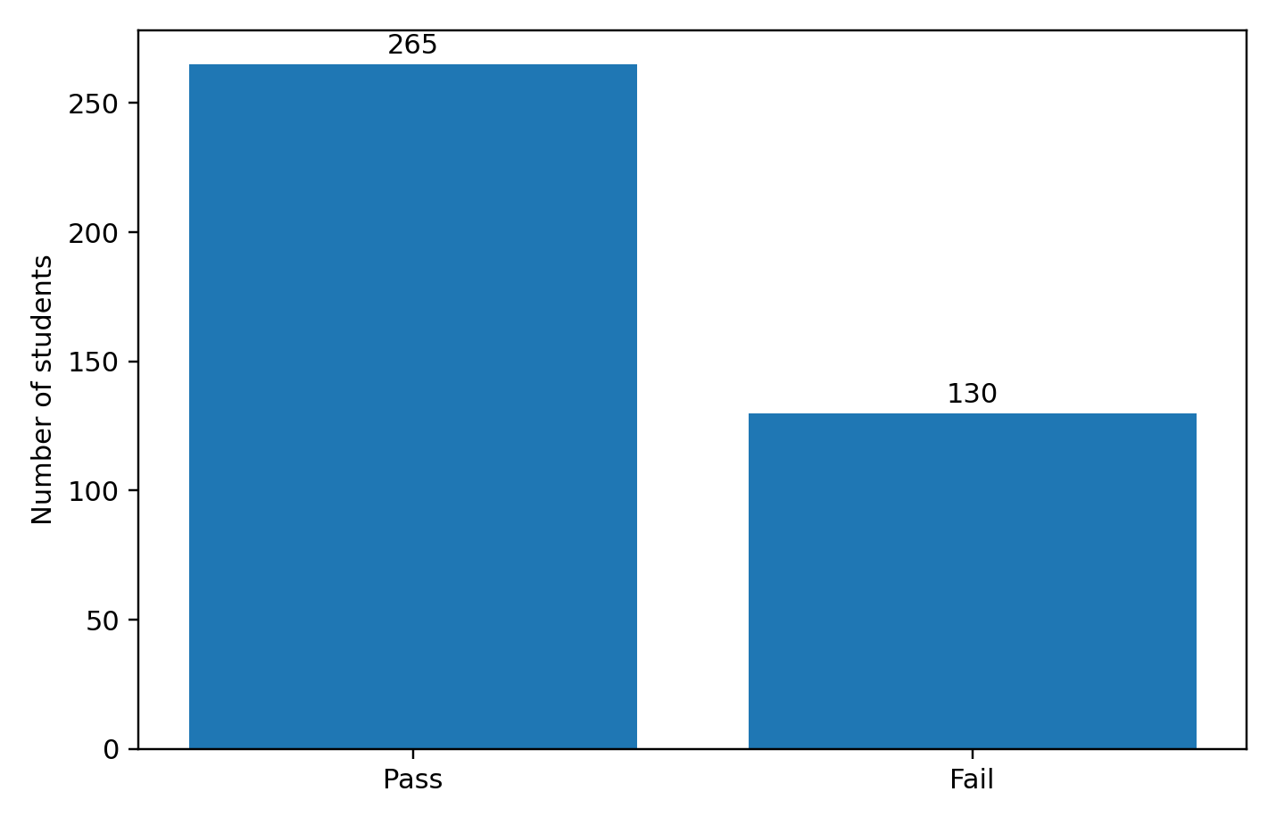

4.2 Primary nested cross-validation performance
Table 2 reports mean performance and standard deviations across the five untouched outer test folds for the two main configurations. With G1 and G2 available, the G2 baseline has accuracy of 0.919, balanced accuracy of 0.924 and failure recall of 0.938. Random Forest is close, with accuracy of 0.914, balanced accuracy of 0.918 and recall of 0.931. Logistic Regression reaches 0.904 accuracy and 0.905 balanced accuracy, while Decision Tree has lower accuracy but recall of 0.923. The central finding is not that one complex model clearly wins: a single recent grade is at least as competitive as the fitted models, and the differences among the stronger methods are small relative to fold variation.
Without G1 and G2, performance becomes moderate and uneven. Random Forest has the highest balanced accuracy by a very small margin (0.627) and the highest overall accuracy (0.684), but identifies only 46.2% of failing students. Logistic Regression has similar balanced accuracy (0.626) and a higher failure recall of 0.538. Decision Tree identifies 59.2% of failures but its accuracy falls to 0.618 and its precision to 0.457. The majority-class baseline already achieves 0.671 accuracy by predicting pass for everyone, while its balanced accuracy is 0.500 and failure recall is zero. The no-grade Random Forest therefore improves overall accuracy by only 1.3 percentage points. Figures 2 and 3 show that the preferred model changes with the value placed on class balance, missed failures and false warnings.
Table 2. Nested stratified five-fold cross-validation performance: mean (standard deviation)
Configuration and model | Accuracy | Balanced accuracy | Precision (risk) | Recall (risk) | F1 (risk)
With prior grades: Naive baseline | 0.919 (0.023) | 0.924 (0.029) | 0.836 (0.034) | 0.938 (0.052) | 0.884 (0.035)
With prior grades: Logistic Regression | 0.904 (0.029) | 0.905 (0.028) | 0.823 (0.062) | 0.908 (0.044) | 0.862 (0.039)
With prior grades: Decision Tree | 0.889 (0.042) | 0.897 (0.034) | 0.786 (0.080) | 0.923 (0.027) | 0.847 (0.049)
With prior grades: Random Forest | 0.914 (0.024) | 0.918 (0.028) | 0.830 (0.041) | 0.931 (0.050) | 0.877 (0.036)
Without prior grades: Naive baseline | 0.671 (0.000) | 0.500 (0.000) | 0.000 (0.000) | 0.000 (0.000) | 0.000 (0.000)
Without prior grades: Logistic Regression | 0.656 (0.074) | 0.626 (0.083) | 0.480 (0.100) | 0.538 (0.119) | 0.507 (0.107)
Without prior grades: Decision Tree | 0.618 (0.073) | 0.611 (0.036) | 0.457 (0.081) | 0.592 (0.104) | 0.506 (0.030)
Without prior grades: Random Forest | 0.684 (0.030) | 0.627 (0.035) | 0.524 (0.054) | 0.462 (0.077) | 0.488 (0.054)

Figure 2. Balanced accuracy across feature configurations
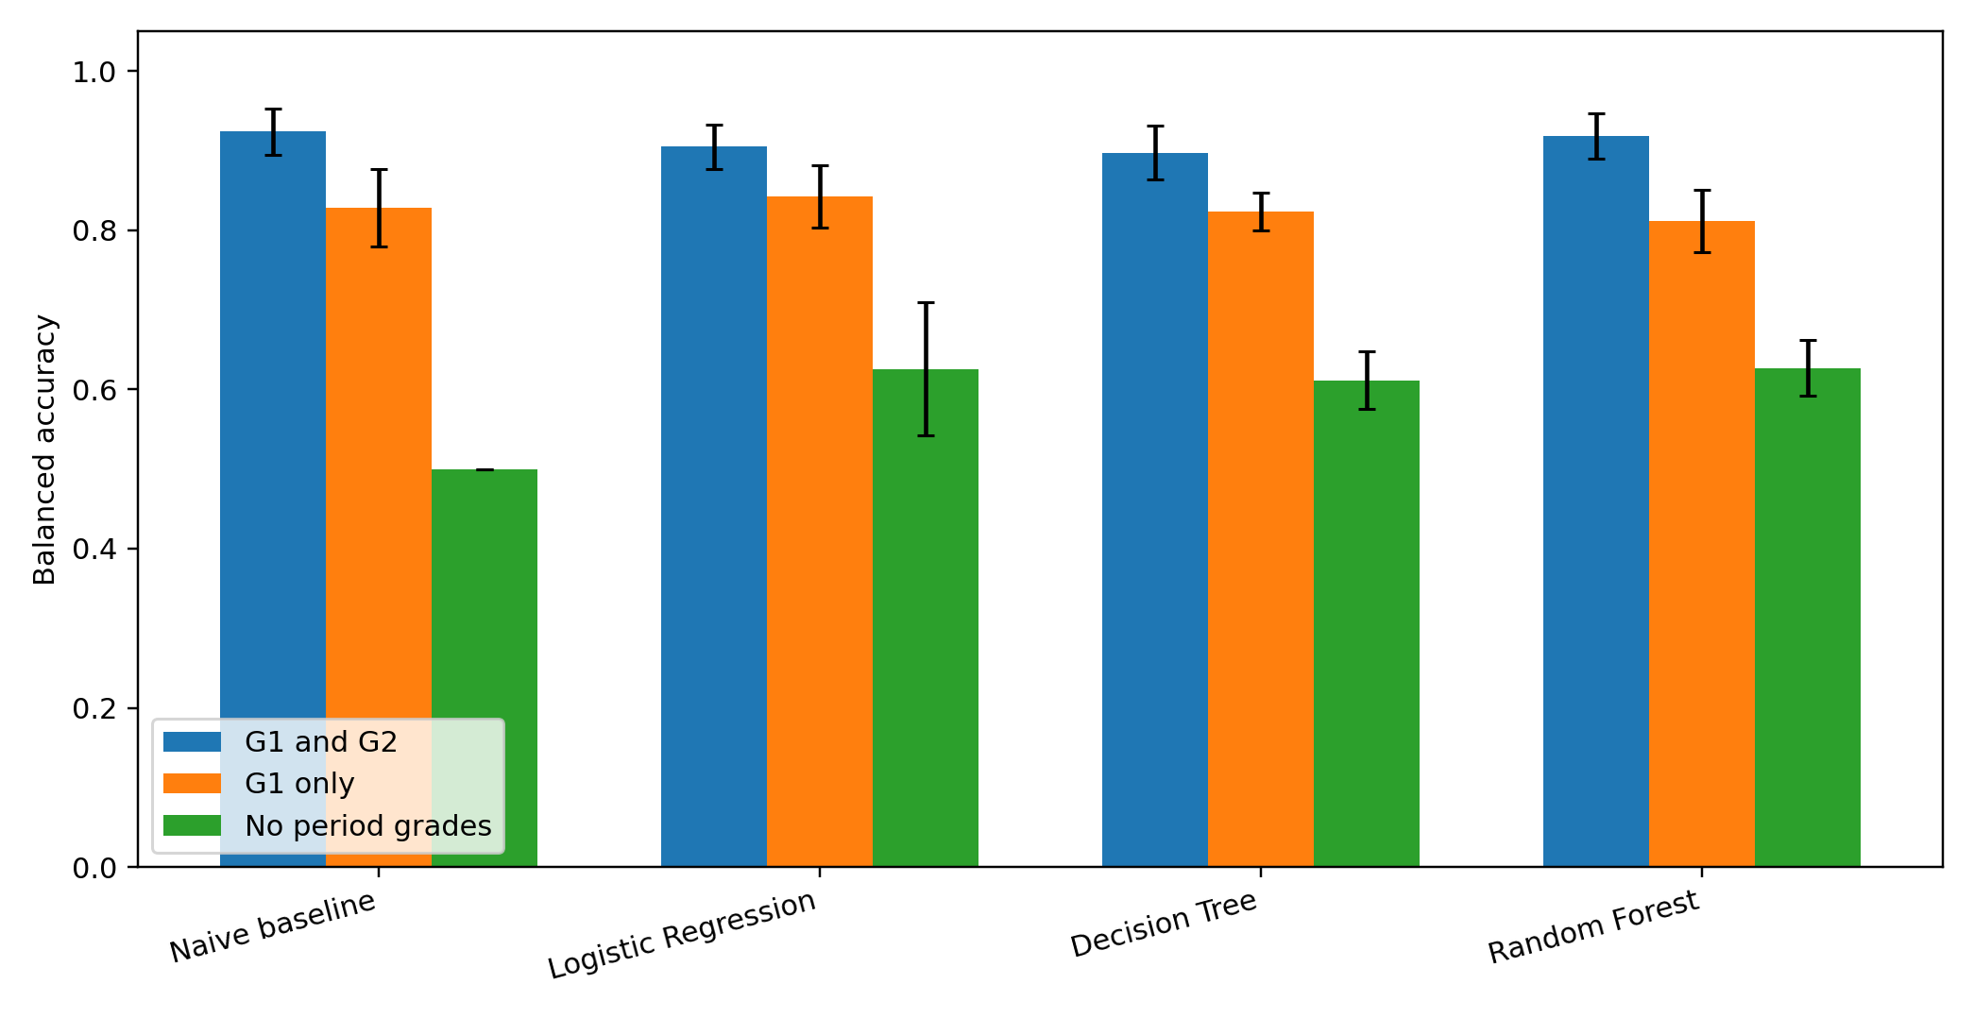
Figure 3. Recall for failing students across feature configurations
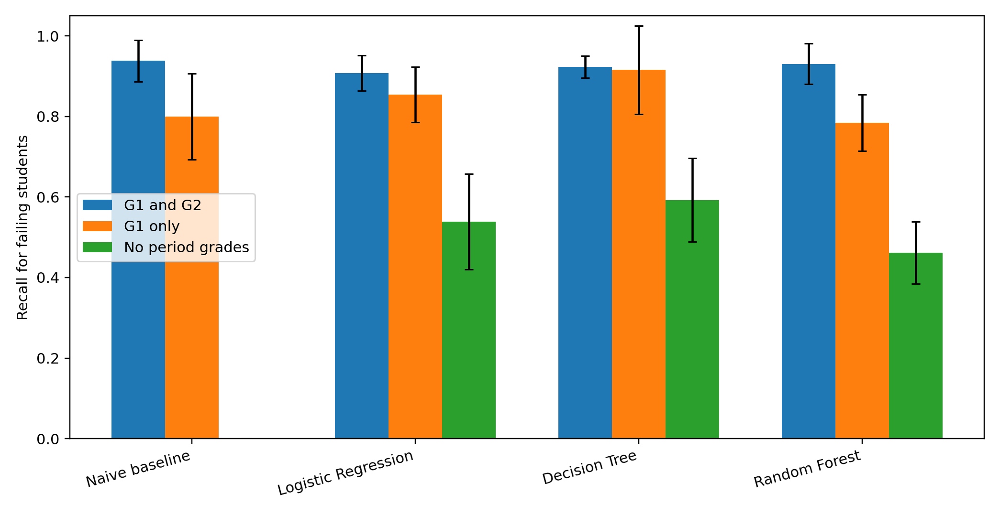

4.3 Confusion matrices and the practical error trade-off
The out-of-fold confusion matrices in Table 3 make the trade-off concrete. With prior grades, the G2 baseline identifies 122 of 130 failing students, Random Forest identifies 121, Decision Tree 120 and Logistic Regression 118. Their false-warning counts range from 24 to 34. Without prior grades, Logistic Regression identifies 70 failures but incorrectly flags 76 passing students. Random Forest generates fewer false warnings (55) but identifies only 60 failures. Decision Tree identifies 77 failures but produces 98 false warnings. The model with the greatest no-grade recall is therefore also the least precise. Accuracy alone cannot resolve the practical choice between missed failures and unnecessary risk reviews.
Table 3. Out-of-fold confusion matrices from one stratified five-fold evaluation
Configuration and model | True pass | False risk warning | Missed failure | Correctly identified failure
With prior grades: Naive baseline | 241 | 24 | 8 | 122
With prior grades: Logistic Regression | 239 | 26 | 12 | 118
With prior grades: Decision Tree | 231 | 34 | 10 | 120
With prior grades: Random Forest | 240 | 25 | 9 | 121
Without prior grades: Naive baseline | 265 | 0 | 130 | 0
Without prior grades: Logistic Regression | 189 | 76 | 60 | 70
Without prior grades: Decision Tree | 167 | 98 | 53 | 77
Without prior grades: Random Forest | 210 | 55 | 70 | 60

4.4 Supplementary first-period-only analysis and original-study comparison
Configuration B retains G1 but removes G2, matching the middle setup in Cortez and Silva (2008). Both the G1 baseline and Logistic Regression achieve 0.838 accuracy, while Random Forest reaches 0.820 and Decision Tree 0.792. Logistic Regression has the highest balanced accuracy (0.842), whereas Decision Tree obtains the highest failure recall (0.915) at the cost of many false warnings. The intermediate setup confirms a graded pattern: prediction is strongest with G2, weaker with G1 alone and weakest when both period grades are removed. Adding demographic, family and social variables does not automatically outperform the latest available grade.
Table 4 aligns the current outer-test accuracy estimates with the original paper’s Mathematics binary results. Random Forest closely reproduces Setup A, is approximately one percentage point lower in Setup B and about two percentage points lower in Setup C. Decision Tree is lower in all three setups. The naive baseline means reproduce the original full-sample values almost exactly, but now have fold-based standard deviations in Setups A and B because they were evaluated on the same outer folds as the models. Direct comparisons remain cautious because Cortez and Silva used 20 runs of 10-fold cross-validation and different algorithm defaults.
Table 4. Accuracy comparison with Cortez and Silva (2008), Mathematics binary classification
Setup | Model | Original accuracy | Current accuracy (SD) | Difference
A | Naive baseline | 0.919 | 0.919 (0.023) | 0.000
A | Decision Tree | 0.907 | 0.889 (0.042) | -0.018
A | Random Forest | 0.912 | 0.914 (0.024) | +0.002
B | Naive baseline | 0.838 | 0.838 (0.032) | 0.000
B | Decision Tree | 0.831 | 0.792 (0.019) | -0.039
B | Random Forest | 0.830 | 0.820 (0.033) | -0.010
C | Naive baseline | 0.671 | 0.671 (0.000) | 0.000
C | Decision Tree | 0.653 | 0.618 (0.073) | -0.035
C | Random Forest | 0.705 | 0.684 (0.030) | -0.021

4.5 Variable importance and tuning stability
Held-out permutation importance reinforces the dependence on prior grades. In Configuration A, shuffling G2 reduces balanced accuracy by 0.305 on average and shuffling G1 reduces it by 0.094. Every other original variable has an average importance below 0.01. The result indicates that family, behavioural and school variables add little incremental predictive information once recent Mathematics grades are known.
Without G1 and G2, previous class failures is the strongest Random Forest variable, with mean held-out importance of 0.069. Mother’s education, family relationships, study time and health have much smaller values and standard deviations that are often larger than their means. The rankings should therefore be read as unstable evidence of model reliance rather than explanations of educational mechanisms. Table 5 also shows that inner validation selected different hyperparameters across outer folds. This variation is most consequential in the no-grade configuration and reinforces the uncertainty created by the small sample and weak signal.
Fold variability is also informative. With prior grades, accuracy standard deviations are approximately 0.02–0.04, whereas no-grade Logistic Regression and Decision Tree vary more substantially across outer folds. No single tree-based setting is selected in most folds, and even the most common no-grade Random Forest setting appears only twice. These patterns indicate that the weak non-grade signal is sensitive to which students are held out and that a different split could change the apparent ranking of the models.
Figure 4. Random Forest permutation importance with prior grades
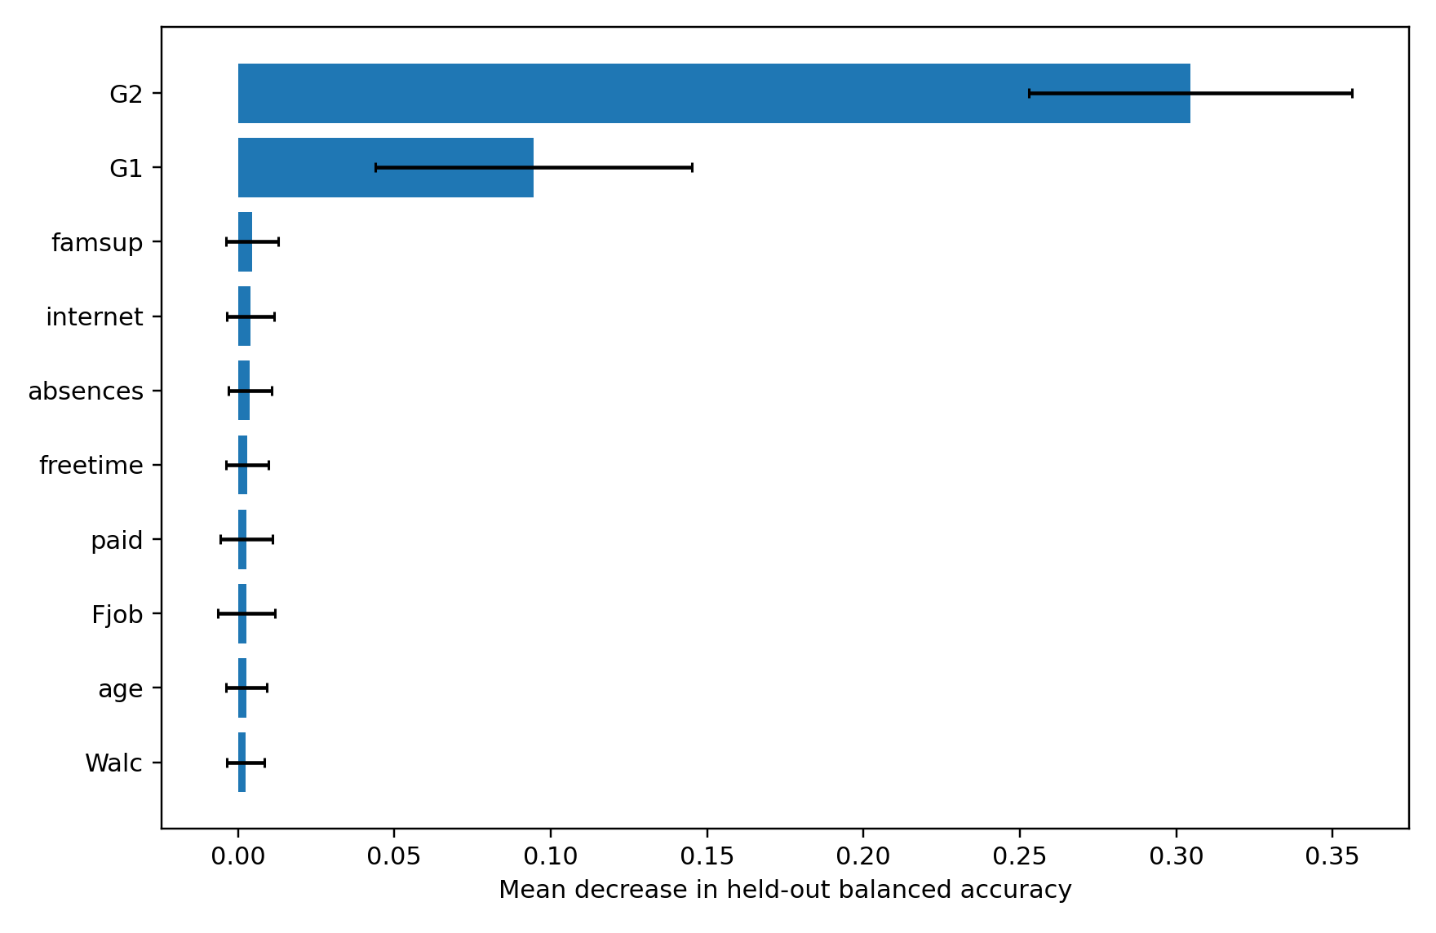
Figure 5. Random Forest permutation importance without prior grades
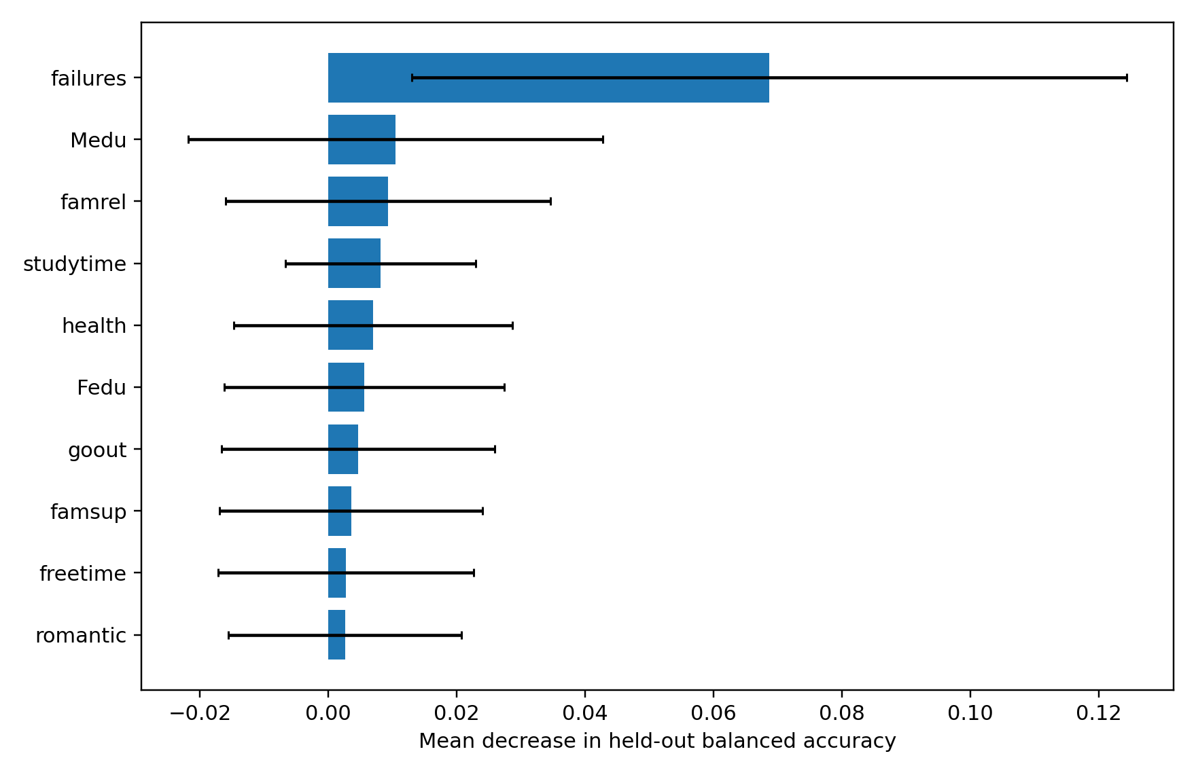
Table 5. Most frequently selected hyperparameters across the five outer folds
Configuration and model | Most frequent selected setting | Frequency
A: Logistic Regression | C=1 or C=10 (tie) | 2/5 each
A: Decision Tree | depth=3, leaf=3 | 2/5
A: Random Forest | unlimited depth, leaf=3 | 2/5
B: Logistic Regression | C=1 | 3/5
B: Decision Tree | depth=3, leaf=3 or 5 (tie) | 2/5 each
B: Random Forest | depth=5, leaf=5 | 2/5
C: Logistic Regression | C=0.1 | 3/5
C: Decision Tree | depth=3/leaf=3 or depth=5/leaf=5 (tie) | 2/5 each
C: Random Forest | depth=3, leaf=3 | 2/5

5. Discussion

5.1 To what extent can the models predict academic risk?
The answer to the main research question is conditional on the information available. When first- and second-period grades are included, final Mathematics failure is predicted with strong internal out-of-sample performance. Random Forest achieves 91.4% accuracy, 91.8% balanced accuracy and recall of 93.1%, while the G2-only baseline is slightly stronger on all three measures. Logistic Regression remains strong but is not equivalent to Random Forest under the nested design. The evidence therefore supports predictability after earlier assessments are available, but it does not show that complex machine learning discovers a broad independent profile of academic risk.
This pattern is consistent with education research identifying prior achievement and course failure as among the strongest indicators of later outcomes (Allensworth and Easton, 2007; Balfanz, Herzog and Mac Iver, 2007; Gubbels, van der Put and Assink, 2019). G2 is a recent assessment in the same subject and compresses information about accumulated learning, attendance, effort and earlier difficulty. The fact that Logistic Regression, Random Forest and the G2 baseline perform similarly suggests that much of the task is structurally simple once this information is known.
When G1 and G2 are excluded, the models retain limited signal but do not support confident individual-level classification. Random Forest and Logistic Regression have almost identical balanced accuracy, but Logistic Regression identifies more failures and Random Forest produces fewer false warnings. Decision Tree obtains the highest recall but the weakest precision and accuracy. The no-grade Random Forest accuracy of 0.684 is only slightly above the 0.671 majority baseline. The models are not entirely uninformative, but their gains are modest and are accompanied by substantial missed failures or false warnings.

5.2 Model choice, tuning and evaluation priorities
Model choice should be linked to the intended use rather than a single ranking. With both grades, Random Forest performs better than Logistic Regression on average, but the G2 rule remains the strongest and simplest benchmark. Logistic Regression may still be attractive where maintenance and explanation matter, but the present results do not justify calling it statistically equivalent without a formal paired uncertainty analysis. The more defensible conclusion is that all strong methods depend on recent grades and that the added complexity of Random Forest produces little practical gain over the G2 rule.
Without grades, metrics encode different practical priorities. Logistic Regression has higher recall and F1, so it finds more students who fail, but it also produces many false warnings. Random Forest has higher precision and overall accuracy, but it misses most failures. If a risk flag only triggers a supportive conversation, recall may be prioritised. If it creates stigma, workload or restricted opportunities, false positives become more consequential. Threshold and metric choices are therefore normative as well as technical.
The nested validation design addresses internal generalisation, not external validity. Inner folds select hyperparameters without using the outer test observations, and the five outer folds estimate performance on unseen students drawn from the same historical dataset. The fold standard deviations describe sensitivity to these partitions but are based on only five estimates. This procedure reduces leakage risk; it does not show that the model will perform in another school, year or country. Cross-validation should therefore not be mistaken for a universal test of deployment readiness.

5.3 What do non-grade variables contribute?
Previous class failures is the clearest non-grade predictor, which is unsurprising because it remains a measure of academic history. Descriptive differences also appear in age, parental education, school support and going out, but the held-out permutation values are small. The literature provides plausible pathways through attendance, parental expectations, engagement, teacher relationships and behavioural difficulties (Sirin, 2005; Hill and Tyson, 2009; Roorda et al., 2011; Gubbels, van der Put and Assink, 2019). The present data cannot establish those pathways.
Several limitations may weaken the non-grade signal. There are only 395 observations, while many predictors are categorical or ordinal. Questionnaire measures such as family relationships, alcohol consumption and social activity are coarse and potentially affected by self-report error. Correlated features can also substitute for one another in permutation analysis. Most importantly, the outcome is one final subject grade, so recent subject grades are naturally closer to the target than broad family or social conditions.
The findings do not imply that demographic and social conditions are educationally unimportant. Predictive importance is not the same as causal, policy or moral importance. A variable can matter for population inequality without allowing accurate classification of which individual will fail, while a variable can predict effectively without being an appropriate basis for intervention.

5.4 Prediction, intervention and target definition
The models identify students who resemble historical students who failed; they do not identify why a particular student is struggling or which support will work. Tutoring may address a knowledge gap, but other students may need pastoral support, disability adjustments, transport assistance or help with family responsibilities. Applying one intervention to every predicted student would confuse predictive association with treatment effectiveness.
Kleinberg et al. (2015) show that prediction can inform some policy decisions, while Wang et al. (2024) caution that predictive optimisation often assumes too quickly that improved forecasts produce beneficial interventions. In this dissertation, the defensible use case is low stakes: a prediction might prompt professional review of existing information and a conversation with the student. It should not automatically determine course access, allocate scarce support or create a permanent risk label.
Target–construct mismatch further limits the claim. A final Mathematics grade below 10 is observable and comparable with Cortez and Silva (2008), but academic risk can also involve disengagement, dropout, wellbeing and difficulties in other subjects. Obermeyer et al. (2019) and Benjamin (2019) demonstrate why seemingly convenient targets can redirect resources in ways that diverge from the underlying need. The current model should therefore be described as predicting Mathematics failure, not measuring a complete latent condition called academic risk.

5.5 Distribution shift, disparate performance and fairness
The dataset comes from two Portuguese schools in 2005–2006. Curricula, grading, technology access, support services and student populations may differ in current or international settings. Internal cross-validation tests new observations from the same historical distribution. It does not demonstrate that model coefficients, thresholds or error rates would remain valid after a distribution shift. External validation would require contemporary local data and a prospective prediction date.
Disparate performance is already visible between outcome classes. The no-grade Random Forest appears reasonable on accuracy but identifies only 41% of failing students. The present study does not establish demographic fairness. The second school contains only 46 students, and intersectional subgroups would be too small for precise error estimates. A deployment study should pre-specify protected groups, minimum sample sizes, acceptable error differences and a process for contesting incorrect records rather than adding fairness analysis after observing the results.
Data availability also has an equity dimension. Grades and attendance are administrative records, whereas family relationships, alcohol use, romantic status and social activity came from questionnaires. Collecting sensitive variables for operational risk scoring would require a clear legal basis, data minimisation, informed communication and evidence that the information adds sufficient value. The current results provide little justification for expanding surveillance when simple academic information performs better.

5.6 Sustainable-development and practical implications
The dissertation relates to sustainable development through quality and equitable education. Academic failure can delay progression, consume additional teaching resources and restrict later opportunities. In resource-constrained settings, systematic review of current assessment and attendance data may help schools organise attention. The results, however, suggest that responsible innovation may mean improving timely use of ordinary educational records rather than deploying a complex black-box system.
A practical decision-support workflow would have several stages. First, a school would define a prediction date and use only data available by that date. Second, the model would produce a review flag rather than a decision. Third, a teacher or pastoral team would check the record, speak with the student and decide whether any support is appropriate. Fourth, the school would log false warnings, missed cases, subgroup errors and the capacity required to respond. Fifth, students and families would have a route to correct data and challenge decisions. Finally, the school would evaluate whether the linked support improves outcomes, not merely whether the prediction was accurate.
This workflow separates technical performance from intervention and governance. It also recognises that a school unable to provide effective support gains little from generating additional risk scores. The sustainable-development contribution is therefore two-sided: the study evaluates whether existing data can support more timely review, and it identifies when predictive systems add insufficient value or create risks of stigma, unequal errors and inappropriate automation.

5.7 Limitations
Several limitations affect the study. The sample is small and restricted to two schools. Most questionnaire variables are observational self-reports, and their collection dates are unclear. The binary target discards variation within grades and addresses only Mathematics. The study does not estimate causal effects, probability calibration, intervention impact or external generalisation. The five outer folds provide limited precision, the hyperparameter grids are deliberately small, and other reasonable models or thresholds may produce different trade-offs.
Permutation importance can be unstable when predictors are correlated and should not be interpreted causally. The original-study comparison is approximate because software, defaults and validation procedures differ. The ethics status still requires formal programme confirmation, and the analysis does not observe how teachers, students or families would respond to a score. Those questions require participatory research and prospective evaluation.

6. Conclusion
This dissertation asked to what extent machine-learning models can predict academic risk among secondary-school students using academic, demographic and social variables. Academic risk was operationalised narrowly as a final Mathematics grade below 10 in a dataset of 395 students from two Portuguese schools. Logistic Regression, Decision Tree and Random Forest were evaluated against simple baselines through leakage-controlled nested stratified five-fold cross-validation, with inner validation used for hyperparameter selection and untouched outer folds used for final performance estimation.
The answer is conditional on prior academic information. When first- and second-period grades are available, Random Forest achieves 91.4% accuracy, 91.8% balanced accuracy and 93.1% recall for failing students. However, the naive rule based only on the second-period grade performs slightly better, and Logistic Regression and Decision Tree do not overturn that benchmark. Permutation importance confirms that G2 and G1 dominate every other predictor. The strong result therefore reflects continuity in assessment performance more than a unique benefit from complex machine learning.
When both period grades are excluded, performance falls substantially. Random Forest and Logistic Regression reach balanced accuracy of approximately 0.627 and 0.626 respectively, but their failure recall is only 0.462 and 0.538. Decision Tree raises recall to 0.592 but generates many false warnings and has the lowest accuracy. Because predicting pass for everyone already yields 0.671 accuracy, Random Forest’s no-grade accuracy of 0.684 represents only a small gain. Previous class failures supplies the clearest remaining signal, while demographic, family and social variables make modest and unstable contributions.
The study contributes a transparent evaluation rather than a deployable universal risk instrument. It demonstrates why simple baselines, class-sensitive metrics, nested tuning and strict train/validation/test separation are necessary. It also shows that prediction does not establish an effective intervention, Mathematics failure is narrower than the broader construct of academic risk, internal validation does not resolve distribution shift, and average accuracy can conceal missed failures.
In practice, any model should function only as a prompt for supportive professional review. A school would need current local data, a defined prediction date, external and subgroup validation, data-minimisation safeguards, accessible explanations and a route to correct errors. It would also need evidence that the support triggered by a flag improves student outcomes. Future research should use contemporary multi-school longitudinal data, evaluate calibration and thresholds, test transfer across cohorts or institutions and connect prediction to prospective intervention evaluation.
The sustainable-development value of the project lies not in claiming that AI automatically improves education, but in identifying the conditions under which predictive analysis might help schools use limited attention more responsibly—and the conditions under which a simple grade record, professional judgement or better support capacity may be more useful than a complex model.

References
Albreiki, B., Zaki, N. and Alashwal, H. (2021) ‘A systematic literature review of students’ performance prediction using machine learning techniques’, Education Sciences, 11(9), 552. https://doi.org/10.3390/educsci11090552.
Alexander, K.L., Entwisle, D.R. and Horsey, C.S. (1997) ‘From first grade forward: Early foundations of high school dropout’, Sociology of Education, 70(2), pp. 87–107. https://doi.org/10.2307/2673158.
Allensworth, E.M. and Easton, J.Q. (2007) What Matters for Staying On-Track and Graduating in Chicago Public High Schools. Chicago: Consortium on Chicago School Research.
Alyahyan, E. and Düştegör, D. (2020) ‘Predicting academic success in higher education: Literature review and best practices’, International Journal of Educational Technology in Higher Education, 17, 3. https://doi.org/10.1186/s41239-020-0177-7.
Archambault, I., Janosz, M., Fallu, J.-S. and Pagani, L.S. (2009a) ‘Student engagement and its relationship with early high school dropout’, Journal of Adolescence, 32(3), pp. 651–670. https://doi.org/10.1016/j.adolescence.2008.06.007.
Archambault, I., Janosz, M., Morizot, J. and Pagani, L. (2009b) ‘Adolescent behavioral, affective, and cognitive engagement in school: Relationship to dropout’, Journal of School Health, 79(9), pp. 408–415. https://doi.org/10.1111/j.1746-1561.2009.00428.x.
Arnold, C., Biedebach, L., Küpfer, A. and Neunhoeffer, M. (2024) ‘The role of hyperparameters in machine learning models and how to tune them’, Political Science Research and Methods, 12(4), pp. 841–848.
Balaji, P., Alelyani, S., Qahmash, A. and Mohana, M. (2021) ‘Contributions of machine learning models towards student academic performance prediction: A systematic review’, Applied Sciences, 11(21), 10007. https://doi.org/10.3390/app112110007.
Balfanz, R., Herzog, L. and Mac Iver, D.J. (2007) ‘Preventing student disengagement and keeping students on the graduation path in urban middle-grades schools: Early identification and effective interventions’, Educational Psychologist, 42(4), pp. 223–235.
Battin-Pearson, S., Newcomb, M.D., Abbott, R.D., Hill, K.G., Catalano, R.F. and Hawkins, J.D. (2000) ‘Predictors of early high school dropout: A test of five theories’, Journal of Educational Psychology, 92(3), pp. 568–582. https://doi.org/10.1037/0022-0663.92.3.568.
Benjamin, R. (2019) ‘Assessing risk, automating racism’, Science, 366(6464), pp. 421–422.
Berens, J., Schneider, K., Görtz, S., Oster, S. and Burghoff, J. (2019) ‘Early detection of students at risk: Predicting student dropouts using administrative student data from German universities and machine learning methods’, Journal of Educational Data Mining, 11(3), pp. 1–41.
Cortez, P. and Silva, A. (2008) ‘Using data mining to predict secondary school student performance’, in Brito, A. and Teixeira, J. (eds.) Proceedings of the 5th Annual Future Business Technology Conference. Porto: EUROSIS, pp. 5–12.
Credé, M., Roch, S.G. and Kieszczynka, U.M. (2010) ‘Class attendance in college: A meta-analytic review of the relationship of class attendance with grades and student characteristics’, Review of Educational Research, 80(2), pp. 272–295. https://doi.org/10.3102/0034654310362998.
De Witte, K., Cabus, S., Thyssen, G., Groot, W. and Maassen van den Brink, H. (2013) ‘A critical review of the literature on school dropout’, Educational Research Review, 10, pp. 13–28. https://doi.org/10.1016/j.edurev.2013.05.002.
Eccles, J.S. and Roeser, R.W. (2011) ‘Schools as developmental contexts during adolescence’, Journal of Research on Adolescence, 21(1), pp. 225–241. https://doi.org/10.1111/j.1532-7795.2010.00725.x.
Erdem, C. and Kaya, M. (2020) ‘A meta-analysis of the effect of parental involvement on students’ academic achievement’, Journal of Learning for Development, 7(3), pp. 367–383.
Fan, X. and Chen, M. (2001) ‘Parental involvement and students’ academic achievement: A meta-analysis’, Educational Psychology Review, 13(1), pp. 1–22. https://doi.org/10.1023/A:1009048817385.
Finn, J.D. (1989) ‘Withdrawing from school’, Review of Educational Research, 59(2), pp. 117–142. https://doi.org/10.3102/00346543059002117.
Fredricks, J.A., Blumenfeld, P.C. and Paris, A.H. (2004) ‘School engagement: Potential of the concept, state of the evidence’, Review of Educational Research, 74(1), pp. 59–109. https://doi.org/10.3102/00346543074001059.
Grimmer, J., Roberts, M.E. and Stewart, B.M. (2021) ‘Machine learning for social science: An agnostic approach’, Annual Review of Political Science, 24, pp. 395–419. https://doi.org/10.1146/annurev-polisci-053119-015921.
Gubbels, J., van der Put, C.E. and Assink, M. (2019) ‘Risk factors for school absenteeism and dropout: A meta-analytic review’, Journal of Youth and Adolescence, 48(9), pp. 1637–1667. https://doi.org/10.1007/s10964-019-01072-5.
Hammond, C., Linton, D., Smink, J. and Drew, S. (2007) Dropout Risk Factors and Exemplary Programs: A Technical Report. Clemson, SC: National Dropout Prevention Center.
Hill, N.E. and Tyson, D.F. (2009) ‘Parental involvement in middle school: A meta-analytic assessment of the strategies that promote achievement’, Developmental Psychology, 45(3), pp. 740–763. https://doi.org/10.1037/a0015362.
Jeynes, W.H. (2007) ‘The relationship between parental involvement and urban secondary school student academic achievement: A meta-analysis’, Urban Education, 42(1), pp. 82–110. https://doi.org/10.1177/0042085906293818.
Kapoor, S. and Narayanan, A. (2023) ‘Leakage and the reproducibility crisis in machine-learning-based science’, Patterns, 4(9), 100804. https://doi.org/10.1016/j.patter.2023.100804.
Kearney, C.A. (2008) ‘School absenteeism and school refusal behavior in youth: A contemporary review’, Clinical Psychology Review, 28(3), pp. 451–471. https://doi.org/10.1016/j.cpr.2007.07.012.
Kleinberg, J., Ludwig, J., Mullainathan, S. and Obermeyer, Z. (2015) ‘Prediction policy problems’, American Economic Review: Papers & Proceedings, 105(5), pp. 491–495. https://doi.org/10.1257/aer.p20151023.
Kotsiantis, S.B., Pierrakeas, C.J. and Pintelas, P.E. (2004) ‘Predicting students’ performance in distance learning using machine learning techniques’, Applied Artificial Intelligence, 18(5), pp. 411–426. https://doi.org/10.1080/08839510490442058.
Ladd, G.W. and Dinella, L.M. (2009) ‘Continuity and change in early school engagement: Predictive of children’s achievement trajectories from first to eighth grade?’, Journal of Educational Psychology, 101(1), pp. 190–206.
Márquez-Vera, C., Cano, A., Romero, C., Noaman, A.Y.M., Fardoun, H.M. and Ventura, S. (2016) ‘Early dropout prediction using data mining: A case study with high school students’, Expert Systems, 33(1), pp. 107–124. https://doi.org/10.1111/exsy.12135.
Morucci, M. and Spirling, A. (2024) Model Complexity for Supervised Learning: Why Simple Models Almost Always Work Best, and Why It Matters for Applied Research. Working paper.
Obermeyer, Z., Powers, B., Vogeli, C. and Mullainathan, S. (2019) ‘Dissecting racial bias in an algorithm used to manage the health of populations’, Science, 366(6464), pp. 447–453. https://doi.org/10.1126/science.aax2342.
Papamitsiou, Z. and Economides, A.A. (2014) ‘Learning analytics and educational data mining in practice: A systematic literature review of empirical evidence’, Educational Technology & Society, 17(4), pp. 49–64.
Romero, C. and Ventura, S. (2020) ‘Educational data mining and learning analytics: An updated survey’, WIREs Data Mining and Knowledge Discovery, 10(3), e1355. https://doi.org/10.1002/widm.1355.
Roorda, D.L., Koomen, H.M.Y., Spilt, J.L. and Oort, F.J. (2011) ‘The influence of affective teacher–student relationships on students’ school engagement and achievement: A meta-analytic approach’, Review of Educational Research, 81(4), pp. 493–529. https://doi.org/10.3102/0034654311421793.
Rumberger, R.W. and Lim, S.A. (2008) Why Students Drop Out of School: A Review of 25 Years of Research. California Dropout Research Project Report 15. Santa Barbara, CA: University of California.
Ryan, A.M. (2001) ‘The peer group as a context for the development of young adolescent motivation and achievement’, Child Development, 72(4), pp. 1135–1150. https://doi.org/10.1111/1467-8624.00338.
Shahiri, A.M., Husain, W. and Rashid, N.A. (2015) ‘A review on predicting student’s performance using data mining techniques’, Procedia Computer Science, 72, pp. 414–422. https://doi.org/10.1016/j.procs.2015.12.157.
Sirin, S.R. (2005) ‘Socioeconomic status and academic achievement: A meta-analytic review of research’, Review of Educational Research, 75(3), pp. 417–453. https://doi.org/10.3102/00346543075003417.
Suresh, H. and Guttag, J.V. (2021) ‘A framework for understanding sources of harm throughout the machine learning life cycle’, in Proceedings of the 1st ACM Conference on Equity and Access in Algorithms, Mechanisms, and Optimization. New York: ACM, Article 17.
Wang, A., Kapoor, S., Barocas, S. and Narayanan, A. (2024) ‘Against predictive optimization: On the legitimacy of decision-making algorithms that optimize predictive accuracy’, ACM Journal on Responsible Computing, 1(1), Article 9. https://doi.org/10.1145/3636509.
Wang, M.-T. and Eccles, J.S. (2012) ‘Social support matters: Longitudinal effects of social support on three dimensions of school engagement from middle to high school’, Child Development, 83(3), pp. 877–895. https://doi.org/10.1111/j.1467-8624.2012.01745.x.
Wentzel, K.R. (1998) ‘Social relationships and motivation in middle school: The role of parents, teachers, and peers’, Journal of Educational Psychology, 90(2), pp. 202–209. https://doi.org/10.1037/0022-0663.90.2.202.
Yağcı, M. (2022) ‘Educational data mining: Prediction of students’ academic performance using machine learning algorithms’, Smart Learning Environments, 9, 11. https://doi.org/10.1186/s40561-022-00192-z.
Suen, K.C.K. (2026) Predicting Secondary-School Academic Risk Using Machine Learning. GitHub repository. Available at: https://github.com/kensuenck/Predicting-Secondary-School-Academic-Risk-Using-Machine-Learning (Accessed: 22 July 2026).

Appendix A: Modelling and leakage-prevention checklist
- Outcome: G3 below 10 is coded as the positive academic-risk class; G3 is excluded from all predictors.
- Configurations: A includes G1 and G2; B includes G1 only; C excludes both period grades.
- Primary validation: nested stratified five-fold cross-validation with random seed 42; three inner folds select hyperparameters by balanced accuracy and five outer folds estimate final performance.
- Tuning: preprocessing and hyperparameter selection occur only within each outer training set; outer test folds remain untouched until final evaluation.
- Preprocessing: imputation, one-hot encoding and scaling are fitted only within the relevant training folds through pipelines.
- Threshold: the default 0.5 threshold is fixed before test evaluation and is not selected from outer-test results.
- Metrics: accuracy, balanced accuracy, risk precision, risk recall, risk F1 and confusion matrices use failure as the positive class.
- Interpretation: held-out permutation importance measures predictive reliance, not causality; model scores are not interpreted as calibrated probabilities.
- Reproducibility: the accompanying script, data, software versions and generated output files correspond to the tables and figures in the report.

Appendix B: Hyperparameter grids and software environment
Primary nested design: five outer stratified folds estimate final performance. Within each outer training set, three inner stratified folds select hyperparameters using balanced accuracy. The default classification threshold of 0.5 is fixed and is not selected from outer-test results.
Hyperparameter grids: Logistic Regression C ∈ {0.1, 1, 10}; Decision Tree maximum depth ∈ {3, 5, unlimited} and minimum leaf size ∈ {3, 5}; Random Forest uses 100 trees, square-root feature sampling, maximum depth ∈ {3, 5, unlimited} and minimum leaf size ∈ {3, 5}. All models use balanced class weights.
Software used in the clean run: Python 3.13.5; pandas 2.2.3; NumPy 2.3.5; scikit-learn 1.8.0; matplotlib 3.10.8; joblib 1.5.3. Repository: https://github.com/kensuenck/Predicting-Secondary-School-Academic-Risk-Using-Machine-Learning. Clean execution time in the supplied environment: approximately 1 minute 28 seconds. Final GitHub release tag proposed: v1.0-dissertation.

