Regional Labor Market in the United States
  - ECON10 — Economics of World Economy
Your Name
2026-04-05

Overview
This report examines state-level unemployment rates across the United States using monthly data from the Bureau of Labor Statistics (BLS). We walk through three steps:
- Data Collection — where the data comes from and how it was obtained
- Data Cleaning — how the raw data was reshaped and prepared for analysis
- Data Visualization — a time trend chart and choropleth maps (static and interactive)

1. Data Source
Item | Detail
Source | U.S. Bureau of Labor Statistics (BLS)
Program | Local Area Unemployment Statistics (LAUS)
File | la.data.3.AllStatesS — Seasonally Adjusted Monthly Unemployment Rates by State
URL | https://download.bls.gov/pub/time.series/la/
Downloaded | April 5, 2026
Coverage | All 50 U.S. states + D.C., January 1976 – present
Unit | Unemployment rate (percent, seasonally adjusted)
Note: Seasonal adjustment removes the effect of predictable seasonal patterns (e.g., holiday hiring, summer farm labor), making month-to-month comparisons more meaningful.

Exact Data Used In This Report
This analysis explicitly uses the following BLS file and filter:
- Primary dataset file: la.data.3.AllStatesS
- Direct URL: https://download.bls.gov/pub/time.series/la/la.data.3.AllStatesS
- Local project file used: data/la.data.3.AllStatesS.txt
- Series filter applied: series_id ending in 003 only
- Meaning of measure code: 03 = unemployment rate (from BLS LAUS measure mapping)
- Documentation URL: https://download.bls.gov/pub/time.series/la/la.txt
- Measure mapping URL: https://download.bls.gov/pub/time.series/la/la.measure
This report does not use the other measure codes in the same file (e.g., 004, 005, 006, 007, 008).

2. Data Loading
The raw file is a tab-separated text file. Each row represents one state’s unemployment rate for one month.
# The raw file looks like this:
# series_id year period value footnote_codes
# LASST010000000000003 1976 M01 6.7
#
# The "series_id" encodes which state:
# - "LASST" = BLS prefix for state-level series
# - Characters 6-7 (0-indexed 5-6) = 2-digit state FIPS code (e.g., "01" = Alabama)
# - The last digit "3" = unemployment rate measure
Using series suffix: ['003']
Total rows: 31,200
 | series_id | year | period | value | footnote_codes
0 | LASST010000000000003 | 1976 | M01 | 6.7 | NaN
1 | LASST010000000000003 | 1976 | M02 | 6.6 | NaN
2 | LASST010000000000003 | 1976 | M03 | 6.6 | NaN
3 | LASST010000000000003 | 1976 | M04 | 6.5 | NaN
4 | LASST010000000000003 | 1976 | M05 | 6.4 | NaN

3. Data Cleaning

Step 1 — Extract State FIPS Code from the Series ID
The series ID encodes which state it refers to. We extract characters at positions 5–6 to get the two-digit FIPS code.
Unique state FIPS codes: 52
<StringArray>
['01', '02', '04', '05', '06', '08', '09', '10', '11', '12', '13', '15', '16',
'17', '18', '19', '20', '21', '22', '23', '24', '25', '26', '27', '28', '29',
'30', '31', '32', '33', '34', '35', '36', '37', '38', '39', '40', '41', '42',
'44', '45', '46', '47', '48', '49', '50', '51', '53', '54', '55', '56', '72']
Length: 52, dtype: str

Step 2 — Map FIPS Codes to State Names and Abbreviations
FIPS codes are numbers assigned to each state by the federal government. We create a lookup table to convert them to readable state names.
Rows after cleaning: 31,200
 | series_id | state_fips | state | state_abbr | year | period | value
0 | LASST010000000000003 | 01 | Alabama | AL | 1976 | M01 | 6.7
1 | LASST010000000000003 | 01 | Alabama | AL | 1976 | M02 | 6.6
2 | LASST010000000000003 | 01 | Alabama | AL | 1976 | M03 | 6.6
3 | LASST010000000000003 | 01 | Alabama | AL | 1976 | M04 | 6.5
4 | LASST010000000000003 | 01 | Alabama | AL | 1976 | M05 | 6.4
5 | LASST010000000000003 | 01 | Alabama | AL | 1976 | M06 | 6.5
6 | LASST010000000000003 | 01 | Alabama | AL | 1976 | M07 | 6.5
7 | LASST010000000000003 | 01 | Alabama | AL | 1976 | M08 | 6.7

Step 3 — Parse Year and Month into a Date Column
The period column is formatted as M01, M02, …, M12. We convert this into a proper date.
Date range: January 1976 to December 2025
 | state | state_abbr | state_fips | date | year | month | unemployment_rate
0 | Alabama | AL | 01 | 1976-01-01 | 1976 | 1 | 6.7
1 | Alabama | AL | 01 | 1976-02-01 | 1976 | 2 | 6.6
2 | Alabama | AL | 01 | 1976-03-01 | 1976 | 3 | 6.6
3 | Alabama | AL | 01 | 1976-04-01 | 1976 | 4 | 6.5
4 | Alabama | AL | 01 | 1976-05-01 | 1976 | 5 | 6.4
5 | Alabama | AL | 01 | 1976-06-01 | 1976 | 6 | 6.5
6 | Alabama | AL | 01 | 1976-07-01 | 1976 | 7 | 6.5
7 | Alabama | AL | 01 | 1976-08-01 | 1976 | 8 | 6.7
8 | Alabama | AL | 01 | 1976-09-01 | 1976 | 9 | 6.8
9 | Alabama | AL | 01 | 1976-10-01 | 1976 | 10 | 6.9

Cleaning Summary
Step | Action | Reason
Column trimming | Removed extra whitespace from column names and series_id | Raw BLS files have padded spaces
FIPS extraction | Extracted characters 5–6 from series_id | State identifier is embedded in the series code
State name mapping | Mapped 2-digit FIPS → state name and abbreviation | Raw data has no human-readable state labels
Date parsing | Combined year + period → proper date column | Enables time-series plotting
Column selection | Kept only relevant columns | Removes unnecessary metadata

4. Visualization

4a — Time Trend: National Average Unemployment Rate
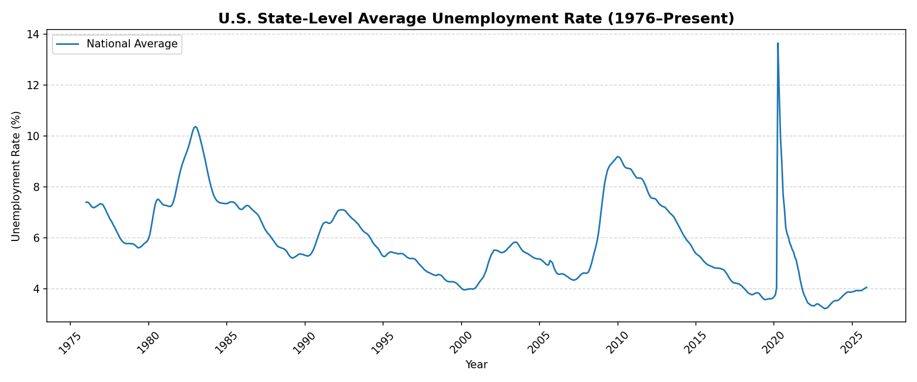
Figure 1. U.S. state-level average unemployment rate (monthly, seasonally adjusted).

4b — Time Trend: Selected States (Interactive)
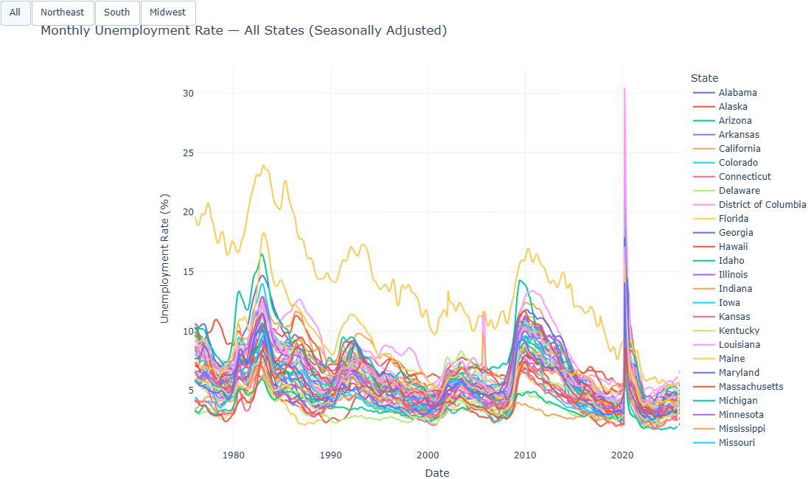
Figure 2. Monthly unemployment rate for all states. Use region filters (All/Northeast/South/Midwest) in the HTML version; this PDF shows a static snapshot.

4c — Static Map: Latest State Unemployment Rate
Mapping data for: December 2025
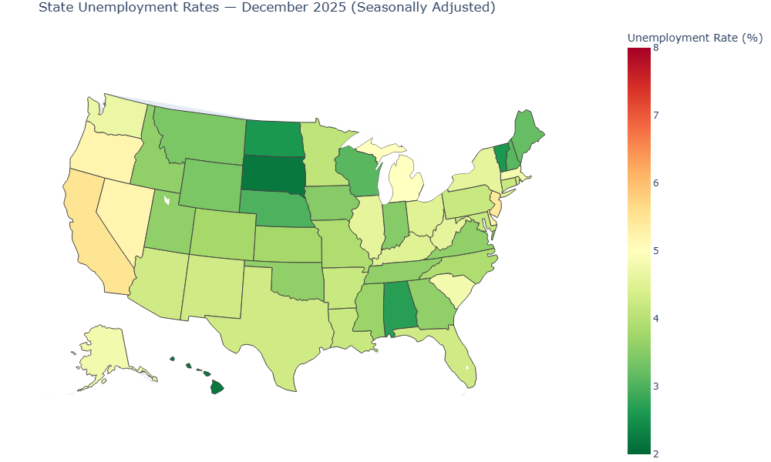
Figure 3. State unemployment rates in the latest complete month (seasonally adjusted).

4d — Static Map: Change from Oldest to Latest Complete Month
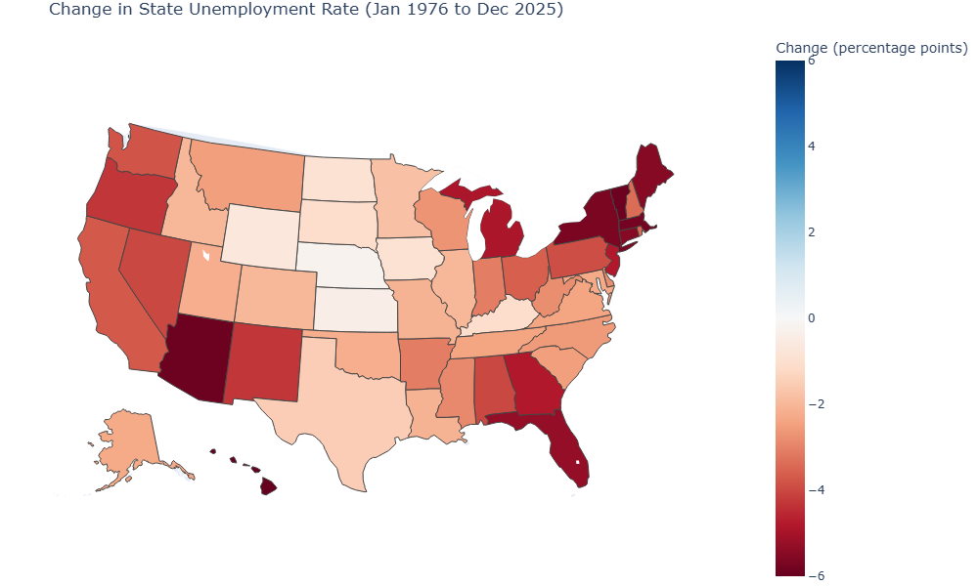
Figure 4. Change in state unemployment rates from the oldest complete month to the latest complete month (percentage points).

4e — Static Map: Recovery from COVID (2021 to 2024)
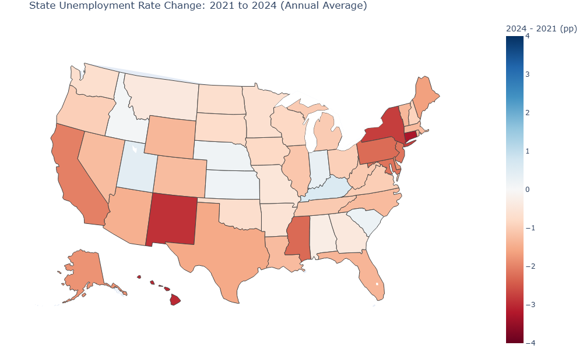
Figure 5. Change in annual-average unemployment rates from 2021 to 2024 (percentage points), showing post-COVID labor market recovery patterns.

4f — Static Map: Relative to Massachusetts
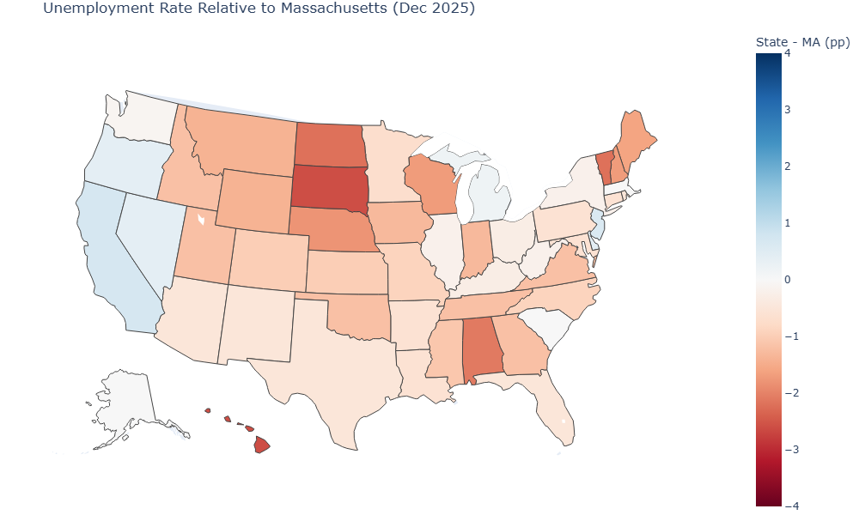
Figure 6. State unemployment rates relative to Massachusetts in the latest complete month (state rate minus MA rate, in percentage points).

4g — Static Map: Latest Annual Average (from annual panel)
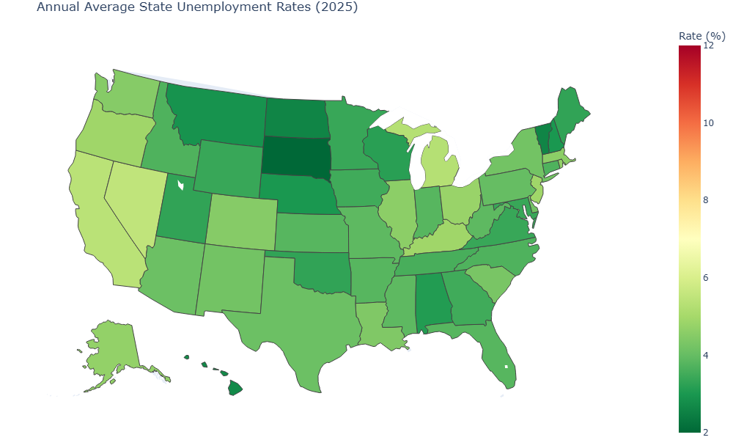
Figure 7. Annual-average unemployment rates by state in the latest available year.

5. Key Observations

Where To Add Your Findings (Fill-In Section)
Use this section to summarize the main empirical findings from Figures 1–7.

Finding 1: National trend (Figure 1)
[Write 2-4 sentences: overall pattern, major turning points, and recent level.]

Finding 2: Regional/state patterns (Figures 2 and 3)
[Write 2-4 sentences: which regions/states are higher or lower, and whether dispersion across states is large or small.]

Finding 3: Long-run change and COVID recovery (Figures 4 and 5)
[Write 2-4 sentences: which states improved more/less, and how 2021 to 2024 compares across regions.]

Finding 4: Relative to Massachusetts (Figure 6)
[Write 2-4 sentences: which states are above MA, which are below MA, and what that implies for local comparison.]

Finding 5: Latest annual snapshot (Figure 7)
[Write 2-4 sentences: summarize the latest cross-state landscape in one paragraph.]

Short Discussion (Interpretation)
Add a brief discussion (about 1 short paragraph each):
- Economic interpretation: [What labor market mechanisms might explain these patterns?]
- Policy relevance: [What does this imply for unemployment policy or wage policy discussions?]
- Limitations: [What this analysis does not capture (e.g., causality, demographics, industry composition).]
- Next step: [One additional dataset or model you would add in a follow-up analysis.]

Slide-Ready Summary (3 bullets)
[Bullet 1: Main takeaway]
[Bullet 2: Evidence from maps/charts]
[Bullet 3: Caution or limitation]

Appendix: Data Citation
U.S. Bureau of Labor Statistics. (2026). Local Area Unemployment Statistics (LAUS): Seasonally Adjusted State Unemployment Rates [Data file]. Retrieved April 5, 2026, from https://download.bls.gov/pub/time.series/la/la.data.3.AllStatesS
U.S. Bureau of Labor Statistics. (2026). LAUS Documentation [Technical documentation]. Retrieved April 5, 2026, from https://download.bls.gov/pub/time.series/la/la.txt
U.S. Bureau of Labor Statistics. (2026). LAUS Measure Mapping (la.measure) [Codebook]. Retrieved April 5, 2026, from https://download.bls.gov/pub/time.series/la/la.measure

