In partial fulfillment of the requirements for the

ITE121 – Intermediate Programming

**“Fusion”**

Presented to:

Dr. Unife O. Cagas

Professor

Prepared by:

Leila Habagat

BSCS – 1B2

**Description**

When the "Generate Fusion" button is clicked, the generate_fusion() function is called. The text entered into the entry fields (entry1 and entry2) is retrieved by this function, which then applies a fusion operation to it and modifies the content of the fusion label (fusion_label) accordingly.Main Window Creation: tk.Tk() is used to construct the GUI's main window, or root, with the title "Name Fusion Generator".

Entry Fields: Users can enter their names in the two entry fields (entry1 and entry2). With some vertical padding, these entry fields are crammed into the primary window.

* **Benefits**
* User Interaction: The code allows users to interactively input their names and generate a fused name with just a few clicks. This can be engaging and fun for users.
* Ease of Use: The GUI provides a simple and intuitive interface for users to input their names and generate the fusion. It's straightforward and easy to understand, even for those who may not be familiar with coding.
* Customization: The code can be easily customized to include additional features or modify the fusion algorithm to suit specific requirements. For example, you could add error handling, validation, or additional text formatting options.
* Reusability: The code serves as a reusable template for creating similar GUI applications in Python using Tkinter. You can modify it for various purposes beyond just name fusion.
* Pythonic Solution: Leveraging Tkinter, a built-in Python library, makes the code efficient and Pythonic. It utilizes Python's strengths for GUI development without relying on external dependencies.
* Cross-Platform Compatibility: Since Tkinter is a standard Python library, the GUI application created with this code will work on multiple platforms (Windows, macOS, Linux) without any additional setup.
* Educational Purpose: This code can be used as a learning tool for those interested in GUI development with Python and Tkinter. It provides a simple example that demonstrates basic concepts such as creating widgets, handling events, and updating the GUI dynamically.
* **OBJECTIVE**
* Allow users to input two names into separate entry fields.
* Provide a button that, when clicked, generates a "fusion" of the two names based on a specific algorithm.
* Display the generated fusion name in a label within the GUI.
* **Purpose**

Fusion It's engaging and enjoyable for users to play around with combining their names or the names of others to create original combinations. This tool allows writers or storytellers to come up with original name combinations for characters or distinctive identifiers.The code can be utilized to help students learn Python GUI development with Tkinter. It offers a practical illustration of fundamental GUI ideas like input fields, buttons, and labels.It can be used as a springboard for creating more intricate graphical user interface apps that need dynamic content updates and user input.

* **Significance**
* It serves as an accessible entry point for individuals interested in learning GUI development in Python. Tkinter is a widely used library for creating graphical interfaces, and this code provides a simple example to get started.
* It can be used as an educational resource in programming courses or workshops to demonstrate basic GUI development principles. Students can analyze the code, experiment with variations, and apply their knowledge to create their own GUI applications.
* This aspect can be engaging and enjoyable, especially for individuals interested in creative writing or name generation.
* **FEATURES**
* Fusion Generation: Upon clicking the "Generate Fusion" button, the code combines the inputted names according to a specific algorithm to generate a fused name.
* User Interaction: The program encourages user engagement by allowing them to input names, generate fusions, and see the results within the GUI interface
* Customization: The code can be easily customized to add additional features, modify the fusion algorithm, or enhance the GUI layout according to specific requirements.
* Reusability: As a template, this code can be reused to create similar GUI applications for various purposes beyond name fusion by simply modifying the functionality and design elements.
* **Code**

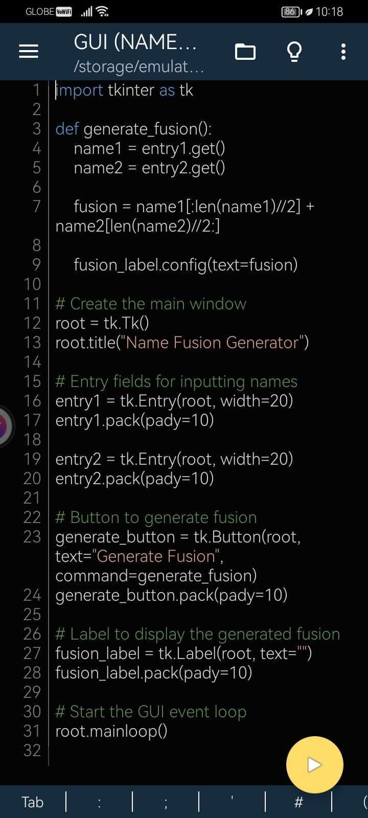

* **Output**

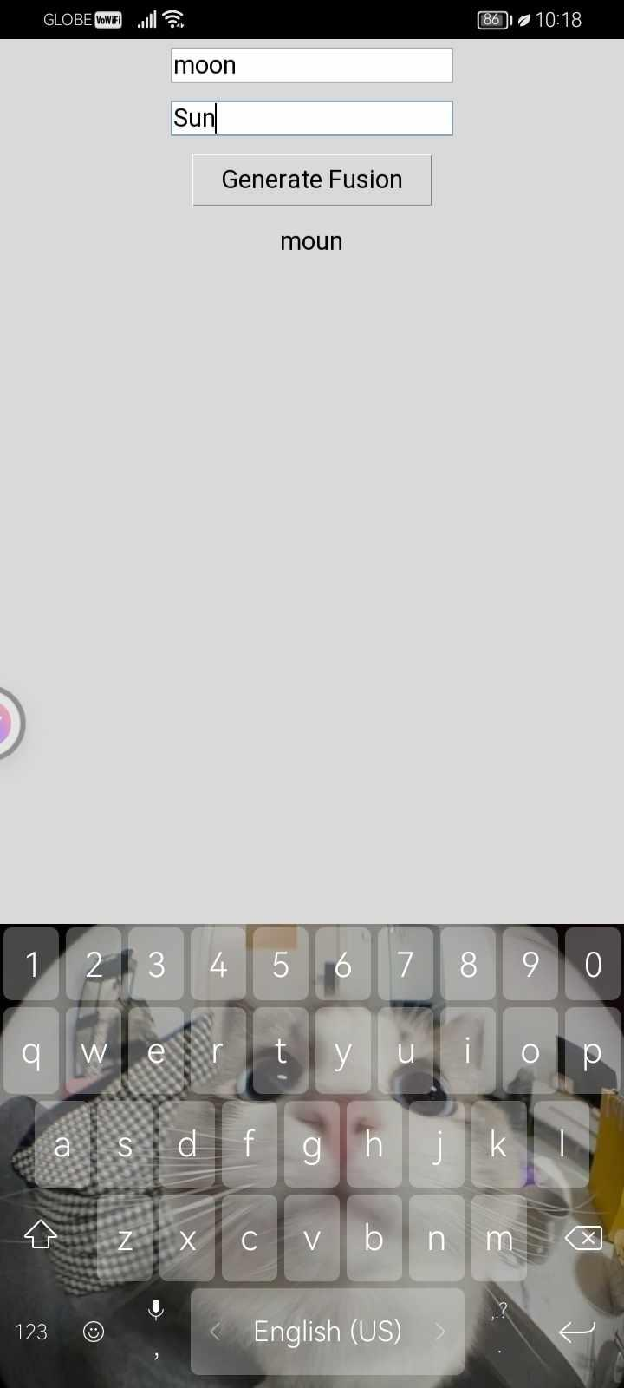



**CURRICULUM VITAE**

**PERSONAL INFORMATION**

Name: Kent Andrie Donoso

Age: 19

Conract Details: 0977-004-1403

Email Address: [Andriekent2005@gmail.com](mailto:Andriekent2005@gmail.com)

Date Of Birth: March 28 2005

Address: Purok 5, Barangay Cantiasay Nonoc Island, Surigao City

Nationality: Filipino

Civil Status: Single

Religion: Catholic

**EDUCATIONAL BACKGROUND**

Elementary: Jesus Cabarrus Catholic School (JCCS)

Junior High School: Jesus Cabarrus Catholic School (JCCS)

Senior High School: Cantiasay National High School (SHNS)

College: Surigao del Norte State University