TaxiShare client application instruction on Google Android Platform
YingYi Chen (u4704324)

Description

TaxiShare Client application is client side software for TaxiShare system on Google Android Platform. The Taxishare Client application is implemented using Java language. The application supports Google Android Platform 1.5 version or higher. The TaxiShare Client application connects to TaxiShare system service via HTTP transmission. The application provides rich and friendly graphical user interface and a touch-screen control for end users. In order to improve user experience, the application combines with Google Geocoder service and simulate operation of Google Map service. Due to the application establish connection with TaxiShare system directly, the respond time is faster than Twitter interface or SMS interface. The goal of TaxiShare Client application is to make the TaxiShare system effective and easy to operate.

Functionality

Search function

The application provides a search location function for users in application menu. User simply types location name into search bar (see Figure 1). If location name contains any miss spelling words or is ambiguous address, the application are able to predict and show up suggestion list for user (see Figure 2). User can select location name from suggestion list and jump to the location on Google Map. And the other way round, Address is precise, thE application will move in to the location on Google map directly. The location will be focused on the centre of screen by the application.
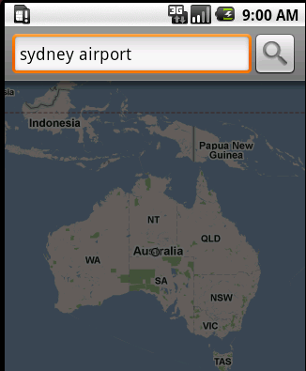
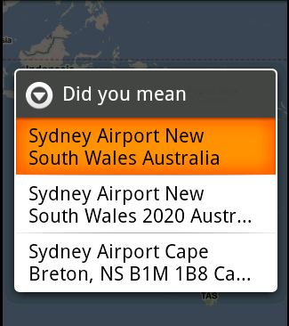

Figure 1 Figure 2
Marker Function

To mark destination and start point, the application has marker function to allow user put markers on their location (see Figure 3). Users have ability to put and drag pins on the Google Map to mark the start and end point.
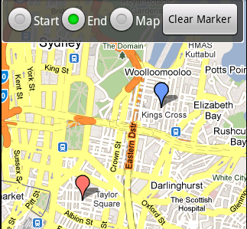

Figure 3
Send Function

After location is marked by user, Send function shows up a message for confirmation of location. User accepts the confirmation and then the application will send the request to Taxishare System. Or user cancels the confirmation and restart location marking.

Cancel Function

User could cancel previous request by choosing cancel function from the application menu so the user will not receive any respond from TaxiShare System

Mode Function

Application could switch Google map view modes between statistical mode and normal map mode.

Algorithm

To avoid ambiguous location name or miss spelling word, Google Geocoder service is introduced in TaxiShare client application. Location name will be processed through Google Geocoder service. The Geocoder service respond to the application with suggestions. The application list all the suggestions for user to select.

Advantage

Android platform development has rich API support for Google Map, Google geocoding. Taxishare client application on Android platform has ability to use dynamic Google map view to display locations for users. So users are able to control and move the map by drugging the map and use the zoom control to view the detail address easily. To avoid miss typing input issue appear on text-based interface, users can mark the locations via different bubble pins on the map instead of manually typing location name in text field. The application also allows users to type a location name manually. A list of suggestions of location name is proposed by application, if there is any ambiguous address or incomplete address in text input. Taxishare client application establishes connection with taxishare system service via HTTP transmission directly, so factor delayed of third-party service provider is excluded from application and respond time is faster than Twitter interface and SMS interface. Comparing with SMS interface requires to SMS charge for using taxishare system service, taxishare client application offers completely free service for users via Internet connection. Android taxishare client application is flexible to add new features for taxishare system in future. For further development on Taxishare system, more advance features and enhancements will be implemented in Taxishare system. Android platform development provided rich API to adapt further change on Taxishare system.

Disadvantage

Taxishare client application on Android platform does not include positioning technique via GPS. Users have to locate their initial position manually on the map. Users also need to provide or confirm a mobile number before the application start. Number of input errors will cause the request fail. The application combines with Google Map service and Google geocoding service which rely on Internet connection. Network delay during operation of the application will be influence on application respond.

