2602112543 – Kent Alber Fredson

WatcHGoods Documentation

Note: For products, the images I use are in .webp extension, so I substitute it with another picture, but the real ones are in html files.

1. Home Page

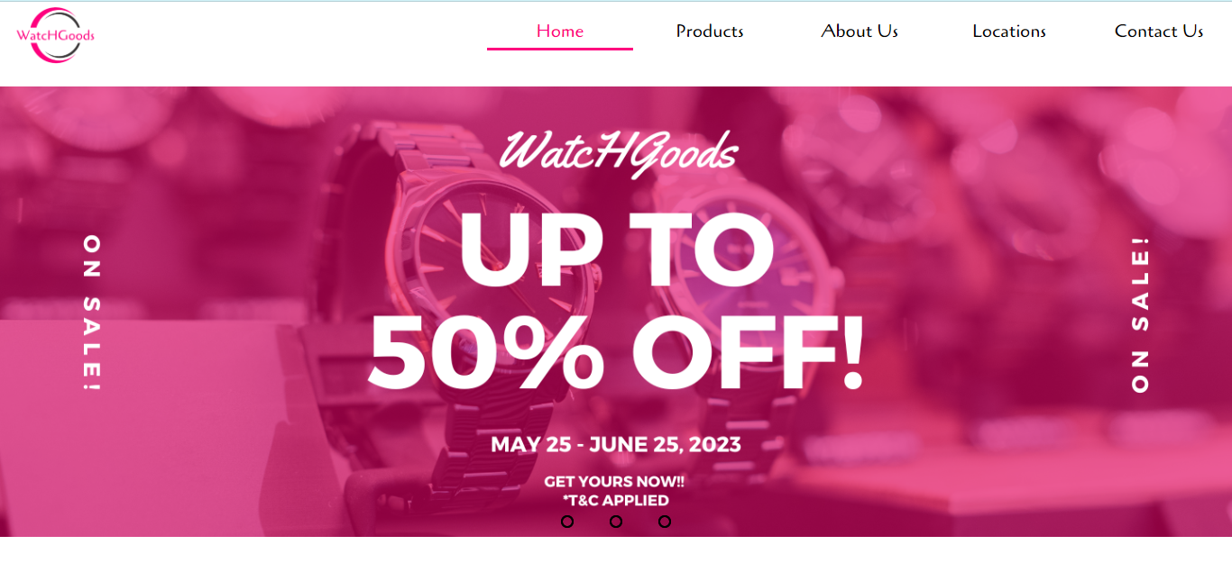

The homepage consists of logo and navigation, and the first thing user will notice is the promotion banner. I created using some templates in Canva. This is the link of my canva:

<https://www.canva.com/design/DAFkwVY6aAs/vGPTS8RQyCk4G7Az67TYqg/edit?utm_content=DAFkwVY6aAs&utm_campaign=designshare&utm_medium=link2&utm_source=sharebutton>

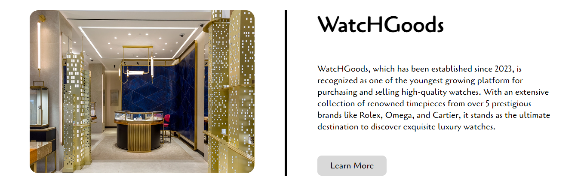

Then, this is the section of information about WatcHGoods and its attributes (authentic, quality, service). If user clicks on ‘Learn More’, then it will direct user to About Us Page

This is where user can see the brand we offer in our stores.  
Reference: <https://www.google.com/url?sa=i&url=https%3A%2F%2F1000logos.net%2Fthe-worlds-most-famous-watch-brands%2F&psig=AOvVaw3MaGs-3no40iO8TcR2gQE4&ust=1686438287133000&source=images&cd=vfe&ved=0CBEQjRxqFwoTCKCm6aqmt_8CFQAAAAAdAAAAABAE>

The last section consists of testimonial from some users, and the footer. Contact Us and Find Us will direct user to Contact Us Page and Find Us Page respectively.

1. Products

This section consists of header and some information about promos. This page will also show the watches we sell in this store with its name, image, and price

If we hover one of the box, it will create an effect like that.

All images I took from this website: <https://www.chrono24.co.id/search/browse.htm>

1. About Us

This section provides the information about WatcHGoods.

References: <https://robbreport.com/style/watch-collector/new-watch-store-openings-put-the-focus-on-in-store-shopping-1234631499/>

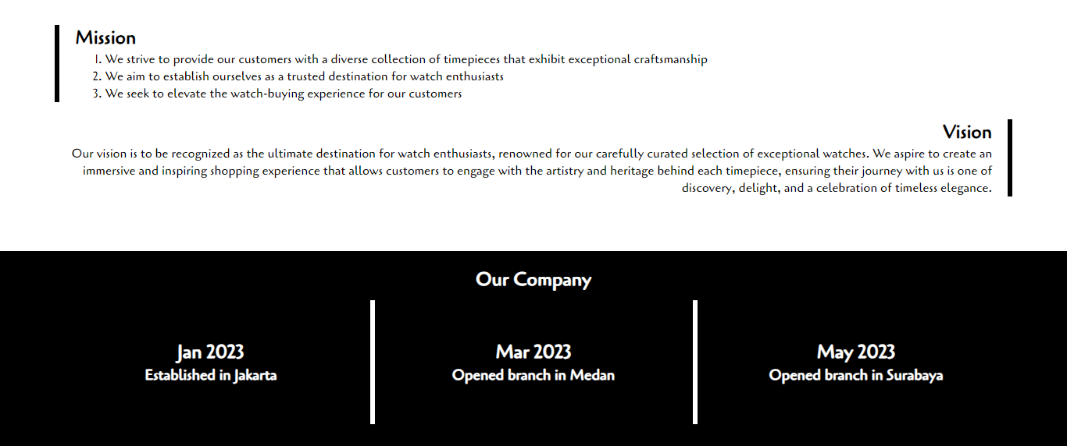

This section will give user insights about our mission, vision, and timeline

Then, this section contains some pictures of our stores, and our records throughout our career.

References:

* <https://www.google.com/imgres?imgurl=https%3A%2F%2Ffeldmarwatch.com%2Fwp-content%2Fuploads%2F2020%2F06%2Fslider-june-2020-store.jpg&tbnid=BiD8GOncJHw2mM&vet=12ahUKEwiIuPW3p7f_AhVZK7cAHQfWDE0QMygBegUIARDjAQ..i&imgrefurl=https%3A%2F%2Ffeldmarwatch.com%2F&docid=3BHoeUU015qnxM&w=2000&h=934&q=watch%20stores&hl=en&ved=2ahUKEwiIuPW3p7f_AhVZK7cAHQfWDE0QMygBegUIARDjAQ>
* <https://www.google.com/imgres?imgurl=https%3A%2F%2Fwww.kirchhofer.com%2Fimg%2Flanding-slider%2Flanding-slider-2.jpg&tbnid=8afzTUy0lgzZUM&vet=12ahUKEwiIuPW3p7f_AhVZK7cAHQfWDE0QMygGegUIARDtAQ..i&imgrefurl=https%3A%2F%2Fwww.kirchhofer.com%2F&docid=0PBjdxn-uXoSAM&w=1440&h=960&q=watch%20stores&hl=en&ved=2ahUKEwiIuPW3p7f_AhVZK7cAHQfWDE0QMygGegUIARDtAQ>
* <https://www.google.com/imgres?imgurl=https%3A%2F%2Fcdn1.ethoswatches.com%2Fmedia%2Fstorelocator%2Fnewstore%2Flist%2FEORI_2.jpg&tbnid=qUJC5X5loxw33M&vet=12ahUKEwiIuPW3p7f_AhVZK7cAHQfWDE0QMygHegUIARDvAQ..i&imgrefurl=https%3A%2F%2Fwww.ethoswatches.com%2Flocatestore%2F&docid=ArlDk-QI25Z_tM&w=1920&h=1440&q=watch%20stores&hl=en&ved=2ahUKEwiIuPW3p7f_AhVZK7cAHQfWDE0QMygHegUIARDvAQ>

1. Locations

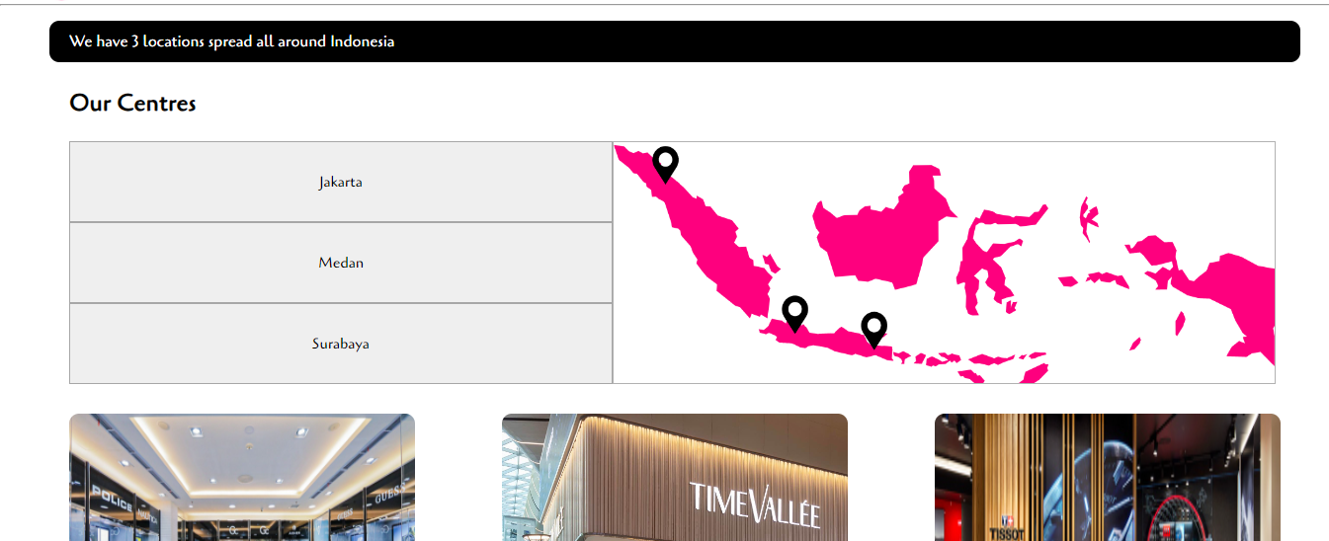

This section will provide user about our locations, if we click on one of the places, it will give user the location in map. For example:

I use Canva Image to do this map. Link Canva: <https://www.canva.com/design/DAFkwYdH3n4/iRNqMnPUh-pu6HrUhC34kw/edit?utm_content=DAFkwYdH3n4&utm_campaign=designshare&utm_medium=link2&utm_source=sharebutton>

This section will provide user images and details of locations of our stores in some branches.

References:

* <https://www.centralparkjakarta.com/directory-tenant-list/watch-zone/>
* <https://www.watchpro.com/watchfinder-opens-the-worlds-first-pre-owned-luxury-watch-store-in-an-airport/>
* <https://store.tissotwatches.com/958-weikhard>

1. Contact Us

This page will give user opportunity to contact WatcHGoods. Some validations are as follows:

* Name must not be empty
* Email must input the real one (Cannot start with @ and cannot end with ., etc)
* Country region must be chosen
* Message must not be empty and minimum 10 words

The number of error messages and their descriptions will be shown after user has clicked submit button.

The Color I use in this website are as follows:

* #fe007e
* #fff
* #000

Reference website:

* <https://www.watchfinder.com/>
* <https://www.chrono24.co.id/#gref>