Practicum Final Exam – Odd Semester Year 2021/2022
Subject |  |  | ISYS6169001 – Database Systems |  |  | 
Class | : | BB01 / BB08 / BU01 |  | Start Date | : 21 January 2022
Lecturer | : | D3709 – Novan Zulkarnain, S.T., M.Kom.  D5197 – Nadila Setiabudiarto, S.E., M.Kom  D5295 – Lay Christian, S.Kom., M.MSI |  | Start Time | : 09:20
Lecturer | : |  |  | End Date | : 21 January 2022
Lecturer | : |  |  | End Time | : 11:20

PERATURAN UJIAN:
Exam Regulations:
- Mahasiswa tidak diperbolehkan berdiskusi dan/atau bekerja sama dengan peserta ujian lainnya
Student is not allowed to discuss and/or work together with other exam participants
- Mahasiswa tidak diperbolehkan untuk membuka dan menyalin dari BUKU atau CATATAN, VIDEO dari pengajar (recording kelas, VBL, Youtube, dsb) dan REFERENSI lainnya
Student isn't allowed to open and copy from any resources such as notes, videos (class recording, VBL, Youtube, etc) and other references
- Mahasiswa tidak diperbolehkan membuka dan menyalin jawaban dari internet (google, stackoverflow, dsb)
Student isn't allowed to open and copy answer from the internet (google, stackoverflow, etc)
- Asisten BERHAK memberi nilai 0 (NOL) bagi peserta ujian yang melakukan segala bentuk kecurangan
Assistant is able to give 0 (ZERO) score for exam participant who does any cheating actions
- Kumpulkan jawaban tepat pada waktunya, apabila terlambat mengumpulkan maka jawaban tidak akan dikoreksi dan nilai mahasiswa adalah 0
Submit the answer on time, if not, then the answer will not be checked, and the students will receive 0 (ZERO)
- Bila Anda tidak membaca peraturan ini, maka Anda dianggap telah membaca dan menyetujuinya
If you have missed to read these regulations, so you are considered to have read and agreed on it

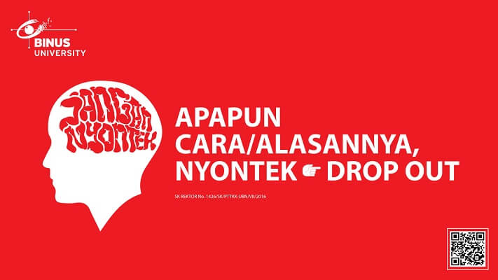

SOFTWARE YANG DIGUNAKAN:
Software will be used:
- SQL Server Developer 2019
- SQL Server Management Studio 18.9.1

FILE YANG DIKUMPULKAN:
File must be collected:
- [Last 6 digit of Student Id].SQL query answer

PERHATIAN!
Attention!
- Bagi yang mengerjakan tidak sesuai dengan soal, maka akan diberikan nilai NOL (0)
For those who do not work in accordance with the exam case will be marked as ZERO (0)
- Bagi yang mengerjakan tidak sesuai dengan software dan versi yang telah ditetapkan, maka akan tetap dikoreksi dengan software dan versi yang telah ditetapkan
For those who do not work in accordance with the software and specific version will be corrected by the predefined software and version
- Kompres semua jawaban yang akan diunggah. Pastikan format pengumpulan nama file dan ekstensi sesuai dengan format berikut: [NIM]-[NAMA].zip
Compress all file that will be uploaded. Make sure the format for collecting file name and extension according to the following format: [NIM]-[NAME].zip

Tabel Relasional
Relational Table

KroffleZ

KroffleZ is a croffle shop that wanted to create a database system that can store data and maintain their sales transactions for every customer that wants to buy croffle and will be handled by a staff. The customer can buy more than one variant croffle in a single transaction. KroffleZ provides several kinds of croffle with various toppings. Below is a picture of Entity Relationship Diagram (ERD) from KroffleZ:

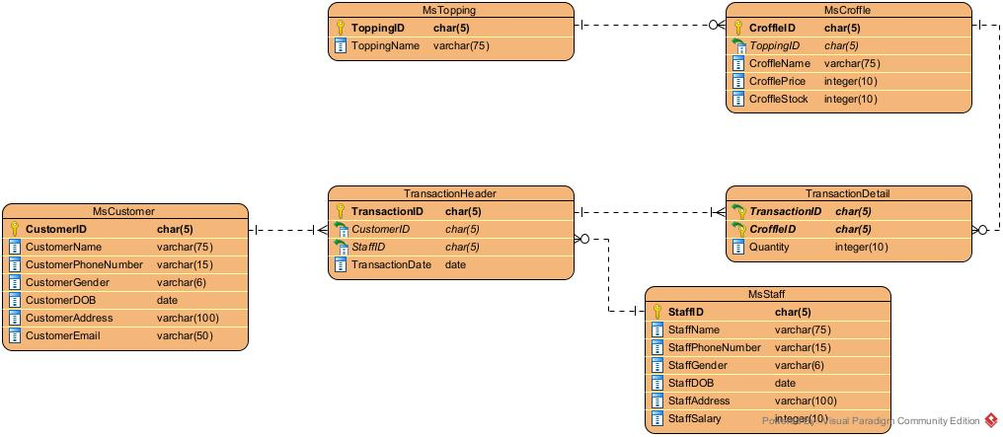

*Note:
Before taking the exam, please open the create+insert.sql file (attached with the case folder) then executes it on SSMS.

Soal
Case

- Display CustomerName, CustomerGender, and CustomerEmail for every customer whose name start with ‘M’.
(LIKE)
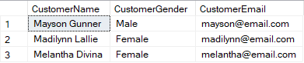

- Display StaffName, and TransactionDate for every transaction that occurs on the 1st quarter.
(DATENAME, QUARTER, JOIN)
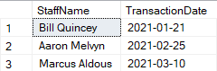

- Display First Name (obtained from the first word before space in CustomerName), and Total Transaction (obtained from the total transaction of customer) for every customer whose gender is ‘Male’.
(JOIN, COUNT, LEFT, CHARINDEX, GROUP BY)
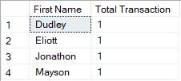

- Display ToppingName, Total Transaction (obtained from the total transaction of croffle), and Average Croffle Price (obtained from average of croffle price) for every croffle name that contains ‘berry’ and Average Croffle Price (obtained from average of croffle price) is greater than 200. Then, combine with ToppingName, Total Transaction (obtained from the total transaction of the croffle), and Average Croffle Price (obtained from average of croffle price) for every croffle name that contains ‘pinky’ and Average Croffle Price (obtained from average of croffle price) is greater than 200.
(COUNT, AVG, LIKE, GROUP BY, HAVING, UNION)
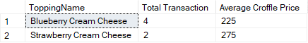

- Display Customer ID (obtained by replacing ‘CU’ in CustomerID with ‘Customer ’), CustomerName, CustomerGender, and CustomerEmail for every croffle stock greater than 100 and croffle name equals to 3 words.
(REPLACE, IN, LIKE)
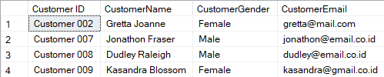

- Display CustomerName, and Phone Number (obtained from customer’s phone number by replacing the first from ‘0’ to ‘+62’) for every customer who was served by staff whose salary is greater than the average of all staff salary and day transaction that occurred on 25th.
(AVG, STUFF, CHARINDEX, DAY. alias subquery)
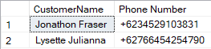

- Create a view named ‘View Strawberry Croffle’ to display CroffleName, CrofflePrice, and Stock (obtained from CroffleStock and ended with ‘ croffle(s)’) for every croffle that has topping name start with ‘Strawberry’.
(CREATE VIEW, CAST, LIKE)
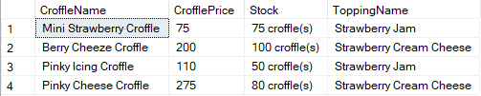

- Create a view named ‘Total Purchase Croffle’ to display ToppingName, and Total Purchase (obtained from the summing of quantity and ended with ‘ croffle(s)’) for every topping whose name contains ‘c’ and croffle price greater than 225.
(CREATE VIEW, CONCAT, SUM, LIKE, GROUP BY)
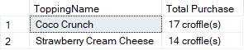

- Add a column named ‘StaffEmail’ on MsStaff table with varchar data type and length is 50. After that, add a constraint to check the email of StaffEmail must end with ‘krofflez.com’.
(ALTER TABLE, ADD, ADD CONSTRAINT, LIKE)
Before alter:
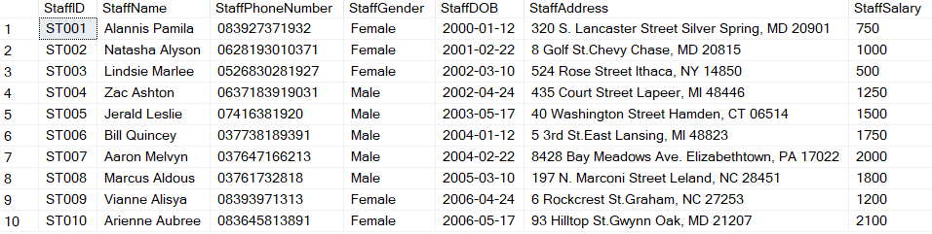

After alter:
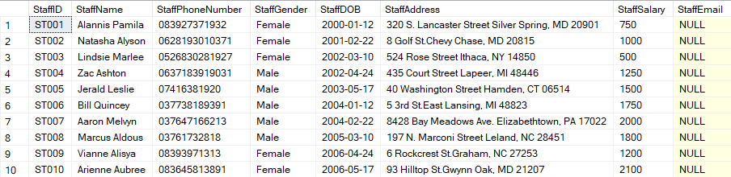

- Delete data from MsCustomer table for every transaction who was served by staff whose salary is greater than 1000 and StaffID is even number.
(DELETE, RIGHT)
Before delete:
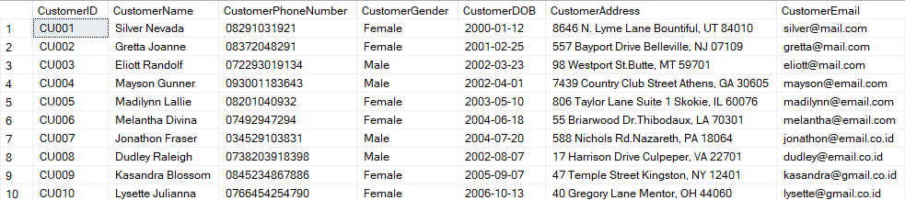
After delete:
