**The BML Simulation Study**

1. For what values of p, the density of the grid, did you find free flowing traffic and traffic jams? Did you find any cases of a mixture of jams and free flowing traffic?

While comparing free flows traffic simulations p <= 0.38 and traffic jams p > 0.39, the simulation ran on a 50 x 50 dimension matrix. As p increases, probability of entering into gridlock also increased.

2. How many simulation steps did you need to run before observing this behavior?

I ran 500 steps with 100 different experiments. The *bml.sim* returns number of experiments that eventually hit gridlock out of the 100 experiments conducted. In addition, also have average number steps to hit gridlock for experiments that actually hit gridlock. For 50 x 50 matrixes, I was able to plot probability of simulation reaching the state of gridlock. On the graph, I also plotted the probability value and number of steps that the simulation took to reach the gridlock point. The probability value ranged from 0.35 to 0.5).

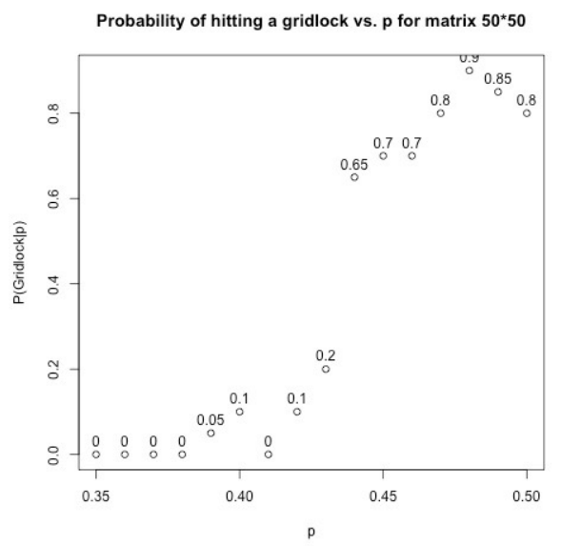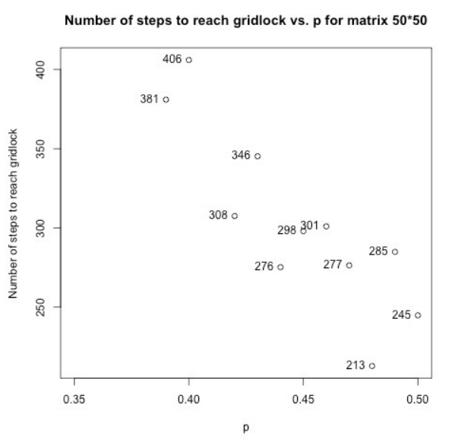

3. Does the transition depend on the size of shape of the grid?

I compared the results from different sized matrices: 10 x 10, 30 x 30, 50 x 50, 70 x 70, and 100 x 100:

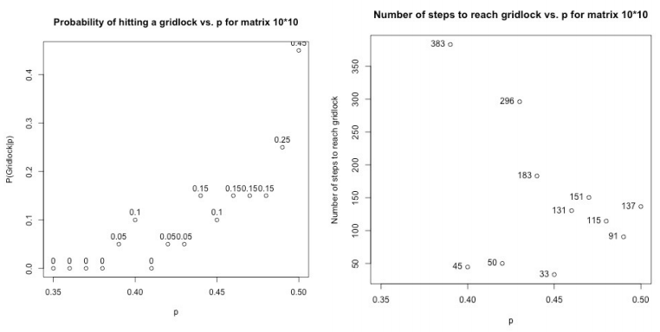

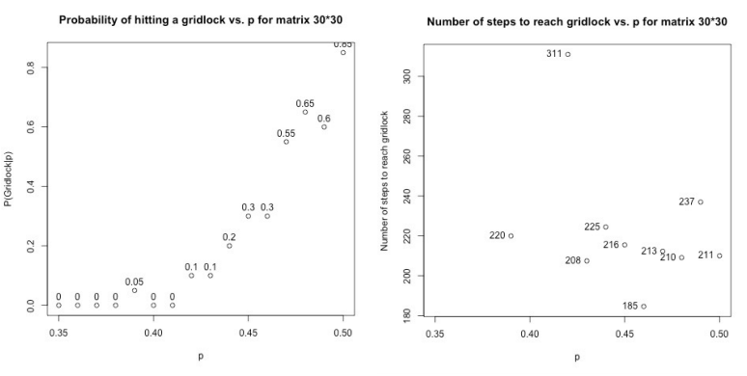

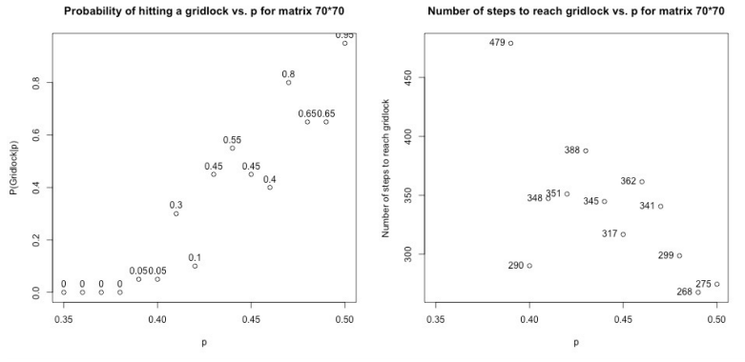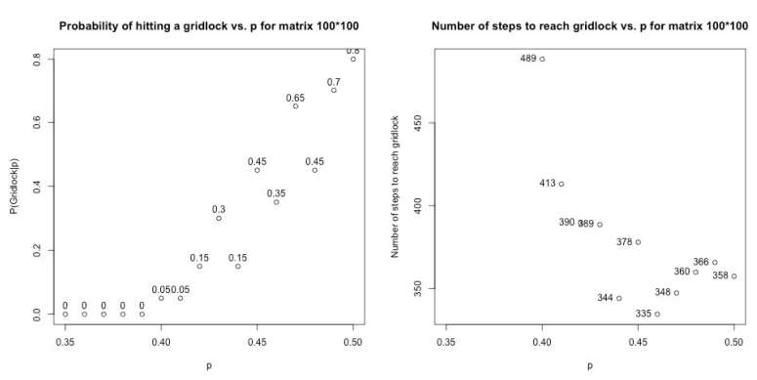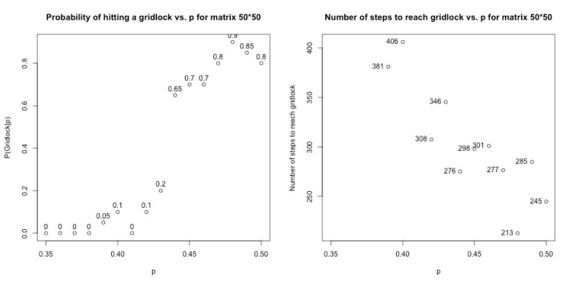

From the observations of the matrices of different sizes, it can be observed that there is little effect on the p value during transition from free flow to traffic jam. However, the number of steps necessary to hit the gridlock increases at p values (approximately equivalent) in the case of larger matrices.

I now investigate changing the shape of the grid and in this case, I chose a 20 x 45 matrix.

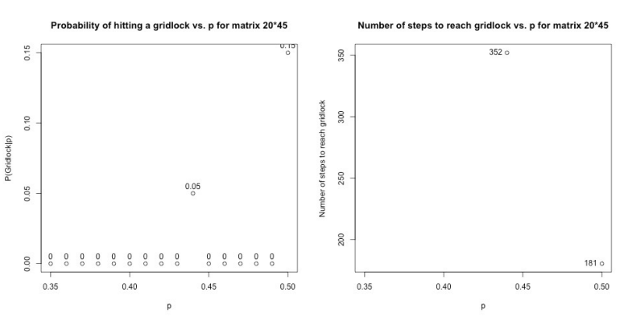

In the event of a 10 x 90 matrix, there is also no gridlock present for (p = 0.35 to 0.5 inclusive)

This information can be inferred that rectangular matrices are less likely to hit gridlock, and therefore the transition should depend on the shape of the matrix as the size of the matrix is fixed between 0.35 and 0.5.