Name: Ming-hung Shih

Part 2. MIRA and Aggressive MIRA

1. For each epoch, it shows the training data MIRA error rate, training average MIRA error rate, dev data MIRA error rate, and dev data average MIRA error rate.

After five epoch, it return the best error rate and epoch in the end.

Iter 1.00 error rate: 0.30400 avg error rate: 0.31000 dev error rate: 0.28363 avg rate: 0.18754

Iter 2.00 error rate: 0.27100 avg error rate: 0.28400 dev error rate: 0.24321 avg rate: 0.18555

Iter 3.00 error rate: 0.26100 avg error rate: 0.27400 dev error rate: 0.23327 avg rate: 0.18158

Iter 4.00 error rate: 0.25075 avg error rate: 0.26075 dev error rate: 0.21935 avg rate: 0.18290

Iter 5.00 error rate: 0.24760 avg error rate: 0.26460 dev error rate: 0.24718 avg rate: 0.16302

Best dev

Iter 0.008 error rate: 0.12500

Iter 0.033 avg error rate: 0.21212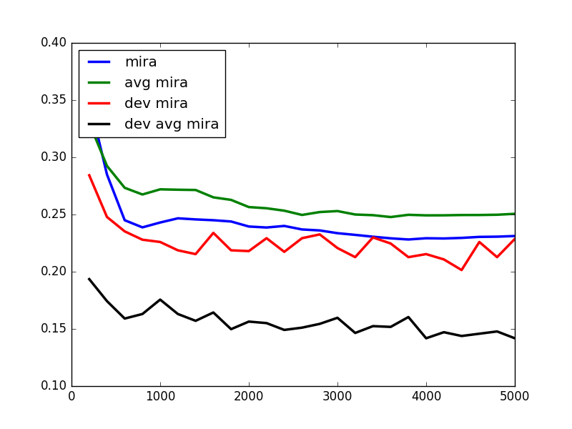

2.

Aggressive MIRA with p = 0.9

Iter 1.00 error rate: 0.28300 avg error rate: 0.27200 dev error rate: 0.23658 avg rate: 0.16965

Iter 2.00 error rate: 0.27100 avg error rate: 0.25650 dev error rate: 0.22929 avg rate: 0.14645

Iter 3.00 error rate: 0.27000 avg error rate: 0.25300 dev error rate: 0.23526 avg rate: 0.15573

Iter 4.00 error rate: 0.26675 avg error rate: 0.24925 dev error rate: 0.22068 avg rate: 0.14380

Iter 5.00 error rate: 0.26380 avg error rate: 0.25060 dev error rate: 0.23260 avg rate: 0.14712

Best dev

Iter 0.008 error rate: 0.12500

Iter 0.033 avg error rate: 0.21212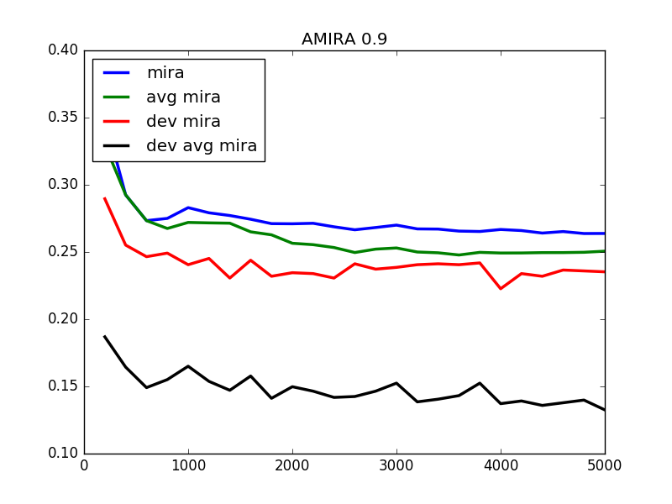

Aggressive MIRA with p = 0.5

Iter 1.00 error rate: 0.26900 avg error rate: 0.27200 dev error rate: 0.23062 avg rate: 0.16965

Iter 2.00 error rate: 0.26800 avg error rate: 0.25650 dev error rate: 0.21604 avg rate: 0.14645

Iter 3.00 error rate: 0.26067 avg error rate: 0.25300 dev error rate: 0.21272 avg rate: 0.15573

Iter 4.00 error rate: 0.25775 avg error rate: 0.24925 dev error rate: 0.21206 avg rate: 0.14380

Iter 5.00 error rate: 0.25840 avg error rate: 0.25060 dev error rate: 0.21537 avg rate: 0.14712

Best dev

Iter 0.039 error rate: 0.20513

Iter 0.033 avg error rate: 0.21212

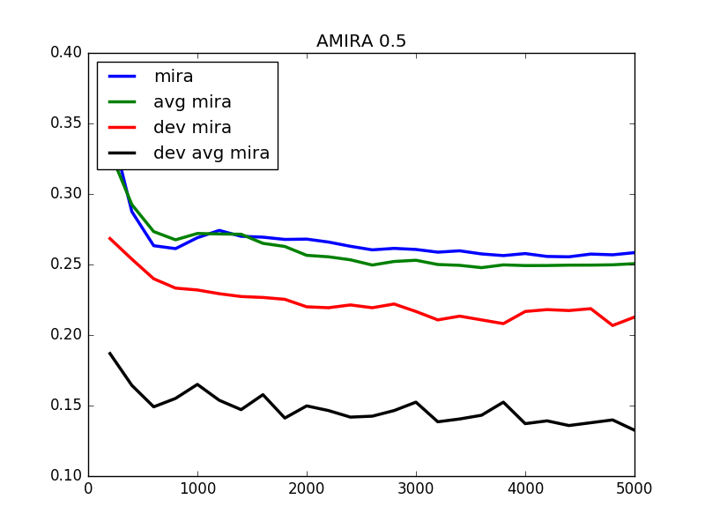

Aggressive MIRA with p = 0.1

Iter 1.00 error rate: 0.28200 avg error rate: 0.27200 dev error rate: 0.23857 avg rate: 0.16965

Iter 2.00 error rate: 0.27150 avg error rate: 0.25650 dev error rate: 0.22797 avg rate: 0.14645

Iter 3.00 error rate: 0.26767 avg error rate: 0.25300 dev error rate: 0.23194 avg rate: 0.15573

Iter 4.00 error rate: 0.26325 avg error rate: 0.24925 dev error rate: 0.21604 avg rate: 0.14380

Iter 5.00 error rate: 0.26160 avg error rate: 0.25060 dev error rate: 0.22664 avg rate: 0.14712

Best dev

Iter 0.040 error rate: 0.17500

Iter 0.033 avg error rate: 0.21212

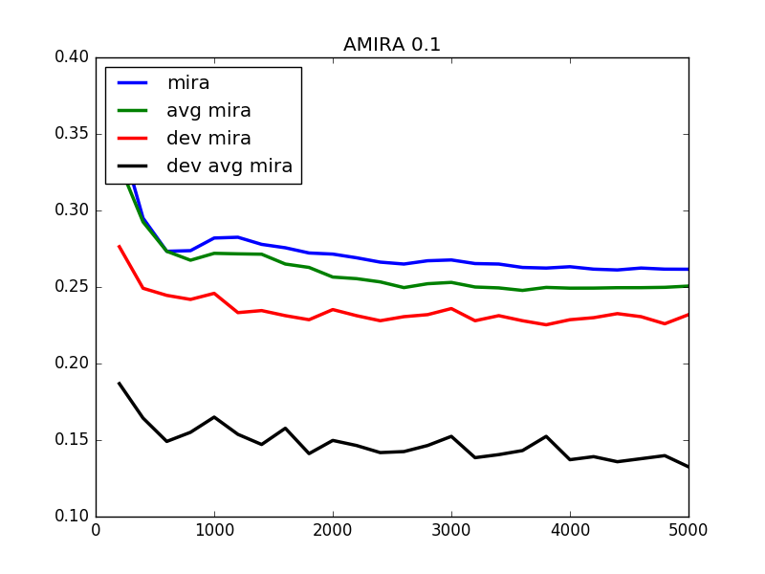

3.Compare MIRA, AMIRA with Perceptron:

Iter 1.00 error rate: 0.27600 avg error rate: 0.27200 dev error rate: 0.21935 avg rate: 0.17561

Iter 2.00 error rate: 0.26550 avg error rate: 0.25650 dev error rate: 0.22863 avg rate: 0.15507

Iter 3.00 error rate: 0.25700 avg error rate: 0.25300 dev error rate: 0.22333 avg rate: 0.16435

Iter 4.00 error rate: 0.25150 avg error rate: 0.24925 dev error rate: 0.22399 avg rate: 0.15176

Iter 5.00 error rate: 0.25280 avg error rate: 0.25060 dev error rate: 0.22730 avg rate: 0.15573

Best dev

Iter 0.033 error rate: 0.18182

Iter 1.447 avg error rate: 0.15826

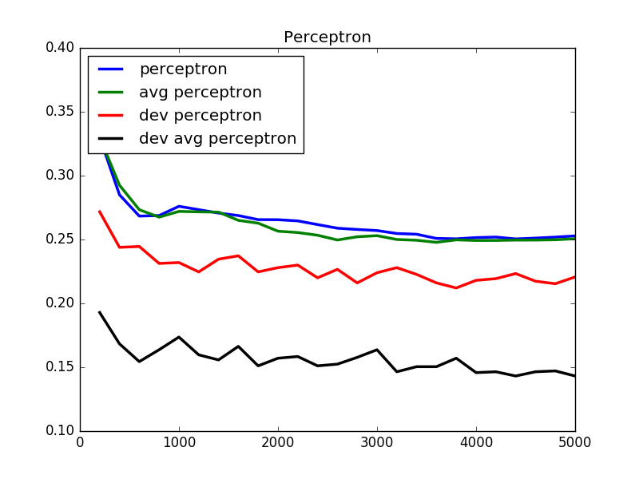

With different p, it will make dev error rate lower but not much.

Too much p, such as 0.9 or 0.1 may result in same value and p = 0.5 could lower the error rate.

Sometimes MIRA prevents much update and it could raise the error rate based on the data type.

Average error rate would not change too much even though p is changed.