PROGRAM TITLE
MARKETING AND OPERATIONS

PROCESS TITLE
Marketing

- SCOPE

This policies and procedures manual establishes policies, systems, procedures and controls on Marketing. All duties and responsibilities stated in this manual are not exclusive to the personnel’s designated responsibilities in this process title.

- OBJECTIVES

- To establish procedures, guidelines and strategies to properly carry out the Marketing function, gain and maintain the Company’s share in the market and the industry.
- To clearly define the duties and responsibilities of all personnel involved in this process title.

- PERSONNEL INVOLVED

  - Marketing Staff

    - Receive duly accomplished and notarized contracts.
    - Assign “contract reference number” chronologically and input contract data to ABAS.
    - Prepares “Service Order”.

  - Marketing Manager

    - Identifies prospective or potential clients.
    - Obtains and receives relevant information and other details of a prospective or potential client.
    - Prepares engagement proposal to a prospective or potential clients.
    - Forwards duly approved engagement proposal to prospective or potential clients.
    - Sets-up close meeting and discuss in detail the terms and needs of prospective or potential client.
    - Prepares contract.
    - Forwards signed contract to prospective or potential client.

    - Prepares addendum to the contract whenever there are changes, amendments, revisions, special provisions or requirements to the contract.
    - Receives duly signed contracts and addendums, if any, and notarized the same to notary public.
    - Notifies and coordinates with Operations Manager of new clients and details of assignment.
    - Verifies contract details inputted to ABAS.
    - Verifies and approves Service Order.

  - Senior Vice President (SVP) for Marketing and Operations

    - Reviews engagement proposal.
    - Reviews and signs a contract.
    - Reviews and signs addendums to contract.

  - President

    - Approves engagement proposal.
    - Reviews and signs a contract.
    - Reviews and signs addendums to contract.

- POLICIES

  - Marketing

    - The Marketing Department shall formulate an effective and efficient marketing techniques and strategies in order to:

- Attract potential clients and gain share in the market and industry;
- Maintain satisfaction and good relationships with clients or maintain share in the market and industry;
- Survive competition in the market and industry; and
- Increase profitability of the Company.

    - Marketing personnel shall be properly trained to handle clients. Knowledge and experience in handling and customer service relationships shall also be considered in requesting personnel from HR Department.

    - The Marketing Department shall properly identify and understand its potential or prospective client prior to sending off proposals and engagement in order to avoid or minimize certain risks and consequences of incorrect acceptance of wrong clients or rejection of a potential or good clients. These shall include, at a minimum, the following information:

- Business information
- Key management personnel, attitude, reputation, style and connections
- Credit reputation and other transaction history
- Scale or magnitude of business and transactions
- Legal and regulatory compliance
- Other matters and relevant issues

  - Pricing

    - In setting up a price, the Company shall select those pricing strategies that are objective, reliable and best derives the optimal price of a particular service. The Company shall not set a price based on a single pricing strategy but a combination of various strategies and due consideration of relevant factors that could affect the price. The following pricing strategies may be adopted by the Company (the list is not exhaustive):

- Cost plus pricing. All costs incurred (variable costs plus direct fixed costs) attributable to a particular service are identified and summed up and a markup percentage is added in order to derive the price.

The basic formula is as follows:

Cost | xx
Markup | xx
Price | xx

Proper costing and computation shall be properly coordinated with the Accounting Department and other subject matter experts (SMEs) as necessary.

- Target pricing. Price is dependent on the desired income or return on investment (ROI).

The basic formula is as follows:

Target income or return of investment | xx
Fixed costs | xx
Contribution margin | xx
Divided by: contribution margin ratio | xx%
Price | xx

Proper costing and computation shall be properly coordinated with the Accounting Department and other subject matter experts (SMEs) as necessary.

- Value pricing. Price is based on the perceived value of the service for the client and not on its costs or desired ROI.

- Strategic pricing. This includes:

- Limitation pricing. Setting low prices in order to protect Company’s share in the market and deter potential competitors from entering the market.

- Penetration pricing. Setting prices below the market rate in order to attract potential clients and gain its share in the market.

- Predatory pricing. Setting prices low enough to drive competitors from the market.

Strategic pricing may be considered or applied by the Company specially when the degree of competition in the market is high or very tight.

- Other pricing strategies

- Freemium pricing. Offering certain services for free to clients (i.e., free consultation, basic operations management, etc.).

- Loss leader pricing. Offering special deals to certain clients for a particular services.

    - The following factors, at a minimum, shall be considered when setting up a price:

- Competitor’s rate for similar services
- Industry rate for similar services
- Degree of competition in the market (low or high)
- Type and scope of services provided (basic or integrated)
- Scheme of payments (lump sum or installments)
- Desired income or return of investment
- Inflation and other economic conditions
- Laws and regulations (i.e., cost of fuel, increase in excise taxes on fuels, VAT, etc.)

    - The Marketing Department shall regularly review, at least annually, the Company’s pricing strategies and shall make a proposal for revision if necessary. This shall be done through a Pricing Analysis which shall be presented for review and approval of the SVP for Marketing and Operations and the President.

  - Contract Preparation

    - Contracts shall be done in a systematic and legal manner and that each party must fully understand and fulfill its roles and responsibilities as clearly stated in the provisions of the contract.
    - Legal effects and implications of the contracts shall be properly consulted with the appropriate legal counsel, as necessary, before signing the contracts.
    - Amendments, revisions, changes or special provisions not covered in the original contract shall be properly and clearly set out in the Addendum of the contracts and shall be duly signed by the SVP for Marketing and Operations and the President.
    - All contracts shall be signed by the SVP for Marketing and Operations and the President and shall be authenticated and notarized.

  - Documentation

    - All forms shall be duly filled-out as to details, signed by the signatories and any alterations thereof shall be duly countersigned.
    - All contracts, addendums, acknowledgements and all other types or forms of documents shall be held confidential and shall not be made available to unauthorized officers or employees.

    - A list of all client’s shall be maintained by the Marketing Department which shall contain, at a minimum, the following information:

- Business information
- SEC registration no.
- Tax identification no.
- Official business address
- Key management personnel and contact information
- Other relevant information

Moreover, each client shall have a separate master file or data which shall be maintained by the Marketing Department.

    - A systematic vessel monitoring system shall be established by the Marketing Department which shall contain, at a minimum, the following information:

- Listing of all vessels of the Company classified as operational, available for operation, under dry dock, etc.
- Current status, assignment or voyage number of each vessel
- Location of each vessel
- Transaction history of each vessels which shall clearly indicate the date of the transactions, cargo delivered or handled, no. of bags or weight, parties involved and the like.
- Other vessel information (capacity, dead weight tonnage, officials and crew, etc.)

    - Rejected, cancelled or voided proposals, contracts or documents, revisions or corrections of any type and other similar cases shall be separately filed by the Marketing Department.

    - Client feedbacks and evaluation shall filed separately by the Marketing Department and shall be evaluated and considered appropriately as part of the Company’s continuous service improvements.

- PROCEDURES

Contracting Process (All Contracts)

Step No. | Activity | Personnel  Involved | Business  Forms
1 | Identify prospective or potential clients. | Marketing Manager/  SVP Marketing and Operations/  President
2 | Obtain and receive relevant information and other details of a prospective/potential client. These shall include, but not limited to, the following:  - Business information  - Key management personnel, attitude, reputation, style and connections  - Credit reputation and other transaction history  - Scale or magnitude of business and transactions  - Legal and regulatory compliance  - Other matters and relevant issues | Marketing Manager/  SVP Marketing and Operations/  President
2 | Prepare engagement proposal to a prospective/potential client. | Marketing Manager | Engagement proposal
3 | Review engagement proposal. | SVP Marketing and Operations | Engagement proposal
4 | Approve engagement proposal. | President | Engagement proposal
5 | Forward duly approved engagement proposal to prospective/potential client. | Marketing Manager
6 | If proposal is accepted, set up a close meeting and discuss in detail the following:  - Types and scope of services able to provide  - Prospective client’s needs and other requirements  - Other terms or agreement | Marketing Manager
7 | Prepare contract. | Marketing Manager | Contract
8 | Review and sign contract. | SVP Marketing and Operations  /President | Contract
9 | Forward contract to prospective client. | Marketing Manager | Contract
10 | Receive and review contract. | Prospective Client | Contract
11 | If the prospective client requires amendment or special provision to the contract, the Marketing Manager must prepare an addendum to the contract. | Marketing Manager | Addendum
12 | Review and sign addendum. | SVP Marketing and Operations  /President | Addendum
13 | Conform and sign to the addendum. | Prospective Client | Addendum
14 | Receive duly signed contracts and addendum, if any. | Marketing Manager | Duly signed contract and addendum, if any
15 | Notarized duly signed contracts and addendum, if any. | Marketing Manager | Duly signed and notarized contract and addendum, if any

Preparation of Service Order

Step No. | Activity | Personnel  Involved | Business  Forms
1 | Receive duly accomplished and notarized contracts. | Marketing Staff
2 | Input contract data to ABAS. These include, but not limited to, the following:  - Contract date  - Client ID  - Service  - Cargo  - Quantity  - Rate  - Amount  - Contract status  - Remarks  - Others  Contract reference no. should be systematically assigned through ABAS. | Marketing Staff
3 | Verify contract details. | Marketing Manager
4 | Prepare Service Order (SO). | Marketing Staff
5 | Verify and approve SO. | Marketing Manager
6 | Receive duly approved SO. | Operations Manager
7 | To process title “Cargo Operations” or “Lighterage Operations”. | Operations Staff

- FLOWCHARTS

  - Contracting Process (All Contracts)

  - Contracting Process (All Contracts)

  - Preparation of Service Order

- BUSINESS FORMS

  - Voyage Charter
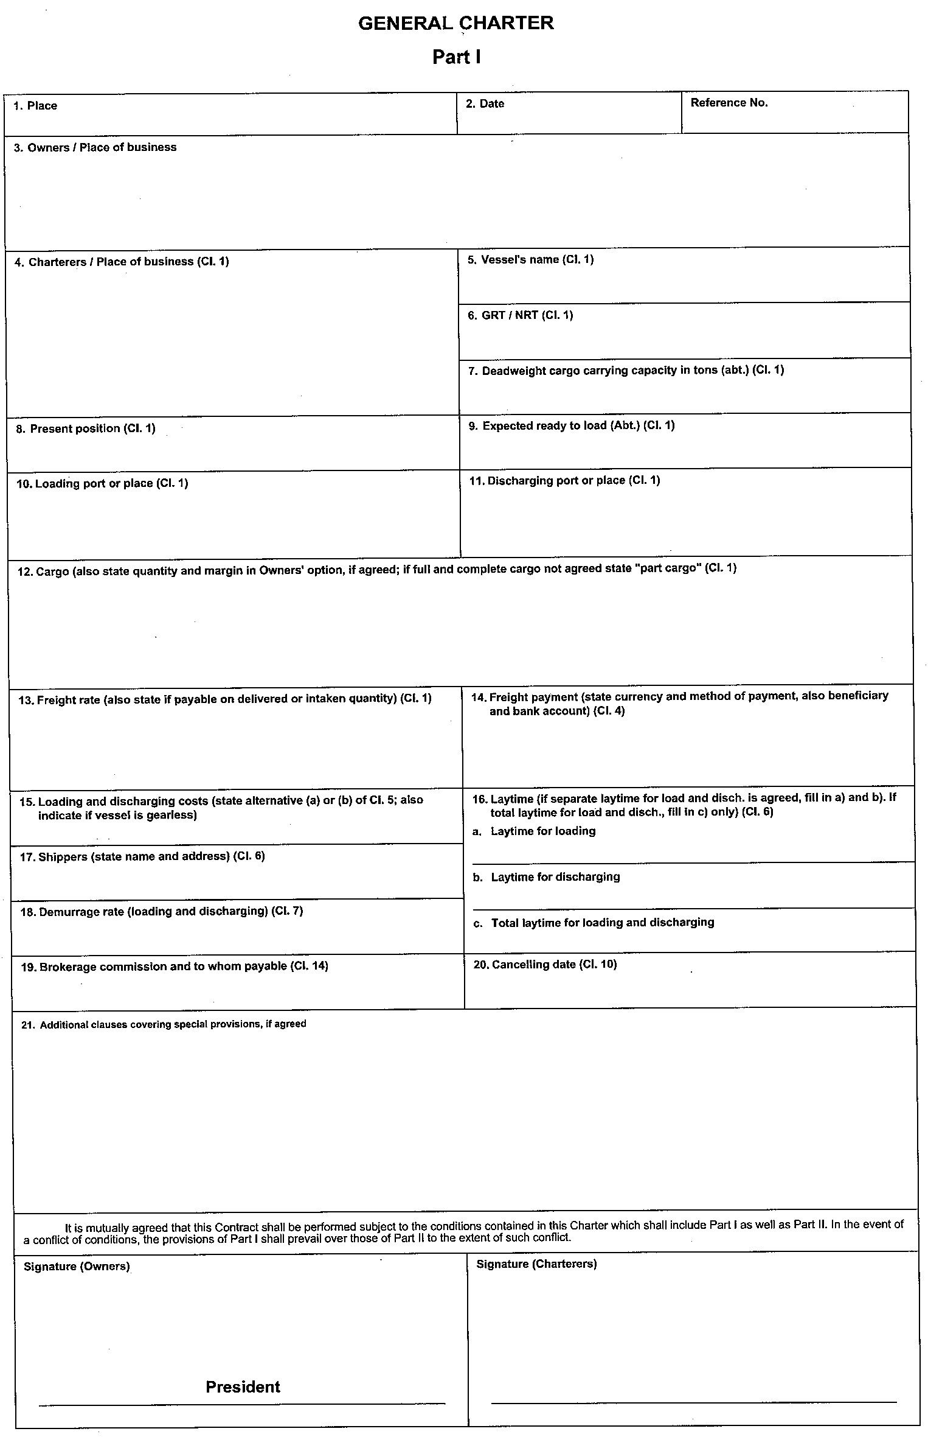

Prepared by - Marketing Manager
Signed by - SVP Marketing and Operations/President
Conformed and signed by - Client

  - Time Charter

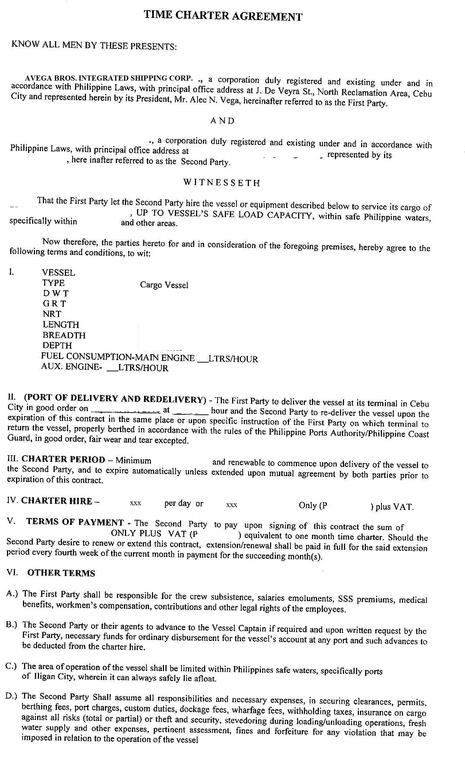

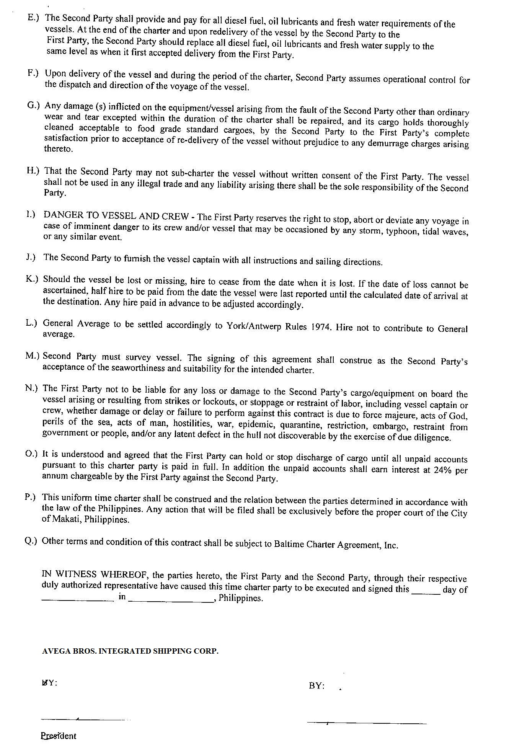

Prepared by - Marketing Manager
Signed by - SVP Marketing and Operations/President
Conformed and signed by - Client
  - Cargo Handling Agreement

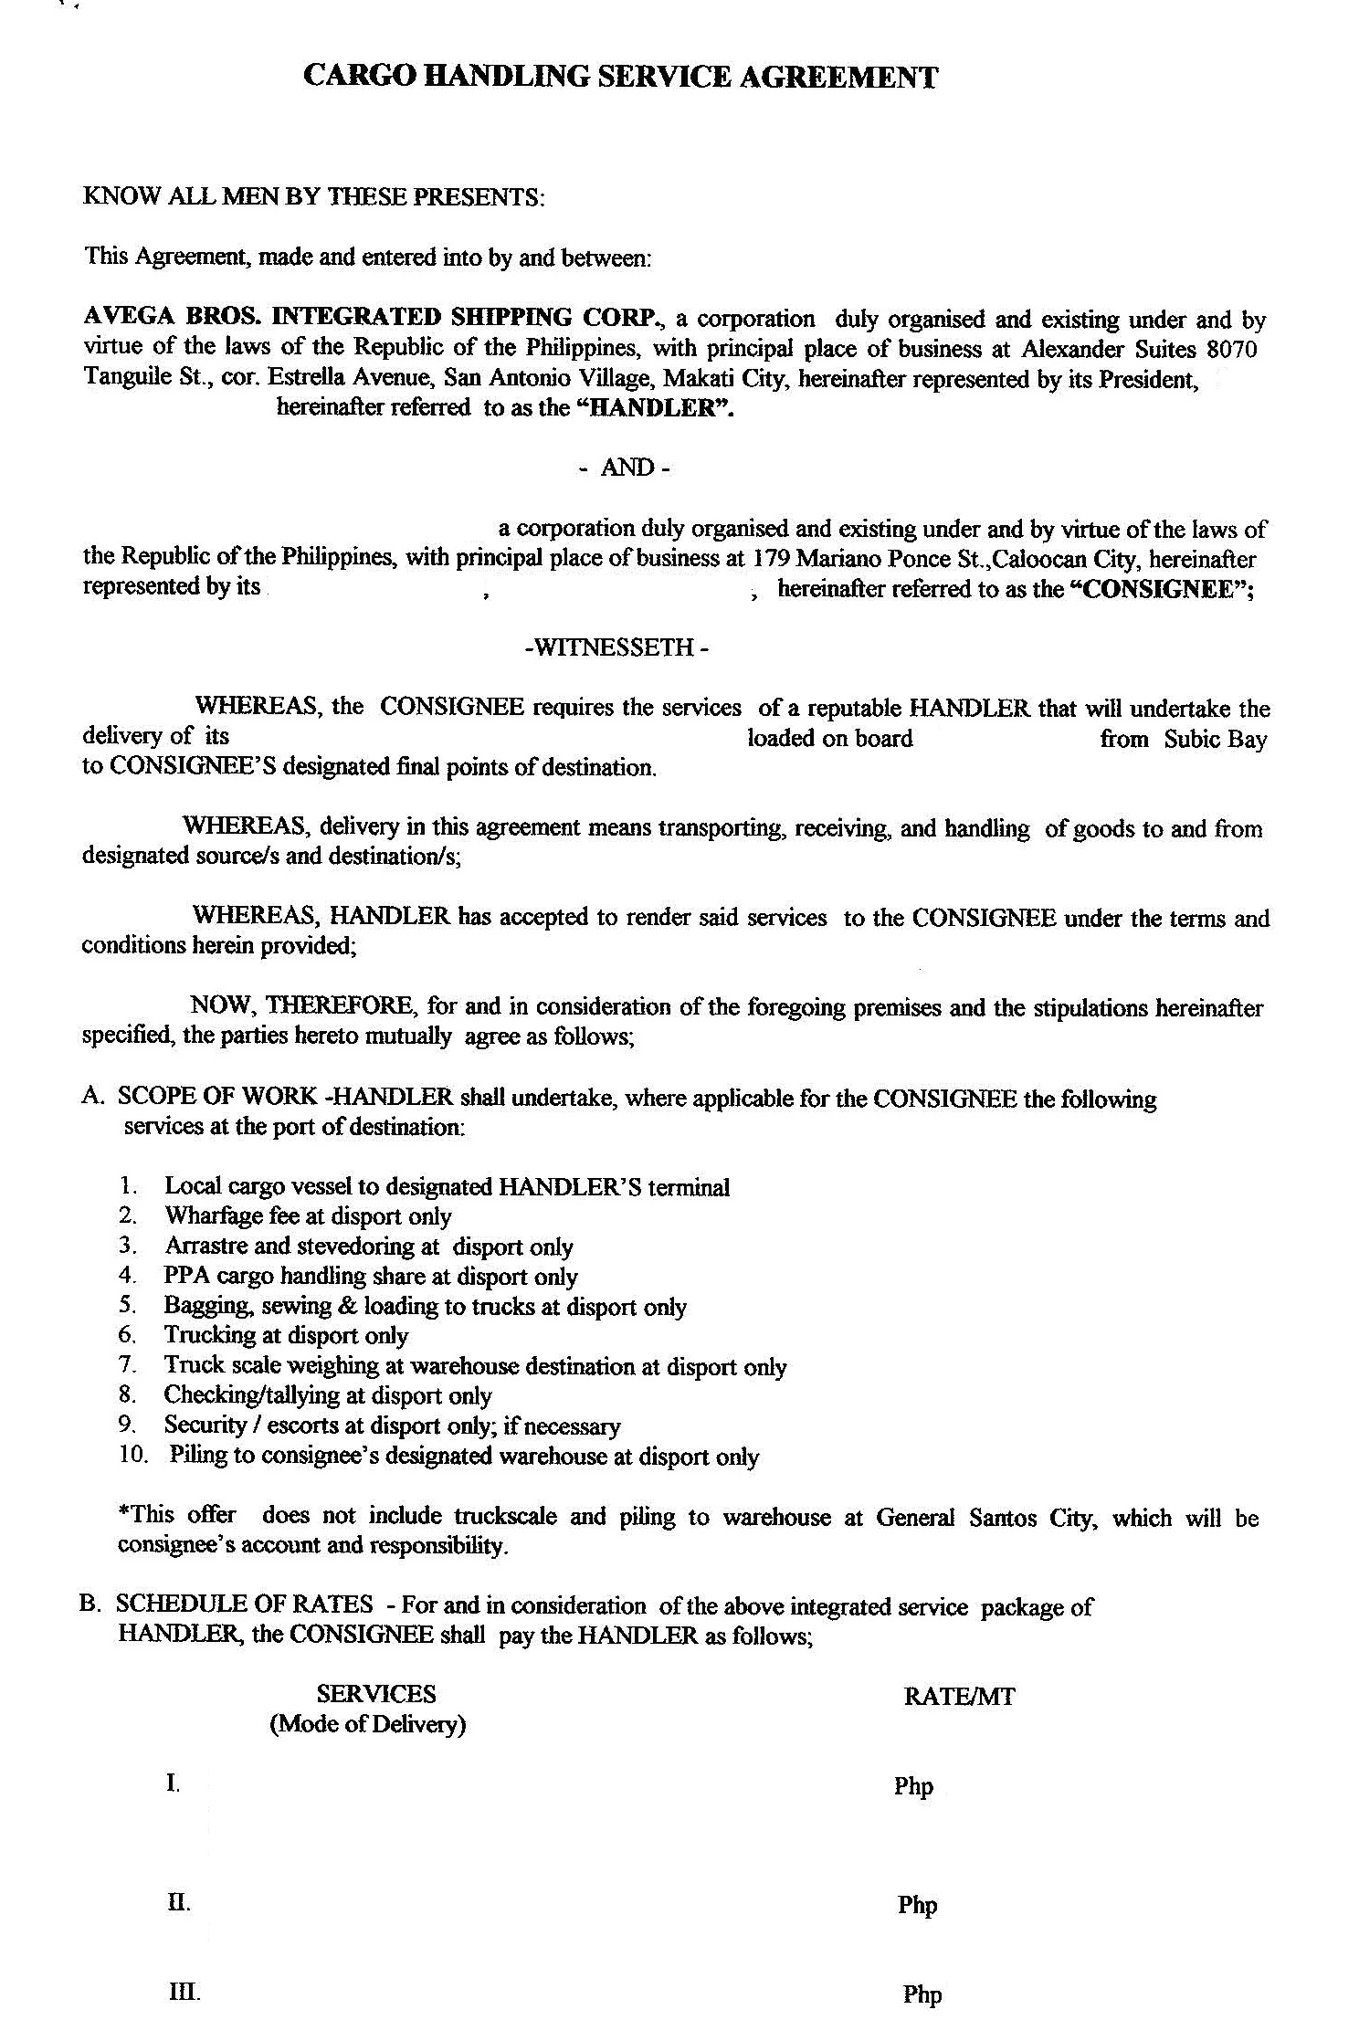

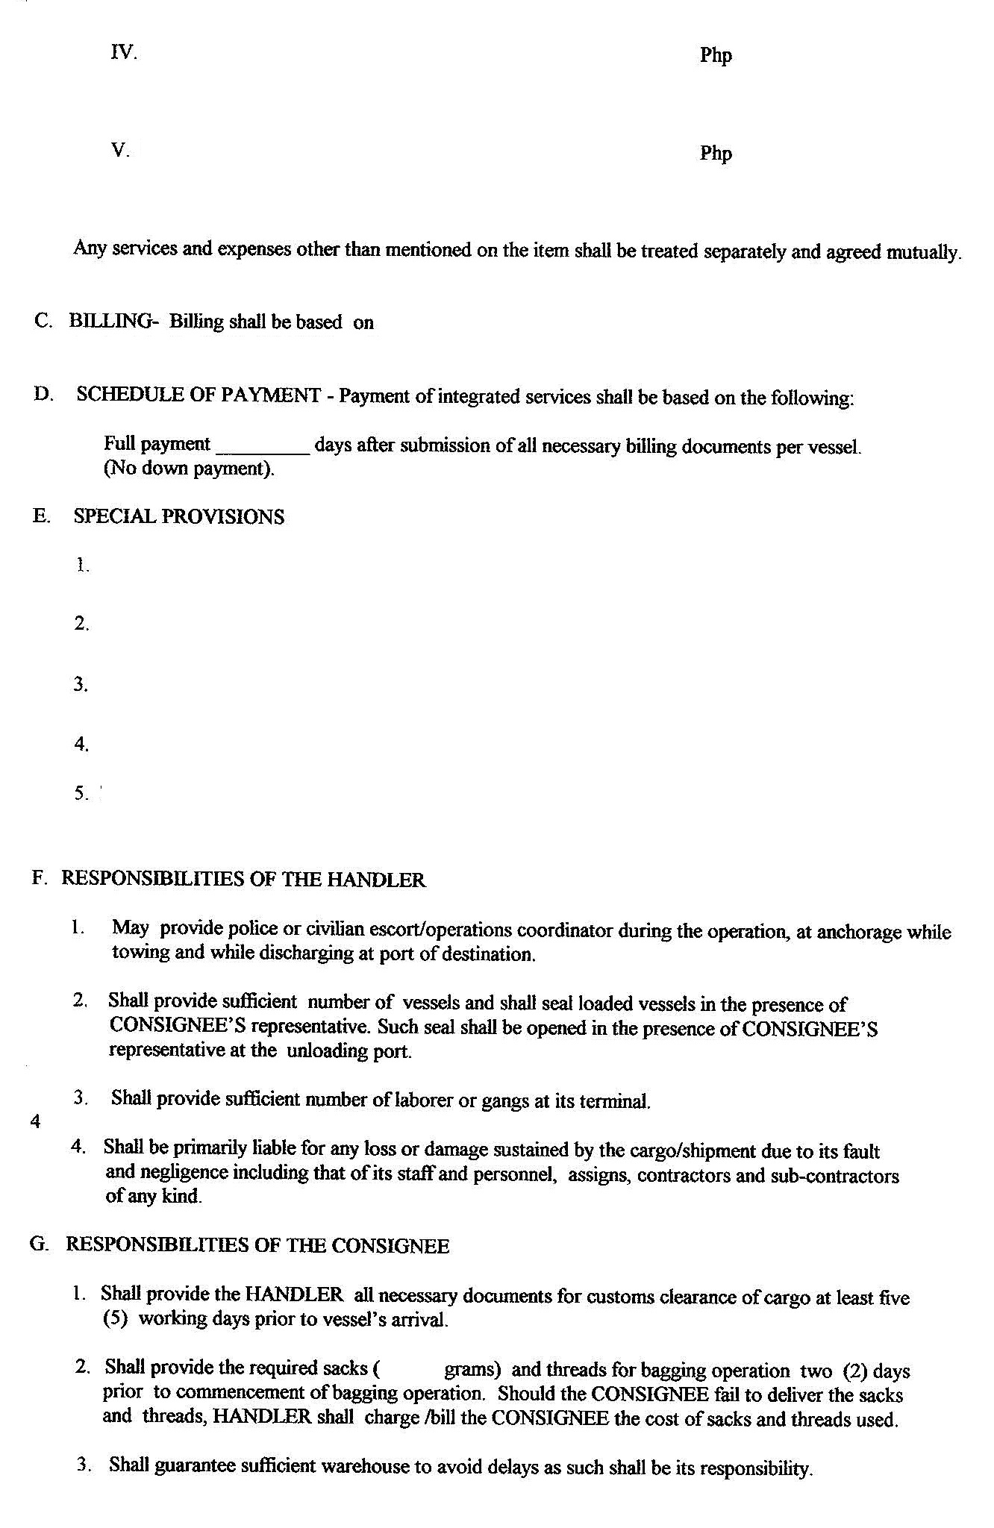
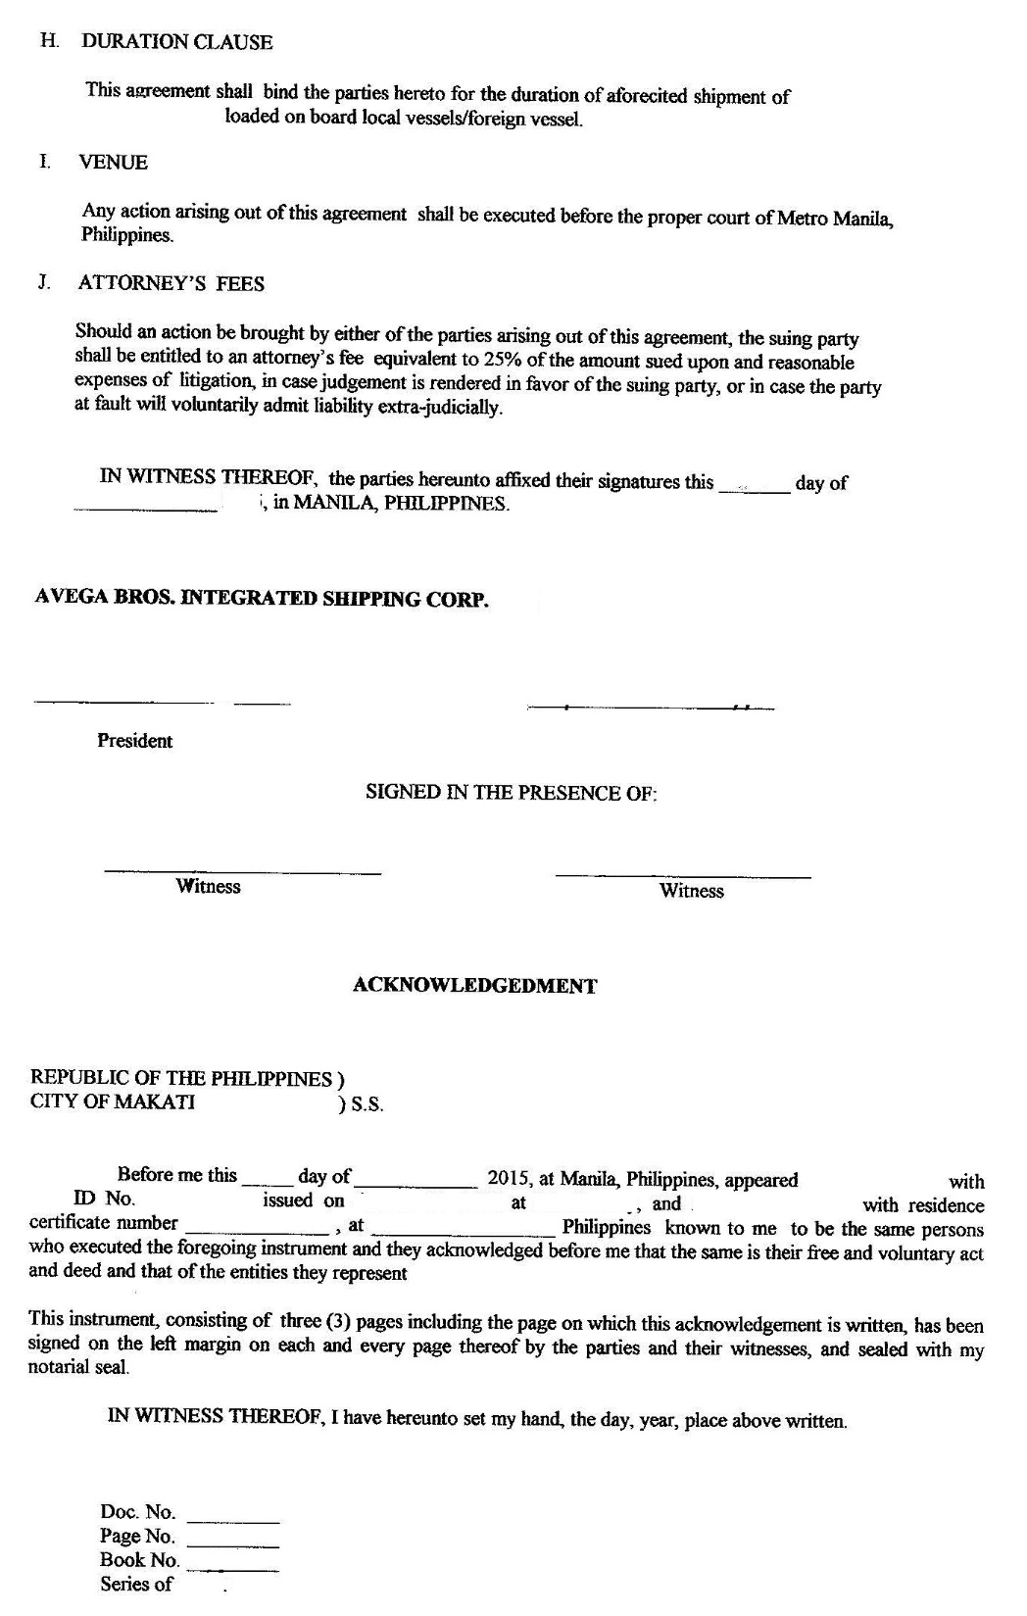

Prepared by - Marketing Manager
Signed by - SVP Marketing and Operations/President
Conformed and signed by - Client
  - Addendum
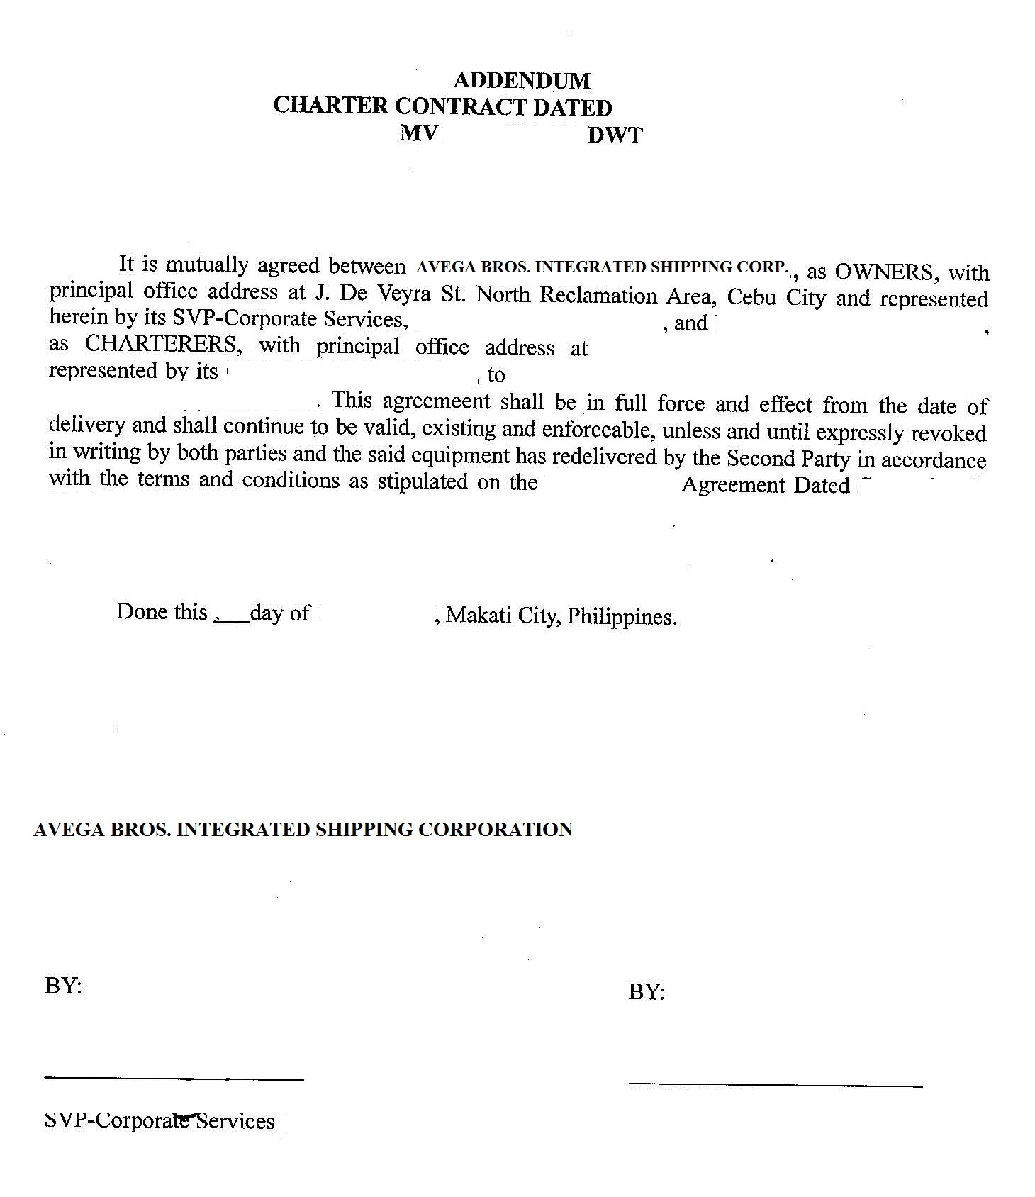

Prepared by - Marketing Manager
Signed by - SVP Marketing and Operations/President
Conformed and signed by - Client

  - Service Order (Voyage Charter/Time Charter)

No. of Copies - 2
Explanation - This is issued to notify the Operations Department of booking and details of assignment for voyage and time charter agreements of vessels, tugboats or barges.
Prepared by - Marketing Staff
Verified and approved by - Marketing Manager
Distribution - Copy 1 - Marketing Department
Copy 2 – Operations Department

  - Service Order (Trucking)

No. of Copies - 2
Explanation - This is issued to notify the Operations Department of booking and details of assignment for trucking services.
Prepared by - Marketing Staff
Verified and approved by - Marketing Manager
Distribution - Copy 1 - Marketing Department
Copy 2 – Operations Department

  - Service Order (Handling)

No. of Copies - 2
Explanation - This is issued to notify the Operations Department of booking and details of assignment for handling services.
Prepared by - Marketing Staff
Verified and approved by - Marketing Manager
Distribution - Copy 1 - Marketing Department
Copy 2 – Operations Department

- EFFECTIVITY

This Policies and Procedures Manual shall take effect upon approval and shall supersede any memorandum/SOP inconsistent with this Policies and Procedures Manual. Any changes to the manual shall comply with the policies and procedures indicated in the process title “Amendment of Manual”.

