PROGRAM TITLE
PROCUREMENT OF MATERIALS AND SERVICES
PROCESS TITLE
Importation

- SCOPE

This policies and procedures manual establishes policies, systems, procedures and controls on the importation of procured materials and supplies. All duties and responsibilities stated in this manual are not exclusive to the personnel’s designated responsibilities in this process title.

- OBJECTIVES

- To ensure that importation of materials, supplies and spare parts are duly authorized.
- To ensure that imported materials, supplies and spare parts are ordered as necessary for the proper conduct of the business operations and are ordered from suitable, approved suppliers.
- To ensure that proper documentation is established in the importation process.
- To clearly define the duties and responsibilities of all personnel involved in this process title.

- PERSONNEL INVOLVED

  - User Department / Requisitioner

    - Requests materials and supplies through the preparation of Materials / Services Requisition Form (MSPRF).
    - Prepares the budget for office materials and supplies used in the department’s operations.

  - Purchasing Staff

    - Acknowledges the receipt of the MSPRF.
    - Prepares the following documents:
- Purchase Order (PO)
- Advance Payment Request (APR), if advance payment is required

    - Obtains the following documents from the supplier:
- Proforma Invoice
- Shipping Documents
- Duly acknowledged PO

    - Updates the Purchase Monitoring System.
    - Forwards duly filled out PO to appropriate signatories for approval.
    - Regularly monitors and follows-up undelivered orders from suppliers.
    - Sends the following documents to the supplier:
- PO
- Bank Receipt, or its equivalent

    - Informs the Supplier of payment and arrival of ordered materials, supplies and spare parts.
    - Informs Warehouse Department of availability of ordered materials, supplies and spare parts for pick-up.

  - Canvasser

    - Performs canvassing of requested materials and supplies from at least three (3) suppliers.
    - Inputs the canvassed items into ABAS.
    - Prepares of the Canvass Report (CR).
    - Forwards duly filled out CR to the appropriate signatories for approval.

  - Department Manager

    - Verifies/notes the following documents: (refer to section VII.K.1, page 13)
- MSPRF
- CR
- PO

    - Approves the following documents: (refer to section VII.K.1, page 13)
- MSPRF
- CR
- PO

  - Department Supervisor

    - Verifies/notes the following documents: (refer to section VII.K.1, page 13)
- MSPRF
- CR

    - Recommends PO to appropriate approving officer. (refer to section VII.K.1, page 13)

  - Vice President – Approves the MSPRF, CR and PO. (refer to section VII.K.1, page 13)

  - SVP / President – Approves the MSPRF, CR and PO. (refer to section VII.K.1, page 13)

  - Broker

    - Receives Shipping Documents from Purchasing Staff.
    - Handles the processing of papers for the release of the ordered materials, supplies and spare parts from the Bureau of Customs.

- KEY TERMS

  - Importation – The bringing of goods (i.e. materials, supplies and spare parts) into the country from abroad.

  - Free on Board (FOB) Destination – The ownership of the goods is still on the supplier while they are in transit, bearing the freight charges.

  - FOB Shipping Point – The ownership of the goods passes to the buyer while the goods are in transit or at shipping point. In this terms, the buyer shoulders the freight charges.

  - Freight Collect – This indicates that the freight charges will be borne by the imported (Company).

  - Freight Prepaid – This indicates that the freight charges will be payable by the exporter (supplier).

  - Functional Currency – The primary type of money that a company uses in its business activities.

  - Proforma Invoice – A preliminary bill of sale sent to buyers in advance of a shipment or delivery of goods. It is a binding agreement between the parties although the terms of the transaction are subject to change.

  - Emergency Requests – This pertains to level of priority of the request wherein the procurement of the materials and supplies is deemed necessary to prevent loss of life, properties or stoppage of operations.

- ACCOUNTS

Account Code | Account Title | Account Description
000-00-00-000-0000-7199-7900 | Forex | This account is used to recognize the fluctuations in the exchange rates of foreign currency transactions.
000-00-00-000-0000-1102-1181 | Advances to Suppliers | This is debited upon full or partial payment of undelivered materials and supplies. This is then credited upon receipt of the materials and supplies by the Company.
- JOURNAL ENTRIES

  - Purchase of Materials and Supplies with Full Payment before Delivery

Advance Payment of Materials and Supplies
Account Code |  | Account Title |  | Dr. | Cr.
000-00-00-000-0000-1102-1181 |  | Advances to Suppliers |  | xx
xxx |  |  | Cash in bank account |  | xx
 |  | To record advance payment of purchases of materials and supplies

Receiving of Materials and Supplies
Account Code |  | Account Title |  | Dr. | Cr.
000-00-00-000-0000-1110-1502 |  | Materials and Supplies |  | xx
000-00-00-000-0000-7199-7902 |  |  | AP Clearing Account |  | xx
 |  | To record receipt of materials and supplies

Recording of AP Voucher
Account Code |  | Account Title |  | Dr. | Cr.
000-00-00-000-0000-7199-7902 |  | AP Clearing Account |  | xx
000-00-00-000-0000-2121-2000 |  |  | Trade Payables |  | xx
 |  | To charge AP Clearing to trade payables account

Charging of Advances to Payables – current rate equal to rate at initial recognition
Account Code |  | Account Title |  | Dr. | Cr.
000-00-00-000-0000-2121-2000 |  | Trade Payables |  | xx
000-00-00-000-0000-1102-1181 |  |  | Advances to Suppliers |  | xx
 |  | To deduct advance payment to trade payables account

Charging of Advances to Payables – current rate higher than rate at initial recognition
Account Code |  | Account Title |  | Dr. | Cr.
000-00-00-000-0000-2121-2000 |  | Trade Payables |  | xx
000-00-00-000-0000-1102-1181 |  |  | Advances to Suppliers |  | xx
000-00-00-000-0000-7199-7900 |  |  | Forex (Gain) |  | xx
 |  | To deduct advance payment to trade payables account

Charging of Advances to Payables – current rate lower than rate at initial recognition
Account Code |  | Account Title |  | Dr. | Cr.
000-00-00-000-0000-2121-2000 |  | Trade Payables |  | xx
000-00-00-000-0000-7199-7900 |  | Forex (Loss) |  | xx
000-00-00-000-0000-1102-1181 |  |  | Advances to Suppliers |  | xx
 |  | To deduct advance payment to trade payables account

  - Purchase of Materials and Supplies with Initial Down Payment before Delivery

Initial Down Payment of Materials and Supplies
Account Code |  | Account Title |  | Dr. | Cr.
000-00-00-000-0000-1102-1181 |  | Advances to Suppliers |  | xx
xxx |  |  | Cash in bank account |  | xx
 |  | To record initial down payment of purchases of materials and supplies

Receiving of Materials and Supplies
Account Code |  | Account Title |  | Dr. | Cr.
000-00-00-000-0000-1110-1502 |  | Materials and Supplies |  | xx
000-00-00-000-0000-7199-7902 |  |  | AP Clearing Account |  | xx
 |  | To record receipt of materials and supplies

Recording of AP Voucher
Account Code |  | Account Title |  | Dr. | Cr.
000-00-00-000-0000-7199-7902 |  | AP Clearing Account |  | xx
000-00-00-000-0000-2121-2000 |  |  | Trade Payables |  | xx
 |  | To charge AP Clearing to trade payables account

Recording of AP Voucher – current rate equal to rate at initial recognition
Account Code |  | Account Title |  | Dr. | Cr.
000-00-00-000-0000-2121-2000 |  | Trade Payables ^{[1]} |  | xx
000-00-00-000-0000-1102-1181 |  |  | Advances to Suppliers ^{[2]} |  | xx
xxx |  |  | Cash in bank account ^{[3]} |  | xx
 |  | To record full payment of trade payables
1 – Amount of purchase translated using the current exchange rate
2 – Equal to the amount of advances initially recorded in the books
3 – Balance of the unpaid purchases translated using the current exchange rate

Recording of AP Voucher – current rate higher than rate at initial recognition
Account Code |  | Account Title |  | Dr. | Cr.
000-00-00-000-0000-2121-2000 |  | Trade Payables |  | xx
000-00-00-000-0000-1102-1181 |  |  | Advances to Suppliers |  | xx
xxx |  |  | Cash in bank account |  | xx
000-00-00-000-0000-7199-7900 |  |  | Forex (Gain) |  | xx
 |  | To record full payment of trade payables

Recording of AP Voucher – current rate lower than rate at initial recognition
Account Code |  | Account Title |  | Dr. | Cr.
000-00-00-000-0000-2121-2000 |  | Trade Payables |  | xx
000-00-00-000-0000-7199-7900 |  | Forex (Loss) |  | xx
000-00-00-000-0000-1102-1181 |  |  | Advances to Suppliers |  | xx
xxx |  |  | Cash in bank account |  | xx
 |  | To record full payment of trade payables

  - Purchase on Account

Receiving of Materials and Supplies
Account Code |  | Account Title |  | Dr. | Cr.
000-00-00-000-0000-1110-1502 |  | Materials and Supplies |  | xx
000-00-00-000-0000-7199-7902 |  |  | AP Clearing Account |  | xx
 |  | To record receipt of materials and supplies

Recording of AP Voucher
Account Code |  | Account Title |  | Dr. | Cr.
000-00-00-000-0000-7199-7902 |  | AP Clearing Account |  | xx
000-00-00-000-0000-2121-2000 |  |  | Trade Payables |  | xx
 |  | To charge AP Clearing to trade payables account

Payment of Trade Payables – current rate equal to rate at initial recognition
Account Code |  | Account Title |  | Dr. | Cr.
000-00-00-000-0000-2121-2000 |  | Trade Payables |  | xx
xxx |  |  | Cash in bank account |  | xx
 |  | To record payment of trade payables

Payment of Trade Payables – current rate higher than rate at initial recognition
Account Code |  | Account Title |  | Dr. | Cr.
000-00-00-000-0000-2121-2000 |  | Trade Payables ^{[1]} |  | xx
000-00-00-000-0000-7199-7900 |  | Forex (Loss) |  | xx
xxx |  |  | Cash in bank account ^{[2]} |  | xx
 |  | To record payment of trade payables
1 – Equal to the amount of payables initially recorded in the books
2 – Amount of purchase translated using the current exchange rate

Payment of Trade Payables – current rate lower than rate at initial recognition
Account Code |  | Account Title |  | Dr. | Cr.
000-00-00-000-0000-2121-2000 |  | Trade Payables |  | xx
xxx |  |  | Cash in bank account |  | xx
000-00-00-000-0000-7199-7900 |  |  | Forex (Gain) |  | xx
 |  | To record payment of trade payables

- POLICIES

  - General Policies

    - Proper segregation of duties should be considered and implemented. As a minimum requirement, “approval”, “custody”, and “recording” functions should be segregated. Thus, management should make sure that an employee is not allowed to perform these functions all on his own.
    - Importations of materials, supplies, and spare parts must adhere with regulatory standards (i.e. Bureau of Internal Revenue, Bureau of Customs, etc.).
    - Business forms shall be duly filled-out and signed by designated signatories. Any details/signatories which are not applicable must be duly indicated with “N/A”.
    - Alterations, if any, shall be duly countersigned.

  - Purchase Requisition

    - A Materials/Services Procurement Requisition Form (MSPRF) shall be prepared for purchases not covered by the Revolving Funds (RF).

    - Materials and supplies should be requested initially to the Warehouse Department using the Materials Requisition Slip (MRS). However, if the materials are not available at the warehouse, the Warehouse Department shall request for the procurement of the requested items using the MSPRF.
    - The MSPRF shall be pre-numbered and used sequentially.

  - Sourcing

    - The following details must be considered when sourcing of materials, supplies and spare parts from foreign suppliers:
- Familiarity with the supplier’s country regarding the level of development and existing trade
- Communication
- Location of the country of the foreign supplier since this will affect the regulatory standards to comply with, shipping costs, the length of the trading cycle and the ease of visiting the supplier, if necessary
- Tariff rules and regulations under the supplier’s country
- Relationships between the Company and the supplier’s countries since this will affect the costs and benefits on the specific transactions with the supplier
- Reliability of the supplier
- Supplier’s creditworthiness or financial standing.

    - Procurement of materials and supplies from foreign suppliers shall be made only when it is more practical and economical to the Company than buying the requested items locally.
    - Additional alternative sources for critical materials shall be identified by the Purchasing Department to ensure that the materials are readily available. They shall also assist in finding substitute materials for cost considerations.
    - Written agreements with the supplier may be made to minimize problems which might be encountered. The following, at a minimum, must be covered by the contract:
- Specify what goods are being purchased, noting any legal or technical rules with which both parties (Company and supplier) must comply
- Specify the amount of payment, including the currency and the exchange rate to be used
- Payment method to be used (refer to section VII.H, page 11)
- Manner and specific place of delivery of the ordered materials, supplies and spare parts
- Trading terms as to who is responsible for the shipping costs, duties, and customs-related formalities (i.e. FOB shipping point, FOB destination, freight prepaid, freight collect)
- Insurance as to who bears the risks (e.g. loss or damage) at each stage of the process
- Procedures that would be implemented whenever a dispute arises (e.g. if one party’s error causes delay or losses for the other party)
- The level of service that the supplier must provide
- Legal jurisdiction of the contract on where the legal proceedings would be heard, if any

  - Canvassing

    - Canvass of prices may be done by taking quotations from suppliers through the phone. However, written quotations must be solicited by the Purchasing Department from the suppliers. If possible, ask for a sample based on the specifications to make sure that the supplier is capable of producing the requested items.
    - Quotations shall be taken only from accredited suppliers. If the items are not available from accredited suppliers or if it’s too costly, quotations may then be secured from other sources but such shall be justified.
    - Prices of repeat orders shall be verified from the supplier. The canvasser shall confirm if the prices and terms offered by the supplier have not changed.
    - The Purchasing Department shall endorse the selected quotation based on price, product quality, compliance to requisitioner’s technical specifications, timeliness of delivery and the suppliers’ after-sales services. The selected quotation shall be approved by the authorized approving officer (refer to section VII.K.1, page 13).
    - Canvass shall be made for each item requested.
    - In cases when purchases are awarded to a supplier that does not offer the least possible cost, justification should be indicated in the canvass report.
    - The requesting department/personnel must be immediately informed whenever requested materials and supplies are to be purchased from foreign suppliers.

  - Specifications

    - Specification requirements should be clearly indicated by the requesting department/personnel. For highly technical products, the requesting department/personnel shall be consulted as to what to be purchased. If necessary, sample of the items requested may be provided. However, the Purchasing Department shall be responsible for the actual purchase of the item(s) based on an approved Purchase Order.
    - The Purchasing Staff shall stick to the end user’s specifications. If the items requested are not available in the market or such is excessively expensive, the end user shall be informed outright. However, if the items requested are very important for the Department to operate and not to incur delay in operations, such matter shall be brought to the attention of the President who shall make the final decision.

  - Mode of Purchase

    - Bulk Purchase
Bulk purchases refers to the purchase of materials, supplies and spare parts that are regularly used for operations at a volume.

    - Individual Purchase
Individual purchase refers to the purchase of materials, supplies and spare parts as the need arises.
    - Negotiated Purchase
Negotiated purchases involves the supply of a single order or one-time purchase. Purchases shall be negotiated only under the following cases:

- Requisitioned materials and supplies are sold by an exclusive distributor or manufacturer
Purchases may be negotiated when the items are available only from an exclusive dealer or manufacturer who does not have sub-dealers for which there are no suitable substitute for such items.

- Failure of canvass
Canvass is considered unsuccessful when the purchase is not awarded to a supplier after at least two (2) consecutive canvasses were made. This may be due to the excessive quotations, insufficiency of suppliers or when the materials do not conform with the end-user’s specifications.

- The items are urgently needed or the project cannot be delayed.
A purchase of materials and supplies may be negotiated when the items are needed for emergency that may involve loss of, or danger of life and/or property.

- Negotiated purchase is beneficial
Purchases may be negotiated when it is most advantageous to the Company, as recommended by the Purchasing Department Head.

A continuous line of supply for a specified period may be negotiated with a supplier provided that product quality, timeliness of delivery, price and after-sales service meets the requirements of the Company. This shall be made at the recommendation of the Purchasing Department.

    - Contracted Purchase
Purchases of materials, supplies and spare parts may be contracted when these shall be used for a specified duration or at a specified volume. A canvass from at least three (3) supplies may be taken to avail of the best terms and prices. These shall be recommended by the Department Head and approved by the President.

  - Purchase Order (PO)

    - All importations must be done with duly approved PO.
    - One PO shall be prepared for every supplier.
    - POs shall be based on duly approved MSPRF and CR.
    - The details of the PO, MSPRF, CR and the RR must be the same and with no deviations.
    - PO must be pre-numbered and issued/printed sequentially.
    - When processing PO, Purchasing Staff must indicate whether the supplier is vatable, non-vatable, vat-exempt or zero-rated. By doing so, the Accounting and Finance Departments can determine the kind of payments needed for processing.
    - When processing PO, Purchasing Staff must indicate whether the supplier is subject to expanded withholding taxes to assist the Accounting Department in the processing of payment and BIR forms (i.e. BIR Form 2307).
    - Cancelled PO forms shall be properly marked “CANCELLED” and all copies shall be attached thereto. These shall be filed together with the Purchasing Department’s filing of PO.
    - Delivery items must be clearly indicated in the PO. Moreover, the estimated time of delivery must be duly indicated in the PO.
    - If purchases are on account, the credit terms must be clearly stated in the PO.
    - Suppliers shall be notified periodically regarding officers who are authorized to issue PO of specific commodity groups.

  - Mode of Payment

    - Advance Payments
This is a type of payment which is made in advance or ahead of its normal schedule before actually receiving the ordered items. In this method, the foreign supplier only ships the ordered materials and supplies once initial down payment or full payment has been received. An Advance Payment Request (APR) is prepared for advance payments. (Refer to process title “Check Requests and Disbursements”)

    - Letters of Credit
It is a mode of payment in which the Company’s bank guarantees to pay when presented with a set of export documents (i.e. proforma invoice, packing list) by the supplier. In the event that the Company is unable to make payment on the purchase, the bank will be required to cover the full or remaining amount of the purchase.

Banks typically require a pledge of securities or cash as collateral for issuing a letter of credit. Banks also collect a fee for service, typically a percentage of the size of the letter of credit.

    - Documentary Collection
This is a type of payment in which the supplier hands over the task of collecting payment for goods supplied to the supplier’s bank, which sends the shipping documents to the Company’s bank together with payment instructions.

In this method, the supplier will receive the payment from the Company in exchange for the shipping documents, with the funds and documents channeled through their respective banks.

    - Open Account Trading
It is the mode of payment in which the supplier ships goods and all the necessary shipping and commercial documents to the Company, and asks for the payment with an agreed period at a future date.

  - Monitoring

    - Analysis on cost trends shall be prepared by the Purchasing Department. They shall maintain the record and prepare reports on the following:
- List of all accredited suppliers, specifying their products and this is to be classified as active or inactive
- List of all accredited foreign suppliers
- Historical price records, particularly on fast moving items
- List of alternative suppliers and substitute materials
- List of suppliers classified per commodity group
- Monthly Price Variance Report
- Supplier Performance Report, prepared annually, particularly for major suppliers
- Complete suppliers’ information (i.e. TIN, address, contact details, authorized representatives, etc.)

    - The Economic Order Quantity and Reorder Point shall be determined by the Purchasing Department in coordination with the Warehouse Department.
    - A monthly report shall be prepared by the Purchasing Department for all purchases that bypass standard procedures stated in this manual. These are also submitted to the President for evaluation purposes.

  - Recognition and Measurement

    - Foreign currency transactions must be converted using the Reference Exchange Rate Bulletin of the Bangko Sentral ng Pilipinas (BSP).
    - On the date of recognition of the foreign currency transactions, these shall be recorded in the functional currency of the Company, based on the exchange rates at the date of transaction. Use of averages is permitted if they are reasonable approximation of the actual exchange rates.
    - When the exchange rates upon the settlement of foreign currency transactions differ from the rates initially recognized or reported in the Company’s records, the difference shall be reported as forex gain or loss during the period.
    - Importation of goods shall be subject to value added tax twelve percent (12%) based on the total value used by the Bureau of Customs in determining tariff and customs duties, plus customs duties, excise taxes, if any, and other charges, such as tax to be paid by the importer prior to the release of such goods from customs custody. However, when the customs duties are determined on the basis of quantity or volume of the goods, the VAT shall be based on the landed cost plus excise taxes, if any.

  - Signing Authorities

    - Forms signing authority matrix follows:

Form | Amount Range | Prepared by | Verified / Noted by | Approved by
Materials/Services Procurement Requisition Form (MSPRF) | P50,000 and below | Requisitioner | Department Supervisor | Department Manager
Materials/Services Procurement Requisition Form (MSPRF) | Above P5,000 to P150,000 | Requisitioner | Department Manager | Vice President
Materials/Services Procurement Requisition Form (MSPRF) | Above P150,000 | Requisitioner | Department Manager | President / SVP
Canvass Report (CR) | P50,000 and below | Canvasser | Department Supervisor | Department Manager
Canvass Report (CR) | Above P50,000 to P150,000 | Canvasser | Department Supervisor | Vice President
Canvass Report (CR) | Above P150,000 | Canvasser | Department Supervisor | President / SVP
Purchase Order (PO) | P50,000 and below | Purchasing Staff | Department Supervisor | Department Manager
Purchase Order (PO) | Above P50,000 to P150,000 | Purchasing Staff | Department Manager | Vice President
Purchase Order (PO) | Above P150,000 | Purchasing Staff | Department Manager | President / SVP

    - The Department Manager/Supervisor shall be construed as to whom the requisitioner is reporting to. However, managers of other departments may approve requests of other departments whenever the concerned department manager is not around provided that the concerned department manager shall communicate to the signing department manager prior to approval.
    - In the absence of the President due to out of town trips or leave of absences, an authorized personal may approve/sign the MSPRF, CR and PO with prior written approval from the President.
    - All CRs which amount is higher than P100,000 must pass through and countersigned by the VP prior to its submission to the SVP/President’s office for approval.

- PROCEDURES

Purchase Requisition

Step No. | Activity | Personnel  Involved | Business  Forms
1 | Prepares the Materials/Services Procurement Requisition Form (MSPRF) in two (2) copies to formally request for materials and supplies.  Distribution of the MSPRF is as follows:  MSPRF 1 – Accounting Department  MSPRF 2 – Requisitioner | User Department / Requisitioner | Duly filled out MSPRF
2 | Forwards the MSPRF to the appropriate verifying officer. | User Department / Requisitioner | Duly filled out MSPRF
3 | Verifies the MSPRF. | Verifying Officer | Verified MSPRF
4 | Forwards the verified MSPRF to the appropriate approving officer. | User Department / Requisitioner | Verified MSPRF
5 | Approves the MSPRF. | Appropriate Approving Officer | Approved MSPRF
6 | Forwards duly approved MSPRF to Purchasing Department for processing of request.  Files one copy of the MSPRF numerically. | User Department / Requisitioner | Approved MSPRF

Canvassing

Step No. | Activity | Personnel  Involved | Business  Forms
1 | Canvass of prices/quotations is conducted from at least three (3) suppliers.  After the canvass, a final choice is made as to where to purchase the products. The supplier that offers the right quality at the lowest costs possible shall be selected as the final choice. If the supplier with the lowest cost was not chosen, justification thereof should be indicated in the CR. | Canvasser
2 | Input the details of the canvassed prices/quotations in the ABAS for the preparation of the Canvass Report (CR) in two (2) copies.  Distribution of the CR is as follows:  CR 1 – Accounting Department  CR 2 – Purchasing Department | Canvasser | CR
3 | Forwards duly filled out Canvass Report to Purchasing Supervisor for verification. | Canvasser | Duly filled out CR
4 | Verifies CR. | Purchasing Supervisor | Verified CR
5 | Forwards duly verifies CR to the appropriate approving authority. | Canvasser | Verified CR
6 | Approves CR.  If the CR is not approved, Canvasser either re-canvass from other supplies or comply with the conditions set by the approving officer. | Refer to section VII.K.1, page 13 | Approved CR
7 | Forwards duly approved CR to Purchasing Staff for the preparation of the Purchase Order (PO).  Files one copy of the CR numerically. | Canvasser | Duly approved CR.

Purchase Order Preparation

Step No. | Activity | Personnel  Involved | Business  Forms
1 | Receives duly approved CR and negotiate terms with foreign supplier based on duly approved CR and request for the Proforma Invoice. | Purchasing Staff | Approved CR; PI
2 | Examine proforma invoice and checks on the terms of the transaction.  If the terms indicated in the PI does not agree with Company requirements and the canvass report, re-negotiate terms and reobtain PI. | Purchasing Staff | PI
3 | Prepares three (3) copies of the PO based on final PI.  The PO shall be distributed as follows:  PO 1 – Supplier  PO 2 – Accounting Department  PO 3 – Purchasing Department | Purchasing Staff | Duly filled-out PO; Approved APR with attachments
4 | Forwards duly filled-out PO to appropriate signatory for approval.  If purchase amounts to P5,000 and below, Purchasing Supervisor shall sign the “Noted by” portion of the PO. If the PO is above P5,000, the Purchasing Manager shall sign the “Noted by” portion of the PO. | Purchasing Staff | Duly filled-out PO
5 | Approves the PO. | Refer to section VII.K.1, page 13 | Approved PO
6 | Receives duly approved PO. | Purchasing Staff | Approved PO
7 | Distribute copies of PO to Supplier, Warehouse Department and file copy. | Purchasing Staff | Approved PO
8 | Obtain acknowledgement of receipt of PO from supplier. | Purchasing Staff | Acknowledged PO
 | If advance payment is required before delivery, an Advance Payment Request (APR) is prepared, approved, and forwarded, together with the PI, to the Accounting and Finance Departments for processing of payment (i.e. wire transfer).  If no advance payment is required, obtain Shipping Documents from Supplier and sends copies to Broker. | Purchasing Staff | Duly approved APR; Shipping Documents

Importation and Receiving

Step No. | Activity | Personnel  Involved | Business  Forms
1 | Receives Shipping Documents from Purchasing Staff. | Broker | Shipping Documents
2 | Wait for shipment of ordered materials, supplies and spare parts. | Broker
3 | Process releasing of delivered materials, supplies and spare parts from Bureau of Customs. | Broker | Shipping Documents
4 | Inform Purchasing Staff of availability of items for pick-up. | Broker | Shipping Documents
5 | Receive advise from Broker of availability of items for pick-up. | Purchasing Staff | Shipping Documents
6 | Inform Warehouse Supervisor of materials, supplies and spare parts for pick-up. | Purchasing Staff | Shipping Documents
7 | Picks up materials, supplies and spare parts. Obtains shipping documents. | Warehouse Department | Shipping Documents
8 | Proceeds to Warehousing Procedures. | Warehouse Department | Shipping Documents
9 | Informs Purchasing Department of receipt of materials, supplies and spare parts. | Warehouse Department | Shipping Documents
10 | Informs Supplier of arrival of materials, supplies and spare parts. | Purchasing Staff | Shipping Documents
11 | Receive Billing Statement from supplier. | Purchasing Staff | Shipping Documents
12 | Forwards Billing Statement to receiving Warehouse Department. | Purchasing Staff | Billing Statement

Payment Procedures

Step No. | Activity | Personnel  Involved | Business  Forms
1 | For advance payments, receives APR, with attached PI, from Purchasing Staff. | Accounting Department | Approved APR with attachments
2 | Check and confirm payment details from supplier. | Accounting Department
3 | Proceeds to Check Requests and Disbursements. | Accounting Department and Finance Department
4 | Send copy of Bank Receipt to Purchasing Staff. | Finance Department | Bank Receipt
5 | Sends copy of Bank Receipt to Supplier for confirmation of receipt of payment. | Purchasing Staff
6 | Inform supplier of payment made. | Purchasing Staff
7 | Acknowledges receipt of payment and sends scanned copy of signed Bank Receipt. | Supplier
8 | If full payment, receives acknowledgement of receipt of payment from supplier.  If initial down payment, obtain Shipping Documents from Supplier and forward documents to Broker for processing | Purchasing Staff | Shipping Documents

- FLOWCHARTS

  - Purchase Requisition

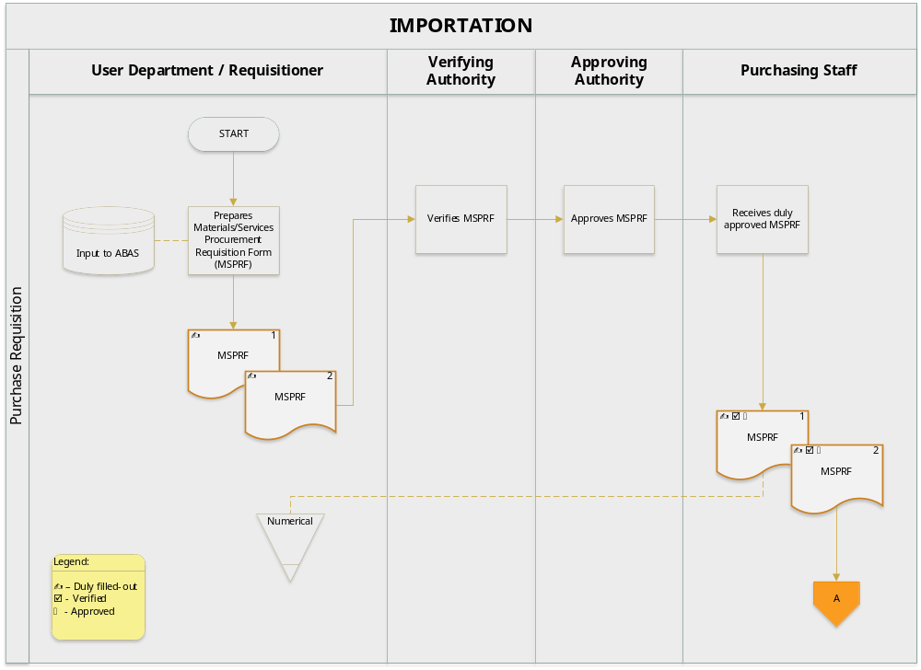

  - Canvassing

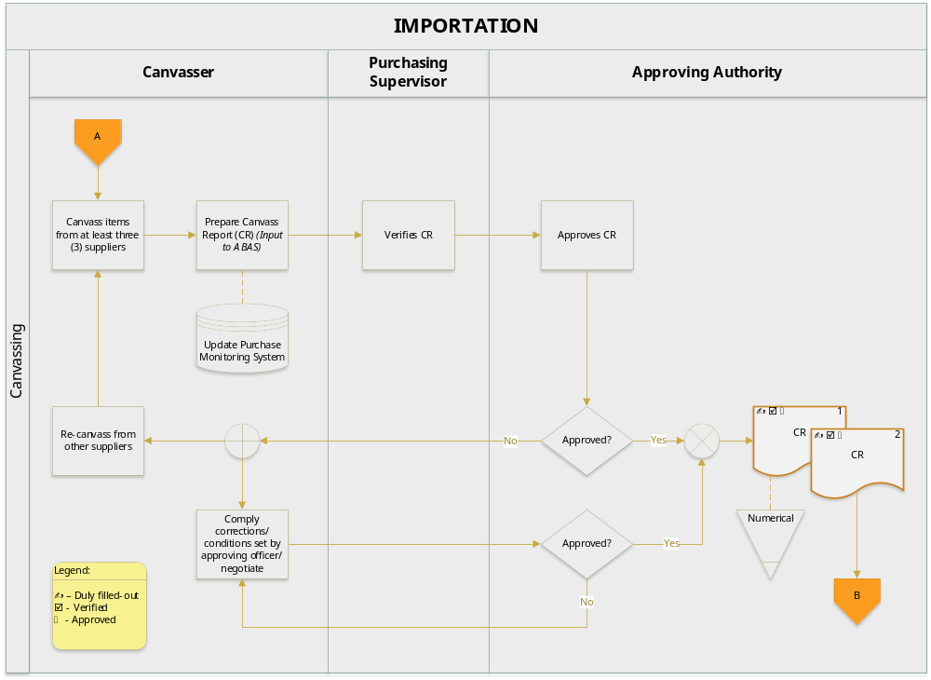

  - Purchase Order Preparation

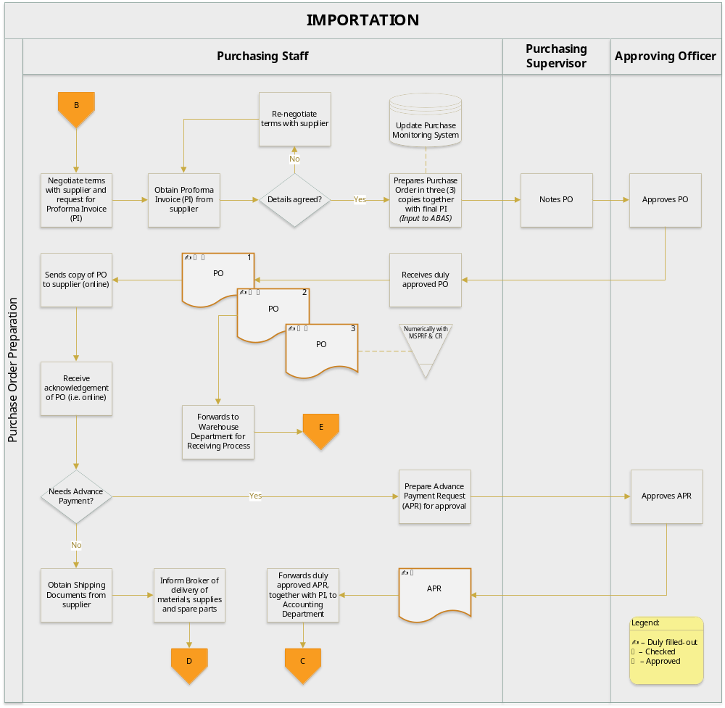

  - Importation and Receiving

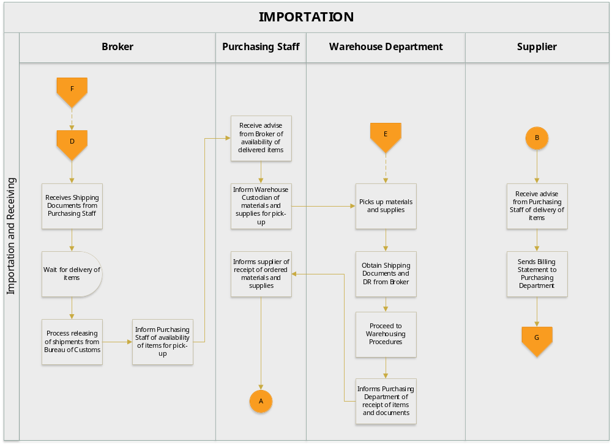

  - Payment Procedures

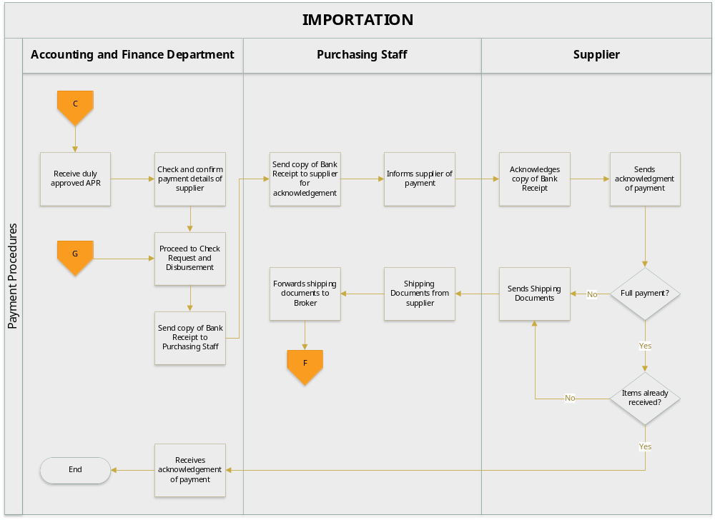

- BUSINESS FORMS

  - Materials/Services Procurement Requisition Form (MSPRF)

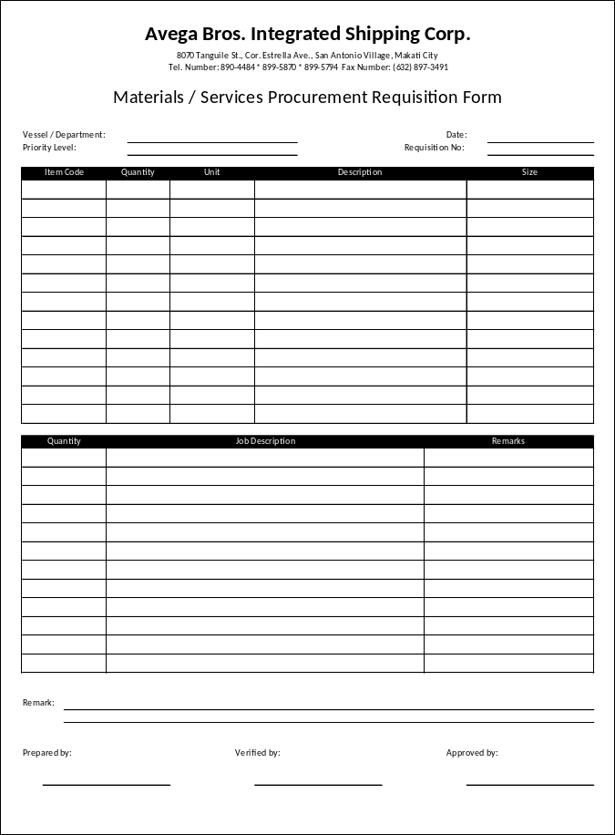

No. of Copies/color - 2
Explanation - this form is prepared to indicate request of materials and supplies by the user departments which are not covered by the Revolving Funds
Prepared by - Requisitioner
Verified by - Department Supervisor
Approved by - Department Manager
Distribution - MSPRF 1 - Initially to Purchasing Department then forwarded to Accounting Department (attached to the CkV)
MSPRF 2 - Requisitioner

  - Open Canvass

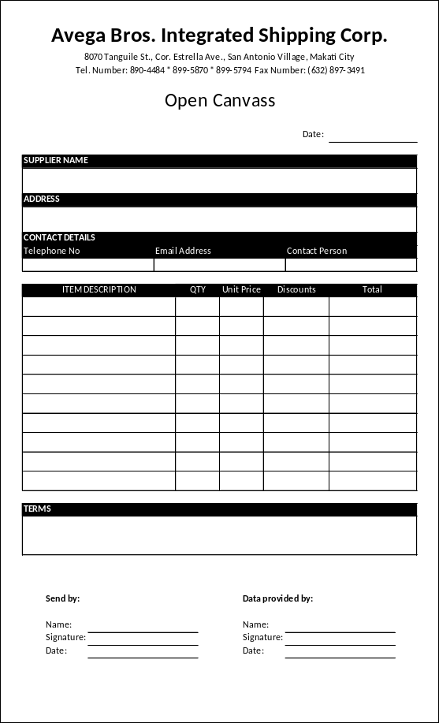

No. of Copies/color - 1
Explanation - this form is used to obtain written quotations from suppliers
Sent by - Canvasser
Data provided by - Service Provider
Distribution - Purchasing Department (file per supplier)

  - Canvass Report (CR)

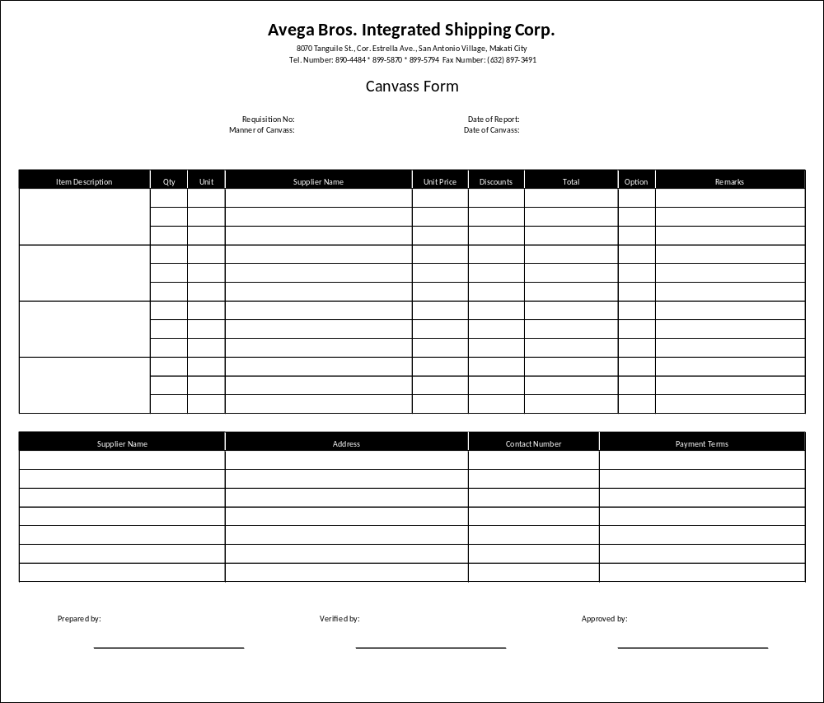

No. of Copies/color - 2
Explanation - this form is used to indicate the details of the canvassed items from at least three (3) suppliers. The final choice of supplier is indicated in the CR
Prepared by - Canvasser
Verified by - Purchasing Supervisor
Approved by - Refer to section VII.K.1, page 13
Distribution - CR 1 - Accounting Department (attached to the CkV)
CR 2 - Purchasing Department

  - Purchase Order

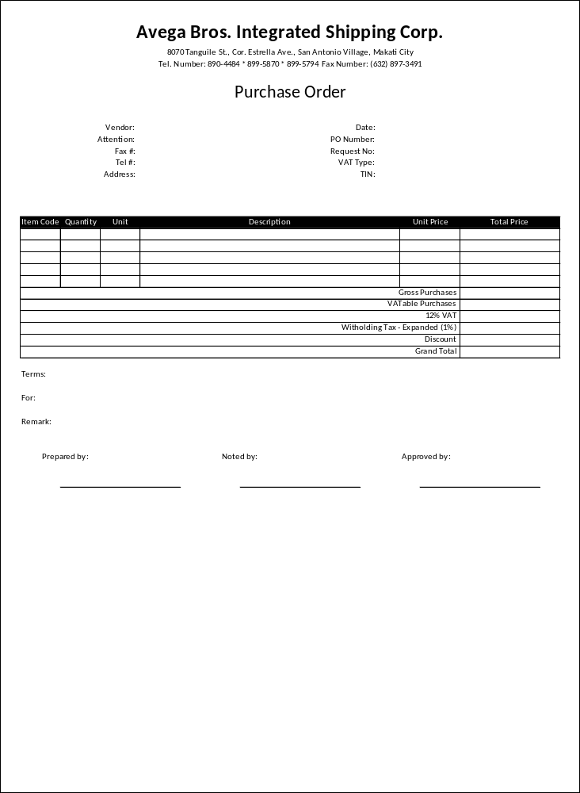

No. of Copies/color - 2
Explanation - This is used to place orders with suppliers. This will serve as the suppliers’ authority to deliver the ordered items to the Company
Prepared by - Purchasing Staff
Noted by - Purchasing Supervisor
Approved by - Refer to section VII.K.1, page 13
Distribution - PO 1 - Supplier
PO 2 - Accounting Department (attached to the CkV)
PO 3 - Purchasing Department (filed numerically)

  - Supplier’s Database

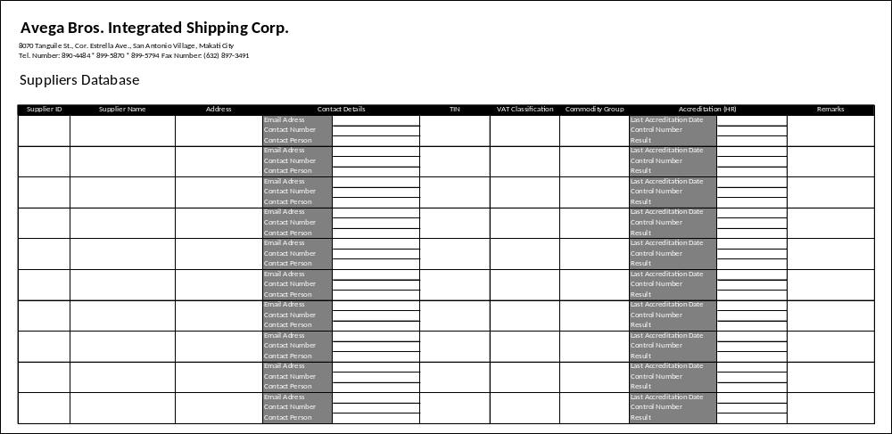

No. of Copies/color - 1 (white)
Explanation - This is used to store the pertinent details of the Company’s suppliers for materials and services
Prepared by - Purchasing Staff
Distribution - Purchasing Department

  - Purchase Monitoring System

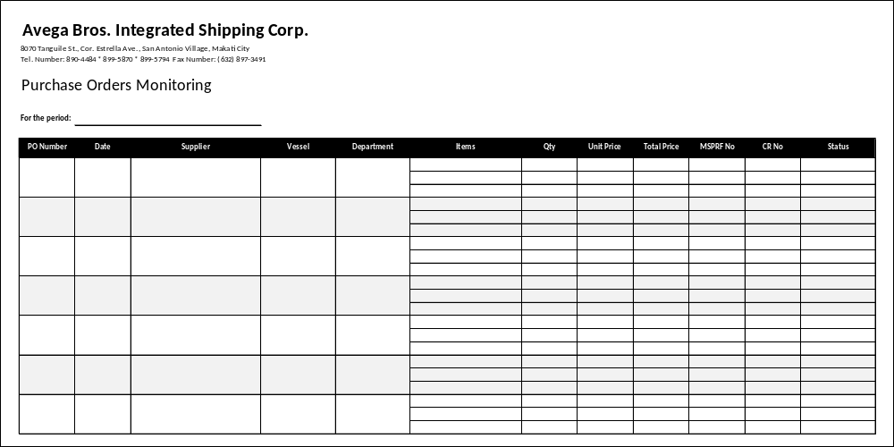

No. of Copies/color - 1
Explanation - This system is used to monitor the purchases by the Company
Prepared by - Purchasing Staff
Distribution - Purchasing Department

- EFFECTIVITY

This Policies and Procedures Manual shall take effect upon approval and shall supersede any memorandum/SOP inconsistent with this Policies and Procedures Manual. Any changes to the manual shall comply with the policies and procedures indicated in the process title “Amendment of Manual”.

