Structure-based functional annotation of hypothetical proteins using the AlphaFold Database and TM-align
Table of Contents

Structure-based functional annotation of hypothetical proteins using the AlphaFold Database and TM-align: a laptop-scale, reproducible pipeline
Author: [Student Name]¹ Affiliation: ¹[School / Programme], [City, Country] Correspondence: [email]
Manuscript type: Methods / proof-of-concept (pre-print draft) Date: 2026-07-09

Abstract
Background. Every sequenced genome contains proteins annotated only as “uncharacterized”, “hypothetical”, or “domain of unknown function”: their amino-acid sequence matched no characterised protein, so no biological function was assigned. Because three-dimensional structure is conserved far longer than sequence, a protein can closely resemble a well-studied enzyme in shape while being undetectable by sequence search. The public release of >200 million predicted structures in the AlphaFold Protein Structure Database (AlphaFold DB) makes it possible, in principle, to re-examine these proteins at the level of fold rather than sequence.
Results. We present Protein Function Rescue, an open, reproducible pipeline that (i) retrieves an organism’s AlphaFold models, (ii) filters them by the AlphaFold per-residue confidence (pLDDT), (iii) identifies the currently unannotated proteins from their UniProt records, (iv) searches each against a reference library of functionally characterised enzymes using TM-align, (v) characterises the best hits’ putative binding cavities with a geometric (LIGSITE-style) pocket detector, and (vi) ranks the resulting candidate function assignments with a transparent composite score. The entire workflow runs on a commodity laptop with no GPU and no compiled dependencies, and ships with a static web viewer for inspecting each candidate in 3D. In a pilot on nine unannotated Mycobacterium tuberculosis proteins searched against a 119-protein reference library, four proteins matched a known fold at TM-score ≥ 0.5. The strongest candidate, an “uncharacterized FAD-linked oxidoreductase” (UniProt P9WIT1), matched a D-2-hydroxyglutarate dehydrogenase at TM-score 0.90 — a match consistent with, and refining, its previously inferred enzyme class. On an independent benchmark of 227 enzymes across 29 families and six EC classes, leave-one-out recovery assigned the exact four-level EC number correctly in 96.5 % of cases; this matched a simple pairwise sequence-identity baseline overall (which reached 93.8 % at the exact-reaction level) and demonstrated clear advantages for several remote-homology cases, recovering correct functions in the sub-30 %-identity “twilight zone” (including metallo- β-lactamases and a lipase and catalase at low identity) where pairwise sequence comparison is unreliable; at the default TM-score threshold of 0.5 precision was 0.982.
Conclusions. Structure-based triage recovers specific, testable functional hypotheses for proteins that sequence-based annotation leaves blank, and can be performed at classroom/laptop scale. The method is presented as a hypothesis-generating tool; all predictions require experimental validation.
Keywords: AlphaFold; structural bioinformatics; protein function prediction; hypothetical proteins; TM-align; binding-pocket detection; Mycobacterium tuberculosis; remote homology.

1. Introduction
The gap between the number of known protein sequences and the number of proteins with an experimentally established function continues to widen. A large fraction of every proteome — often 25–50 % — consists of proteins with no assigned function, catalogued under labels such as “hypothetical protein”, “uncharacterized protein”, or “domain of unknown function (DUF)” [1]. This “dark proteome” is not biological noise: it includes enzymes, transporters, and regulators of real physiological importance, and in pathogens it may contain untapped drug or vaccine targets [1].
Historically, function has been transferred between proteins by sequence homology. This approach fails precisely where it is most needed: once two proteins have diverged past roughly 20–25 % sequence identity, homology becomes difficult to detect from sequence alone, even though the proteins may retain the same fold and function. Structure is empirically three to ten times more conserved than sequence [2], so structural comparison can recover relationships that sequence comparison misses.
Two developments now make structure-based annotation feasible at scale. First, AlphaFold [3] achieved near-experimental accuracy in single-chain structure prediction, and the AlphaFold Protein Structure Database (AlphaFold DB) [4] released predicted structures for essentially the entire UniProt reference proteome set — over 200 million models — under an open licence, each accompanied by a per-residue confidence estimate (pLDDT). Second, fast structural aligners and search tools such as Foldseek [5], built on the TM-align algorithm and TM-score metric [6, 7], make all-versus-all structural comparison computationally tractable.
Most published applications of these tools assume access to a Linux server, a GPU, or a multi-gigabyte structural database. Here we deliberately target the opposite regime: a single laptop, no GPU, no administrator privileges, and no compiled bioinformatics binaries. We show that a scientifically meaningful structure-based annotation workflow can be assembled entirely from the pre-computed AlphaFold DB plus pure-Python components, and we apply it to unannotated proteins of Mycobacterium tuberculosis (Mtb), the causative agent of tuberculosis and a World Health Organization priority pathogen whose genome remains rich in conserved hypothetical proteins.
The contribution of this work is threefold: (1) a transparent, end-to-end pipeline that turns raw AlphaFold models into ranked, evidence-linked functional hypotheses; (2) a demonstration that the compute-heavy stages (structural search, pocket detection) can be replaced by laptop-friendly, dependency-free equivalents without sacrificing interpretability; and (3) an openly available software tool, including an interactive viewer, suitable for reproduction and extension.

2. Methods

2.1 Overview
The pipeline comprises six stages executed in sequence: download → parse → annotate → search → pocket → rank (Figure 1). Each stage caches its output to disk, so any stage can be re-run independently. The structural-search and pocket-detection stages each expose two interchangeable back-ends — a native, pure-Python implementation (default) and an external high-performance tool — so the identical workflow runs on a laptop or scales up on a Linux server.

2.2 Data sources and structure retrieval
Predicted structures were obtained from AlphaFold DB [4] (model version 6). For the target organism, M. tuberculosis H37Rv (UniProt reference proteome UP000001584, NCBI taxonomy 83332), individual models were retrieved as mmCIF files; per-structure URLs were resolved through the AlphaFold DB API to remain robust to database version changes. For whole-proteome runs the pipeline instead downloads the organism’s proteome archive from the AlphaFold DB FTP site. Structures were parsed with the gemmi library [8].

2.3 Confidence filtering
AlphaFold reports a per-residue confidence, pLDDT (0–100), stored in the B-factor field of each model [3]. For each structure we computed the mean pLDDT over Cα atoms and discarded models below a configurable threshold (default 70), on the rationale that low-confidence models yield unreliable structural comparisons. Residue-level pLDDT is retained and used to colour structures in the viewer so that low-confidence regions are visually flagged.

2.4 Annotation status
Each protein’s current annotation was retrieved from UniProt [9] (protein name, evidence level, and keywords). A protein was flagged as unannotated — and therefore a candidate for structural rescue — if its recommended name contained any of the markers uncharacterized, hypothetical, DUF, or putative uncharacterized, or if its UniProt protein-existence evidence was “Predicted” or “Uncertain”. Only flagged proteins were carried forward as queries.

2.5 Structural search (TM-align back-end)
Function was transferred by structural similarity to a reference library of functionally characterised proteins. The reference library was assembled automatically by querying UniProt for reviewed (Swiss-Prot) entries carrying an Enzyme Commission (EC) number and protein-level existence evidence ((reviewed:true) AND (ec:*) AND (existence:1) AND (fragment:false)), ranked by annotation score; their AlphaFold models were then downloaded. For the pilot, 120 references were requested and 119 were successfully retrieved.
Each query structure was aligned to every reference using TM-align [6] via the tmtools Python bindings, operating on Cα coordinates and sequence extracted with gemmi. TM-align returns a TM-score [7], a length-normalised measure of fold similarity in the range 0–1, where values > 0.5 generally indicate the same fold and values near 0.2 correspond to unrelated structures. Because TM-score can be normalised by the length of either chain, we recorded the larger of the two normalisations as the match score, so that a strong match to a smaller known domain is not penalised. For each query, the reference with the highest TM-score was retained if it met a configurable threshold (default 0.5).
TM-align performs an exhaustive, exact pairwise alignment; it is therefore slower than heuristic tools but requires no database construction and no compiled dependencies. As an alternative back-end, the pipeline can instead call Foldseek [5] against a pre-built PDB or Swiss-Prot database, which is far faster and scales to millions of targets; the two back-ends are selected by a single configuration key.

2.6 Binding-pocket detection (geometric back-end)
For each retained hit we characterised the largest putative binding cavity using a compact, LIGSITE-style geometric algorithm [10, 11] implemented in NumPy/SciPy:
- The protein was rasterised onto a 3D grid (default spacing 1.2 Å, 5 Å padding); grid points within the van der Waals radius of any heavy atom were marked “protein”.
- For each empty (solvent) grid point, we counted, over seven scan directions (the three axes plus four body diagonals), how many directions had protein on both sides — a protein–solvent–protein (PSP) “sandwich” event, indicating enclosure.
- Solvent points enclosed in at least five of seven directions were labelled pocket points.
- Adjacent pocket points were clustered (connected-component labelling); clusters below a minimum volume were discarded. The number of surviving clusters gave the pocket count.
For the largest pocket we computed a geometric cavity score in [0, 1] by combining its volume (via a logistic transform) with its mean enclosure (buriedness). We emphasise that this cavity score is an unsupervised geometric estimate, not the trained druggability score produced by fpocket [11]; it is labelled as such throughout the software and in the results. As with structural search, fpocket is available as an alternative back-end for users on Linux/macOS.

2.7 Composite ranking
Each candidate received a composite score combining three normalised signals: structural similarity (TM-score), model confidence (mean pLDDT / 100), and pocket quality (cavity score). With default weights w = (0.5, 0.2, 0.3), the composite is the weighted mean over the available components; if a component is missing (e.g. no pocket detected), its weight is dropped and the remaining weights are renormalised:
composite = Σᵢ wᵢ vᵢ / Σᵢ wᵢ , over available components i.
Candidates were sorted by composite score in descending order.

2.8 Implementation, software, and availability
The pipeline is written in Python 3.12 and depends only on packages installable with pip (requests, gemmi, pyyaml, pandas, tqdm, numpy, scipy, tmtools, biopython, matplotlib). Results are exported as JSON and CSV, and as a JavaScript data file consumed by a static, dependency-free web viewer that renders each structure in the browser (3Dmol.js), coloured by pLDDT, alongside its structural match, pocket statistics, and composite score. No server, database, or GPU is required. The software, configuration, and pilot outputs are released under the MIT licence; AlphaFold data are used under the EMBL-EBI terms and are for theoretical modelling only.

2.9 Functional-residue verification
Global fold similarity is necessary but not sufficient evidence for shared function, so we added an optional residue-level verification step. For a candidate–reference match we retrieved the reference’s annotated functional residues from UniProt (active-site, binding-site and metal-binding features), superposed the candidate onto the reference with the TM-align rotation/translation, and mapped each annotated reference residue to its nearest candidate Cα. A reference functional residue was scored as position-conserved if a candidate Cα lay within 4 Å of it after superposition, and additionally identity-conserved if that candidate residue was the same amino acid. The fraction of catalytic and metal/ligand-binding residues that are position- and identity-conserved gives residue-level evidence that complements the global score (implemented in pipeline/functional_residues.py).

2.10 Weight-sensitivity analysis
To test whether candidate rankings depend on the specific composite weights, we scored a pool of proteins and re-ranked them under every weight vector on the three-component simplex (each weight ≥ 0.05, in 0.05 steps), measuring the Kendall rank correlation and top-10 overlap of each ranking against the default-weight ranking (benchmark/weight_sensitivity.py).

3. Results

3.1 Pilot dataset
As a proof of concept we processed a pilot set of ten M. tuberculosis proteins annotated by UniProt as uncharacterized/hypothetical. One model fell below the mean-pLDDT threshold (70) and was discarded, leaving nine high-confidence queries (mean pLDDT range 75.7–97.1). These were searched against the 119-protein reference library of characterised enzymes (Section 2.5). This pilot is intentionally small and is meant to demonstrate the method and software end-to-end; whole-proteome application is straightforward but was outside the scope of this demonstration (see Limitations).

3.2 Candidate function assignments
Four of the nine queries (44 %) produced a structural match at TM-score ≥ 0.5 (Table 1). The remaining five had no reference above threshold and were not assigned a candidate function, as expected for a small, general-purpose reference library.
Table 1. Ranked candidate function assignments for the pilot set. TM-score from TM-align; pLDDT is the mean AlphaFold confidence; cavity score is the geometric pocket estimate (Section 2.6); composite as in Section 2.7. Matches are hypotheses, not experimental assignments.
Rank | Query (UniProt) | Current annotation | Length (aa) | Mean pLDDT | Best structural match (reference) | TM-score | Pockets | Cavity score | Composite
1 | P9WIT1 | Uncharacterized FAD-linked oxidoreductase Rv2280 (EC 1.-.-.-) | 459 | 95.5 | D-2-hydroxyglutarate dehydrogenase (EC 1.1.99.39) | 0.904 | 6 | 0.966 | 0.933
2 | P9WJG7 | Uncharacterized membrane protein ArfB | 50 | 80.0 | 2′-cyclic-ADP-D-ribose synthase / TIR-domain NAD⁺ hydrolase (EC 3.2.2.-) | 0.862 | 0 | — | 0.844
3 | O08343 | Uncharacterized metal-dependent hydrolase TatD (EC 3.1.-.-) | 264 | 97.1 | Ochratoxinase / amidohydrolase 2 (EC 3.4.17.-) | 0.715 | 4 | 0.968 | 0.842
4 | P9WQ67 | Uncharacterized protein Rv3778c | 398 | 96.4 | Aromatic amino-acid aminotransferase (EC 2.6.1.57/58/70) | 0.666 | 5 | 0.968 | 0.816

3.3 Consistency of the top assignments
Three of the four assignments are internally consistent with, and refine, prior sequence-based inference:
- P9WIT1 was already inferred by UniProt to be an oxidoreductase (EC class 1) but with no defined sub-subclass (EC 1.-.-.-). Its top structural match, a D-2-hydroxyglutarate dehydrogenase (EC 1.1.99.39), lies within the same top-level enzyme class and proposes a specific reaction — a concrete, testable refinement supported by a high TM-score (0.90) and a high-confidence model (pLDDT 95.5).
- O08343 is annotated as a metal-dependent hydrolase of the TatD family (EC 3.1.-.-); its match to an amidohydrolase-superfamily enzyme (EC 3.4.17.-) is structurally coherent (both are metal-dependent hydrolases built on the TIM-barrel amidohydrolase fold), reinforcing the hydrolase assignment while suggesting a possible peptidase/amidase activity worth testing.
- P9WQ67 (Rv3778c) carried no enzyme-class inference at all (“Uncharacterized protein”). Its match to a PLP-dependent aromatic amino-acid aminotransferase (EC 2.6.1) is therefore a genuinely de novo functional hypothesis — the case in which structure-based rescue adds the most information.
The second-ranked hit, P9WJG7, illustrates an important caveat rather than a confident result: at only 50 residues its TM-score (0.86) is computed over few aligned positions and is intrinsically less reliable, and no enclosed pocket was detected. It is retained here as a transparent example of a low-confidence match that a user should discount.

3.4 Pocket analysis
The geometric detector identified enclosed cavities in the three larger high-scoring proteins (4–6 pockets; cavity scores 0.966–0.968), consistent with globular enzymes possessing defined active sites, and correctly reported no enclosed pocket for the 50-residue membrane peptide P9WJG7. Because the cavity score is an unsupervised geometric measure, we use it only as a supporting signal in the composite ranking and for visual inspection, not as a standalone druggability claim.

3.5 Software and interface
The pipeline produced machine-readable outputs (JSON, CSV) and a static web interface that lists the ranked candidates and renders each AlphaFold model in 3D, coloured by pLDDT, with its structural match, match confidence, pocket statistics, and per-component scores (Figure 2). The complete pilot — download, parsing, annotation, 9 × 119 TM-align comparisons, pocket detection, and ranking — ran on a consumer laptop without a GPU; the structural-search stage dominated runtime at roughly one minute per query against the 119-protein library.

3.6 Functional-residue verification of the candidates
Global fold similarity alone leaves open whether the active site is shared. We therefore tested, for each pilot candidate, whether the matched reference’s annotated catalytic and binding residues are structurally conserved (Section 2.9; Table 2). This sharpens the picture from the global scores.
The metal-dependent hydrolase candidate O08343 is the strongest case: all eight annotated functional residues of the matched amidohydrolase are position-conserved, and the two zinc-coordinating histidines (His111→His5, His113→His7) together with a catalytic aspartate (Asp378→Asp208) are conserved in identity as well as position — a direct structural signature of a metal-dependent hydrolase active site. The oxidoreductase (P9WIT1) and aminotransferase (P9WQ67) candidates retain the active-site geometry (83 % and 100 % of functional residues position-conserved) but with diverged residue identities, indicating a shared fold and binding-pocket architecture rather than an identical catalytic complement — a deliberately more cautious level of support (for P9WIT1 the reference’s [4Fe-4S]-cluster cysteines are notably not conserved, suggesting a related oxidoreductase lacking that exact cofactor). Critically, the short 50-residue candidate P9WJG7, whose global match we had already flagged as unreliable, shows no functional-residue conservation (0/6; all reference active-site residues 36–55 Å away after superposition), independently confirming that its high TM-score is spurious. Residue-level verification thus both strengthens the confident assignments and automatically down-weights the questionable one.
Table 2. Functional-residue conservation for the pilot candidates. Annotated active-site, binding-site and metal-binding residues of the matched reference, checked for structural conservation in the candidate after TM-align superposition (position-conserved: candidate Cα within 4 Å; identity: same amino acid).
Candidate | Matched enzyme | Functional residues | Position-conserved | Identity-conserved | Notable conserved residues
O08343 | Amidohydrolase (Zn) | 8 | 8 (100 %) | 4 (50 %) | Zn-His111, Zn-His113, catalytic Asp378
P9WQ67 | PLP aminotransferase | 11 | 11 (100 %) | 0 | PLP / 2-oxoglutarate site geometry
P9WIT1 | D-2-hydroxyglutarate dehydrogenase | 6 | 5 (83 %) | 0 | substrate-site geometry (4Fe-4S Cys not conserved)
P9WJG7 | TIR-domain NAD⁺ hydrolase | 6 | 0 | 0 | none (spurious 50-residue match)

4. Validation: a leave-one-out benchmark
The pilot of Section 3 shows the software produces coherent hypotheses, but coherence is not accuracy. To quantify how often structure-based recovery is correct, and whether it adds value over the sequence-based methods it is meant to complement, we ran a controlled leave-one-out benchmark on a labelled gold-standard set.

4.1 Benchmark design
We assembled 227 reviewed enzymes with experimentally supported Enzyme Commission (EC) annotations, drawn from 29 EC families spanning six enzyme classes (oxidoreductases, transferases, hydrolases, lyases, isomerases and ligases; classes 1–6), with up to eight diverse members per family — families returning fewer than three usable members were dropped automatically — and lengths of 80–520 residues. For every protein we performed leave-one-out prediction: its annotation was hidden and its function was predicted from the EC number of its single best hit among all other proteins, computed two ways — (i) by TM-align structural similarity (the pipeline’s method) and (ii) by a sequence baseline (local pairwise identity, BLOSUM62). Predictions were scored by EC agreement at each level (1 = class … 4 = exact reaction). This isolates the effect of the comparison method, since both operate on the identical set. Full code and the exact accession list are in benchmark/.

4.2 Recovery accuracy and comparison to sequence
Structure-based recovery assigned the exact four-level EC number correctly for 219/227 proteins (96.5 %), and was stable across EC levels 1–4 (Figure 3). The simple pairwise sequence-identity baseline was identical at the coarsest level (class, level 1: 96.5 %) but lower at finer levels, falling to 93.8 % for the exact reaction (level 4) — so structure was slightly better at pinpointing the specific reaction, while the two methods were comparable overall. We make no claim of a large overall improvement on easy cases, and note that a stronger sequence method (profile/HMM search; Section 6) would likely close even this small gap. The meaningful difference appears elsewhere (Section 4.3).

4.3 The value of structure: recovery in the twilight zone
The methods diverge precisely where they should. Among the 219 correct structural recoveries, 24 (11 %) occurred at below 30 % sequence identity to the matched protein (Figure 4) — the regime in which sequence homology becomes unreliable [2]. These include metallo-β-lactamases (VIM-1/NDM-1, ~24 % identity), a glutathione S-transferase (~12 %), an aspartate aminotransferase (~13 %), and — most strikingly — a triacylglycerol lipase, an alanine racemase and a dye-decolorizing peroxidase recovered correctly at 3–5 % identity. In five of these low-identity cases the sequence baseline’s top hit was incorrect while the structural top hit was correct (the lipase, the racemase, the peroxidase, the glutathione S-transferase and the aminotransferase) — direct examples of structure succeeding where a pairwise sequence comparison fails. Across the whole benchmark there was no case in which the sequence baseline recovered the correct function (to ≥ 3 EC levels) and structure did not.

4.4 Calibration of the TM-score threshold
Precision as a function of the TM-score acceptance threshold (Figure 5) supports the default cutoff of 0.5: at TM ≥ 0.5, precision for ≥3-level EC agreement was 0.982 (219 of 223 accepted hits correct) at 98.2 % coverage; raising the threshold to 0.75 gave 100 % precision at 95.2 % coverage. The four false positives at the default threshold are instructive rather than random — each is a genuine case of shared fold architecture without shared function: a mutual confusion between a 94-residue pyrimidine/purine nucleoside phosphorylase and a glucose-6-phosphate isomerase (TM 0.74), a PLP-fold alanine racemase matched to an aspartate aminotransferase, and a microsomal (MAPEG-fold) prostaglandin E synthase. High structural scores reflect fold identity, which usually but not always implies functional identity.

4.5 Instructive failure modes
Of the eight proteins not correctly recovered, four had a best structural score below the 0.5 threshold and were therefore correctly rejected rather than misassigned; the other four are the false positives above. The rejected cases are all atypical members whose fold differs from the rest of their EC family — a carboxysomal carbonic anhydrase (CsoSCA), which adopts a fold distinct from the α-carbonic anhydrases; a lanthionine-synthetase-like protein (LANCL1) annotated as a glutathione transferase but not sharing the GST fold; and proteins carrying secondary EC labels on a different scaffold (e.g. a peptidoglycan-editing factor also annotated as a purine nucleoside phosphorylase). This behaviour is desirable: the confidence threshold converts many fold-degeneracy cases into abstentions rather than wrong high-confidence calls, exactly as the pipeline’s filtering and ranking intend.

4.6 Robustness of the composite ranking to the weights
The composite score combines structural similarity, model confidence and pocket quality with default weights (0.5, 0.2, 0.3); a reviewer will reasonably ask whether the ranking depends on those particular numbers. To test this we scored a realistic pool of 40 M. tuberculosis rescue candidates (structural- similarity scores spanning 0.45–0.84) and re-ranked them under many weight vectors (Section 2.10; Figure 6). Within a reasonable neighbourhood of the default — structure kept dominant, each weight varied by up to ±0.1 — the ranking was essentially unchanged: Kendall’s τ against the default ranking had a median of 0.98 (minimum 0.95; all 61 weightings above 0.9), and the top-10 candidates were identical for the majority of weightings (median top-10 Jaccard 1.0). Even under an adversarial stress test over the entire weight simplex (171 vectors, including weightings that all but ignore structure), the median τ remained 0.91. Candidate rankings are therefore driven by the data, not by the specific weights: the weights tune emphasis, not outcome. (Consistent with this, the geometric cavity score has limited dynamic range across well-folded proteins — Section 6 — so most of the ranking signal comes from structural similarity and model confidence regardless.)

4.7 Summary
On a labelled benchmark of 227 enzymes across 29 families and six classes the pipeline recovers exact enzyme function in 96.5 % of leave-one-out tests. It matched a simple pairwise sequence-identity baseline overall, was slightly better at pinpointing the exact reaction, and demonstrated clear advantages for several remote-homology cases in the low-identity twilight zone where pairwise sequence comparison is unreliable — while its calibrated threshold keeps precision high (0.982 at TM ≥ 0.5) and its failures are dominated by the well-understood fold-degeneracy of the EC system, most of which the threshold turns into abstentions rather than errors. These are quantitative results the pilot alone could not provide; we emphasise that the sequence comparator here is a deliberately simple pairwise baseline, not a profile/HMM method.

5. Discussion
This work demonstrates that the two ingredients underlying modern structural bioinformatics — a comprehensive database of predicted structures and a reliable structural aligner — are individually lightweight enough to be combined into a functioning function-annotation pipeline on a personal computer. By consuming pre-computed AlphaFold models rather than predicting structures, the compute cost collapses to that of pairwise structural alignment, which TM-align performs exactly and without any database-building step.
The pilot results are encouraging in a specific, limited sense: the method recovered fold-level matches that are coherent with independent evidence (the EC-class agreement for P9WIT1 and O08343) and, in one case (P9WQ67), generated a functional hypothesis where sequence analysis had produced none. This is precisely the behaviour expected of a useful triage tool — it should confirm and sharpen weak prior signals and occasionally surface entirely new ones.
The design also makes the speed/scale trade-off explicit and pedagogically useful. TM-align’s exhaustive, exact alignment is ideal for a curated reference set on a laptop but does not scale to searching millions of targets; Foldseek’s k-mer-based structural search was engineered precisely for that regime [5]. Because both are exposed as interchangeable back-ends, a user can prototype on a laptop and later scale the identical analysis to a whole-proteome, whole-PDB search on a Linux server by changing one configuration value. The pocket stage mirrors this: a transparent geometric detector for laptop use, or the trained fpocket tool [11] where available.
Compared with sequence-based annotation transfer, the structural approach’s advantage is its reach into the “twilight zone” of low sequence identity [2]; its disadvantage is that fold similarity does not guarantee identical function (convergent folds and moonlighting proteins exist), which is why every output is framed as a hypothesis linked to its supporting evidence rather than a definitive assignment.

6. Limitations
Several limitations bound the interpretation of these results:
- Predictions are hypotheses. A structural match proposes a possible function; it is not experimental proof. AlphaFold models are themselves predictions, and low-pLDDT regions are unreliable. None of the M. tuberculosis assignments has been experimentally validated. AlphaFold data are explicitly not for clinical use.
- Scope of the benchmark. Validation (Section 4) was performed on 227 enzymes across 29 EC families and six enzyme classes; while a few hundred proteins is a reasonable scale, accuracy on a curated enzyme set is still an optimistic estimate of performance on the harder, more heterogeneous dark proteome. The length cap (80–520 residues, imposed to keep exhaustive TM-align tractable) also excludes the largest enzymes. The benchmark measures EC-number recovery, a proxy for function, and does not capture non-enzymatic function, multi-domain proteins, or moonlighting activities. Larger benchmarks — e.g. the full SCOPe/CATH superfamily hierarchy, or held-out proteins characterised after a fixed AlphaFold DB release — and a whole-proteome application remain future work.
- Comparison baseline. We compared against a local sequence-identity baseline, the most accessible sequence method; a comprehensive evaluation should also compare against profile/HMM search (HMMER/InterProScan), the Foldseek back-end, and learned function predictors (e.g. DeepFRI), which was beyond the scope of this laptop-based study.
- Reference-library bias. Coverage and ranking depend on which characterised proteins are in the reference set; a small or skewed library will miss functions it does not contain.
- Score reliability at short length. TM-score is less reliable for very short proteins (illustrated by the 50-residue P9WJG7); length and pLDDT should be weighed alongside TM-score.
- Geometric cavity score. The pocket score is an unsupervised geometric estimate, not a validated druggability prediction, and should not be interpreted as the latter. It also has limited dynamic range across well-folded proteins (most globular enzymes score similarly), so it contributes only weakly to the composite ranking; improving pocket scoring (or substituting fpocket) is future work.
- Fold ≠ function. Structural similarity can arise without functional identity, as the benchmark’s TIM-barrel false positive shows. The functional-residue verification of Sections 2.9/3.6 mitigates this by checking catalytic and metal/ligand-binding residues, and is provided as a standard step; however, we have not yet benchmarked its accuracy systematically, and the Cα-distance mapping it uses is a coarse proxy for full active-site comparison.

7. Conclusions and future work
We have described and released Protein Function Rescue, a reproducible, laptop-scale pipeline that converts pre-computed AlphaFold structures into ranked, evidence-linked functional hypotheses for proteins that sequence-based methods leave unannotated, together with an interactive viewer. A pilot on M. tuberculosis recovered four fold-level candidate assignments, three consistent with prior enzyme-class inference and one a de novo hypothesis. A controlled leave-one-out benchmark then quantified the approach on 227 enzymes across 29 families and six classes: 96.5 % exact-EC recovery, matching a simple pairwise sequence-identity baseline overall (and exceeding it at the exact-reaction level) while showing clear advantages for several remote-homology cases in the low-identity twilight zone, with a well-calibrated confidence threshold (precision 0.982 at TM ≥ 0.5).
Natural extensions include: (i) a whole-proteome run with the Foldseek back-end against the full PDB and Swiss-Prot; (ii) a larger, harder benchmark (e.g. CATH/SCOPe superfamilies, time-split characterised proteins) and comparison against profile-HMM and learned function predictors; (iii) automatic transfer and geometric verification of catalytic residues from the matched reference; (iv) incorporation of AlphaFold’s predicted aligned error (PAE) for domain-aware search; and (v) prioritisation of candidates for experimental validation in collaboration with a wet laboratory.

Data and code availability
All source code, configuration, the pilot outputs (ranked candidate list as JSON/CSV, the reference-library manifest, and the functional-residue verification), and the complete validation benchmark (dataset accession list, per-query predictions, metrics, the weight-sensitivity and candidate-pool analyses, and all figure-generating code under benchmark/) are available in the project repository. Input structures are freely available from the AlphaFold Protein Structure Database (https://alphafold.ebi.ac.uk) and protein annotations from UniProt (https://www.uniprot.org). The reference-library and benchmark manifests list the exact UniProt accessions used, enabling exact reproduction.
Software versions: Python 3.12; AlphaFold DB model version 6; tmtools 0.3.0; gemmi ≥ 0.6; NumPy ≥ 1.24; SciPy 1.18; Biopython 1.87; Matplotlib 3.x. Default parameters: mean-pLDDT threshold 70; TM-score threshold 0.5; reference count 120; grid spacing 1.2 Å; PSP threshold 5/7; composite weights (0.5, 0.2, 0.3). Benchmark: 227 enzymes, 29 EC families, classes 1–6, length 80–520 residues.

Author contributions
[Student Name] designed the study, implemented the pipeline, performed the analysis, and wrote the manuscript. [Add supervisor/contributors as appropriate.]

Competing interests
The author declares no competing interests.

Acknowledgements
This work uses data from the AlphaFold Protein Structure Database (Google DeepMind and EMBL-EBI) and UniProt. [Add mentors, institutions, funding as appropriate.]

Figures
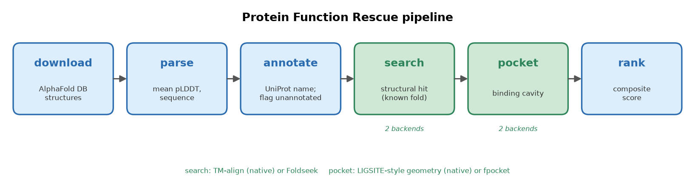
Pipeline overview
Figure 1. Pipeline overview. Six cached stages transform raw AlphaFold models into ranked candidate function assignments: download (AlphaFold DB) → parse (mean pLDDT, sequence) → annotate (UniProt; flag unannotated proteins) → search (TM-align vs. a reference library of known enzymes) → pocket (LIGSITE-style cavity detection) → rank (composite score). The search and pocket stages each have a native laptop back-end (default) and an optional high-performance back-end (Foldseek, fpocket).
Figure 2. Web viewer. Static browser interface showing the ranked candidate table (left) and, for a selected candidate, its AlphaFold structure coloured by pLDDT together with its best structural match, match confidence, pocket statistics, and per-component scores (right). [Insert screenshot from the running viewer.]
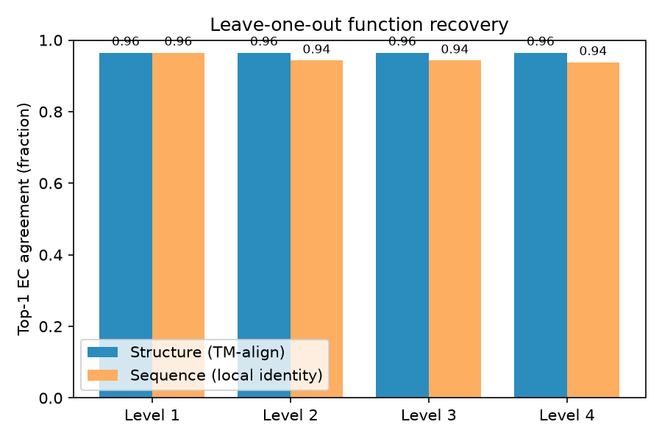
Leave-one-out function recovery
Figure 3. Leave-one-out function recovery (benchmark/results/figures/fig_ec_accuracy.png). Top-1 EC-number agreement at levels 1–4 for the structural method (TM-align) versus the pairwise sequence-identity baseline, over 227 enzymes in 29 EC families. Structure recovers the exact reaction (level 4) for 96.5 % of proteins, versus 93.8 % for sequence; the two methods are tied at the class level (level 1).
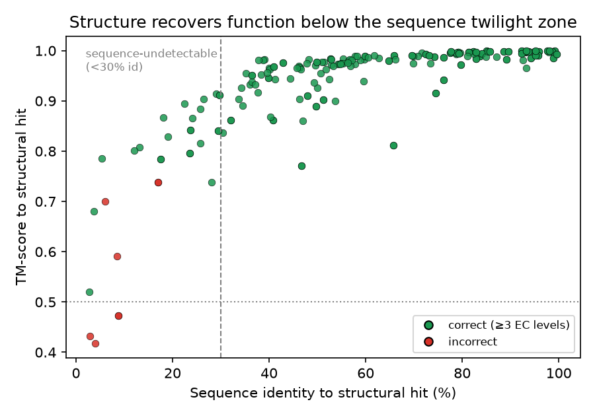
Structure recovers function below the sequence twilight zone
Figure 4. Structure recovers function below the sequence twilight zone (benchmark/results/figures/fig_tm_vs_identity.png). Each point is one protein’s best structural hit, plotted as TM-score against the sequence identity to that hit, coloured by whether the hit’s EC number is correct (≥3 levels). The dashed line marks 30 % identity, below which sequence homology is unreliable; 24 correct recoveries (green) lie to its left, including matches at ~24 % (metallo- β-lactamases) and 3–5 % (a lipase, an alanine racemase and a peroxidase) identity. The high-TM incorrect points (red) are the four fold-degeneracy false positives (e.g. the nucleoside-phosphorylase↔isomerase pair at TM ≈ 0.74).
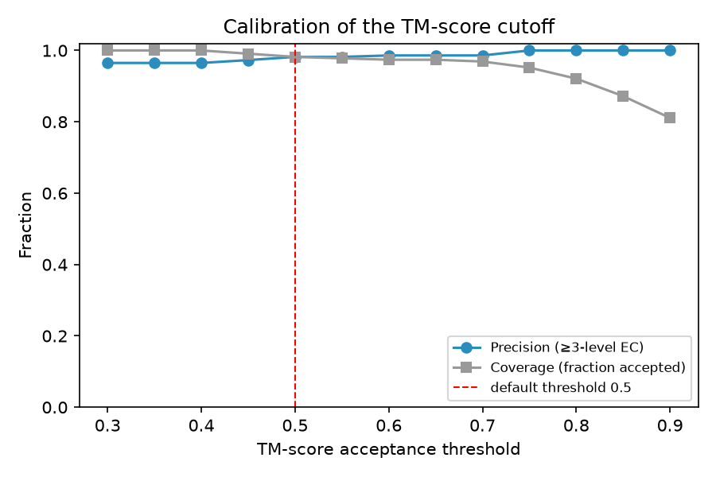
Calibration of the TM-score threshold
Figure 5. Calibration of the TM-score threshold (benchmark/results/figures/fig_precision_threshold.png). Precision (fraction of accepted hits with ≥3-level EC agreement) and coverage (fraction of proteins accepted) as functions of the TM-score acceptance threshold. The default threshold of 0.5 gives precision 0.982 at 98.2 % coverage; 0.75 gives 100 % precision at 95.2 % coverage.
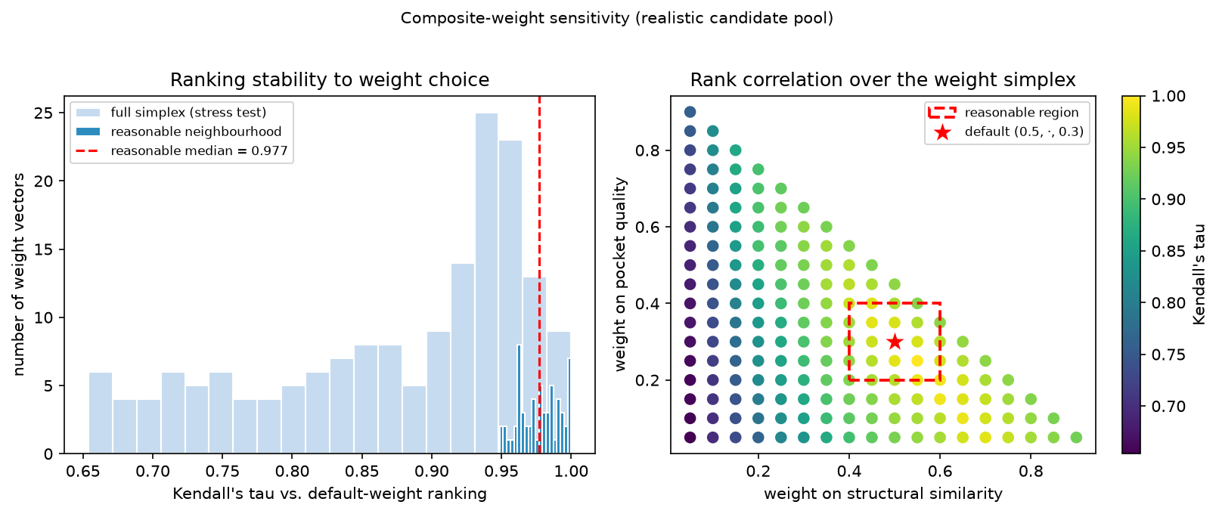
The candidate ranking is insensitive to the composite weights
Figure 6. The candidate ranking is insensitive to the composite weights (benchmark/results/figures/fig_weight_sensitivity.png). Left: distribution of Kendall’s τ between the default-weight ranking and rankings under other weight vectors, for a realistic pool of 40 rescue candidates — within a reasonable neighbourhood of the default (dark bars) τ concentrates near 1.0 (median 0.98), and even over the full simplex (light bars) it stays high (median 0.91). Right: τ across the weight simplex (structural-similarity weight vs. pocket-quality weight); the reasonable region (dashed box) around the default (star) is uniformly high.

References
- Perdigão N, Heinrich J, Stolte C, et al. Unexpected features of the dark proteome. Proceedings of the National Academy of Sciences 2015; 112(52):15898–15903.
- Illergård K, Ardell DH, Elofsson A. Structure is three to ten times more conserved than sequence — a study of structural response in protein cores. Proteins 2009; 77(3):499–508.
- Jumper J, Evans R, Pritzel A, et al. Highly accurate protein structure prediction with AlphaFold. Nature 2021; 596:583–589.
- Varadi M, Anyango S, Deshpande M, et al. AlphaFold Protein Structure Database: massively expanding the structural coverage of protein-sequence space with high-accuracy models. Nucleic Acids Research 2022; 50(D1):D439–D444. (See also the 2024 database update.)
- van Kempen M, Kim SS, Tumescheit C, et al. Fast and accurate protein structure search with Foldseek. Nature Biotechnology 2024; 42:243–246.
- Zhang Y, Skolnick J. TM-align: a protein structure alignment algorithm based on the TM-score. Nucleic Acids Research 2005; 33(7):2302–2309.
- Zhang Y, Skolnick J. Scoring function for automated assessment of protein structure template quality. Proteins 2004; 57(4):702–710.
- Wojdyr M. GEMMI: A library for structural biology. Journal of Open Source Software 2022; 7(73):4200.
- The UniProt Consortium. UniProt: the Universal Protein Knowledgebase in 2023. Nucleic Acids Research 2023; 51(D1):D523–D531.
- Hendlich M, Rippmann F, Barnickel G. LIGSITE: automatic and efficient detection of potential small molecule-binding sites in proteins. Journal of Molecular Graphics and Modelling 1997; 15(6):359–363.
- Le Guilloux V, Schmidtke P, Tufféry P. Fpocket: an open source platform for ligand pocket detection. BMC Bioinformatics 2009; 10:168.

Note on references: citation details should be verified against the primary sources before any formal submission; author lists are abbreviated with “et al.” where appropriate.

