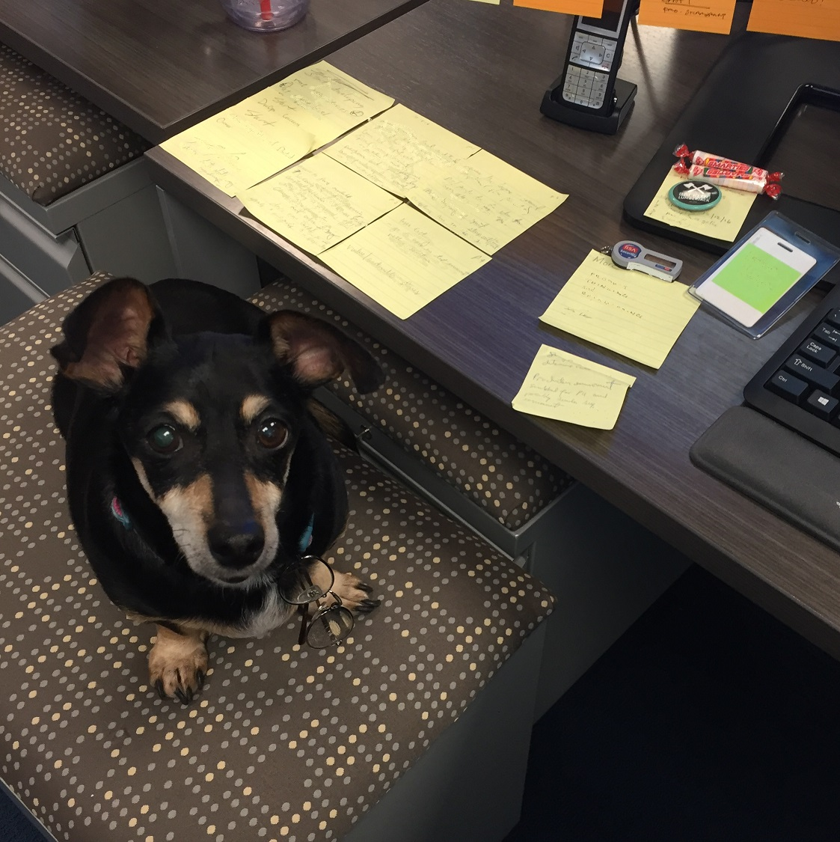

CLEAN DESK

**Before you leave your desk**

* **Lock the screen**
* **Secure any sensitive documents in your file cabinet**
* **Secure any two factor token or badges**
* **Keep your badge with you**
* **Place personal valuables in your file cabinet or drawer**