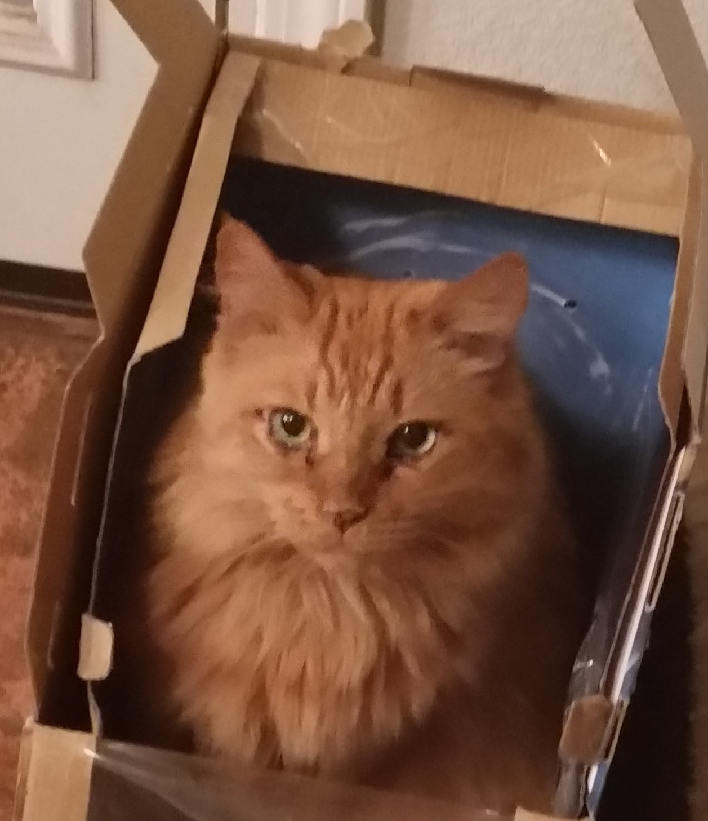

BACKUP YOUR DATA

* **Files in your MyDocuments, the OSI SharePoint and OSI OneDrive are backed up automatically**
* **The OSI Laptop, and the Desktop are NOT included in the backups**
* **If you keep documents on your desktop, use shortcuts instead, and place the original document in MyDocuments**
* **You are responsible for backups of thumb drives and other portable media**
* **All portable media must be encrypted!**