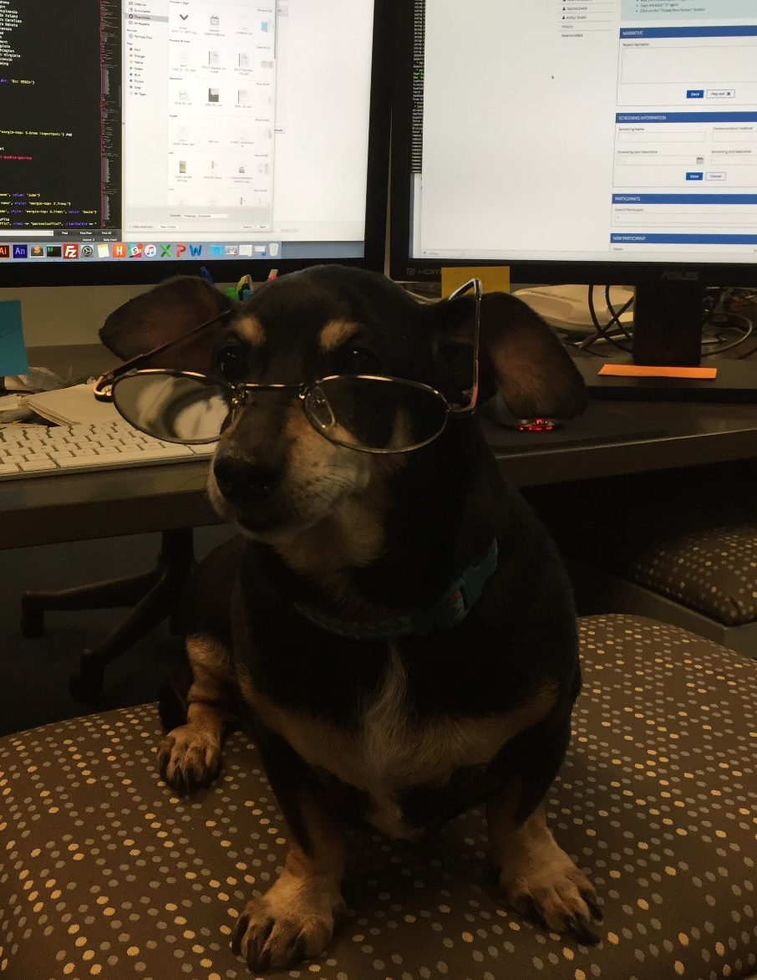

LOCK YOUR COMPUTER

**Dogs cannot read, but people can!**

**Do not leave your computer unlocked when you are away from your desk**