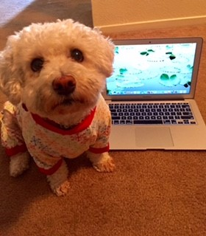

SAFE DATA HANDLING

**My data is where?**

* **Never store state data in personal cloud storage.**
* **Data must always be encrypted when in transit; physically encrypted disk, or over encrypted communications.**
* **Never post sensitive information, such as logons, passwords, or IP addresses in social media, such as Slack.**
* **Know what your data security requirments are before you work with the data.**
* **Contact your Information Security Office for assistance with data classification and handling.**