Nama: Kadek Wahyu Alpha Kusuma Putra

NIM :2415091012

Kelas: IKI

**INTERPRETATION**

**Objective of the Analysis:**

Examine whether car weight (wt) affects fuel efficiency (mpg) using linear regression.

**Code Explanation :**

1. Loading Required Libraries

**library(ggplot2)**

**library(car)**

- ggplot2: For creating informative and aesthetic plots.

- car: For regression diagnostics, such as Q-Q plots using qqPlot.

2. Loading Dataset

**data("mtcars")**

**head(mtcars)**

- data("mtcars"): Loads the built-in R dataset containing information about 32 cars, including variables like:

- mpg: Miles per gallon (fuel efficiency).

- wt: Weight of the car (in 1,000 pounds).

- head(mtcars): Displays the first six rows of the dataset to verify the data.

3. Building the Linear Regression Model

**model <- lm(mpg ~ wt, data = mtcars)**

**summary(model)**

- lm(mpg ~ wt, data = mtcars): Creates a linear regression model with:

- mpg as the response variable (fuel efficiency).

- wt as the predictor variable (car weight).

- summary(model): Displays the summary of the model, including:

- Regression coefficients.

- P-value for the slope.

- R² (coefficient of determination).

4. Checking Assumptions

(a) Linearity:

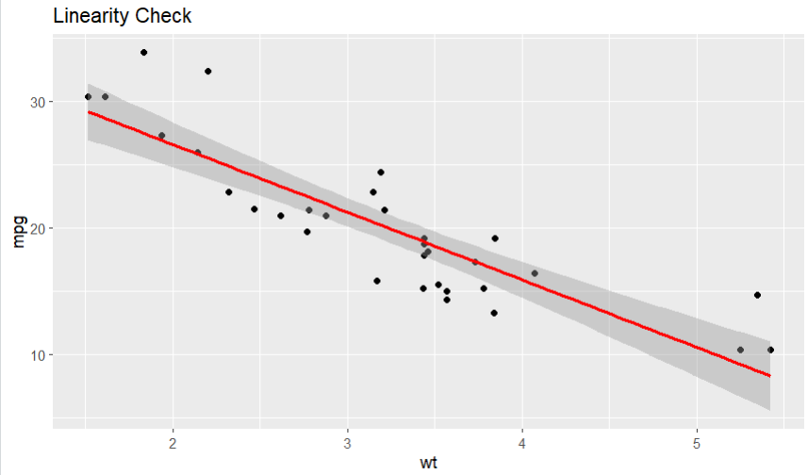

**linearity_plot <- ggplot(mtcars, aes(x = wt, y = mpg)) +**

**geom_point() +**

**geom_smooth(method = "lm", col = "red") +**

**ggtitle("Linearity Check")**

- Checks if the relationship between wt and mpg is linear.

(b) Homoscedasticity: 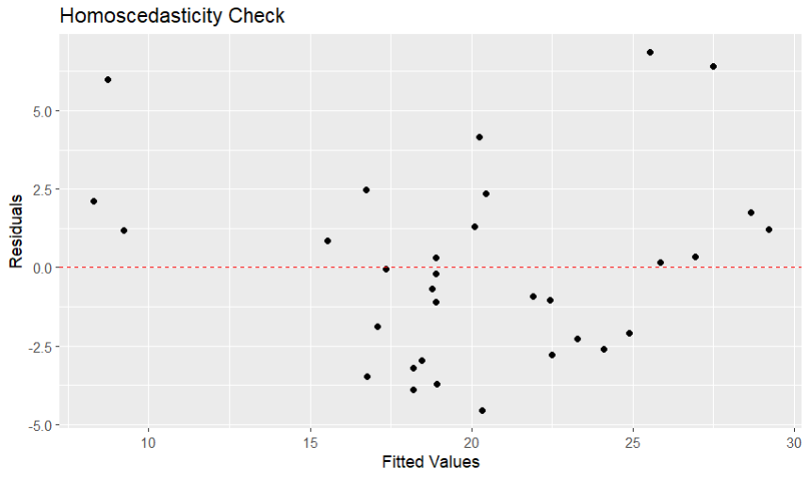

**homoscedasticity_plot <- ggplot(mtcars, aes(x = model$fitted.values, y = model$residuals)) +**

**geom_point() +**

**geom_hline(yintercept = 0, col = "red", linetype = "dashed") +**

**ggtitle("Homoscedasticity Check") +**

**labs(x = "Fitted Values", y = "Residuals")**

- Checks if residual variance is consistent across fitted values.

(c) Normality of Residuals: 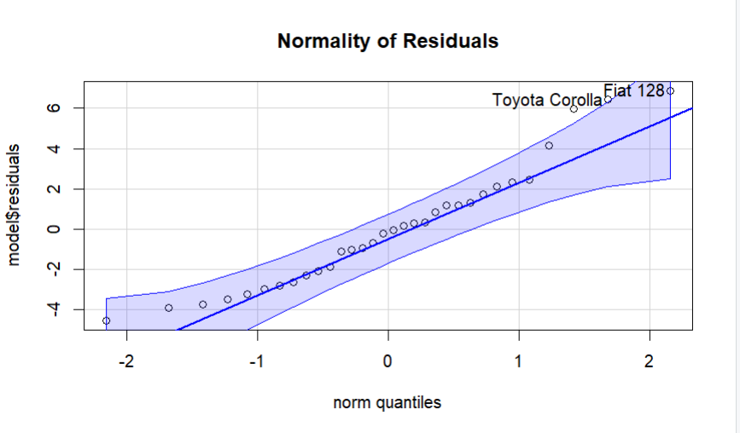

**qq_plot <- qqPlot(model$residuals, main = "Normality of Residuals")**

- Uses a Q-Q plot to check if residuals follow a normal distribution.

5. Visualizing Regression Results

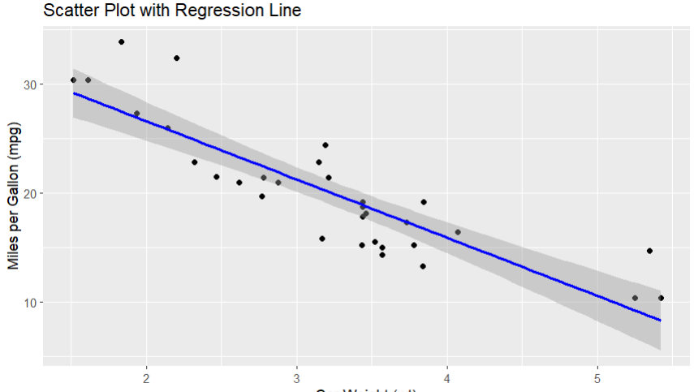

**scatter_plot <- ggplot(mtcars, aes(x = wt, y = mpg)) +**

**geom_point() +**

**geom_smooth(method = "lm", col = "blue") +**

**ggtitle("Scatter Plot with Regression Line") +**

**labs(x = "Car Weight (wt)", y = "Miles per Gallon (mpg)")**

- Creates a scatter plot to visualize the relationship between car weight (wt) and fuel efficiency (mpg), with the regression line overlaid.

6. Interpretation and P-Value

**cat("Interpretation:\n")**

**cat("Regression equation: mpg =", round(coef(model)[1], 2), "+", round(coef(model)[2], 2), "* wt\n")**

**cat("P-value of the slope:", summary(model)$coefficients[2, 4], "\n")**

- coef(model): Extracts the coefficients of the regression model.

- Intercept and slope are used to form the regression equation.

- summary(model)$coefficients[2, 4]: Extracts the p-value for the slope, indicating whether the relationship between wt and mpg is statistically significant.

**Results and Conclusion**

1. Regression Equation:

Example: mpg = 37.29 - 5.34 * wt

- Each 1,000-pound increase in car weight reduces fuel efficiency by an average of 5.34 mpg.

2. P-Value:

A very small p-value (e.g., 1.29e-10) indicates that the relationship is statistically significant.

3. Plots:

Graphs validate assumptions and visualize the relationship between car weight and fuel efficiency.

**Conclusion**

* Car weight has a significant impact on fuel efficiency. As cars become heavier, their fuel efficiency tends to decrease.
* The relationship is statistically very strong, making it highly unlikely that this result is due to chance.
* Your analysis and visualization clearly demonstrate this trend, with the regression line showing a decrease in fuel efficiency as car weight increases.