GSOF-ArduBridge Development Environment – Guide

The ArduBridge development environment is based on the CVM (Control, View, Model) methodology.

Installation
There are 3 types of installation that should be made.
- Arduino-Firmware programming.
- Python 2.7 and 3rd partty librarys.
- GSOF_ArduBridge module installation.
- Additional viewers and control applications installation.

Arduino firmware installation:
The Arduino programming is done via the xloader application with a compiled version of the ArduBridgeFW firmware.
- Open the xloader application
- Select the COM port that the ArduinoUno R3 is connected to.
- Select the Hex file "Bridge_Ctrl_V11.ino.hex" (or the most updated FW you have)
- Press the "Upload" button and wait for the programming operation to finish (few seconds)
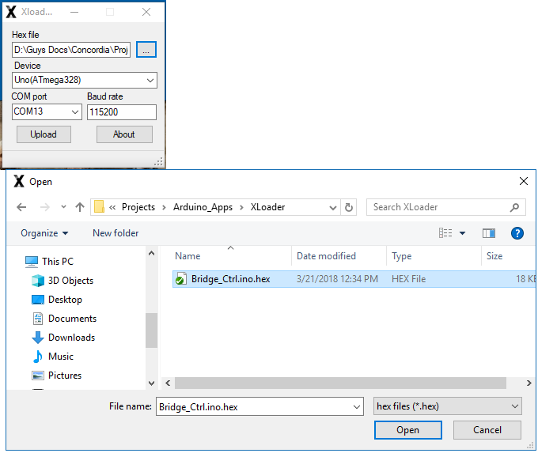

Python related installations:
Download and install the latest python2.7.
Download and install the latest pySerial module (pip install pyserial).
Install the GSOF_Ardubridge module in two option to perform the instalation:
- By double clinking the setup.bat batch file
- By running the setup.py script in a command prompt ("DOS") window.
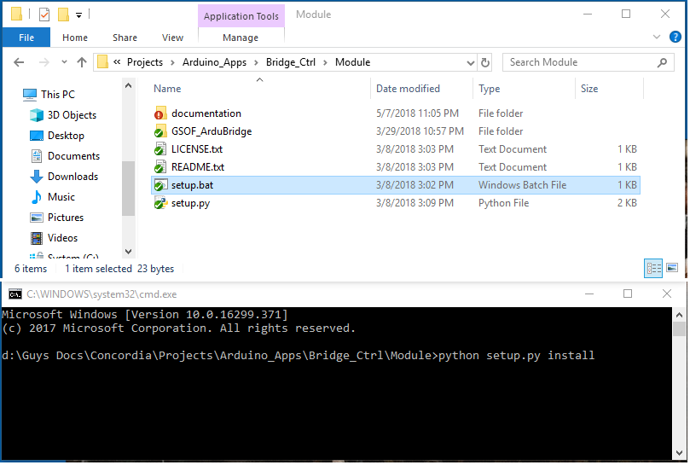
Instalation by double clicking the setup.bat batch file
Instalation via the command prompt

Verify:

With RealTerm (Without Python):

With Python:

