CS490 Windows Internals

Solutions for Assignment 1

Solution 1:
Answer the following questions and give a short explanation of your answers and their applicability in context of the Windows operating system:
- List four objectives for the design of an operating system!
  - Portability, extensibility, performance, ease-of-use, maintainability, stability, recoverability, availability
- Give two examples for operating system functionality that has to be implemented in kernel mode and user mode respectively!
  - Kernel mode: CPU scheduling, memory management, interprocess communication
  - User mode: user account management, printer spooling

Solution 2:
Explain the structuring of the Windows kernel. List five kernel mode components.
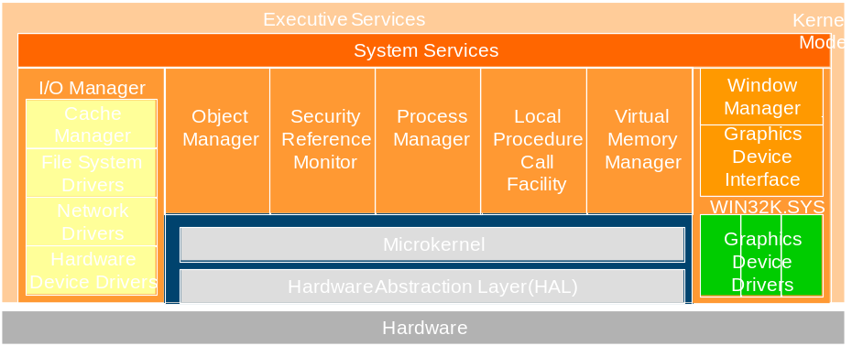
    - Process Manager
    - Object Manager
    - Cache Manager
    - LPC (local procedure call) Facility
    - Configuration Manager
    - Memory Manager
    - Security Reference Monitor
    - I/O Manager
    - Power Manager
    - Plug-and-Play Manager

Solution 3:
Explain why Windows NT 4 move windows manager and graphics services from running in the context of the Windows Subsystem process to a set of callable services running in kernel mode.
The primary reason for this shift was to improve overall system performance. Having a separate server process that contains the Windows graphics subsystem required multiple thread and process context switches, which consumed considerable CPU cycles and memory resources even though the original design was highly optimized.

Solution 4:
Windows applications refer to operating system objects via handles. Discuss the effect of changing permissions (access rights) for an OS resource on those applications that have already opened the resource.
Since permissions are only checked in the process of opening a handle via object manager, changing access rights for an OS resource does not affect applications that have already opened the resource. All changes are effective only when attempting to open the resource the next time.

