1. **JavaScript Validation for login and sign-up page**
2. **Whenever we entered a login button with an empty field the pop-up message should be displayed.**
3. **Same for the sign-up page.**
4. **Need to solve the bug in log in page, like whenever we login even with empty field, it is redirected to the dashboard which should be solved.**
5. **Same for the sign-up page**
6. **Add view schedule page by user where user can view the details of each workout or activities such as date and time.**
7. **Contact model should be created in the Django administration.**
8. **In the read more content of home page whenever we click on the link there appears to come same page for all three cards. Need to solve that**

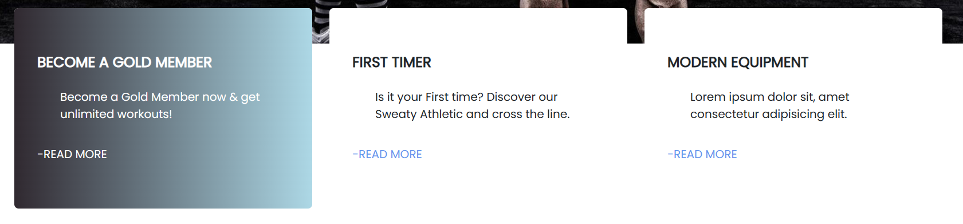

1. **In the pricing plan page, whenever I click on the buy now button, this error occur.**



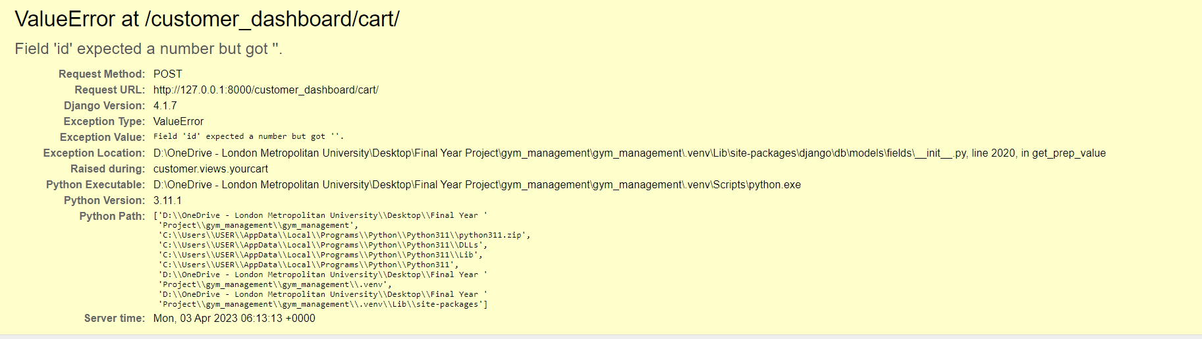

1. **Whenever I add a product , the image appears to be same.**
2. 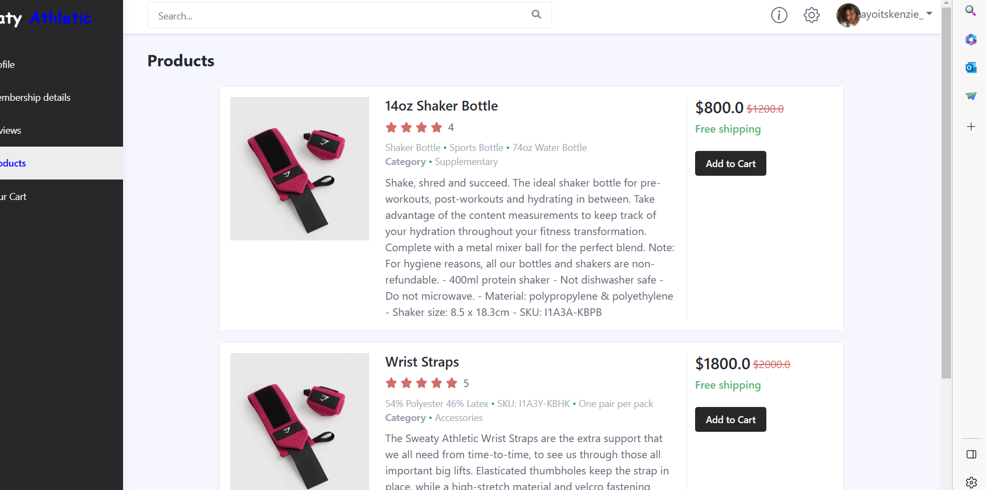
3. **The hire button in the job request option is throwing error**
4. 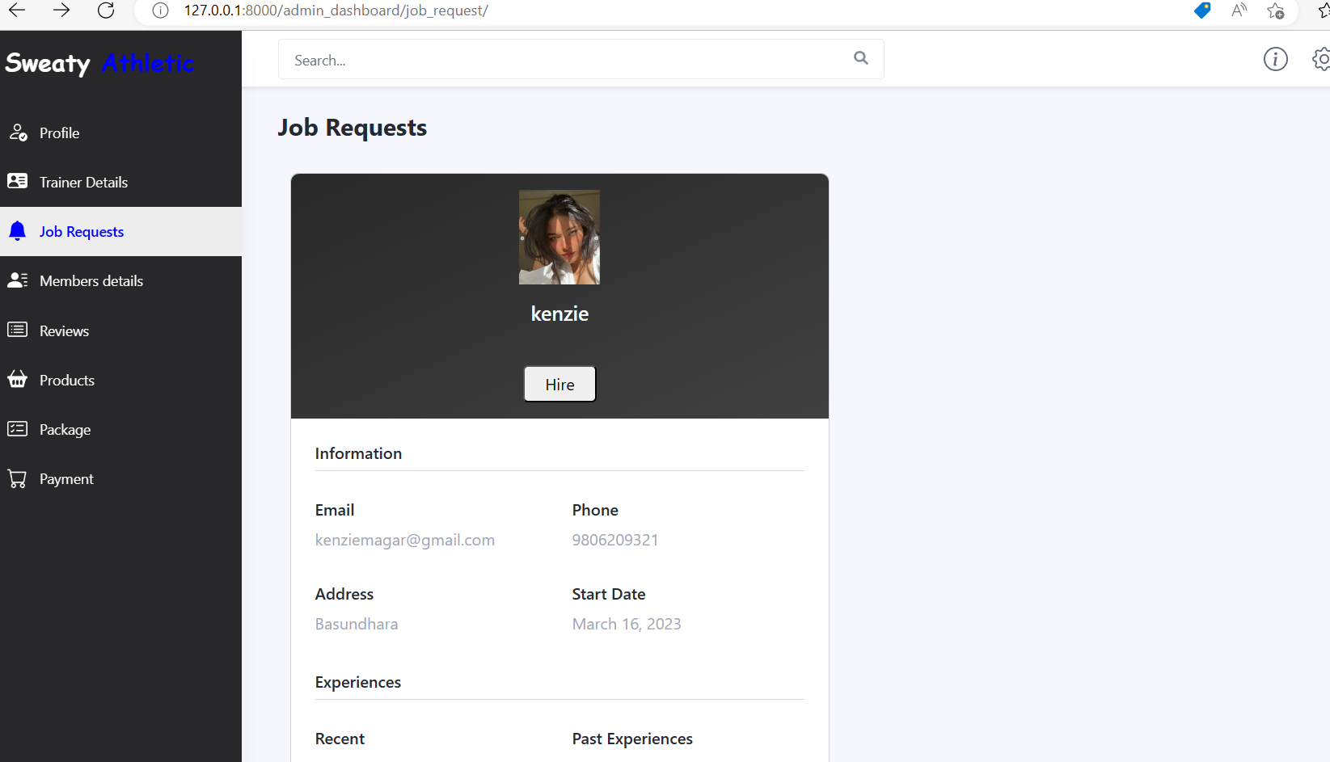
5. 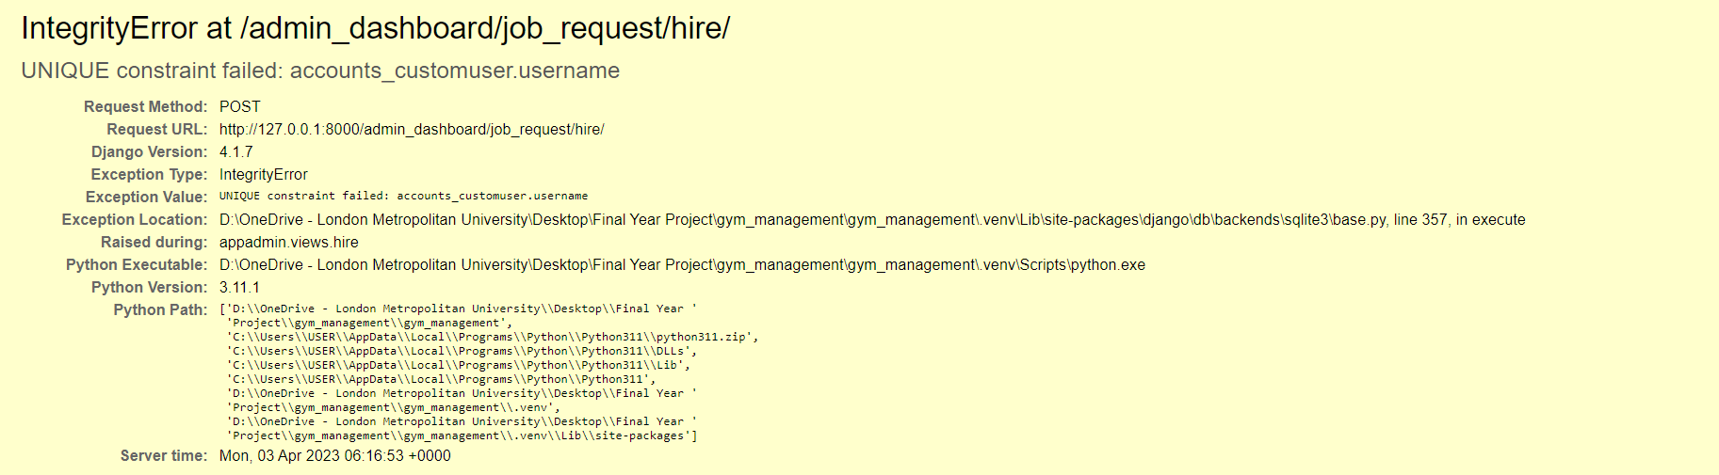

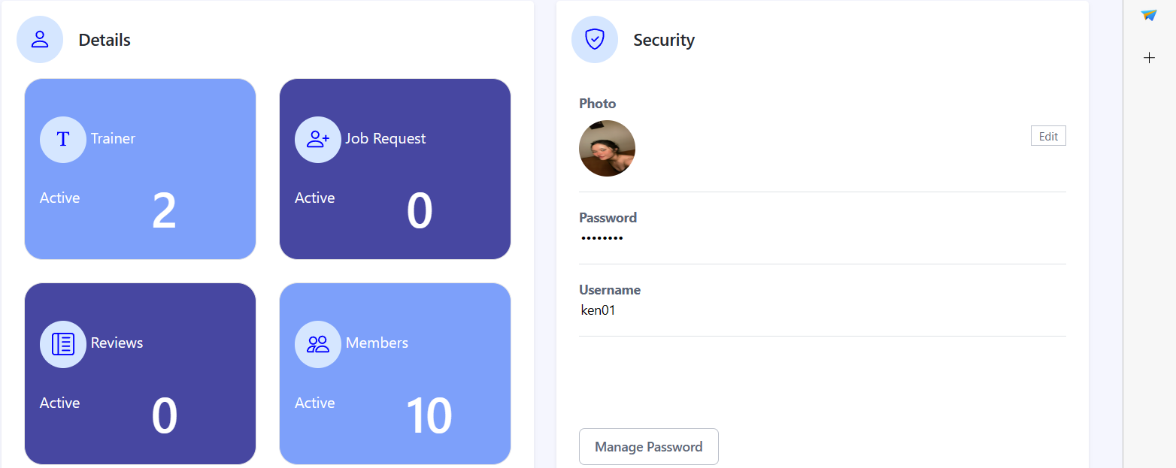

1. **The job request and reviews section is not showing any number**

**Payment gateway code**

Simple Steps to integrate Khalti payment gateway

1. Sign up for merchant account
2. Test keys (Get test public and private keys from your dashboard and use it during integration)

Test secret key

test_secret_key_420bb4f223334904ade89e90390fc0c6 //this is my secret key

Test public key

test_public_key_b0fde82ef6a64eb8981b0282075101fe

1. Integrate Khalti using payment SDKS
2. Multiple payment options
3. Payment successful

This code is based on class

data = {"return_url": "<http://127.0.0.1:8000/>",  
"website_url": "<https://example.com/>",  
"amount": 1300,  
"purchase_order_id": "test12",  
"purchase_order_name": "test",  
}  
# replace the key with your live secret key  
headers = {"Authorization": "Key 420bb4f223334904ade89e90390fc0c6"  
  
}

//the request.post(I don’t have an idea regarding this need to look after this)  
response = [requests.post](http://requests.post/)("<https://a.khalti.com/api/v2/epayment/initiate/>", json=data, headers=headers)  
print(response, response.text)  
data = response.json()  
if response.status_code == 200:  
  
return HttpResponseRedirect(data.get("payment_url"))