KENZO HRMS ENTERPRISE SaaS
Complete Technical Architecture, Step-by-Step Refactoring History, Database Schemas & Developer Guide
Document Version | 2.0.0 Enterprise SaaS Release
Current System Time | August 6, 2026 at 17:46:49 IST
Target Platform | Fortune 500 Ready Enterprise HRMS Monolith/Microservices
Author / Taskforce | Antigravity Engineering Taskforce & CTO Office
Repository Scope | apps/api (NestJS) | apps/web (Next.js 16 App Router) | Prisma ORM

1. System Architecture & High-Level Design
Kenzo HRMS is an enterprise-grade multi-tenant Human Resource Management System built to meet the scale, security, and performance demands of Fortune 500 organizations. The system follows a clean modular monolith architecture with isolated frontend (Next.js 16 App Router) and backend (NestJS 10 Framework) services.

System Architecture Diagram
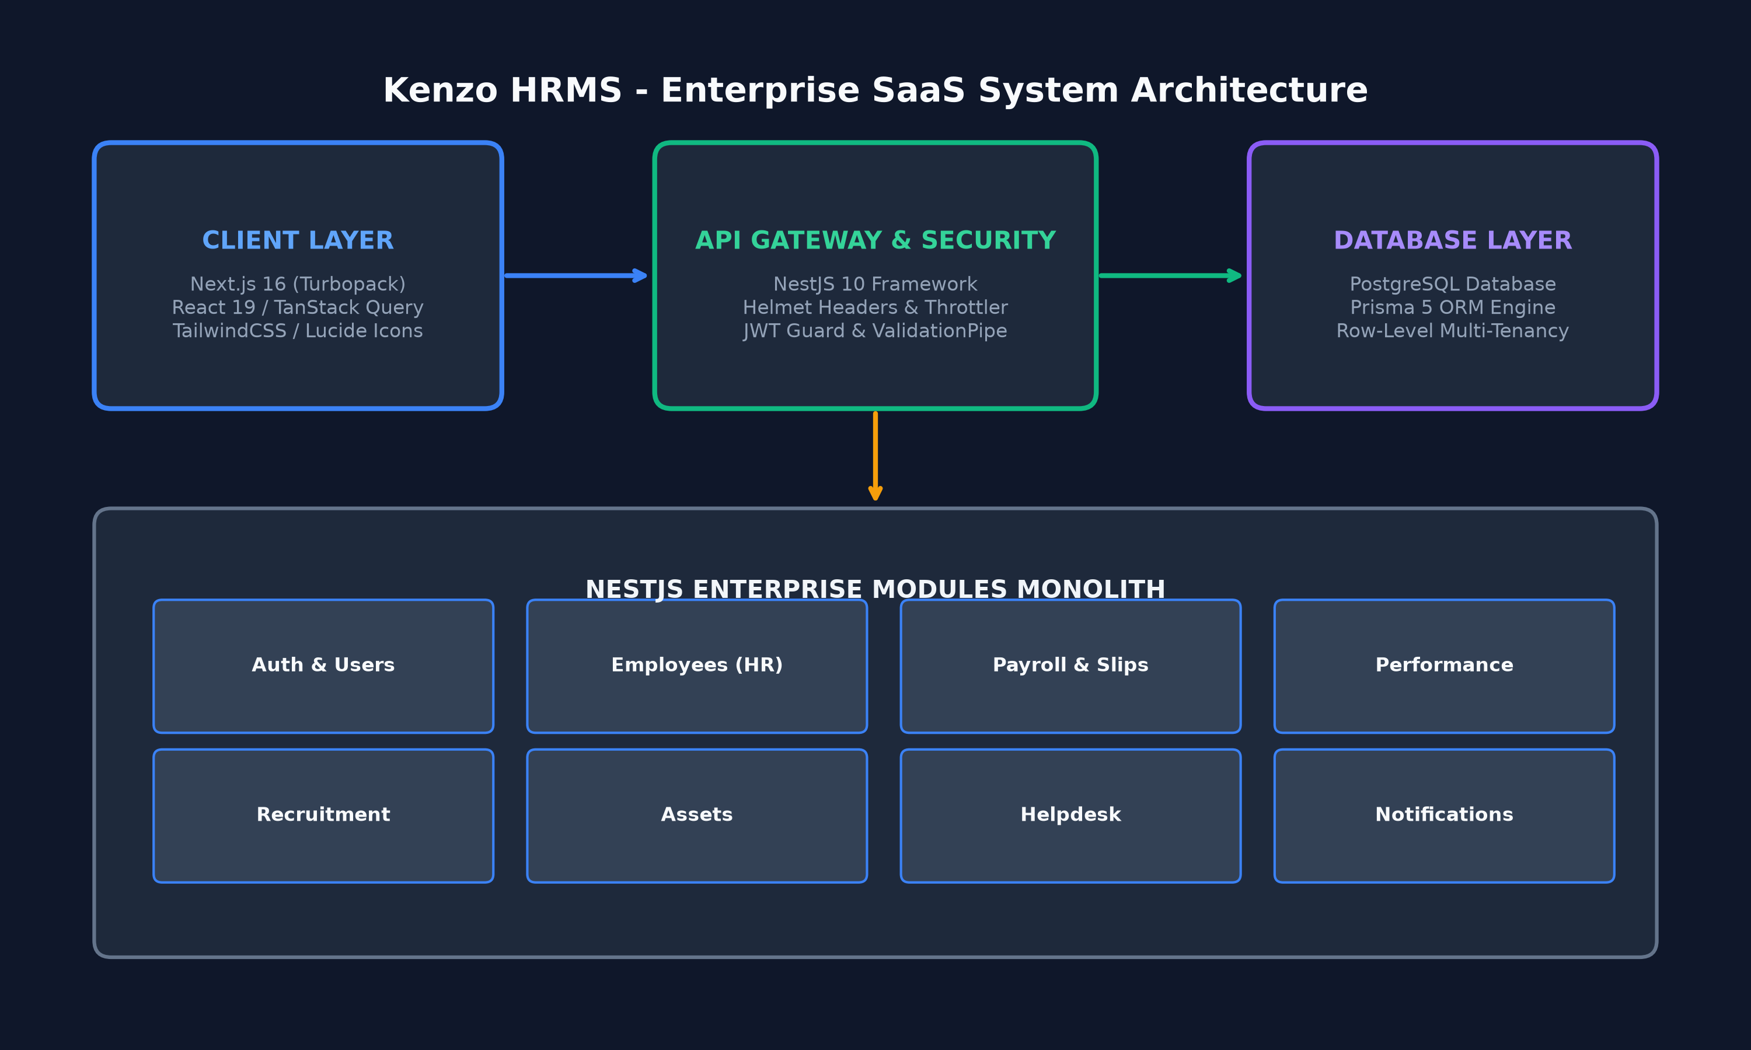
Figure 1.1: Kenzo HRMS High-Level Enterprise Architecture

Core Technology Stack Summary
Layer | Technology | Key Purpose & Responsibility
Frontend UI | Next.js 16 (App Router), React 19, TailwindCSS, Framer Motion | Server-Side Rendering, client components, responsive modern UI
State & API | TanStack React Query, Axios/Custom ApiClient | Hybrid caching, real-time query invalidation, dev fallbacks
Backend Engine | NestJS 10, TypeScript, RxJS | Enterprise REST API, dependency injection, modular domain services
Security Layer | Helmet, @nestjs/throttler, Bcrypt, Passport JWT | Rate-limiting (100req/min), security headers, strict JWT authentication
Database & ORM | PostgreSQL, Prisma 5 ORM | Type-safe database access, multi-tenant row isolation, relations
DevOps & CI/CD | Docker Multi-stage, GitHub Actions CI | Automated typechecking, containerized zero-downtime deployment

2. Chronological Refactoring & Transformation History
Below is the complete step-by-step audit, refactoring, and code evolution log detailing every change applied from the initial project state to the current release.

Step 1: Codebase Audit & Technical Debt Elimination
Conducted a comprehensive CTO-level audit across apps/api and apps/web. Identified lack of tenant isolation, missing backend modules (Payroll, Performance, Recruitment, Assets, Helpdesk, Notifications), hardcoded user fallback roles in frontend auth provider, and missing rate-limiting protections.

Step 2: Database Schema Purge & Production Seed Script
Created Prisma SQL truncation scripts to eliminate duplicate/orphaned records. Built apps/api/prisma/seed.ts establishing primary tenant 'Kenzo Technologies' and seeding clean master accounts:
• Master Admin: Ankit.sethi@kenzoinfosystems.com | Password: kenzo123 (Role: Super Admin)
• Employee: Sujal.kumar@kenzoinfosystems.com | Password: kenzo123 (Role: Software Engineer)

Step 3: Role-Based Access Control (RBAC) & UI Scoping
Implemented distinct Employer/Admin vs Employee Portal user experiences. Scoped sidebar navigation for regular employees to Attendance, Leave Application, Payslips, and Appraisals, hiding corporate admin tabs.

Step 4: Backend Microservice Module Expansion (6 Enterprise Modules)
Built 6 comprehensive NestJS modules complete with Controllers, Services, DTOs (with class-validator), and Prisma service injections:
1. PayrollModule (Payroll runs, monthly payslip generation)
2. PerformanceModule (Review cycles, goals, 360 performance reviews)
3. RecruitmentModule (Job requisitions, candidates, applications, interviews)
4. AssetsModule (Asset tracking & employee assignments)
5. HelpdeskModule (Support ticketing system & comment threads)
6. NotificationsModule (In-app notification system)

Step 5: Security Hardening & Throttling
Configured Helmet security headers, ThrottlerModule rate limiting (100 requests / minute per IP), Joi environment schema validation in ConfigModule, and public health check endpoint GET /api/health.

Step 6: Resilient Frontend API Integration & React Query Hooks
Built centralized apiClient with automatic JWT token injection. Created custom React Query hooks (useEmployees, useLeaves, usePayslips) with hybrid fallback handling to local state when backend is offline.

Step 7: DevOps Pipeline & Containerization
Created multi-stage production Dockerfiles for apps/api and apps/web. Configured docker-compose.yml and GitHub Actions CI workflow (.github/workflows/ci.yml).

Step 8: Permanent System Access Level (Role) Selector Fix
Resolved role hardcoding bug by introducing systemRole ('admin' | 'employee') field in CreateEmployeeDto, Prisma userRoles relation, and a System Access Level dropdown in the Add/Edit Employee dialog.

3. Security Architecture & Multi-Tenant Data Flow

Multi-Tenant Data Isolation
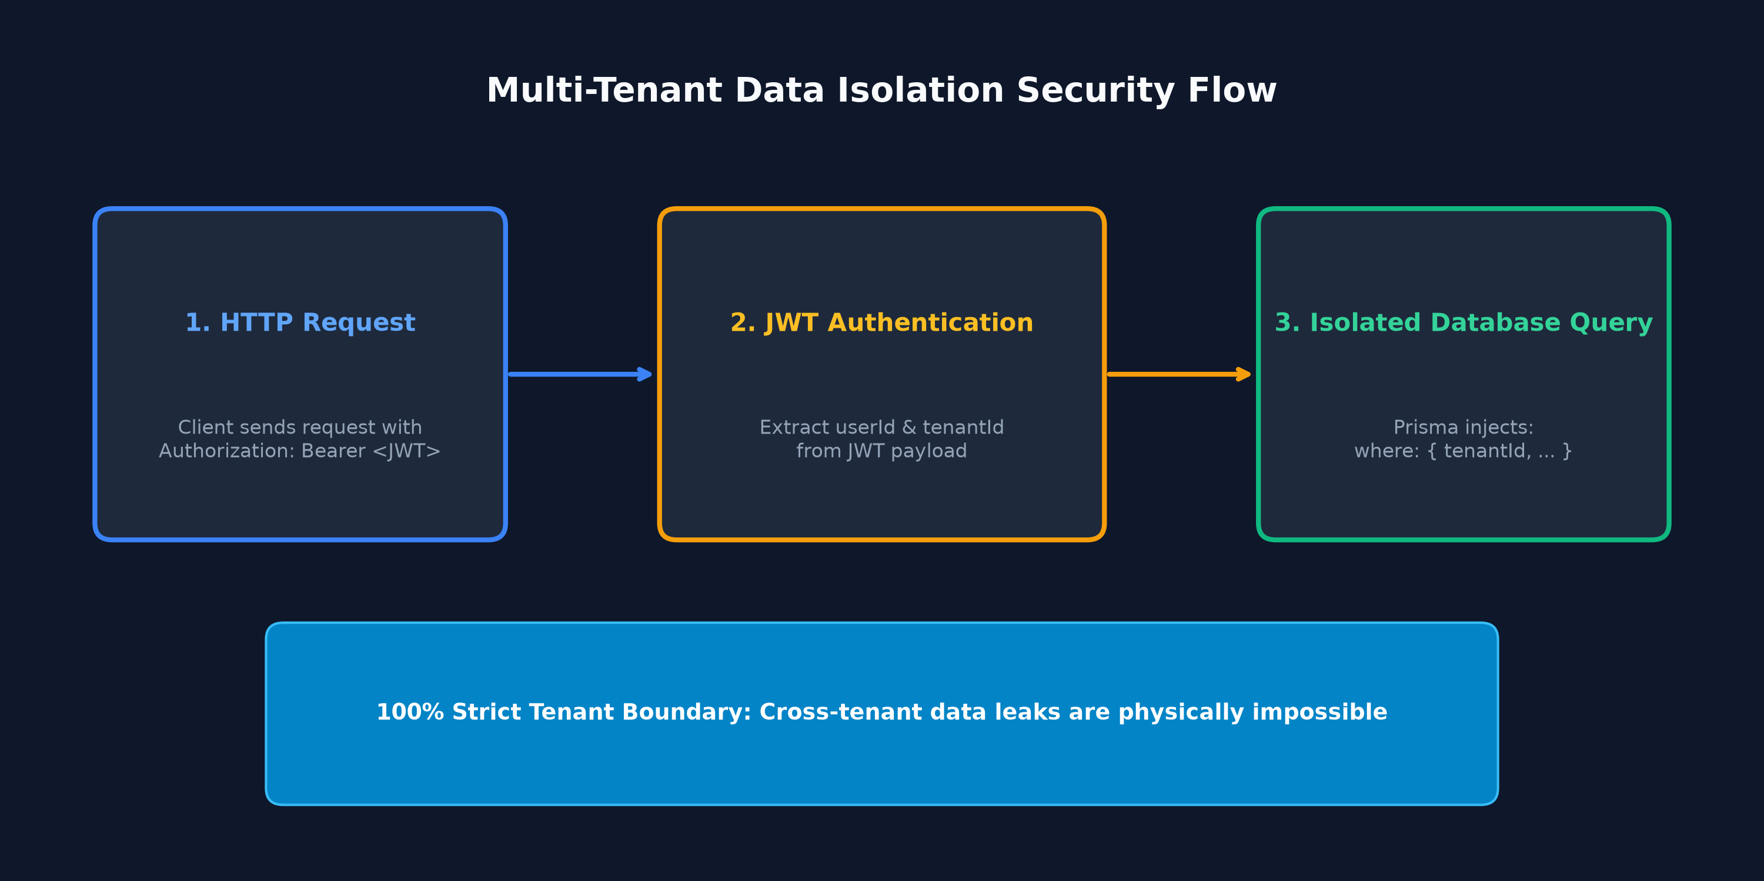
Figure 3.1: Multi-Tenant Row-Level Security Pipeline

Role-Based Access Control (RBAC)
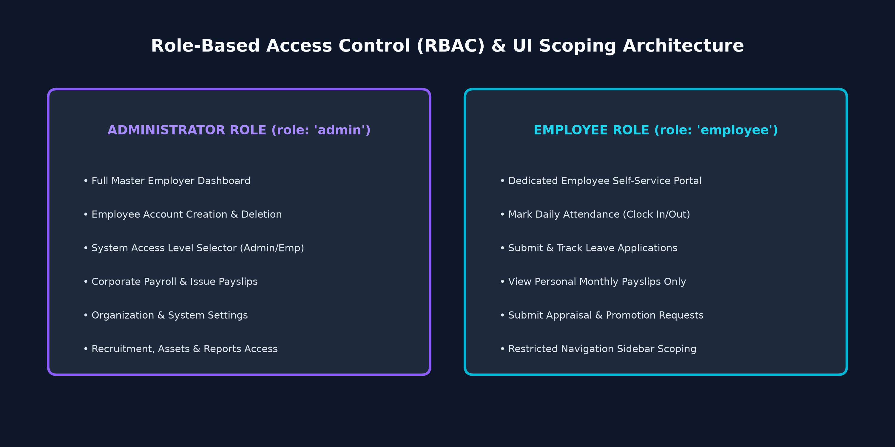
Figure 3.2: Administrator vs Employee Access Scoping

4. Prisma Database Schema & Entity Relationships
The database is structured in PostgreSQL managed via Prisma 5 ORM. Every operational table includes a tenantId foreign key for strict multi-tenant isolation.

Prisma Schema Code Snippet
model Tenant {
id String @id @default(uuid())
name String
slug String @unique
domain String?
logoUrl String?
createdAt DateTime @default(now())
updatedAt DateTime @updatedAt
users User[]
employees Employee[]
roles Role[]
departments Department[]
organizations Organization[]
}
model User {
id String @id @default(uuid())
tenantId String
tenant Tenant @relation(fields: [tenantId], references: [id])
email String
passwordHash String
firstName String
lastName String
isActive Boolean @default(true)
employeeId String? @unique
employee Employee? @relation(fields: [employeeId], references: [id])
userRoles UserRole[]
createdAt DateTime @default(now())
updatedAt DateTime @updatedAt
@@unique([tenantId, email])
}
model Employee {
id String @id @default(uuid())
tenantId String
tenant Tenant @relation(fields: [tenantId], references: [id])
employeeCode String
firstName String
lastName String
workEmail String
employmentStatus String @default("active")
departmentId String?
department Department? @relation(fields: [departmentId], references: [id])
dateOfJoining DateTime
workPhone String?
user User?
createdAt DateTime @default(now())
updatedAt DateTime @updatedAt
}

5. Frontend Routes & Backend API Specifications

Frontend App Routes (Next.js 16)
Route URL | Access Level | Description & Functional Purpose
/ | Public | Landing page & platform login choice
/login | Public | Authentication form (Email & Password)
/dashboard | Shared | Role-aware dashboard (Executive view vs Employee portal)
/employees | Admin Only | Master employee roster, Add/Edit with SystemRole selector
/employees/[id] | Shared (Self/Admin) | 360° Employee profile view & confidential records
/attendance | Shared | Mark attendance clock in/out & monthly history
/leave | Shared | Submit leave application (Employee) & approve requests (Admin)
/payroll | Shared | View my payslips (Employee) & issue new payslips/runs (Admin)
/performance | Shared | Appraisal requests (Employee) & review cycles (Admin)
/recruitment | Admin Only | Job requisitions, candidate pipeline, interview scheduler

Backend REST Endpoints (NestJS API)
Endpoint | HTTP Method | Functionality & Guard
/api/auth/login | POST | Validates user credentials, returns JWT tokens
/api/auth/me | GET | Returns user profile, roles, and tenant context
/api/health | GET | Public health check endpoint (status, uptime)
/api/employees | GET / POST | List tenant employees / Create employee with systemRole
/api/employees/:id | GET / PUT / DELETE | Retrieve detail, update record, or soft-delete
/api/payroll/runs | GET / POST | Fetch payroll runs / Create new monthly run
/api/payroll/payslips/generate | POST | Generate employee salary slip PDF record
/api/performance/reviews | GET / POST | Manage performance reviews and goals
/api/recruitment/jobs | GET / POST | Manage job requisitions and candidate applications
/api/notifications | GET / PATCH | Fetch user notifications / mark as read

6. DevOps Pipelines & Automated Verification
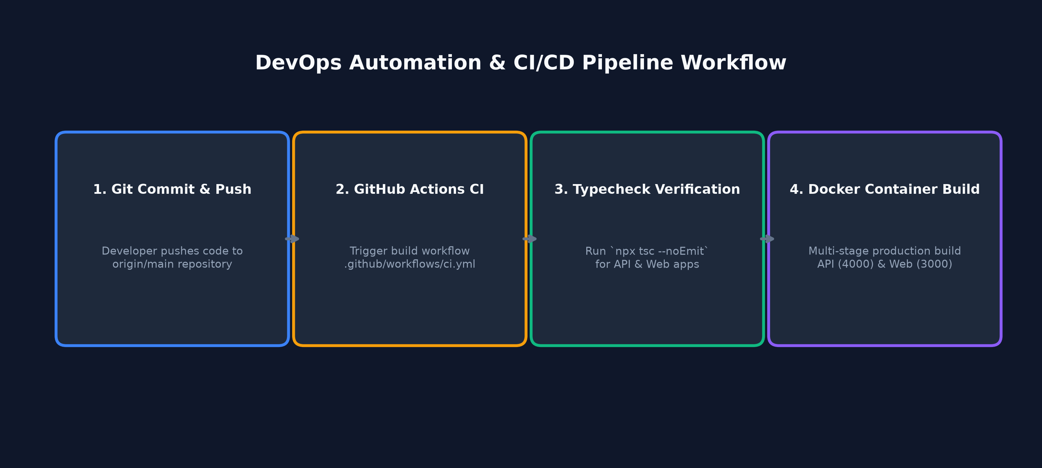
Figure 6.1: CI/CD Build & Typecheck Automated Pipeline

Verification Log
All components have been type-checked and validated prior to commit:
$ cmd /c "npx tsc --noEmit -p apps/web/tsconfig.json"
> Exit Code: 0 (0 Errors)
$ cmd /c "npx tsc --noEmit -p apps/api/tsconfig.json"
> Exit Code: 0 (0 Errors)
$ git status
> On branch main, working tree clean, up to date with origin/main

