Object - Oriented Programming
ITPE 120
IT-2A


Submitted By:
Christopher Lyod B. Mercado
Kenth Justine B. Sumalinab
Ma. Stefanie Celine Dela Salde
STUDENTS

Submitted to:
Mr. Dony Dongiapon
Instructor

DAVAO ORIENTAL STATE UNIVERSITY
BACHELOR OF SCIENCE IN INFORMATION TECHNOLOGY

December 2025

PROGRAM SPECIFICATION DOCUMENT
Object-Oriented Programming Project with Java Swing and Database Connectivity
1. Project Overview
1.1 Project Title
AgriConnect: Seed and Product Trading System
A Java OOP-Based Desktop Application with Swing GUI and Database Integration
1.2 Project Description
This project involves developing a Java desktop application that fully demonstrates Object-Oriented Programming (OOP) principles with a Graphical User Interface (GUI) using Java Swing. The program must connect to a simple database (e.g., SQLite, MySQL, or H2 Database). Additionally, the system may optionally support flat file storage (CSV or text file) for exporting or importing data.
AgriConnect is a Java desktop application designed to connect farmers, buyers, and administrators through a unified platform. It demonstrates Object-Oriented Programming (OOP) principles with a Swing-based GUI and SQLite database integration. The system allows farmers to list seeds/products, buyers to purchase in bulk or reserve items, and administrators to manage users and export reports.
The system should demonstrate:
- OOP concepts (encapsulation, inheritance, polymorphism, abstraction)
- GUI design using Swing
- Event-driven programming
- Basic CRUD (Create, Read, Update, Delete) operations with a database or/and flat file.

1.3 Target Users
- Students practicing OOP and GUI development
- Farmers and buyers in agricultural communities
- Administrators managing seed/product records

1.4 Platform and Technologies
- Programming Language: Java SE (JDK 8 or later)
- GUI Toolkit: Java Swing
- Database: SQLite (recommended), MySQL, PostgreSQL, or H2
- File Handling: Text file or CSV (optional)
- Development Tool: Eclipse or VSCode

2. Project Objectives
- Implement OOP concepts in a real-world application.
- Build an interactive desktop GUI using Java Swing.
- Connect Java application to a database for CRUD operations.
- Implement flat-file export/import.
- Ensure code modularity through proper class design.
- Implement OOP concepts in a real-world agricultural trading application.
- Build an interactive desktop GUI using Java Swing.
- Connect Java application to SQLite for CRUD operations.
- Support optional CSV export for reporting.
- Ensure modularity and maintainability through MVC architecture.

3. Functional Requirements
3.1 User Interface (Swing-Based)
The application must include at least four (4) GUI windows, built fully using Swing components:
Figure 1.1 (Main Menu Window)
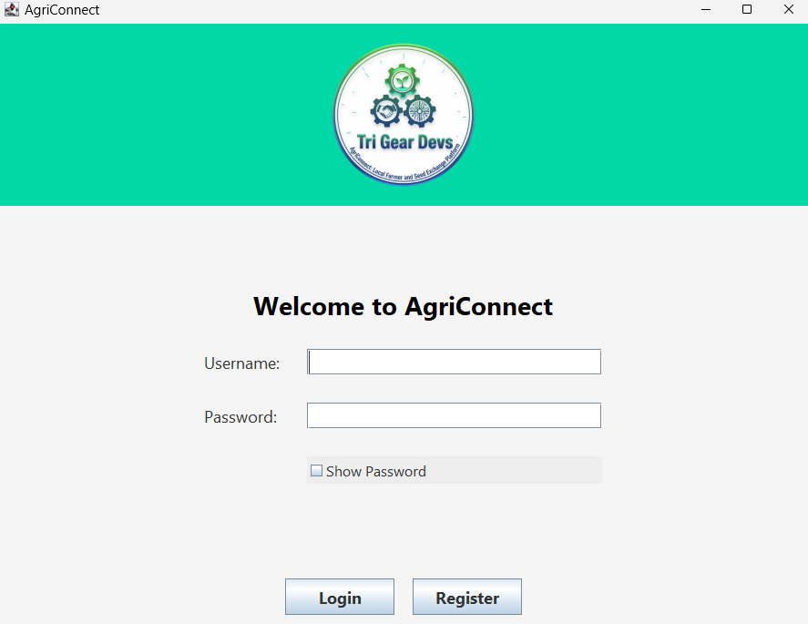
Figure 1.2 (Input or Registration Form)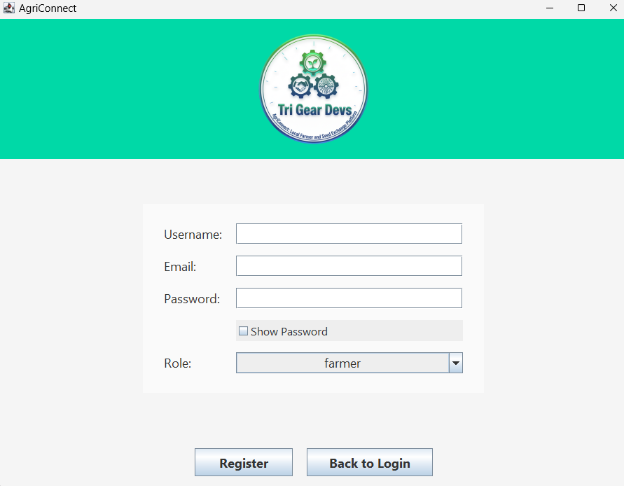
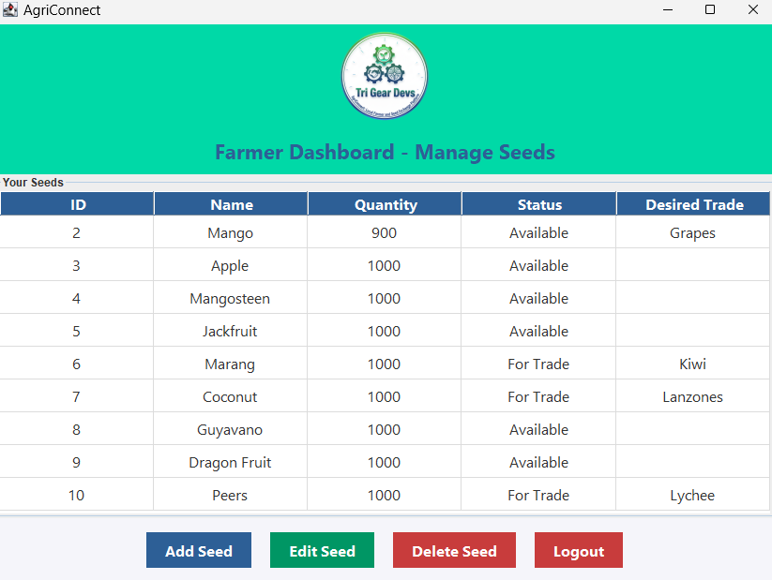
Figure 1.3 (Records Management Window)

Figure 1.4 (Reports or Result Window)
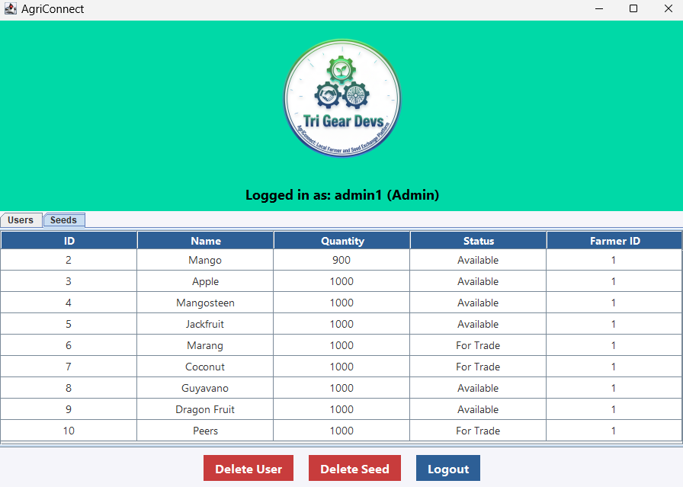

Recommended Swing components:
- JFrame, JPanel, JButton, JTextField, JLabel,
- JTable, JScrollPane, JMenuBar, JComboBox, JOptionPane
3.2 OOP Requirements
https://drive.google.com/drive/folders/1ukWmfJtEovT8yXTUJJiMxheeXt1Hko1U?usp=sharing
The system must show clear use of:
- Encapsulation
  - Private fields, getters, and setters
- Inheritance
  - At least one base class and two subclasses
- Polymorphism
  - Method overriding
- Abstraction
  - Interface or abstract class
OOP Principle | Class Name | Location | Remarks
Inheritance | RegisterPanel, LoginPanel, FarmerPanel, BuyerPanel | package Panel | Each panel class extends JPanel, inheriting Swing UI behavior.
Inheritance | UserDAO, FarmerDAO, BuyerDAO | package dao | DAO classes may extend a base DAO (if implemented), otherwise they use composition.
Inheritance (planned UML) | Farmer, Buyer, User | package Model | Could extend a common Person superclass to unify shared attributes (id, name, email, age).
Encapsulation | User | package Model | Fields (id, username, email, passwordHash, role, age) are private with getters/setters to protect data.
Encapsulation | Seed, TradeRequest | package Model | Attributes are private, accessed via getters/setters, ensuring controlled access.
Abstraction | UserDAO, FarmerDAO, BuyerDAO | package dao | Abstracts database operations (insert, update, delete, query) away from UI logic.
Polymorphism | JPanel subclasses (RegisterPanel, LoginPanel, FarmerPanel, BuyerPanel) | package Panel | Each overrides/extends behavior of JPanel differently (custom UI, buttons, actions).
Polymorphism (runtime) | LoginPanel → role-based switching | package Panel | Depending on User.role, the system loads FarmerPanel, BuyerPanel, or AdminPanel. This is runtime polymorphism.

3.3 Core Functionalities
The application must support:
3.3.1 Database CRUD Operations
  - Add new record (users, seeds).
  - View records (display through JTable/JList).
  - Edit record (update seed info).
  - Delete record (remove seed/user).
3.3.2 Flat-File Functionalities
  - Export records to CSV/TXT/PDF.
  - Import records from CSV/TXT (optional).
3.3.3 Input Validation
(Provide matrix of evaluation for the items below}
- Must ensure no null/empty fields
- Must validate numeric fields
Example
Add Customer Transaction
Case | Accepted Format/Value | Input Value (Example) | System Response | Remarks
Username too short | Minimum 3 characters, alphanumeric | ab | Show error: "Username must be at least 3 characters." | Prevents weak/invalid usernames
Valid Username | ≥3 characters, alphanumeric | farmer123 | Accepted, stored in DB | Passes validation
Invalid Email | Must contain @ and . | farmermail.com | Show error: "Enter a valid email." | Ensures proper email format
Duplicate Email | Unique email | farmer@gmail.com (already exists) | Show error: "Email is already used." | Checked via UserDAO.isEmailTaken()
Password too short | ≥6 characters | 12345 | Show error: "Password must be at least 6 characters." | Prevents weak passwords
Valid Password | ≥6 characters | securePass1 | Accepted, hashed and stored | Uses SecurityUtil.hashPassword()
Age below minimum | Integer between 18–60 | 16 | Show error: "Age must be between 18 and 60." | Enforces age restriction
Age above maximum | Integer between 18–60 | 75 | Show error: "Age must be between 18 and 60." | Enforces age restriction
Non-numeric Age | Integer only | twenty | Show error: "Please enter a valid numeric age." | Prevents invalid input
Valid Age | Integer between 18–60 | 25 | Accepted, stored in DB | Passes validation
Seed Quantity invalid | Positive integer | -5 | Show error: "Quantity must be a number greater than 0." | Prevents invalid seed entries
Seed Quantity valid | Positive integer | 100 | Accepted, stored in DB | Passes validation
Trade Offer empty | Non-empty string | "" | Show error: "You must specify an offer." | Ensures trade requests are meaningful
Trade Offer valid | Non-empty string | "10kg rice" | Accepted, stored in DB | Passes validation
Login invalid credentials | Correct username + password | farmer123 / wrongpass | Show error: "Invalid username or password." | Prevents unauthorized access
Login valid credentials | Correct username + password | farmer123 / securePass1 | Redirect to role-based panel | Farmer → FarmerPanel, Buyer → BuyerPanel, Admin → AdminPanel

4. Non-Functional Requirements
4.1 Usability
- GUI must use clear layouts (BorderLayout, GridLayout, FlowLayout, etc.).
- Buttons and labels must be descriptive.
4.2 Reliability
- Stable database connection
- Robust exception handling
4.3 Performance
- Database queries: less than 2 seconds
- UI windows must open instantly
4.4 Maintainability
- Use packages (model, view, controller, database, utils).
- Must include JavaDoc comments.

5. System Architecture
5.1 Recommended Architecture: MVC Pattern
Component | Description
Model | Data classes, OOP structures, database models
View | Swing forms and UI components
Controller | Event handlers and logic
Database Layer | Connection, queries, CRUD operations
Utils (Optional) | Flat-file operations
5.2 Sample Class Diagram
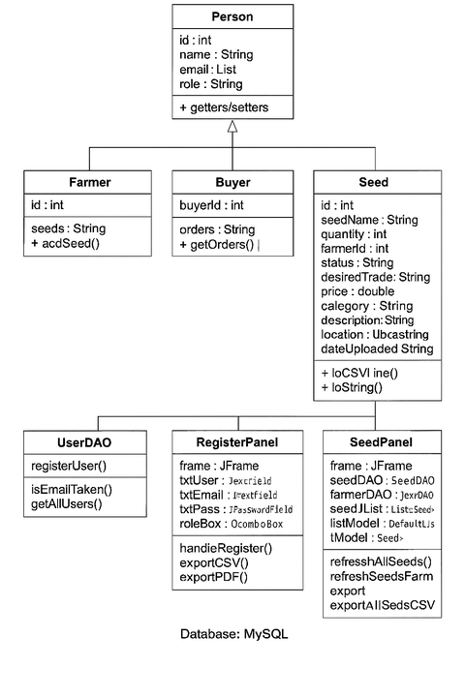

6. Database Specification
6.1 Database Type
- SQLite (recommended for simplicity)
- or MySQL / H2 Database
6.2 Required Table (Example)
Table:Persons
Field | Type | Description
id | INTEGER PRIMARY KEY | Record ID
name | TEXT | Person name
type | TEXT | Student or Teacher
code | TEXT | studentId / employeeId
6.3 Database Functionalities
- Add record
- Read all records
- Update record
- Delete record
- Search (optional)

7. GUI Design
7.1 Main Menu Window
Buttons:
- Open Registration Form
- Manage Records
- Exit

7.2 Registration Form
Fields:
- Name
- Age
- Role (Student/Teacher)
- Student ID or Employee ID (dynamic field)
Buttons:
- Save
- Clear
- Back to Menu
7.3 Records Window
Components:
- JTable for displaying records
- Edit button
- Delete button
- Refresh button
- Optional: Export to CSV/Text
7.3 Trade Wi

8. Flat-File Module
Functions:
- Export to CSV: write all records to a CSV file
- Export to text file: one object per line
- Import from file (optional): read CSV or text and insert into database
Technologies:
- Java File I/O
- BufferedReader, BufferedWriter, FileWriter, FileReader

9. Constraints {Ayaw na ni hilabti}
- Must use Swing only
- Must connect to a database.
- Flat-file storage is optional.
- Must compile and run offline.
- Students must not use external GUI libraries.

10. Deliverables
- Source Code Folder
- Executable JAR
- Database File
- Documentation
  - Use case diagrams
  - Class diagrams
  - Database schema
  - User manual
  - And other attachments as mentioned above.
- Screenshots of GUI
- Final Presentation Slides

11. Acceptance Criteria
- GUI is 100% Swing.
- Minimum of 4 functional windows.
- Database connection is functioning with CRUD operations.
- OOP concepts are properly implemented.
- flat-file export/import works.
- Code is modular and maintainable.

Rubrics of Ratings

