

Egypt University of Informatics

Computer and Information Systems

Data Analysis Course

The Analysis of the Performance of Data Analysis Students

Submitted by: Kenzy Ahmed Abdelrhman

19/3/2025

# Introduction

Anxiety levels in university students is an increasing problem since it is related to their welfare and studies. This report analyses how anxiety impacts students' progress in studies at Egypt University of Informatics using survey data gathered from a student sample. We aim to answer the problem’s amplifying sources and analyse stress management techniques that will equip the students to handle such situations.

# Research Question

How common are mental health struggles and anxiety among students, and what are the main reasons behind them??

# Hypothesis

Students with higher anxiety levels tend to report a negative impact on academic performance. An ANOVA test was conducted to check for differences in anxiety levels across faculties. If the p-value is below 0.05, we conclude that anxiety levels vary significantly among faculties; otherwise, there is no significant difference.

# Population of Interest:

The population of interest includes undergraduate students enrolled in various faculties at Egypt University of Informatics.

# Sampling Method:

The study used a stratified random sampling method to ensure representation from various faculties and academic levels, reducing selection bias and providing a comprehensive view of student experiences. Additionally, students across different faculties and academic years at Egypt University of Informatics were invited to participate through WhatsApp groups. While this approach facilitated broad outreach, it also introduced self-selection bias, as many responses came from the Computer Science faculty, where students actively collaborated to gather enough responses for the project.

# Bias Identification:

* **Self-selection bias:** Many respondents were from the Computer Science faculty, where students actively helped each other gather enough responses for the project. Additionally, students who are more affected by anxiety may have been more inclined to participate.
* **Social desirability bias:** Some students might have downplayed or exaggerated their anxiety levels due to personal reasons. To mitigate these biases, the survey was anonymized, ensuring participants felt comfortable providing honest responses.

# Survey Questions:

**What is your faculty/major?**

* ⬜ Engineering
* ⬜ Computing & Information Sciences
* ⬜ Business Informatics
* ⬜ Digital Arts & Design

**What is your gender?**

* ⬜ Male
* ⬜ Female

**How often do you experience symptoms of anxiety (e.g., excessive worrying, nervousness, difficulty concentrating)?**

* ⬜ Never
* ⬜ Rarely (Once a month or less)
* ⬜ Sometimes (A few times a month)
* ⬜ Often (A few times a week)
* ⬜ Daily

**What are the main sources of anxiety in your university life? (Select all that apply)**

* ⬜ Academic pressure (exams, assignments, grades)
* ⬜ Financial concerns (tuition, living expenses)
* ⬜ Social interactions (making friends, relationships)
* ⬜ Family expectations
* ⬜ Career uncertainty

**Has your academic performance been affected by anxiety?**

* ⬜ Not at all
* ⬜ Slightly
* ⬜ Moderately
* ⬜ Significantly

**What do you do to manage stress and anxiety? (Select all that apply)**

* ⬜ Exercise / Sports
* ⬜ Meditation / Breathing exercises
* ⬜ Talking to friends/family
* ⬜ Professional counseling/therapy
* ⬜ Taking medication

Online survey link:

https://docs.google.com/forms/d/e/1FAIpQLSfjz5Pv1axbJVr0wHqzXRhPmaG1S8IJRNvRP3RZz5Ppw9etTA/viewform?usp=sharing

Number of samples collected: 60

# Analysis:

The data suggests that anxiety is a common issue among students, with only a small fraction reporting no anxiety. This indicates a need for mental health support strategies within the university.

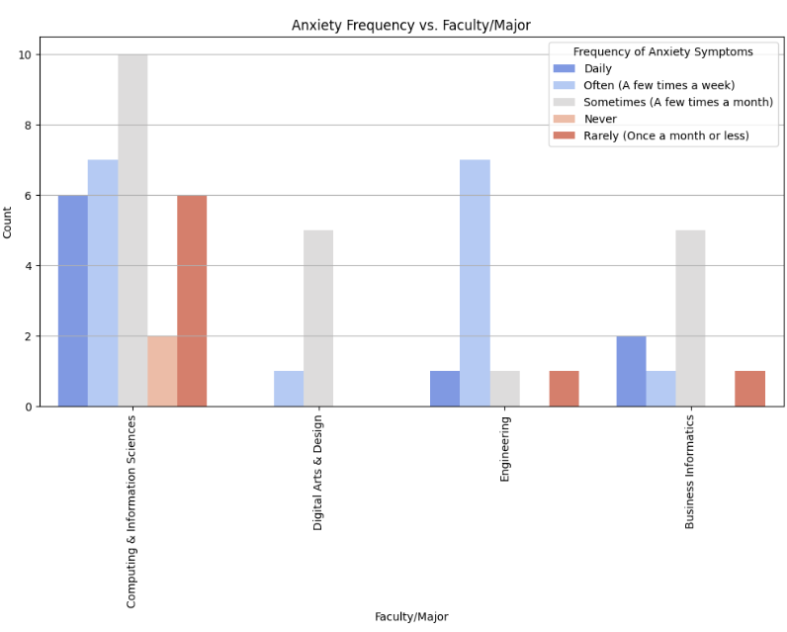 Anxiety affects both male and female students, but males may experience slightly higher academic disruption. Universities should provide targeted interventions for both groups, ensuring adequate mental health resources and academic support.

The findings suggest that students in technical fields like Computing & Information Sciences and Engineering experience higher anxiety, possibly due to workload and academic pressure. Tailored support programs may be needed for these faculties.

# Conclusion

The analysis confirms that a significant number of students struggle with mental health and anxiety, primarily due to academic pressure and social factors. Universities should take proactive steps in providing mental health support, increasing awareness, and reducing stressors where possible.

# Any potential issues

1. **Self-reporting Bias** – Students may not accurately represent their mental health condition due to personal or social stigma, in addition most response are from Computing & Information Sciences.
2. **Sample Size** – The number of respondents may not fully represent the entire student body.
3. **External Factors** – Other external influences, such as personal circumstances, were not considered in depth in this analysis.