Title Of Project
Clinic Management System

Student Name | ID
Kenzy Ehab Mostafa | 221001910
Salma Naser Salah | 211002068
Peter Emad Gamil | 221002131
Ahmed Adel Saad | 221001749
Marina Romany Nasry | 211002071

Dr\ Muhammed elsayeh

(1)Design of the Database
The Database include Entity which are:
1. Department Entity
- Attributes:
  - Department_ID (Integer, Primary Key) — Unique identifier for each medical department.
  - Name (Variable Character, Mandatory) — The explicit name of the specialty (e.g., Cardiology, Dermatology).
  - Description (Variable Character, Optional) — Narrative overview of what clinical criteria the department handles.
2. Clinic Entity
- Attributes:
  - Clinic_ID (Integer, Primary Key) — Unique structural identifier assigned to the physical medical unit.
  - Name (Variable Character, Mandatory) — Commercial or organizational name of the center.
  - Address (Variable Character, Optional) — Geographic location of the facility.
  - Department_ID (Integer, Foreign Key) — Establishes the governing department that operates this clinical room.
3. Doctor Entity
- Attributes:
  - Doctor_ID (Integer, Primary Key) — Unique medical license or professional ID code.
  - Name (Variable Character, Mandatory) — Full name of the physician.
  - Phone_Number (Variable Character, Optional) — Primary contact telephone number.
  - Address (Variable Character, Optional) — Residential or mailing address details.
  - Department_ID (Integer, Foreign Key) — Links the physician to their explicit field of medical specialty.

4. Patient Entity
- Attributes:
  - Patient_ID (Integer, Primary Key) — Unique national identifier or hospital record number.
  - Name (Variable Character, Mandatory) — Full name of the patient.
  - Phone_Number (Variable Character, Optional) — Direct contact telephone link.
  - Address (Variable Character, Optional) — Home address.
  - Birth_Date (Date, Optional) — Date of birth, utilized for age-based pediatric or geriatric tracking.
  - Job (Variable Character, Optional) — Employment background context (helpful for tracking occupational health patterns).
5. Appointment Entity
- Attributes:
  - Appointment_ID (Integer, Primary Key) — Auto-incremented unique transactional tracking ticket number.
  - Date (Date, Mandatory) — The specific calendar date booked for the checkup.
  - Start_Time (Time, Mandatory) — Scheduled baseline consultation initiation hour.
  - End_Time (Time, Mandatory) — Scheduled completion timeline boundary.
  - Cost (Decimal, Mandatory) — Financial fee charged for the clinical checkup instance.
  - Status (Enumeration, Mandatory) — Restricts state updates exclusively to 'Scheduled', 'In Progress', or 'Postponed'.
  - Patient_Diagnosis (Variable Character, Optional) — Clinical diagnostic conclusions recorded on-site by the physician.
  - Patient_ID (Integer, Foreign Key) — Links the specific patient who booked the time block.
  - Doctor_ID (Integer, Foreign Key) — Links the specialized physician assigned to host the consult.

(2)ERD Diagram
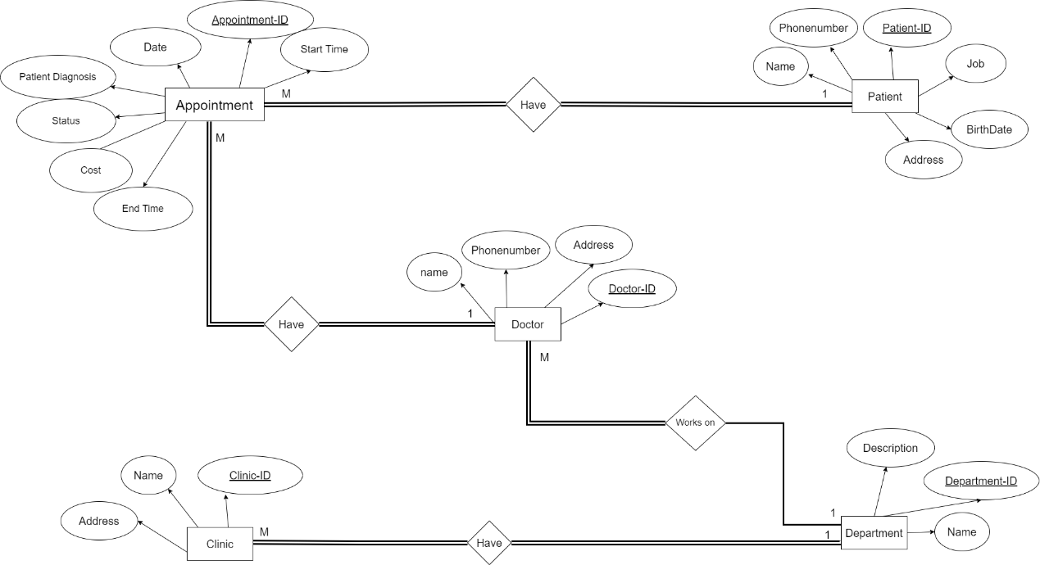
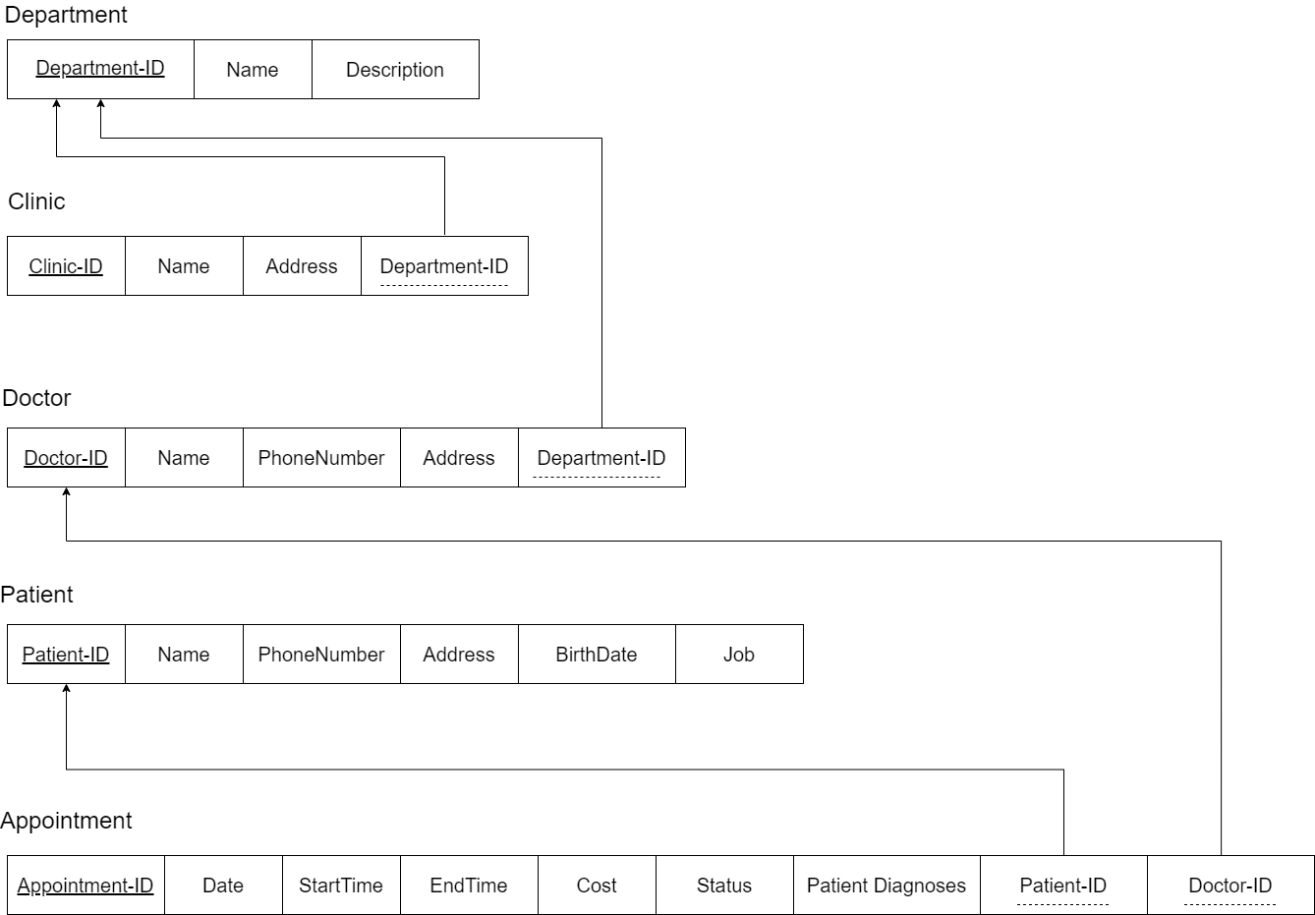
(3)Schema

(4)MYSQL
-- Create Department table
CREATE TABLE Department (
Department_ID INT AUTO_INCREMENT PRIMARY KEY,
Name VARCHAR(200),
Description VARCHAR(300)
);

-- Create Clinic table
CREATE TABLE Clinic (
Clinic_ID INT PRIMARY KEY,
Name VARCHAR(200),
Address VARCHAR(250),
Department_IDS INT,
FOREIGN KEY (Department_IDS) REFERENCES Department(Department_ID)
);

-- Create Doctor table
CREATE TABLE Doctor (
Doctor_ID INT PRIMARY KEY,
Name VARCHAR(200),
Phone_Number VARCHAR(20),
Address VARCHAR(250),
Department_ID INT,
FOREIGN KEY (Department_ID) REFERENCES Department(Department_ID)
);

-- Create Patient table
CREATE TABLE Patient (
Patient_ID INT PRIMARY KEY,
Name VARCHAR(200),
Phone_Number VARCHAR(20),
Address VARCHAR(250),
Birth_Date DATE,
Job VARCHAR(150)
);

-- Create Appointment table
CREATE TABLE Appointment (
Appointment_ID INT AUTO_INCREMENT PRIMARY KEY,
Date DATE,
Start_Time TIME,
End_Time TIME,
Cost DECIMAL(15, 2),
Status ENUM('Scheduled', 'In Progress', 'Postponed'),
Patient_Diagnosis VARCHAR(250),
Patient_ID INT,
Doctor_ID INT,
FOREIGN KEY (Patient_ID) REFERENCES Patient(Patient_ID),
FOREIGN KEY (Doctor_ID) REFERENCES Doctor(Doctor_ID)
);

(5)Test Data

-- Insert sample data into Department table
INSERT INTO Department (Name, Description) VALUES
('Dermatology', 'Deals with skin-related issues'),
('Orthopedics', 'Deals with musculoskeletal system disorders'),
('Pediatrics', 'Deals with medical care of infants, children, and adolescents'),
('Cardiology', 'Deals with heart-related issues'),
('Psychiatry', 'Deals with mental health disorders'),
('Urology', 'Deals with urinary tract and male reproductive system disorders'),
('Rheumatology', 'Deals with autoimmune and inflammatory disorders'),
('Pulmonology', 'Deals with respiratory system disorders'),
('Neurology', 'Deals with nervous system disorders'),
('Ophthalmology', 'Deals with eye-related issues'),
('Endocrinology', 'Deals with hormone-related disorders'),
('Gastroenterology', 'Deals with digestive system disorders'),
('ENT', 'Deals with ear, nose, and throat disorders');

-- Insert sample data into Clinic table
INSERT INTO Clinic (Clinic_ID, Name, Address, Department_ID) VALUES
(12211, 'Al Rawda Clinic', '1111 Paris St, Menoufia, eg', 1),
(23322, 'AL Sallam Center', '1212 Sallam St, Suiz, eg', 2),
(34433, 'Dar Al Chafaa Clinic', '15 Gomhorya, Sohag, eg', 3),
(45544, 'Abn Sina Center', '1414 Sallam, Bor Saeed, eg', 4),
(56655, 'Khawatya Clinic', '1515 Baher, Gerga, eg', 5),
(67766, 'Dar Al Foud Center', '1616 Al Hosary, 6 Oct, eg', 6),
(78877, 'Om Masryin Clinic', '1717 Cournesh nile, Maady, eg', 7),
(89988, 'Nabd Heart Center', '404 Al Tahrer St, Cairo, eg', 8),
(91199, 'NeuroHealth Clinic', '505 Elm St, Alexandria, eg', 9),
(10222, 'EyeCare Center', '606 Nile St, Giza, eg', 10),
(11333, 'Hormone Health Clinic', '707 Pyramids St, Giza, eg', 11),
(12444, 'Digestive Health Clinic', '808 Freedom St, Mansura, eg', 12),
(13555, 'ENT Specialist Clinic', '909 Unity St, Ismailia, eg', 13);

-- Insert sample data into Doctor table
INSERT INTO Doctor (Doctor_ID, Name, Phone_Number, Address, Department_ID) VALUES
(122955, 'Dr. Mohamed', '234-567-8901', '789 Sallam St, Asyout, eg', 1),
(133895, 'Dr. Nada', '345-678-9012', '234 Oroba St, Sohag, eg', 2),
(144695, 'Dr. Omar', '567-890-1234', '567 Al Nile St, Aswan, eg', 3),
(155295, 'Dr. Ekram', '678-901-2345', '890 Al Baher St, Tanta, eg', 4),
(166285, 'Dr. Sara', '901-234-5678', '123 Al Hram, Geza, eg', 5),
(177735, 'Dr. Emad', '123-456-7890', '456 Dahshour, Helwan, eg', 6),
(988465, 'Dr. Yousef', '234-567-8901', '789 Osmaan, Suiz, eg', 7),
(599245, 'Dr. Hanen', '345-678-9012', '123 Abdel Nasser, Menoufia, eg', 8),
(110235, 'Dr. Reem', '385-688-9812', '1618 Al Tahrer, Cairo, eg', 1),
(211346, 'Dr. Hossam', '123-987-6543', '101 Freedom St, Cairo, eg', 9),
(222457, 'Dr. Dina', '234-876-5432', '202 Liberation St, Giza, eg', 10),
(233568, 'Dr. Khaled', '345-765-4321', '303 Justice St, Giza, eg', 11),
(244679, 'Dr. Ayman', '456-654-3210', '404 Independence St, Mansura, eg', 12),
(255790, 'Dr. Laila', '567-543-2109', '505 National St, Ismailia, eg', 13);

-- Insert sample data into Patient table
INSERT INTO Patient (Patient_ID, Name, Phone_Number, Address, Birth_Date, Job) VALUES
(12527, 'Rawda Al Safty', '111-222-3333', '101 Mobark St, Menoufia, eg', '1980-01-01', 'Engineer'),
(92346, 'Fares Fawzy', '444-555-6666', '202 Mobara St, Tanta, eg', '1990-05-15', 'Teacher'),
(82345, 'Shahd Khalaf', '777-888-9999', '303 Faisal St, Geza, eg', '1975-10-20', 'Nurse'),
(78360, 'Radwan Khattap', '222-333-4444', '404 Korba St, Cairo, eg', '1988-03-05', 'Doctor'),
(61213, 'Haidy Naser', '555-666-7777', '505 Paris St, Menoufia, eg', '1982-07-12', 'Lawyer'),
(51516, 'Tina Moheb', '888-999-0000', '606 Abo Sympile St, Aswan, eg', '1995-12-30', 'Artist'),
(41819, 'Omar Tarek', '111-484-5885', '707 Shobra St, Banha, eg', '1970-08-25', 'Dentist'),
(85258, 'Esraa Madian', '333-224-5225', '707 Elshohada St, Menoufia, eg', '1970-08-25', 'Engineer'),
(96369, 'Marwa Ali', '222-774-5775', '707 Mydan Sallam St, Mansura, eg', '1970-08-25', 'Engineer'),
(10721, 'Ahmad Hossam', '111-333-5555', '808 Unity St, Ismailia, eg', '1985-09-15', 'Architect'),
(11832, 'Yasmine Khaled', '222-444-6666', '909 Liberation St, Giza, eg', '1992-08-19', 'Librarian'),
(12943, 'Mustafa Ali', '333-555-7777', '1010 National St, Ismailia, eg', '1978-11-22', 'Pharmacist'),
(14054, 'Hana Saad', '444-666-8888', '1111 Independence St, Mansura, eg', '1983-04-13', 'Scientist');

-- Insert sample data into Appointment table
INSERT INTO Appointment (Date, Patient_ID, Doctor_ID, Start_Time, End_Time, Cost, Status, Patient_Diagnosis) VALUES
('2023-09-01', 12527, 122955, '10:00:00', '11:00:00', 100.00, 'Scheduled', 'Fatty Liver'),
('2023-09-15', 92346, 133895, '14:00:00', '15:00:00', 150.00, 'In Progress', 'Hypertension'),
('2023-07-03', 82345, 122955, '09:00:00', '10:00:00', 120.00, 'Postponed', 'Fatty Liver'),
('2023-08-20', 12527, 144695, '11:00:00', '12:00:00', 130.00, 'In Progress', 'Eye Infection'),
('2023-09-10', 61213, 155295, '15:00:00', '16:00:00', 140.00, 'Scheduled', 'Knee Pain'),
('2023-10-05', 51516, 166285, '08:00:00', '09:00:00', 160.00, 'In Progress', 'Migraine'),
('2023-11-12', 41819, 177735, '13:00:00', '14:00:00', 170.00, 'Scheduled', 'Childhood Illness'),
('2023-11-30', 96369, 988465, '10:00:00', '11:00:00', 110.00, 'Scheduled', 'Asthma'),
('2023-12-05', 78360, 599245, '09:00:00', '10:00:00', 200.00, 'In Progress', 'Heart Disease'),
('2023-12-15', 14054, 211346, '12:00:00', '13:00:00', 220.00, 'Postponed', 'Migraine'),
('2023-12-20', 10721, 222457, '11:00:00', '12:00:00', 210.00, 'Postponed', 'Eye Infection'),
('2023-12-25', 12943, 233568, '14:00:00', '15:00:00', 230.00, 'Scheduled', 'Diabetes Checkup'),
('2023-12-30', 11832, 244679, '15:00:00', '16:00:00', 250.00, 'Scheduled', 'Digestive Issues');

(6)Explanation
- Department-Doctors Relationship (1:M)
  - Each Doctor Work's on one Department But Each Department have many Doctors
  - optional on Department sides.
  - Mandatory on Doctor side.
- Department-Clinic Relationship (1:M)
- Each Department can hire multiple clinics but each Clinic belongs to only one Department.
- Mandatory on both sides.
- Doctor-Appointment Relationship (1:M)
- One Doctor can have multiple appointments with Different Patient's, But each appointment is associated with exactly one doctor.
- Mandatory For Doctor.
- Mandatory For Appointment.
- Appointment-Patient Relationship (M:1)
  - One Patient can have Multiple appointments over time, But Each appointment is associated with exactly one Patient.
  - Mandatory for both Appointment and Patient.

(7)Triggers
-- Trigger 1: Protects schedule integrity. Prevents data input errors
-- where an end-time is accidentally input before the start-time.
DELIMITER //
DROP TRIGGER IF EXISTS Before_Appointment_Insert//
CREATE TRIGGER Before_Appointment_Insert
BEFORE INSERT ON Appointment
FOR EACH ROW
BEGIN
IF NEW.End_Time <= NEW.Start_Time THEN
SIGNAL SQLSTATE '45000'
SET MESSAGE_TEXT = 'Error: Appointment End_Time cannot be earlier than or equal to Start_Time.';
END IF;
END//

-- Trigger 2: Audit/Sanitization rule. Automatically capitalizes
-- critical Patient names during entry to standardize user input records.
DROP TRIGGER IF EXISTS Before_Patient_Insert//
CREATE TRIGGER Before_Patient_Insert
BEFORE INSERT ON Patient
FOR EACH ROW
BEGIN
SET NEW.Name = CONCAT(UPPER(SUBSTRING(NEW.Name,1,1)), LOWER(SUBSTRING(NEW.Name,2)));
END//

DELIMITER ;

(8)Check Database
1) SELECT Patient.Name
FROM Patient
JOIN Appointment ON Patient.Patient_ID = Appointment.Patient_ID
WHERE Appointment.Patient_Diagnosis = 'Fatty Liver'
AND Appointment.Date >= DATE_SUB(CURDATE(), INTERVAL 1 YEAR);
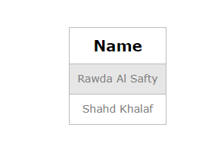
2)SELECT Clinic.Address
FROM Clinic
JOIN Department ON Clinic.Department_ID = Department.Department_ID
WHERE Department.Name = 'Cardiology';

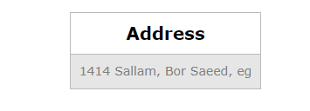
3)SELECT SUM(Appointment.Cost) AS Total_Cost
FROM Appointment
WHERE Appointment.Patient_ID = 12527
AND Appointment.Date >= DATE_SUB(CURDATE(), INTERVAL 3 YEAR);
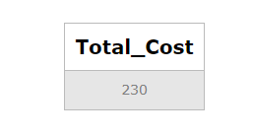
4)SELECT p.Name AS Patient_Name, d.Name AS Doctor_Name, a.Date, a.Start_Time, a.End_Time, a.Cost, a.Status, a.Patient_Diagnosis
FROM Appointment a
INNER JOIN Patient p ON a.Patient_ID = p.Patient_ID
INNER JOIN Doctor d ON a.Doctor_ID = d.Doctor_ID;
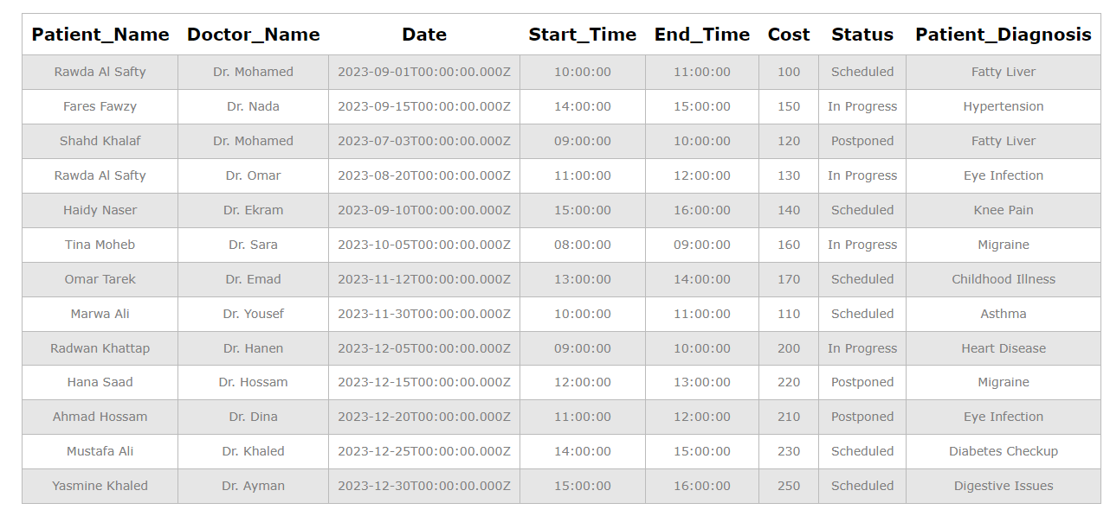

5)SELECT a.Date, a.Start_Time, a.End_Time, a.Cost, a.Status, a.Patient_Diagnosis
FROM Appointment a
INNER JOIN Patient p ON a.Patient_ID = p.Patient_ID
WHERE p.Name = 'Omar Tarek';
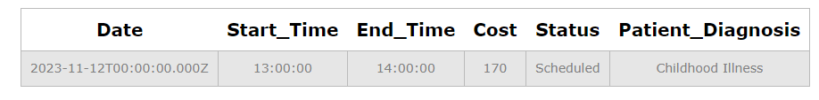
6)SELECT a.Date, a.Start_Time, a.End_Time, a.Cost, a.Status, a.Patient_Diagnosis
FROM Appointment a
INNER JOIN Doctor d ON a.Doctor_ID = d.Doctor_ID
WHERE d.Name = 'Dr. Mohamed'
AND a.Date BETWEEN '2023-09-01' AND '2023-09-30';

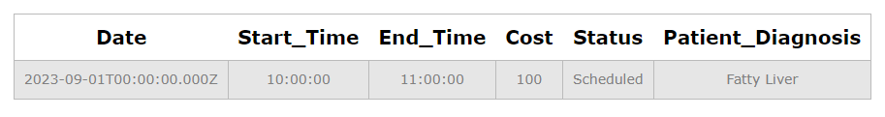
7)SELECT d.Name AS Doctor_Name, COUNT(*) AS Total_Appointments
FROM Doctor d
INNER JOIN Appointment a ON d.Doctor_ID = a.Doctor_ID
GROUP BY d.Name;

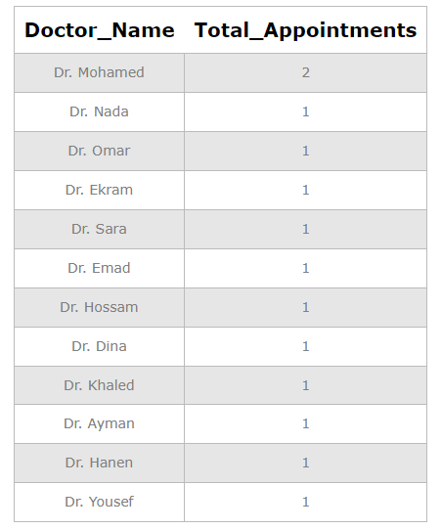

8)SELECT Status, AVG(Cost) AS Average_Cost
FROM Appointment
GROUP BY Status;
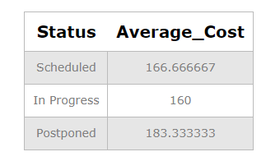

9)select *
from Appointment;

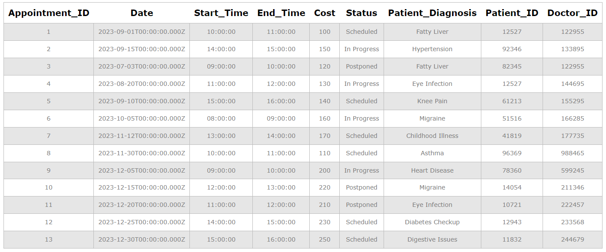
10)UPDATE Appointment
SET Status = 'Postponed'
WHERE Appointment_ID = 1;
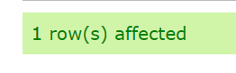

11)select *
from Appointment;
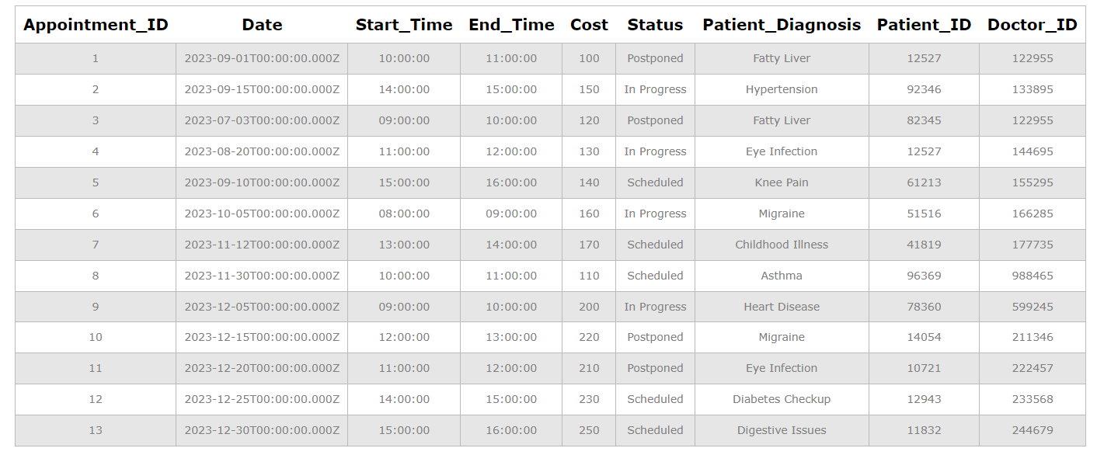

12)DELETE FROM Appointment
WHERE Appointment_ID = 13;
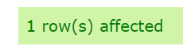

13)select *
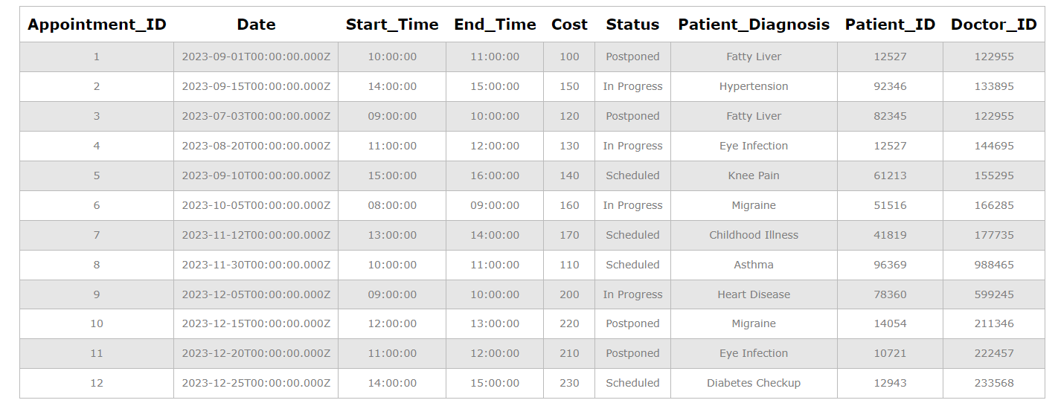
from Appointment;

14) truncate table Appointment;

