STEP 2 — Architecture (Output)
Deliverable ຂອງ STEP 2 ຕາມ Book 3 (Prompt) + Book 2 Phase 2. ອ້າງອີງ Book 1: ຫົວຂໍ້ 3, 9, 22, 26, 33, 39. Deliverable ບັງຄັບ 5 ອັນ: Architecture Diagram, Module Dependency Diagram, Google Drive Folder Tree, Google Sheets Schema (ຮ່າງ), Sequence Diagram.
⚠ STEP 1 Approved (99/100), ADR-002 Approved. STEP 2 ອອກແບບໂຄງສ້າງລວມ ໂດຍຍຶດ KISS/YAGNI (ຫົວຂໍ້ 22.2) — ບໍ່ໃສ່ pattern ລະດັບ Enterprise.

1. Architecture Diagram (Layered)
ລະບົບແບ່ງເປັນ 4 ຊັ້ນ (Layered Architecture, ຫົວຂໍ້ 22.1). ກົດເຫຼັກ: UI ຫ້າມຮຽກ Google Sheets/Drive ໂດຍກົງ — ຕ້ອງຜ່ານ Service → Repository ສະເໝີ. ການແຍກຊັ້ນນີ້ຊ່ວຍໃຫ້ຂະຫຍາຍສູ່ ERP ໄດ້ໃນອະນາຄົດ (ຫົວຂໍ້ 57).
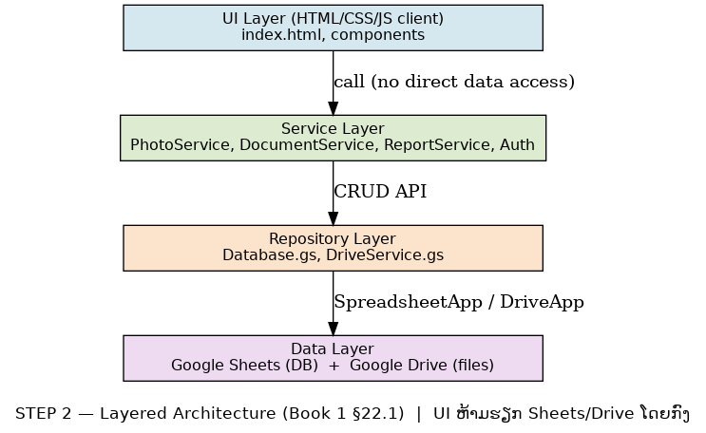
ຮູບ 1 — Layered Architecture (UI → Service → Repository → Data)

ໜ້າທີ່ຂອງແຕ່ລະຊັ້ນ
- UI Layer: HTML/CSS/JS ຝັ່ງ client (index.html + components) — ສະແດງຜົນ ແລະຮັບ input ເທົ່ານັ້ນ.
- Service Layer: PhotoService, DocumentService, ReportService, Auth — ໂຕ businesslogic + ກວດ Feature Toggle (ຫົວຂໍ້ 43).
- Repository Layer: Database.gs (Sheets), DriveService.gs (Drive) — CRUD + Validation ບ່ອນດຽວ (ຫົວຂໍ້ 22.1).
- Data Layer: Google Sheets (DB) + Google Drive (ໄຟລ໌).

2. Module Dependency Diagram
ຄວາມສຳພັນລະຫວ່າງ Module (ຫົວຂໍ້ 39). Code.gs ເປັນ Entry point; ທຸກ Service ຂຶ້ນກັບ Repository; Repository ຂຶ້ນກັບ Utils/Config. ບໍ່ມີ circular dependency.
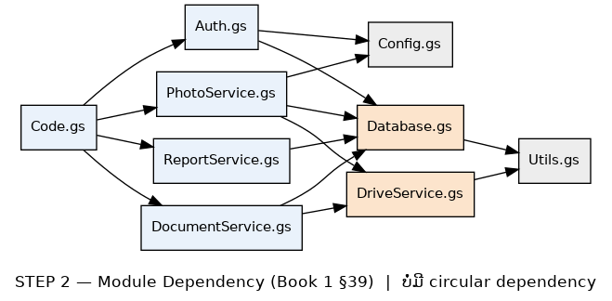
ຮູບ 2 — Module Dependency (ບໍ່ມີ circular)

3. Google Drive Folder Tree
ໂຄງສ້າງ Folder Production ຕາມ ຫົວຂໍ້ 3.2 — ປັບໃຫ້ຕົງ Business ຮ້ານຖ່າຍຮູບ (Category = event/id/restoration/general).
[CompanyName]_DataArchive/
├── Photos/
│ └── {Year}/{Month}/{Category}/{CustomerCode}/
├── Thumbnails/ (cache ຂອງ Preview)
├── Documents/
│ └── {Category}/{Year}/
├── Temp/ (upload ຊົ່ວຄາວ, clear ທຸກ 24 ຊມ.)
├── RecycleBin/ (soft-delete, ລຶບຖາວອນ 30 ວັນ)
├── Archive/ (ຂໍ້ມູນເກົ່າ 1–2 ປີ)
├── Backups/
│ └── Sheets_Backup/{Year}/{Month}/
└── System/ (Templates, Logo, Config)

⚠ Category ຄ່າທີ່ຍອມຮັບ: general, event, id, restoration (ຜູກ Field Category ໃນ Sheet Photos — Section 4).

4. Google Sheets Schema (ຮ່າງ)
ຮ່າງ Schema ເບື້ອງຕົ້ນ (ຈະ finalize ໃນ Phase 3/STEP 3). ທຸກ Sheet ມີ Primary Key ແລະ Field ມາດຕະຖານ (ຫົວຂໍ້ 6, 10). Field Status ອີງ State Machine (ຫົວຂໍ້ 55); EventType ອີງ Event Log (ຫົວຂໍ້ 52).

Sheet: Users
Field | Type | ໝາຍເຫດ
UserID | String | PK
Email | String | Google account (OAuth)
Name | String
Role | Enum | Admin/Editor/Viewer (ຫົວຂໍ້ 13)
Active | Boolean
CreatedAt | Datetime

Sheet: Customers
Field | Type | ໝາຍເຫດ
CustomerCode | String | PK (Naming ຫົວຂໍ້ 10)
Name | String
Phone | String
Note | String
CreatedAt | Datetime

Sheet: Photos
Field | Type | ໝາຍເຫດ
PhotoID | String | PK
CustomerCode | String | FK → Customers
Category | Enum | general/event/id/restoration
DriveFileID | String | ID ໃນ Drive
ThumbID | String | Thumbnail
UploadedBy | String | FK → Users
CreatedAt | Datetime

Sheet: Orders
Field | Type | ໝາຍເຫດ
OrderID | String | PK
CustomerCode | String | FK → Customers
Status | Enum | New/Uploaded/Verified/Printing/Completed/Archived (ຫົວຂໍ້ 55)
Type | Enum | print/event/id/restoration
AssignedTo | String | FK → Users
UpdatedAt | Datetime

Sheet: Documents
Field | Type | ໝາຍເຫດ
DocID | String | PK
CustomerCode | String | FK → Customers
OrderID | String | FK → Orders (nullable)
DriveFileID | String
CreatedAt | Datetime

Sheet: AuditLogs / EventLog
Field | Type | ໝາຍເຫດ
LogID | String | PK
EventType | Enum | ຫົວຂໍ້ 52
UserID | String | FK → Users
Detail | String
Timestamp | Datetime

5. Sequence Diagram (Upload → Drive → Sheets → Search → Print)
ລຳດັບການເອີ້ນຂອງ Use Case ຫຼັກ ຜ່ານ Layer (ຫົວຂໍ້ 22.1). Thumbnail ສ້າງເປັນ Background Job (ຫົວຂໍ້ 46).
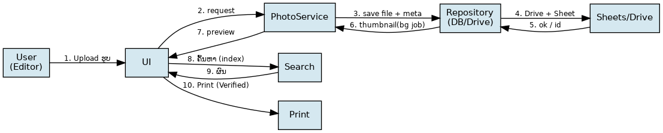
ຮູບ 3 — Sequence: Upload → Drive → Sheets → Search → Print

6. ADR (Architecture Decision Records)
ADR | Status | ສະຫຼຸບ
ADR-001 | Accepted | Layered Architecture — ແຍກ UI/Service/Repository/Data (ຫົວຂໍ້ 22.1)
ADR-002 | Accepted | Order Tracking (Lite) ໃນ v1.0 — State Machine, ບໍ່ມີ POS
ADR-003 | Accepted | Simple Repository — ບໍ່ໃສ່ pattern Enterprise (YAGNI ຫົວຂໍ້ 22.2)

7. Deliverables & Acceptance (STEP 2)

Deliverables (ບັງຄັບ 5 + ADR)
- Architecture Diagram (ຮູບ 1)
- Module Dependency Diagram (ຮູບ 2)
- Google Drive Folder Tree
- Google Sheets Schema (ຮ່າງ)
- Sequence Diagram (ຮູບ 3)
- ADR-001/002/003

Acceptance (ຫົວຂໍ້ 25 + Phase 2)
- ທຸກ Layer ແຍກໜ້າທີ່ຊັດເຈນ — UI ບໍ່ຮຽກ Sheets/Drive ໂດຍກົງ ✔
- ບໍ່ມີ circular dependency ✔
- ບໍ່ໃສ່ pattern ທີ່ຂັດ YAGNI ✔
- ADR ຫຼັກ Accept ✔

8. ສະຫຼຸບ (Code Review) & ວິທີທົດສອບ
ສ້າງຫຍັງ: STEP 2 Architecture doc + 3 diagram (arch/mod/seq) + Drive Tree + Sheets Schema ຮ່າງ + ADR.
ວິທີທົດສອບ: (1) Design Review ຮ່ວມທີມ. (2) ກວດ dependency ບໍ່ circular. (3) ຢືນຢັນ Schema ພຽງພໍກ່ອນ Phase 3.
ຂັ້ນຕໍ່ໄປ: ຫຼັງ Accept STEP 2 → STEP 3 (Database) — finalize Schema + ຂຽນ Database.gs.

