STEP 9 — Photo Archive Core (Output)
Deliverable ຂອງ STEP 9 ຕາມ Book 3 (Prompt) + Book 2 Phase 9 — ຫົວໃຈຂອງລະບົບ. ອ້າງອີງ Book 1: §13, §45, §46, §52, §53, §55, §56. ຂຽນ src/PhotoService.gs + client photos.html + CSRF (Auth.gs) + Photos.Status (schema 1.1.0).
⚠ STEP 8 Approved (100/100). ໃສ່ 7 ຂໍ້ຄົບ: Upload Pipeline, CSRF, Duplicate Detection (SHA256), Lazy Preview, Photo State Machine, Batch Upload+Progress, Error Recovery.

1. Upload Pipeline (§53)
Pipeline ເຕັມ ຕັ້ງແຕ່ client ຈົນ audit — ຜ່ານ CSRF + RBAC ກ່ອນເລີ່ມ:
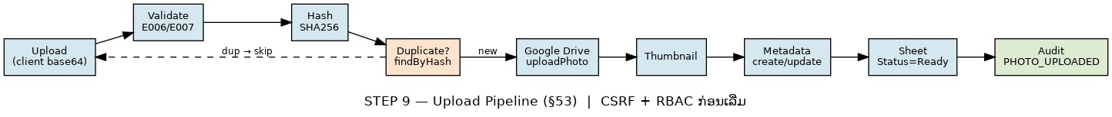
ຮູບ 1 — Upload Pipeline: Upload→Validate→Hash→Dup→Drive→Thumbnail→Metadata→Sheet→Audit

2. CSRF Protection (ເລື່ອນມາຈາກ STEP 5)
- csrf token ຜູກກັບ session (ສ້າງຕອນ login, ຄືນໃນ login().csrf).
- ທຸກ mutating action (photoUpload/batch/archive) ຮຽກ requireCsrf(token, csrf) ກ່ອນ — mismatch → audit CSRF_FAILED + E005.
- client ເກັບ window.__csrf ຈາກ bootstrap login ແລ້ວສົ່ງທຸກ upload.

3. Duplicate Detection (SHA256)
- computePhotoHash(bytes) → SHA256 hex; findPhotoByHash() ກວດ Photos.Hash (ວາງໄວ້ STEP 3).
- ພົບຊ້ຳ → ຄືນ {duplicate:true, existing:PhotoID} + audit PHOTO_DUPLICATE (ບໍ່ upload ຊ້ຳ). override ໄດ້ດ້ວຍ allowDuplicate.

4. Photo State Machine (§55)
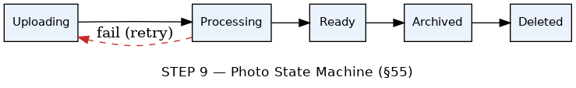
ຮູບ 2 — Photo State: Uploading→Processing→Ready→Archived→Deleted (fail→Uploading retry)
- Field Photos.Status (enum ໃນ Config.ENUMS.PhotoStatus). Ready = ພ້ອມ Preview; Archived = archivePhoto() ຍ້າຍໄຟລ໌ Drive.

5. Batch Upload + Progress + Error Recovery
- client loop upload ເທື່ອລະໄຟລ໌ → progress bar ອັບເດດ % ຕໍ່ໄຟລ໌ (SLA Upload ≤5s/ໄຟລ໌ §56).
- Error Recovery: ໄຟລ໌ໃດລົ້ມ → ໝາຍ ✗ ແລ້ວໄປໄຟລ໌ຕໍ່ໄປ (ບໍ່ຍົກເລີກທັງ batch). server photoBatchUpload() ຄືນ {success, failed, duplicates}.
- record ທີ່ upload ລົ້ມ ຄົງ Status=Uploading ໄວ້ ເພື່ອ retry (ບໍ່ລຶບ).

6. Lazy Preview Gallery
- listPhotos() ຄືນ field ຫຍໍ້ (thumbUrl); gallery ໃຊ້ <img loading="lazy"> — ໂຫຼດ thumbnail ເມື່ອເລື່ອນເຫັນ (ຮູບຫຼາຍບໍ່ໜັກ).
- States: skeleton ຂະນະໂຫຼດ, empty ("ຍັງບໍ່ມີຮູບ"), error — ຈາກ Design System STEP 7/8.

7. Deliverables & Acceptance (STEP 9)

Deliverables
- PhotoService.gs (hash, dup, pipeline, state, batch, archive)
- CSRF (Auth.gs: getCsrfToken/requireCsrf + login.csrf)
- photos.html (upload zone, batch+progress, lazy gallery)
- Photos.Status + ENUMS.PhotoStatus (schema 1.1.0)
- style: upload-zone/progress/gallery/thumb; Code.gs route photos.list

Acceptance (§25 + Phase 9)
- Workflow ຄົບ end-to-end (§53) ✔
- Upload ≤5s/ໄຟລ໌, lazy preview (§56) ✔
- ຮູບ/Metadata ບໍ່ສູນ + State ຖືກ (§55) ✔
- Duplicate ກວດດ້ວຍ SHA256 ✔
- CSRF + RBAC ບັງຄັບທຸກ mutating call ✔
- Batch: ໄຟລ໌ລົ້ມບໍ່ຍົກເລີກທັງໝົດ ✔

8. ສະຫຼຸບ (Code Review) & ວິທີທົດສອບ
⚠ Schema 1.1.0 (Photos +Status): DB ທີ່ສ້າງກ່ອນໜ້າ ຕ້ອງ re-run createDatabase() (dev — v1.0 ຍັງບໍ່ deploy). Production ໃຫ້ໃຊ້ ALTER migration (ບໍ່ clear).
ໄຟລ໌ທີ່ເພີ່ມ/ແກ້: PhotoService.gs (ໃໝ່), photos.html (ໃໝ່), Auth.gs (CSRF), Config.gs (Status/enum/ver), Code.gs (route), index.html (view+router+bootstrap), style.html. Syntax ຜ່ານ node --check.
ວິທີທົດສອບ (ໃນ GAS): (1) re-run createDatabase→seed. (2) photoUpload(payload,token,csrf) → Status Ready + ໄຟລ໌ໃນ Drive. (3) upload ຮູບເກົ່າຄືນ → duplicate. (4) csrf ຜິດ → E005 + CSRF_FAILED. (5) batch 3 ໄຟລ໌ (1 .exe) → 2 ok + 1 fail (E006).
ຂັ້ນຕໍ່ໄປ: ຫຼັງ Accept STEP 9 → STEP 10 (Document Management).

