create table PERSON (

driver_id varchar(10) primary key,

name varchar(20),

Address varchar(30)

);

create table CAR (

regno varchar(20) primary key,

model varchar(20),

Year int

);

create table ACCIDENT (

report_number int primary key,

accd_date date,

location varchar(30)

);

create table OWNS (

driver_id varchar(10),

regno varchar(20),

foreign key (driver_id) references PERSON,

foreign key (regno) references CAR

);

create table PARTICIPATED (

driver_id varchar(10),

regno varchar(20),

report_number int,

damage_amount int,

foreign key (report_number) references ACCIDENT ON DELETE CASCADE,

foreign key (driver_id) references PERSON,

foreign key (regno) references CAR

);

-- ii

insert into PERSON values (‘1’,’keoul’,’address 1’);

insert into PERSON values (‘2’,’dhruvik’,’address 2’);

insert into PERSON values (‘3’,’nimesh’,’address 3’);

insert into PERSON values (‘4’,’devesh’,’address 4’);

insert into PERSON values (‘5’,’ansh’,’address 5’);

OUTPUT:

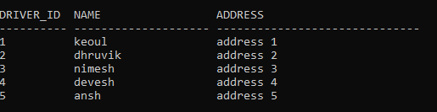

insert into CAR values (‘1’,’i20’,2019);

insert into CAR values (‘2’,’scorpio’,2010);

insert into CAR values (‘3’,’xuv500’,2009);

insert into CAR values (‘4’,’jetta’,2013);

insert into CAR values (‘5’,’polo’,2017);

OUTPUT:

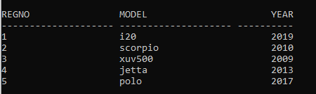

insert into ACCIDENT values (1,DATE ‘2020-12-7’,’address 1’);

insert into ACCIDENT values (2,DATE ‘2012-3-31’,’address 2’);

insert into ACCIDENT values (3,DATE ‘2013-6-25’,’address 3’);

insert into ACCIDENT values (4,DATE ‘2018-11-17’,’address 4’);

insert into ACCIDENT values (5,DATE ‘2001-1-16’,’address 5’);

OUPUT:

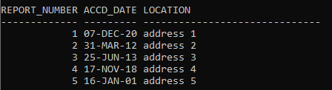

insert into OWNS values (‘3’,’4’);

insert into OWNS values (‘5’,’5’);

insert into OWNS values (‘2’,’4’);

insert into OWNS values (‘2’,’3’);

insert into OWNS values (‘2’,’1’);

OUTPUT:

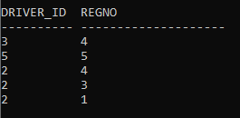

insert into PARTICIPATED values (‘3’,’4’,1,11000);

insert into PARTICIPATED values (‘5’,’5’,4,12000);

insert into PARTICIPATED values (‘2’,’4’,2,70800);

insert into PARTICIPATED values (‘2’,’3’,3,2800);

insert into PARTICIPATED values (‘2’,’1’,5,68000);

OUTPUT:

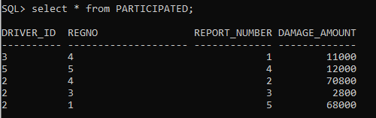

-- iii

update PARTICIPATED

set damage_amount = 25000

where report_number = 2 and regno = 4;

OUTPUT:

Before :



After:

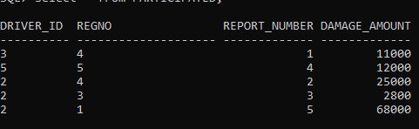

-- iv

delete from ACCIDENT where (extract(year from accd_date)) = 2018;

OUTPUT:

Before:

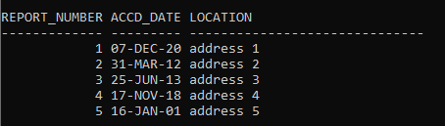

After:

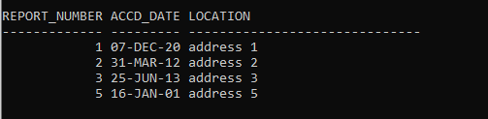

-- v

alter table PERSON add AGE INT;

OUTPUT:

Before:



After:

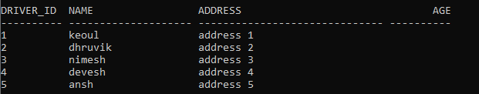

alter table PERSON drop column AGE;

OUTPUT:

Before:



After:



-- vi

alter table CAR add constraint check (Year > 2008);

OUTPUT:

