1. Select count(*) as total from OWNS o,PARTICIPATED p, ACCIDENT a Where o.driver_id = p.driver_id and p.report_number = a.report_number and (extract(year from a.accd_date)) =2008;

OUTPUT:

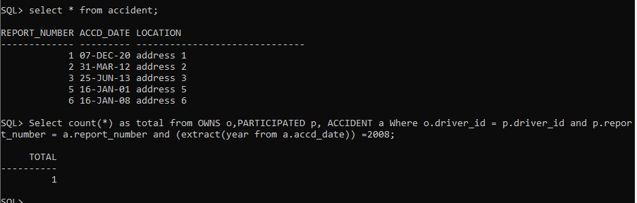

1. Select count(*) as total from CAR c,PARTICIPATED p where c.model=’i20’ and c.regno = p.regno;

OUTPUT:

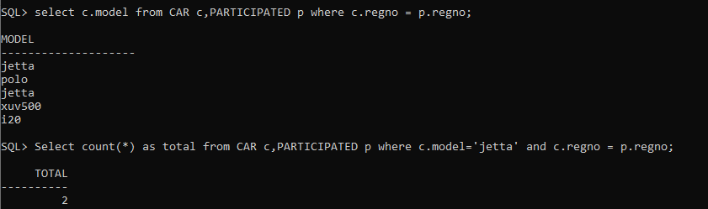

1. select name as owner_name, count(*) as "no. of accidents", sum(p.damage_amount) as "total damage amount" From person pe, participated p where p.driver_id = pe.driver_id group by name order by "total damage amount";

OUTPUT:

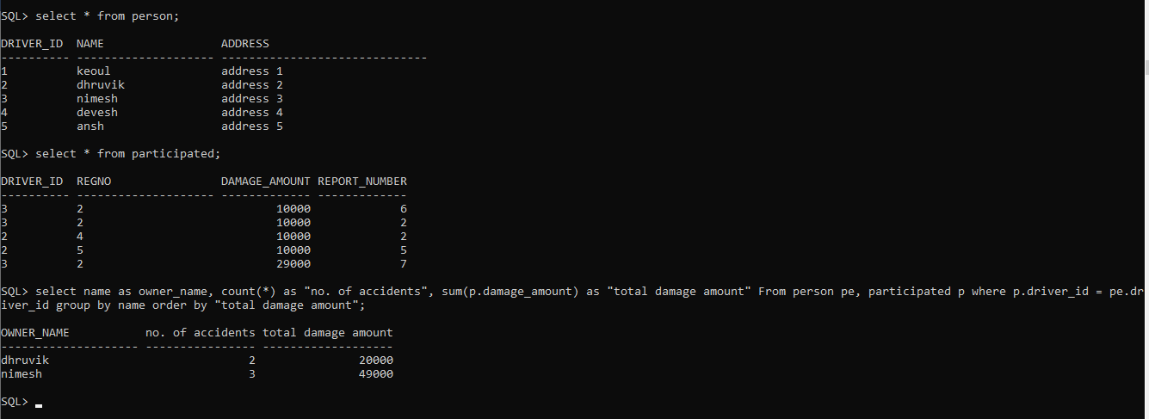

1. Select pe.driver_id , (extract(year from a.accd_date)) as year, count(*) as total from person pe, participated p, accident a

Where a.report_number = p.report_number and pe.driver_id = p.driver_id

Group by pe.driver_id , (extract(year from a.accd_date))

Having count(*)>2;

OUTPUT:

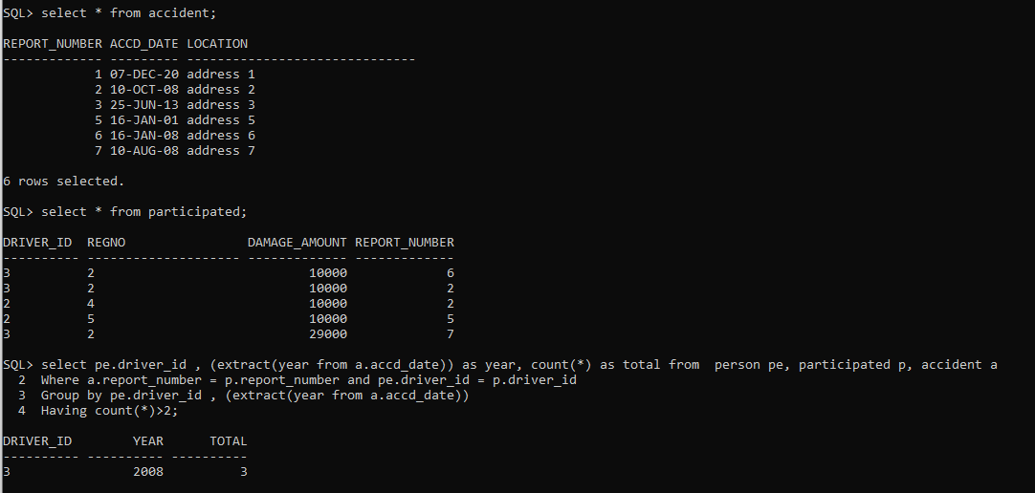

1. (select * from person)

Minus

(select person.driver_id,name,address from person,participated where person.driver_id = participated.driver_id);

