Description of system
The advances within WiFi positioning system(WPS) has promoted business interest, with that there has been a huge flow of funding into precise localization of a signal using widely available infrastructure and data. WiFi fingerprinting based on machine learning are commonly used in literature as they provide the highest accuracy among all other technique. It compares the current fingerprint to a prepossessed finger print database according to multiple factors: a distance function, data representation used by the machine learning algorithm, a function to determine the boundaries. In this paper we present a comprehensive study using 100 data-points to create a fingerprinting database. The results shown in this paper demonstrate that factors that should be taken into account to improve the accuracy of current systems. This paper compares two 2/3 methods on how to process the data. This includes k-means, k-NN algorithm, Sorensen distance. The IPSs based on k-NN are improved by just selecting the appropriate configuration (mainly distance function and data representation).

Introduction
WPS has garnered a lot of attention within the current market with an expected $2.6 billion market in 2018 and is only expected to grow. The ability to use the current infrastructure without any additional investment to precisely localize is a tempting opportunity. Context-aware application that employ user’s location need precise location base service, GPS is not able to accurately locate indoor position.

There is a large number of technologies in development indoor positioning systems (IPSs): radio-frequency identification (RFID), Bluetooth , WLAN or Wi-Fi, ultrasound, magnetic field variations, and even LED light

Wi-Fi is a good choice for indoor positioning technology due to the ubiquity of wireless access points, embedded Wi-Fi connectivity in modern mobile phones, and the use of preexisting WiFi network infrastructure. The IPSs based on Wi-Fi fingerprinting are preferred to those based on the propagation model, angle of arrival, time of arrival and time difference of arrival because they do not require any very specialized hardware, line-of-sight to the emitter and knowing emitter’s. This paper explores three different techniques to analyze data. Literature currently only explores and data analyses aspect of the WPS missing out on an essential components, data collection. This paper tries to shed some light and the problems with RSS data.

Scope of system
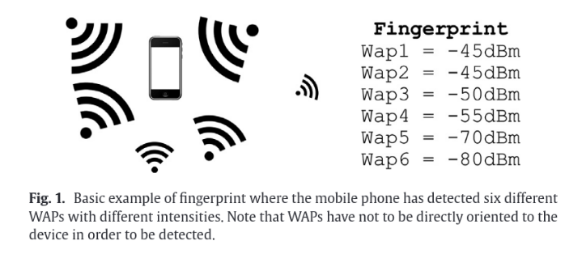
Data

Problems with data collection and RSSI

Radio-wave propagation through indoor environments has no guarantee that the received signal strength indicator (RSSI) values from a given Access Point collected at different location inside a building would reflect the architectural aspects such as similarity among WiFi fingerprints taken at the same floor. RSSI is also is affected by many other aspects the WiFi module used by the device, configuration of access points, the angle of the device, and random noise in the system. Some WAPs can appear and disappear in a fingerprint with respect to a prior fingerprint taken at the same place less than a second before. This behavior tends to occur with weak signals (very low RSS values).

Although there exists a general model to represent the RF signal propagation loss, it is not possible to create an appropriate model for a particular scenario since it would be altered by many factors.

To negate the problems faced by RSSI collection we emply Wi-Fi fingerprinting machine learning techniques (k-NN, neural networks, support vector machines, decision trees).

Issues with software
The first issue is the lack of a deep comparison of disance/similarity measurements for the k-NN algorithm, Wi-Fi fingerprinting this is because most publish data do not publish the method of data collection and the database which was used to test the algorithm. Moreover, most of observations contain missing values and the Euclidean distance may not be appropriate to deal with them.

The second issue is that the logarithmic nature of the Wi-Fi fingerprints is not usually considered and the differences between fingerprints are linearly computed. For instance, the difference between a received signal strength of —100 dBm and —97 dBm has the same weight in fingerprinting than the difference between —60 dBm to —57 dBm when the they are linearly computed. The difference is only 3 dBm in both cases, but the power differences in Watts (W) are 0.1 pW and 1nW(1000 pw) respectively. Although this difference is significantly different in both cases.

The third issue is that fingerprints contain information provided by far detected WAPs. Some previous works only consider the strongest signals to provide indoor locations, so they have introduced clusterin techniques to remove, irrelevant information from fingerprints. They assume that this information should be removed because it injects noise. In contrast, some other works do not apply clustering. It is not clear whether applying clustering benefits or worsens the accuracy of IPSs.

Implementation Plan:

- Hardware Selection
  - Search current off the shelf hardware for three access points
- Hardware Testing and Firmware Exploration
  - Implementing code that will measure the signal strength from access points and create RSSI fingerprint database.
- Create Fingerprinting database
  - Develop code to measure the signal strength of the user transponder
    - Care taken to reduce “collisions” of data packets
  - All data transmitted to master node and assembled into a list

- Processing data
  - Using machine learning, clustering and k-NN algorithm to create model.
  - Analyze model to remove any bias
- Deploy and test system in the field

Hardware Selection

Design

Analysis

Results
Conclusion

