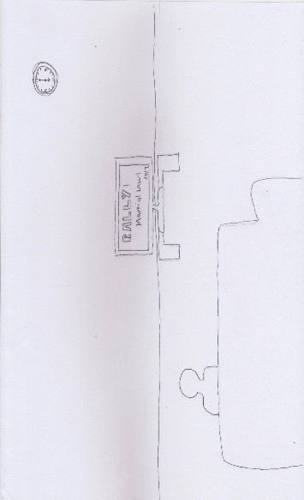Once upon a time, there was a young man who did not believe in all the wrongdoings the Marcos regime had created.

 Everyday, he would hear news and would read articles about how the Martial Law badly affected the nation.

One day, his class went on a field trip to a historical museum. He learned about all the things that had happened during the Marcos era.

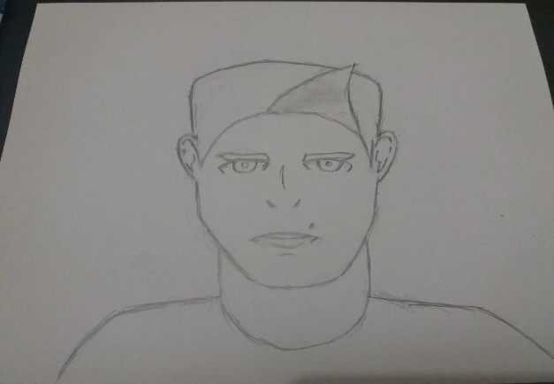

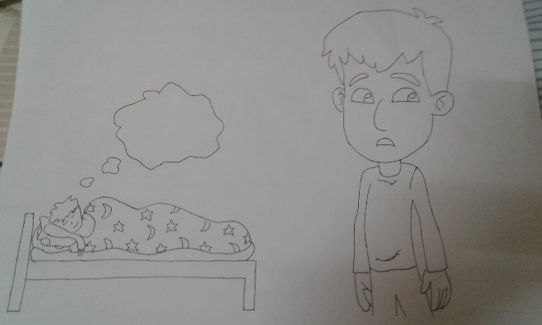

Because of that, when he fell asleep on that night, he went back in time through his dream and saw through the eyes of another person in the past who was being tortured.

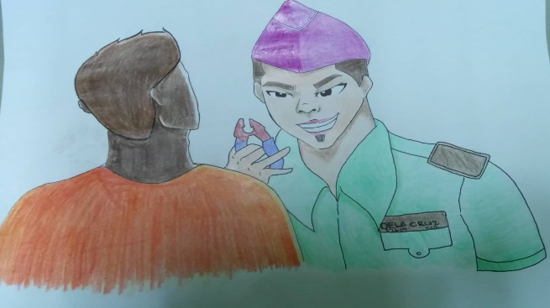

Because of that, he felt afraid, but a woman helped him escape. The young man suddenly fell in love with the mysterious woman.

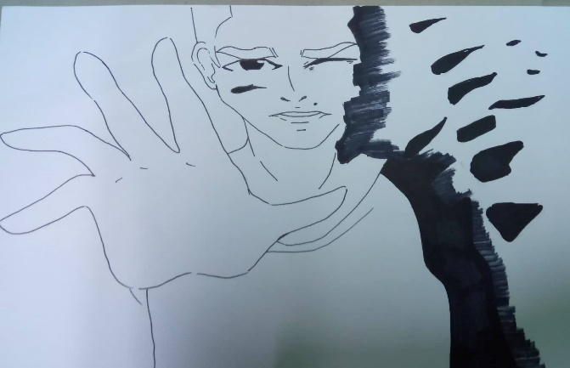

Until finally, he woke up and, as he looked around, noticed a portrait which resembles the woman he had met in his dream.

Just a dream

Group 1 11 kepler

Jean Acosta

Raphael Dingal

Gail Dela Cruz

JD Laguna

Nyah Regalado

Miguel Timoner