21ST CENTURY LITERATURE

THE BLAZE AND THE RAINDROP

GROUP 5

11 KEPLER

BAUTISTA, Elizabeth Joy

PULIS, Isaiah Janni

SIA, Angelee Marie

CASTELLANES, Geoseff Earl

GALDO, John

MACAPALLAG, Justin

**THE BLAZE AND THE RAINDROP**

Once upon a time there was a raindrop living under a big tree. He was alone until one day, a wild fire occurred and a blaze appeared.

When the raindrop saw the blaze, he approached her, introduced himself and soon they became friends. Every day they are telling stories and singing songs together.

The raindrop realized that he already fell in love with the blaze. Then, he decided to tell the blaze about his feelings. He’s not expecting anything in return from the blaze, but she told him that she feels the same way and to his surprise, he hugged the blaze.

The raindrop quickly disappeared. The blaze waited for a long time, hoping that the raindrop will return.

The season changes as the months go by. It’s already rainy season in the forest. Droplets of the rain started to fall. The blaze saw the raindrop not far away. She was very excited that she ran towards the raindrop immediately and forgot that it was raining.

A single droplet fell on her. As expected, she turned into steam and disappeared.

The raindrop expected to see the blaze; with her nowhere to be found he searched and searched the forest until the sun beated its heat upon him, he evaporated and came back as droplet of rain each time and every time he comes back, all he's left with is steam.

They could not understand why they couldn't see each other; the blaze when the ground is dry, the raindrop when the skies cry. Each storm, each forest fire, they always wonder why.

They wait and wait until the sun shines, until the rain falls. Until finally, the thunderstorm rang, and lightning struck creating fire from a pinewood buck. Then came blaze, greeting raindrop once again; it will be again their first and last after a century passed.

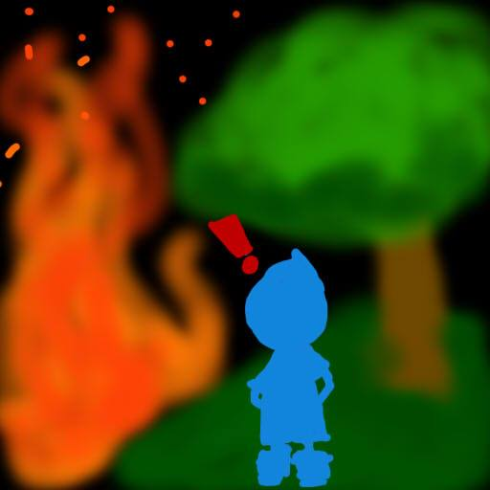

Once upon a time there was a raindrop living under a big tree. He was alone until one day, a wild fire occurred and a blaze appeared.

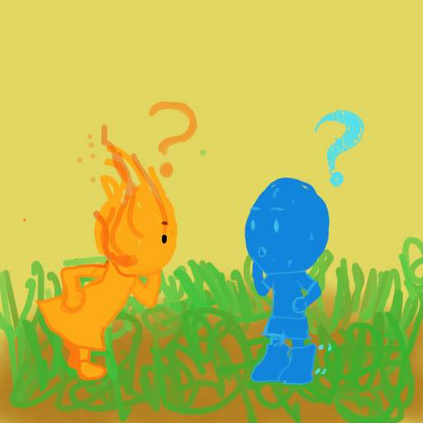

When the raindrop saw the blaze, he approached her, introduced himself and soon they became friends. Every day they are telling stories and singing songs together.



The raindrop realized that he already fell in love with the blaze. Then, he decided to tell the blaze about his feelings. He’s not expecting anything in return from the blaze, but she told him that she feels the same way and to his surprise, he hugged the blaze.

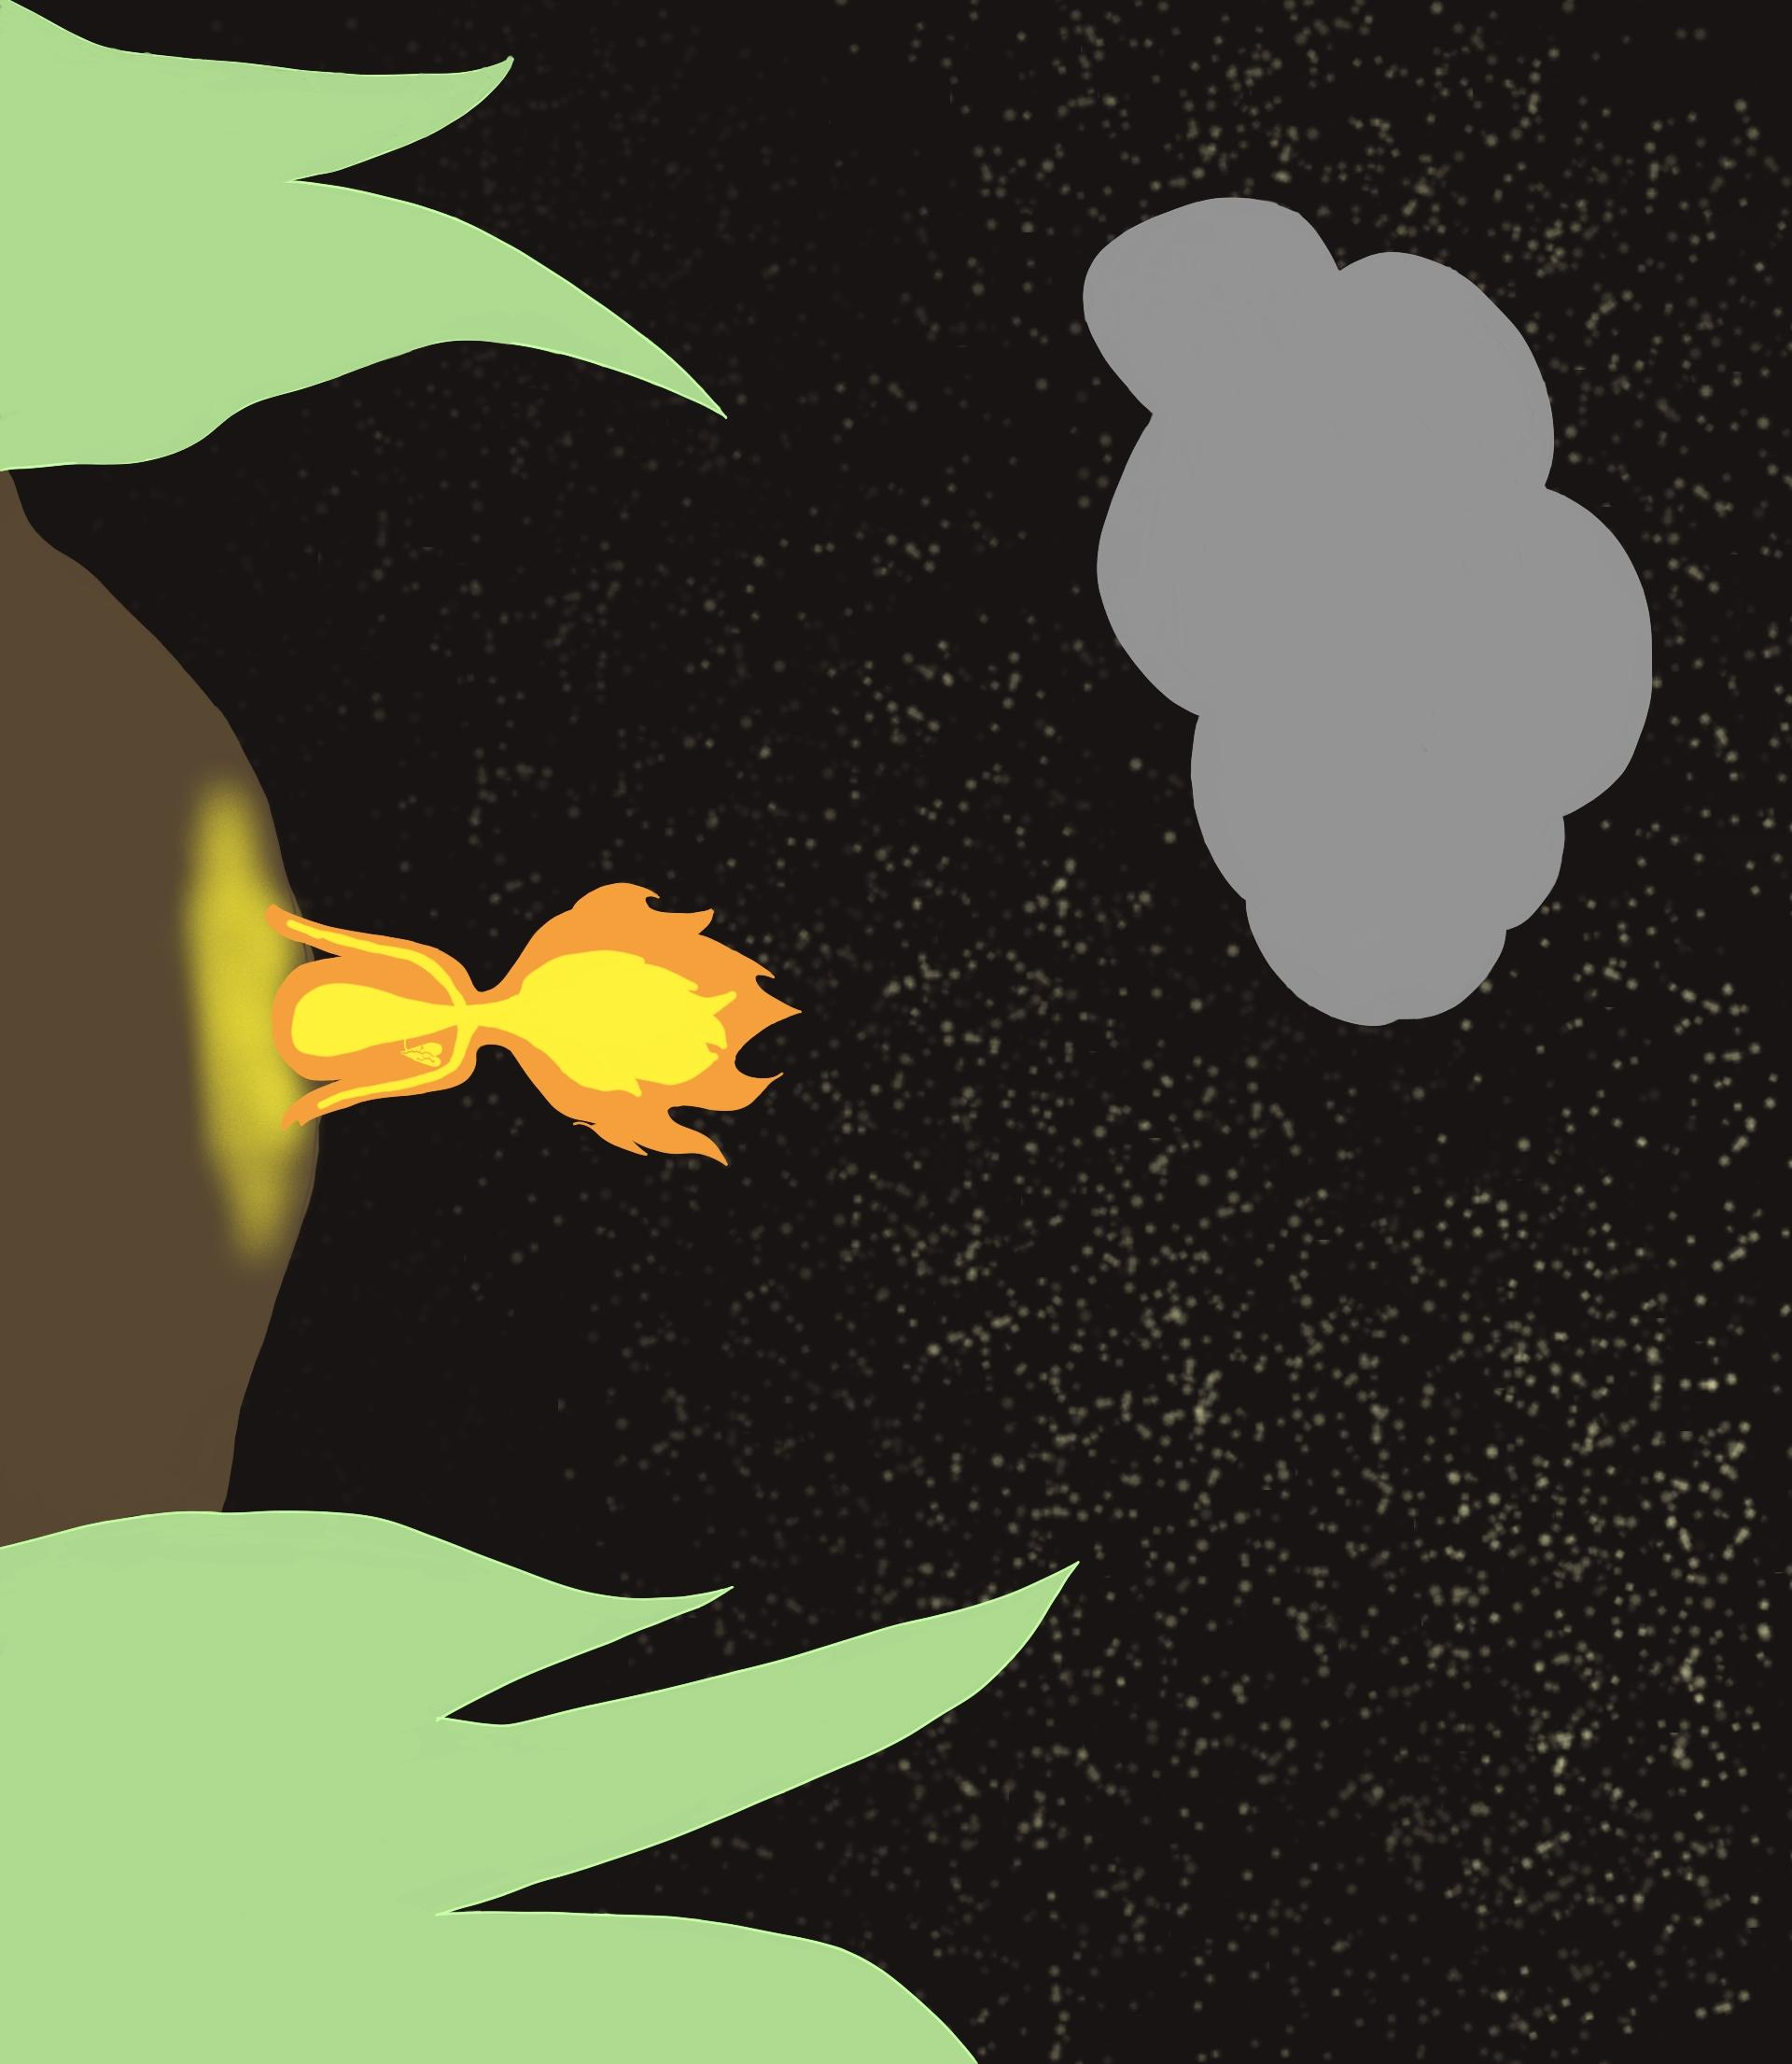

The raindrop quickly disappeared. The blaze waited for a long time, hoping that the raindrop will return.

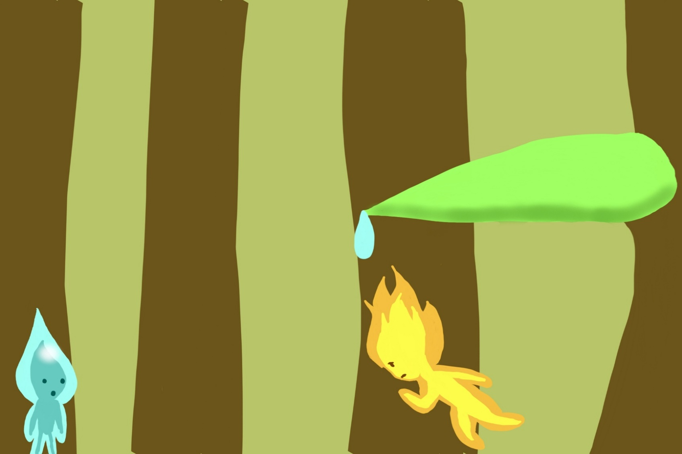

The season changes as the months go by. It’s already rainy season in the forest. Droplets of the rain started to fall. The blaze saw the raindrop not far away. She was very excited that she ran towards the raindrop immediately and forgot that it was raining.

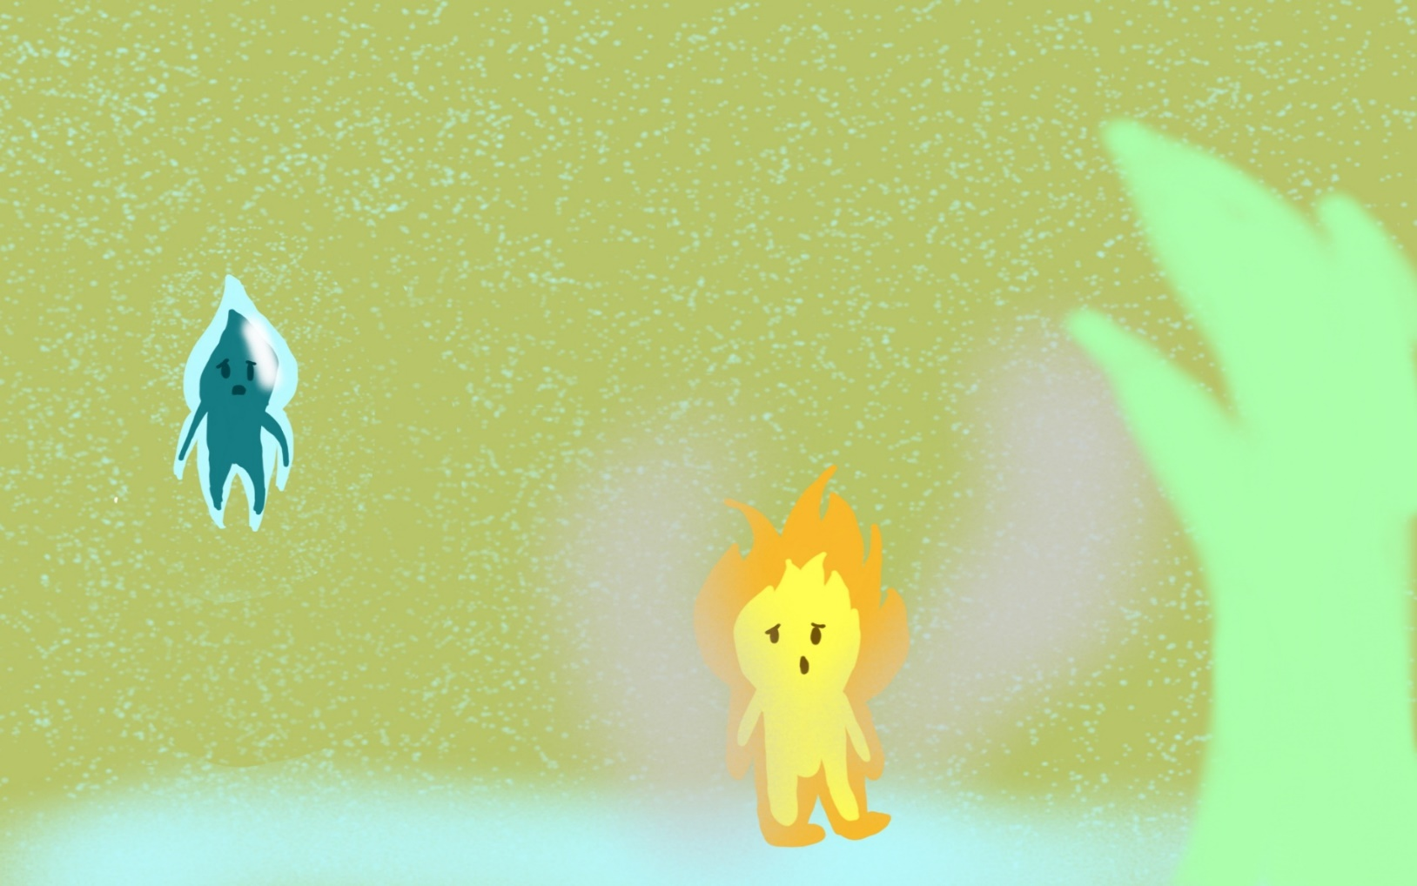

A single droplet fell on her. As expected, she turned into steam and disappeared.

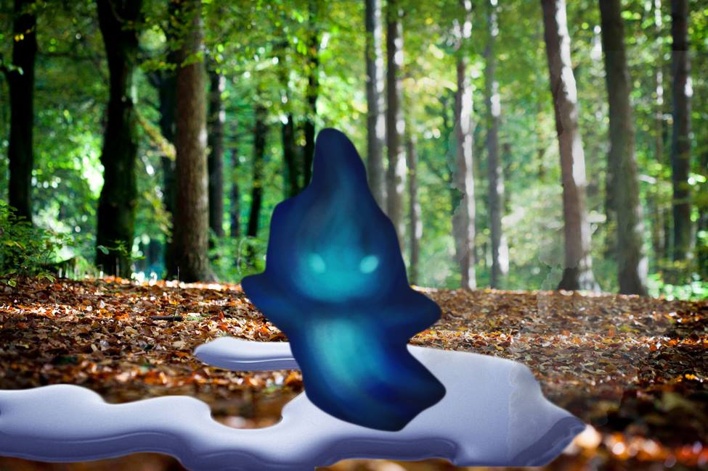

The raindrop expected to see the blaze; with her nowhere to be found he searched and searched the forest until the sun beated its heat upon him, he evaporated and came back as droplet of rain each time and every time he comes back, all he's left with is steam.

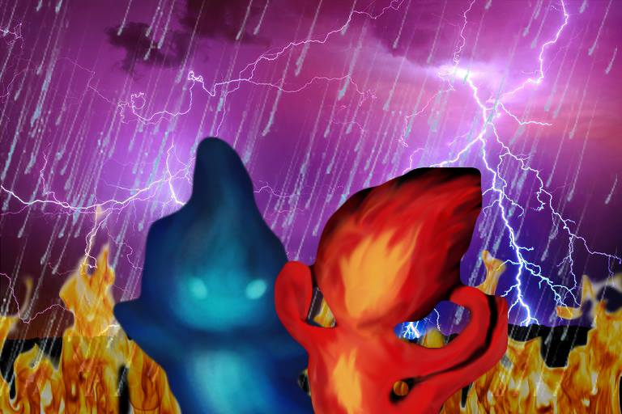

They could not understand why they couldn't see each other; the blaze when the ground is dry, the raindrop when the skies cry. Each storm, each forest fire, they always wonder why.

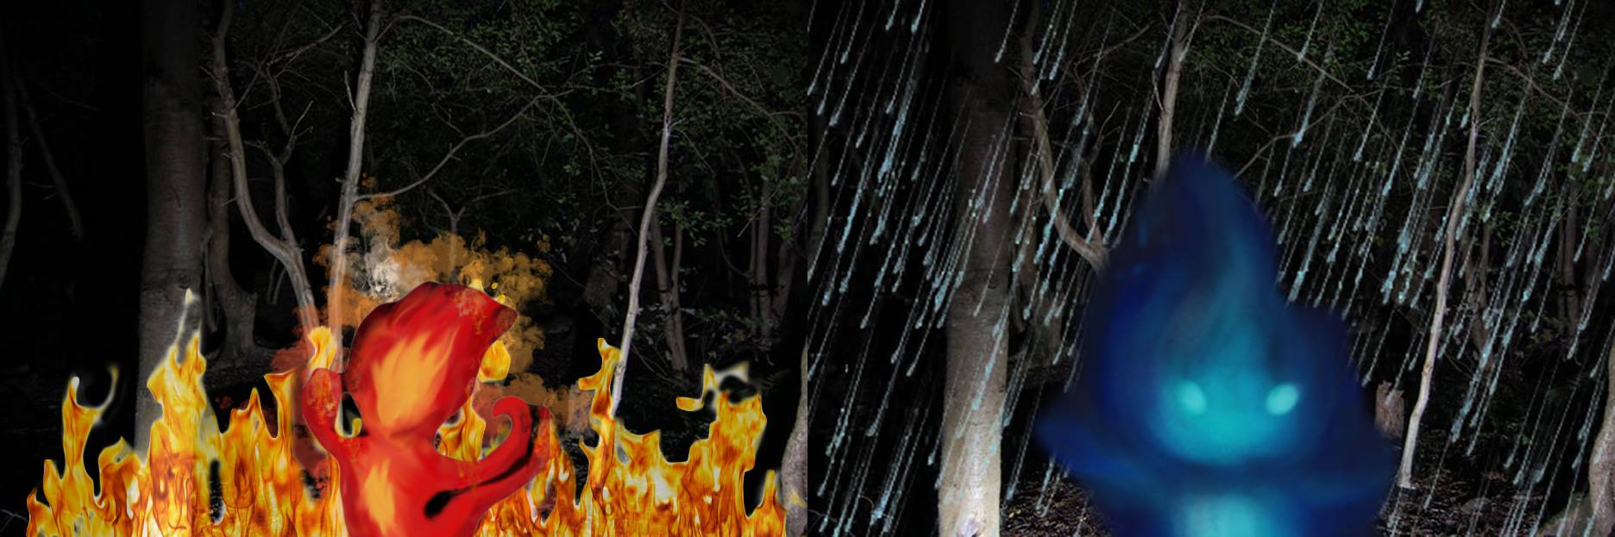

They wait and wait until the sun shines, until the rain falls. Until finally, the thunderstorm rang, and lightning struck creating fire from a pinewood buck. Then came blaze, greeting raindrop once again; it will be again their first and last after a century passed.