**INCEPTION REPORT**

**TEAM 8**

**Vision and Business Case:**

The main objective of the faculty facilitation system is to develop the CAS(Career Advancement Scheme) of the faculty based on R&D aspects. The prime concept here is to calculate the total no of points gained by the faculty on a particular time basis based on the programs attended by them essentially conferences, FDP(faculty development program), Conferences, Journals and Government projects. All these scores hereby are tracked by an administrator, in this case the principal acts as the administrator. To alert the faculty HOD should monitor their activities through CAS on monthly or quarterly basis so that they can be on par with the required no of points. In order to accomplish this procedure some key constraints are Max score is set to 1000 points and Barrier score is set to 500 points.

**Use-Case model-Functional Requirements:**

Actors: The Users within the system.

Primary Use Cases:

-Authentication (Credentials Verification)

Login: The authorized users only can access the data of the system by using the username and password.

Login Failure: This situation occurs when the user does not exist in the Database or else has not yet been given permission by the system.

-Authorization: The system will grant permissions to access the database only for the authorized users.

-Edit and Calculate points: Only administrators can edit the data and compute their points based on the programs attended. Not all users will have access to perform  this action in the system.

-Search: An authorized user such as HOD only can look through the database to monitor their activities monthly or quarterly basis.

**Supplementary specifications**

It includes non-functional requirements with an impact on architecture.

* The project should be written feasibly to ensure that any future progress can be done easily without affecting the whole system.
* The data needs to be updated when professors submit their new works and it should be defined for how long the reviews on professor works should be stored in the system.
* The professor’s works must be reviewed by only assigned people. When unauthorized people attempt to review their work it should be reported to the administrator.
* New works added by the professor to get reviewed must be updated in the database and for all users accessing the data quickly.
* The project is coded in a way that makes it platform-independent.
* A user’s unsuccessful login attempts must be recorded.
* The response time for which page loads must take less than two seconds.

**Glossary**

Authentication: The process of verifying the users’ identity.

Authorization: It is a security measure for determining the access related to information possessed by the system.

Flask: It is a lightweight WSGI web application framework written in python. It is a built-in development server and fast debugger. More information can be found on <https://en.wikipedia.org/wiki/Flask_(web_framework)>

**Risk list and management plan**

There are risks in the projects which are known and expected. Based on the severity of the risk and the stage at which the risk might occur, there would be a mitigation plan to avoid or remove the risk. In our project, the risk factors would be

* Technical risk is not being able to get the required data using the API when there might be a network issue or the other website is down.
* Resource risk would be the data not being documented on time by the other website when the points need to be updated.
* Scheduled risks would be something like not being able to develop the site for an organization with the required options within the given time.

**Prototype**

Faculty facilitation system consists of the following pages. In this prototype the important pages that are to be displayed on the website are shown. Note that this is just the layout design of the features to be present in the website in further steps while developing the website all these functionalities will work. This prototype is made in Marvel app which allows to make prototypes for websites and apps. You can view this prototype by clicking on the below shared link <https://marvelapp.com/prototype/267i2g6g>

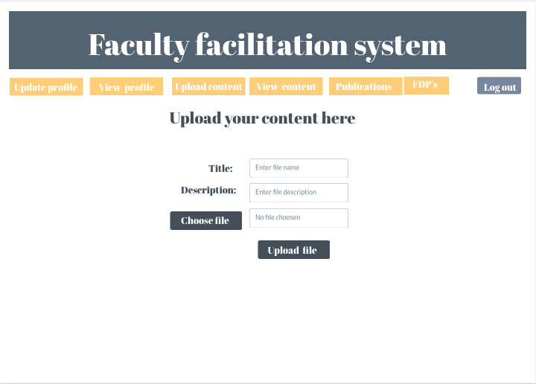

Figure 1.1 Page for uploading documents

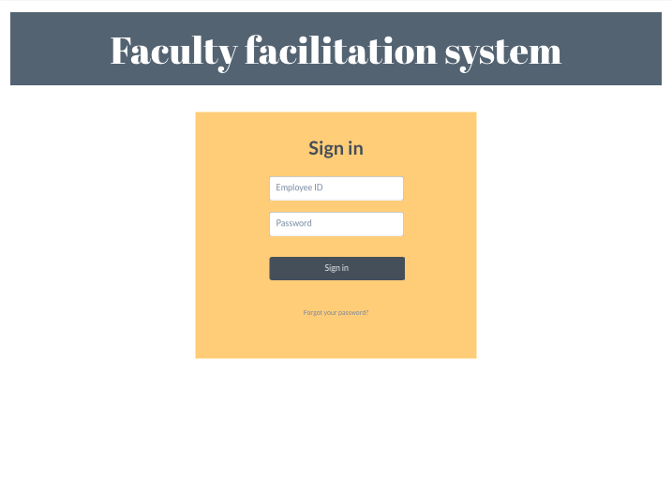

Figure 1.2 Sign in page

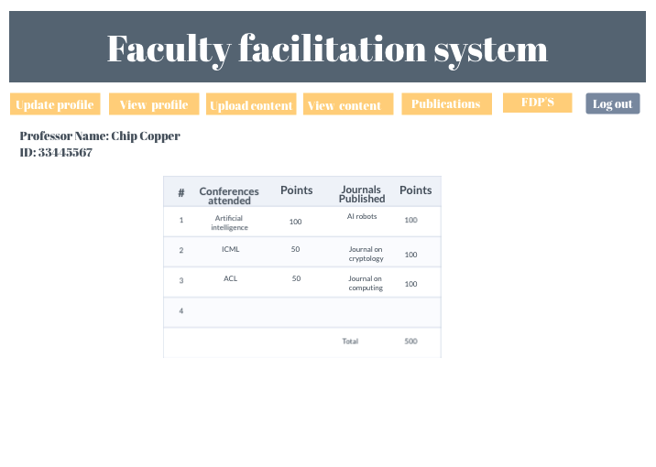

Figure 1.3 Review based on works submitted

**Iteration plan**

The iteration plan includes the steps that are to be completed in the first elaboration phase. The first elaboration phase consists of diagrams to be made. These diagrams can include class diagrams, sequence diagrams, and use-case diagrams. In this case, the project is divided into a collection of user stories from the users’ point of view. As a platform to assess the lecturer/professor, the features required would consist of various information websites used for the API. Registering a professor and also registering the admin with rights to assign points and positions are some of the stories.  Checking the professor’s research papers and projects, assigning points based on the research paper’s value would be considered as stories in the next phase. These stories are further reviewed in the upcoming phase.

**Development Case**

The current output of calculating the points would be mainly useful in determining the present position of the faculty in their research field and help them improve their knowledge and career

All the results have been verified and output has been generated as per the commitment.

The future work would be distinguished as the modified version of the present work giving the most advanced notifications to the faculty regarding their research and publishing work.

**Phase plan and software development plan**

The aim of the Software Development Plan is to collect all the information required to track the project. It explains the process of the development of the software and is a top-level strategy which has been generated

We are developing a faculty facilitation system that contains all the data of the faculty who are attending the programs or conferences. The main risk that we have found with this framework is that individuals who are not authorized to use the database might try to access the data and attempt to misuse or try to interpret the data.

Tools that we have used for the system:

●      Python 2.7 or higher versions

●      Flask framework

●      Virtualenv

●      Xampp server