L A W F U L I N T E R C E P T I O N X 2 / X 3
SIP Interception Link:
Investigation and Build
Report
From silently dropped INVITEs to a live-monitoring X3 receiver
Environment: mega_cs lab - 172.26.13.15 (voidalims), lin build server (esipserv)
Scope: root-cause analysis, interop dialect, HI2/HI3 recording, live web monitoring
Date: 27-28 October 2026

esipserv project progress report v1.0

Contents
Executive Summary
Executive Summary 1
1. Initial Problem 2
2. Root-Cause Investigation 3
3. Dialect Requirements for the Gateway 3
4. HI2 Records Decoded 4
5. esipserv: the C X3 Receiver 4
6. Live Monitoring over the Web 6
7. Configuration and Open Items 7
Open items 7

Right-click the table of contents and choose Update Field to refresh page numbers.

Executive Summary
This report documents a complete investigation-and-build cycle on the mega_cs lawful-interception environment: from a captured SIP trace in which the receiver silently dropped every INVITE from the MGCF gateway, through root-cause analysis on the voidalims Java receiver, to a from-scratch C replacement (esipserv) with multi-codec HI3 recording and live browser monitoring.
- Root cause. The received INVITEs were never the problem: no post-2018 SIP feature was in play. The Java receiver failed during its own initialization (missing rtp.receiver.port in static mode), and independently requires the ZTE ETSI-108 dialect (isub correlation parameters + single-part SDP body).
- Fix on .15. A missing one-line configuration fix plus restart restored the receiver - it answered its first INVITE in its recorded history with 200 OK + SDP.
- New receiver. esipserv (C, statically linked) now implements the full X3 receiver role: multipart/no-isub INVITEs, isub extraction, per-party SSRC demux, PCMA/PCMU/AMR recording to per-packet .ehif BER records plus playable .au/.amr copies, HI2 IRI begin/end records, and a web UI with WebSocket live audio, per-party volume and a rolling RMS level graph.
- Watermark ready. A 64-bit watermark hook (esipwm_embed, keyed by the per-call correlation number) is wired into the decoded-PCM path, config-gated, with the .ehif archive kept watermark-free.

1. Initial Problem
The starting point was a packet capture (5060_dump_2.pcap) of SIP traffic between the gateway (10.240.16.1:5050) and the receiver (172.26.13.15:5060). The receiver answered OPTIONS keepalives within ~6 ms but ignored a call INVITE completely - the gateway retransmitted it seven times over 32 seconds (RFC 3261 Timer E pattern) and gave up. The original question was whether anything new since 2018 prevented the receiver from parsing the INVITE.
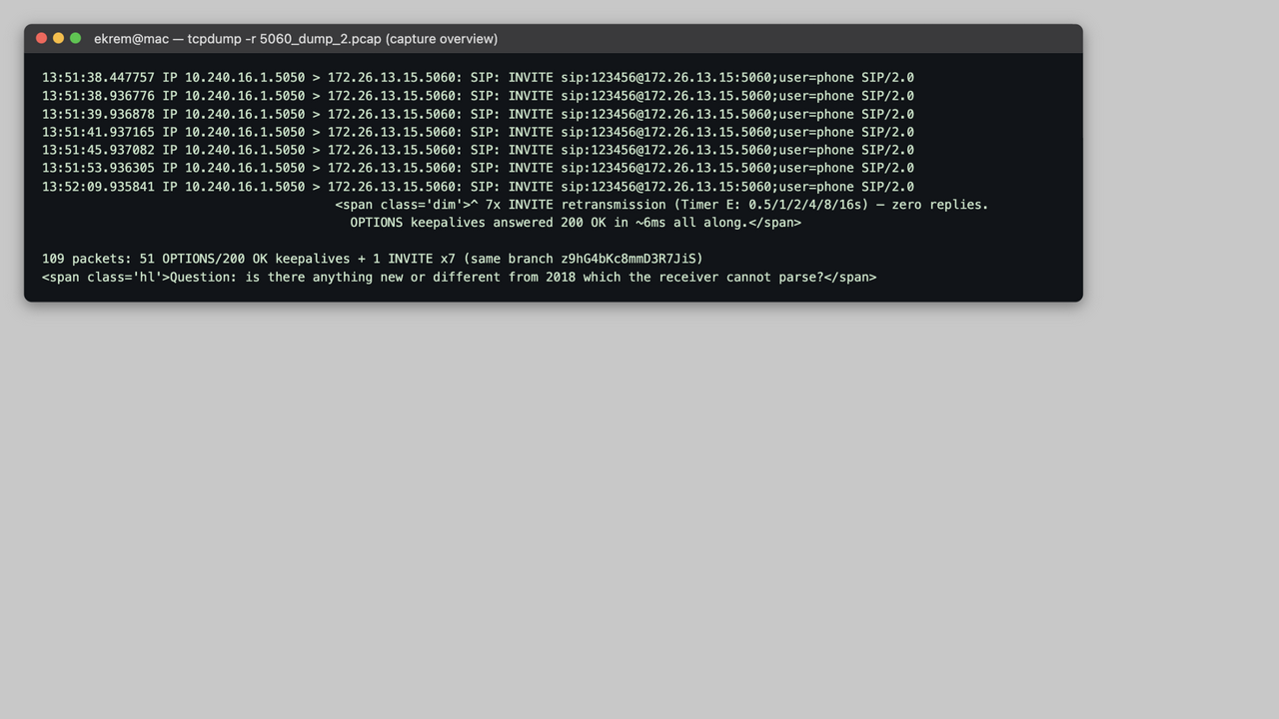
Figure 1 - Capture overview: OPTIONS answered, INVITE retransmitted 7x with zero replies.
The INVITE itself is a 1292-byte multipart/mixed message carrying an SDP offer (PCMA/PCMU/telephone-event) and a 40-byte binary ISUP IAM. Several irregularities stood out: the ISUP Content-Type parameters base/version appear swapped compared to RFC 3204, the Accept header is folded across lines, and Content-Length has a double space - all legal or cosmetic, all later proven irrelevant.
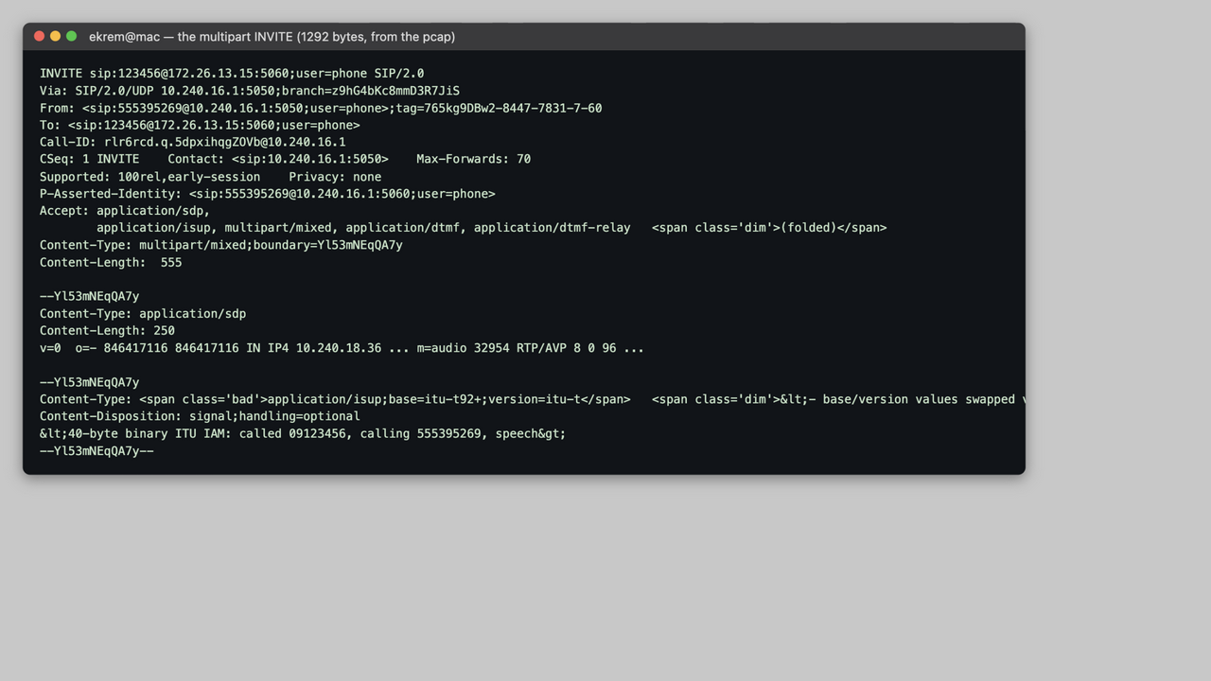
Figure 2 - The multipart INVITE (SDP + ISUP) exactly as captured.

2. Root-Cause Investigation
Differential probing from the lab network showed the receiver answered OPTIONS but silently discarded REGISTER, unknown methods, malformed junk and every INVITE - including a byte-perfect ZTE-dialect INVITE. That eliminated content parsing as the immediate blocker and pointed at a method-aware policy. Receiver-side inspection (SSH) then ruled out iptables/firewalld/nftables (empty), SELinux (cannot distinguish methods) and identified the listener as a Java process - the voidalims LI receiver. Its TRACE-level log caught every INVITE dying with ERROR run - Cannot process!.
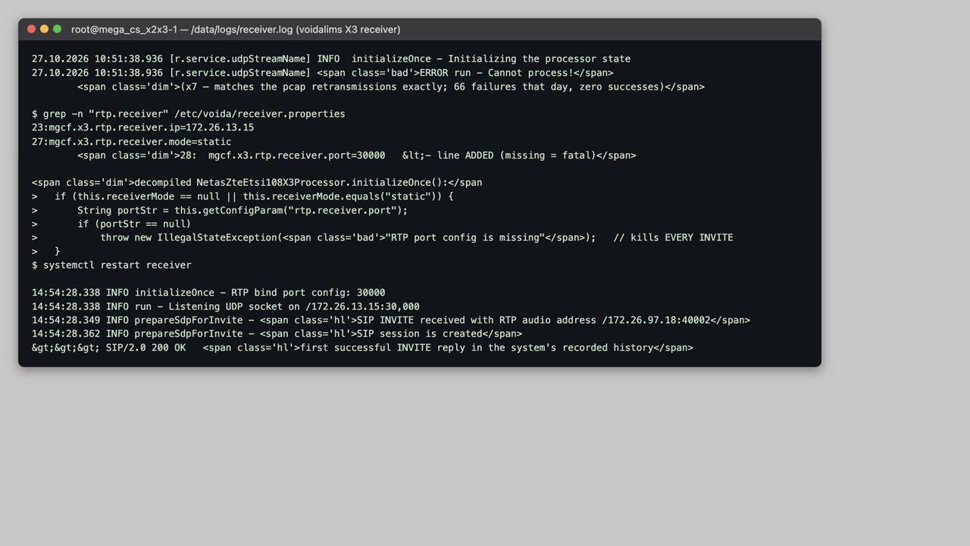
Figure 3 - Receiver log: the failure, the decompiled cause, the one-line config fix, and the first success.
Table 1 - Candidate causes vs. evidence
Candidate | Verdict | Evidence
Post-2018 SIP extension | Eliminated | No pn-*/STIR/Feature-Caps anywhere; probes with plain SDP also dropped
Multipart body / ISUP content-type | Not the trigger | Single-part SDP INVITEs equally dropped
Network firewall / SELinux | Eliminated | iptables empty; OPTIONS reaches the app on the same socket
App peer ACL | Superseded | Both lab IPs and localhost INVITEs fail identically
Receiver init failure | CONFIRMED | IllegalStateException: RTP port config is missing (decompiled)

3. Dialect Requirements for the Gateway
With the receiver fixed, a systematic INVITE matrix established exactly what the NetasZteEtsi108X3Processor accepts. Two independent requirements emerged, both mandatory for the production gateway.
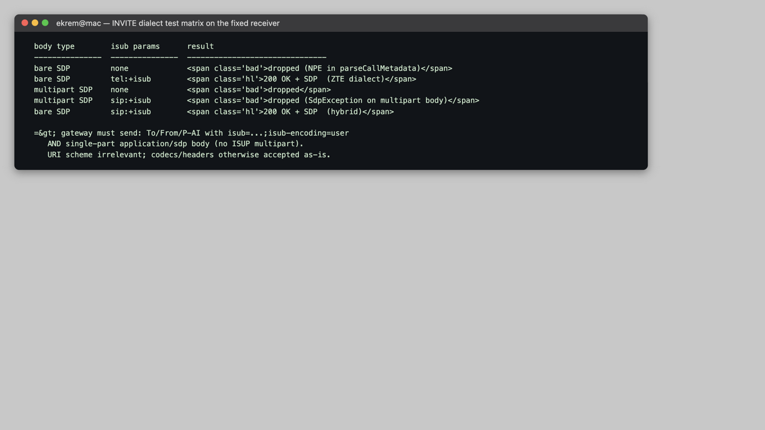
Figure 4 - Test matrix: body type x isub presence on the fixed receiver.
- Correlation. To URI must carry isub=<X>f<numeric>f<string> (split on literal f); From or P-Asserted-Identity must carry isub=<string>f<int>f... - missing isub is a NullPointerException and a silent drop.
- Body. The body must be a single application/sdp part. multipart/mixed fails SDP parsing even with valid isub. The URI scheme (sip:/tel:) is irrelevant; codecs, user=phone, PAI and keepalives pass as-is.

4. HI2 Records Decoded
The system's own .ehif output was reverse-engineered with a purpose-built BER walker. Records are ETSI TS 101 671-style HI2 IRIs: one BER sequence per file carrying LIID, microsecond timestamps, operator/network-element identification, a correlation number, and the IRI payload (BEGIN with caller/callee, END with a status code). This format was then reproduced byte-compatibly by esipserv.
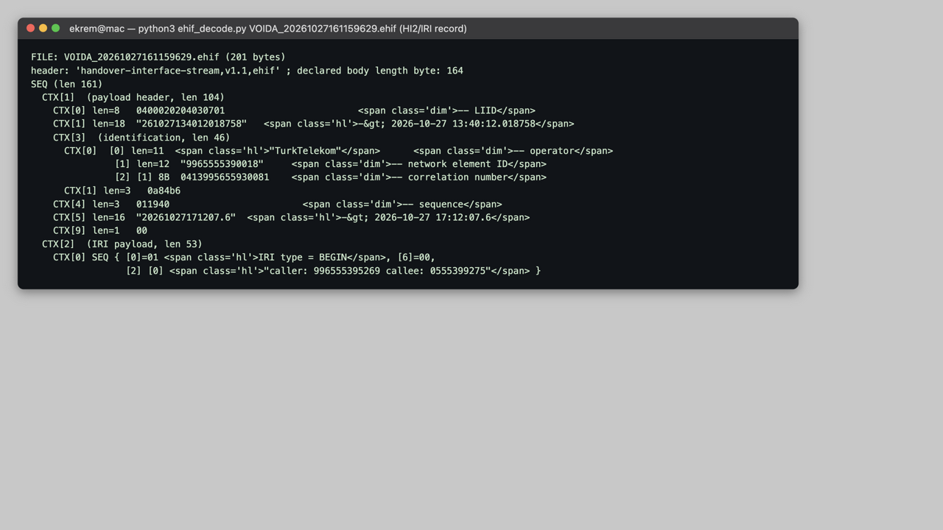
Figure 5 - Decoded VOIDA .ehif IRI-Begin record (TurkTelekom operator, caller/callee content).

5. esipserv: the C X3 Receiver
Rather than patching the Java side, the team's own gateway software (esipserv, plain C on the lin build server) was extended into a full X3 receiver equivalent. It is statically linked (no glibc dependency), deploys as a single binary, and passed the project's own regression suite 7/7 after every change.
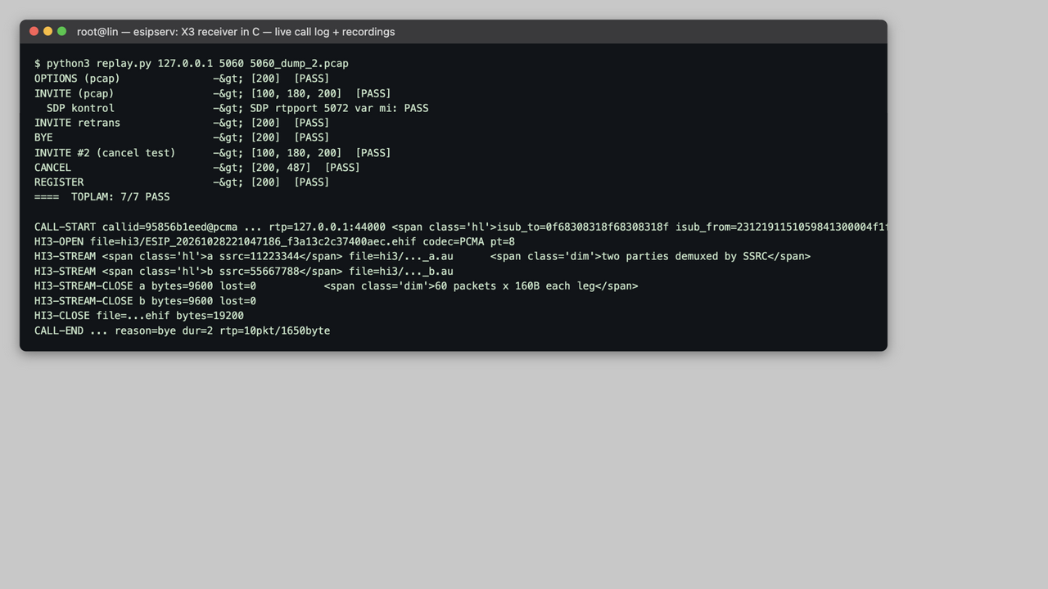
Figure 6 - Regression suite 7/7 PASS, live call log with isub extraction, per-party recording files.
- SIP. Accepts the gateway's real dialect: multipart SDP+ISUP INVITEs (SDP part extracted, remote RTP address learned), missing-isub INVITEs, folded headers; answers 100/180/200 with its own SDP.
- HI3 archive. Per-packet BER records (LIID, microsecond timestamp, sequence, SSRC, RTP timestamp/sequence, payload) framed in the same handover-interface-stream container; identification block on the first record.
- Playable copies. Per-party SSRC demux (a/b/c/d legs), per-leg .au (PCMA/PCMU) or real .amr files (RFC 4867 CMR stripped), sequence-loss counters, RMS levels.
- HI2. IRI-Begin/End records in the decoded HI2 format, keyed by an FNV-1a correlation derived from the Call-ID.
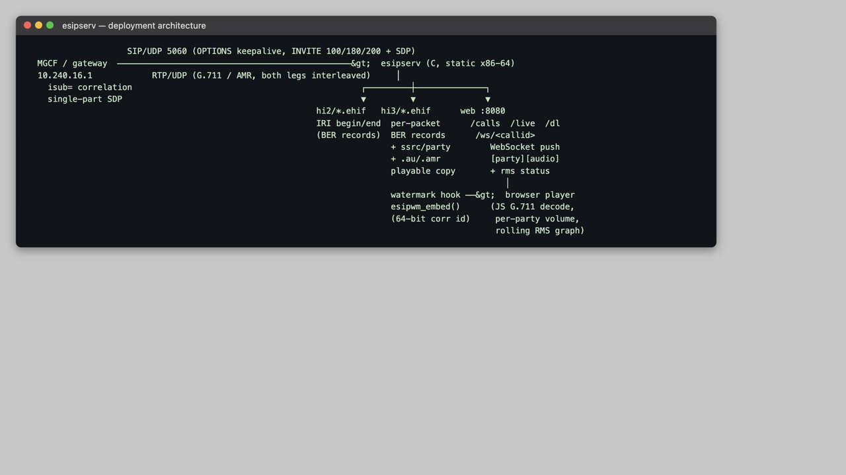
Figure 7 - Deployment architecture and data flow.

6. Live Monitoring over the Web
A built-in HTTP/WebSocket server (single-threaded, poll-loop friendly) provides live monitoring: /calls (JSON status), /live (offset-polled fallback stream), /dl (recording download) and /ws/<callid> - a real RFC 6455 WebSocket that pushes each RTP packet the moment it arrives as [party-byte][native audio], announces the codec once, and streams periodic RMS levels for the graph. The player page decodes G.711 in JavaScript (both A-law and u-law), plays each party through its own gain slider, and draws a rolling two-channel level graph. Browser-side quirks were hardened during a real-browser test session (default-rate AudioContext, getChannelData, autoplay resume), which also caught and fixed two genuine bugs: a broken onclick quoting in the LIVE button and URL-encoded call-IDs not matching dialogs server-side.
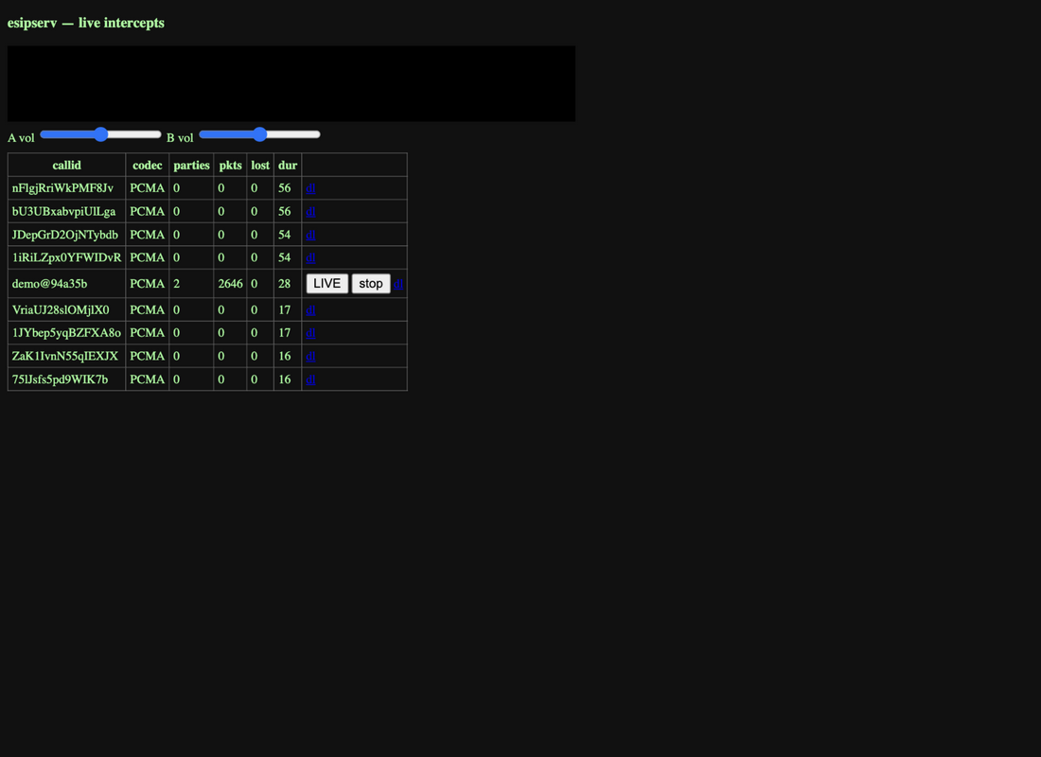
Figure 8 - Live player: call list with codec, parties, packet/loss counters.
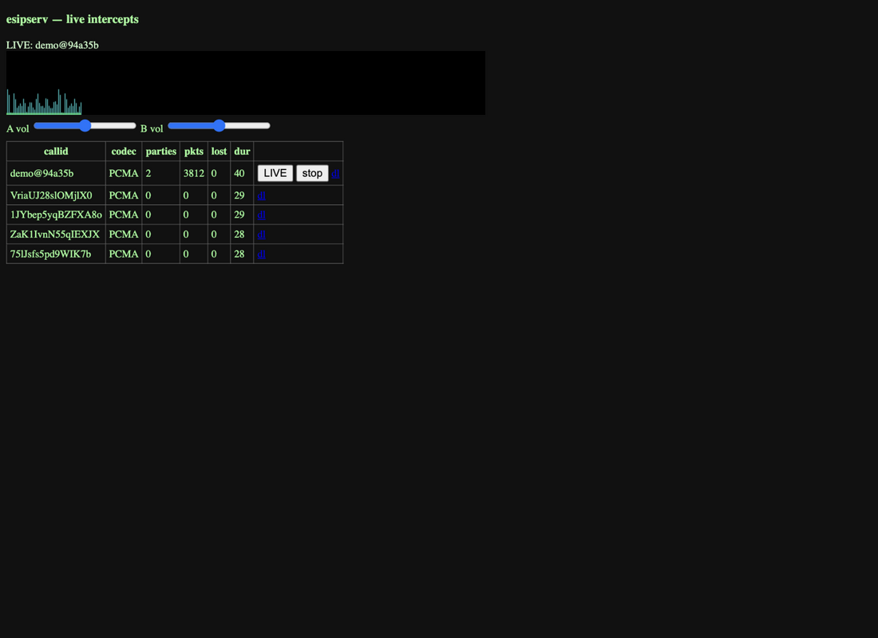
Figure 9 - LIVE mode: two-party call streaming over WebSocket; RMS graph (green = party A, cyan = party B), per-party volume sliders.
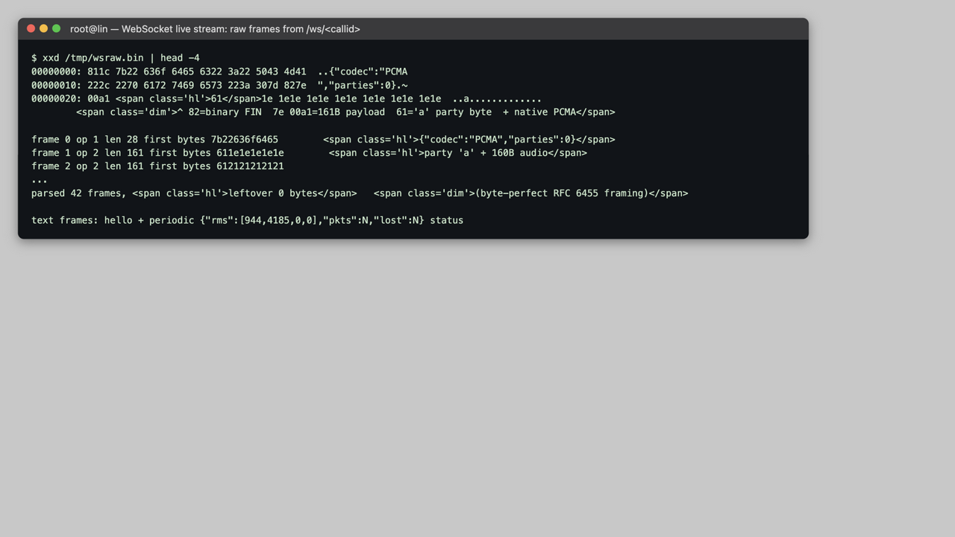
Figure 10 - Raw WebSocket capture: byte-perfect framing (hello + party-tagged audio + RMS status frames).

7. Configuration and Open Items
Table 2 - esipserv configuration keys (esipserv.json; defaults shown)
Key | Default | Meaning
esipserv.sip.port / sip.rtpport | 5070 / 5072 | SIP UDP port; static RTP receiver port
esipserv.sip.rtprecv | 1 | RTP listener on/off
esipserv.hi2.enable / hi2.folder | 1 / hi2 | IRI begin/end .ehif output
esipserv.hi3.au / hi3.folder | 1 / hi3 | playable per-party copies
esipserv.hi3.watermark | 0 | enable esipwm_embed() on decoded PCM
esipserv.hi2.liid / operator / neid | 0400020204030701 / TurkTelekom / esipserv | record identification fields
esipserv.web.enable / web.port | 1 / 8080 | HTTP + WebSocket monitoring

Open items
- Watermark. The real watermark implementation (separate project) drops into esipwm_embed(short* pcm, int n, uint64_t id); the hook carries the per-call 64-bit correlation and is verified end-to-end except for the embedding itself.
- Byte-compat. The .ehif media format is same-family but not byte-identical to the voida Serializer output; aligning byte-for-byte needs a V-*.ehif sample from 172.26.13.15 (unreachable during this session; binary staged at /opt/esipserv awaits an update push).
- Ops. Verify the player once in Safari (Chrome-class browsers verified at protocol level and via the in-app browser test). Firewall 5060/8080 on internet-facing hosts - scanner traffic was observed.

