Download Istio

curl -L https://istio.io/downloadIstio | sh -
cd istio-1.27.3
export PATH=$PWD/bin:$PATH
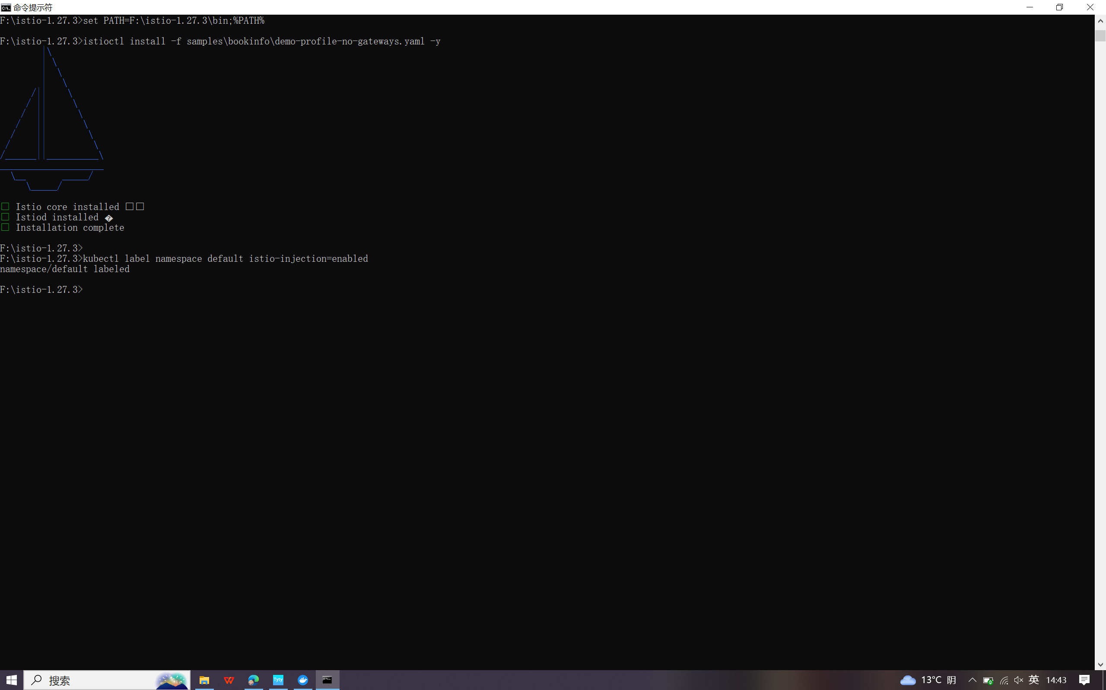

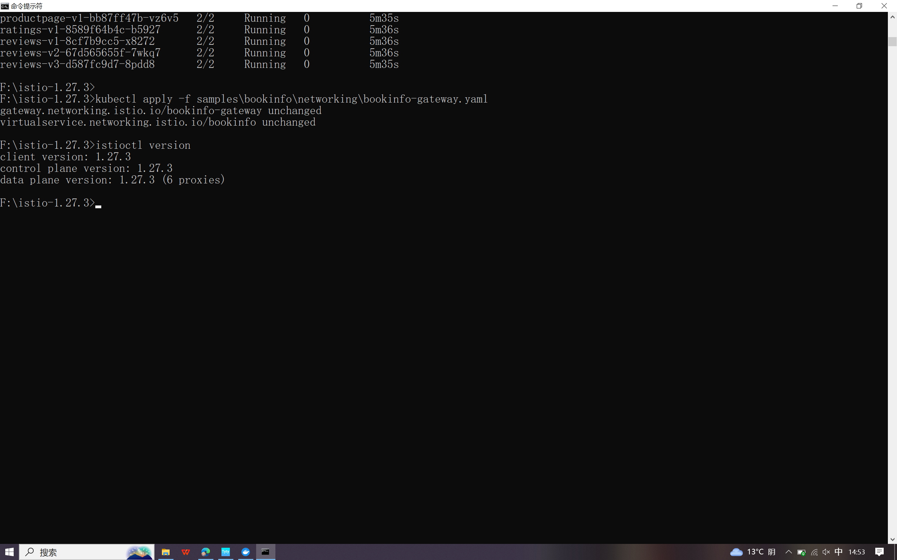

Install Istio

istioctl install -f samples/bookinfo/demo-profile-no-gateways.yaml –y
kubectl label namespace default istio-injection=enabled
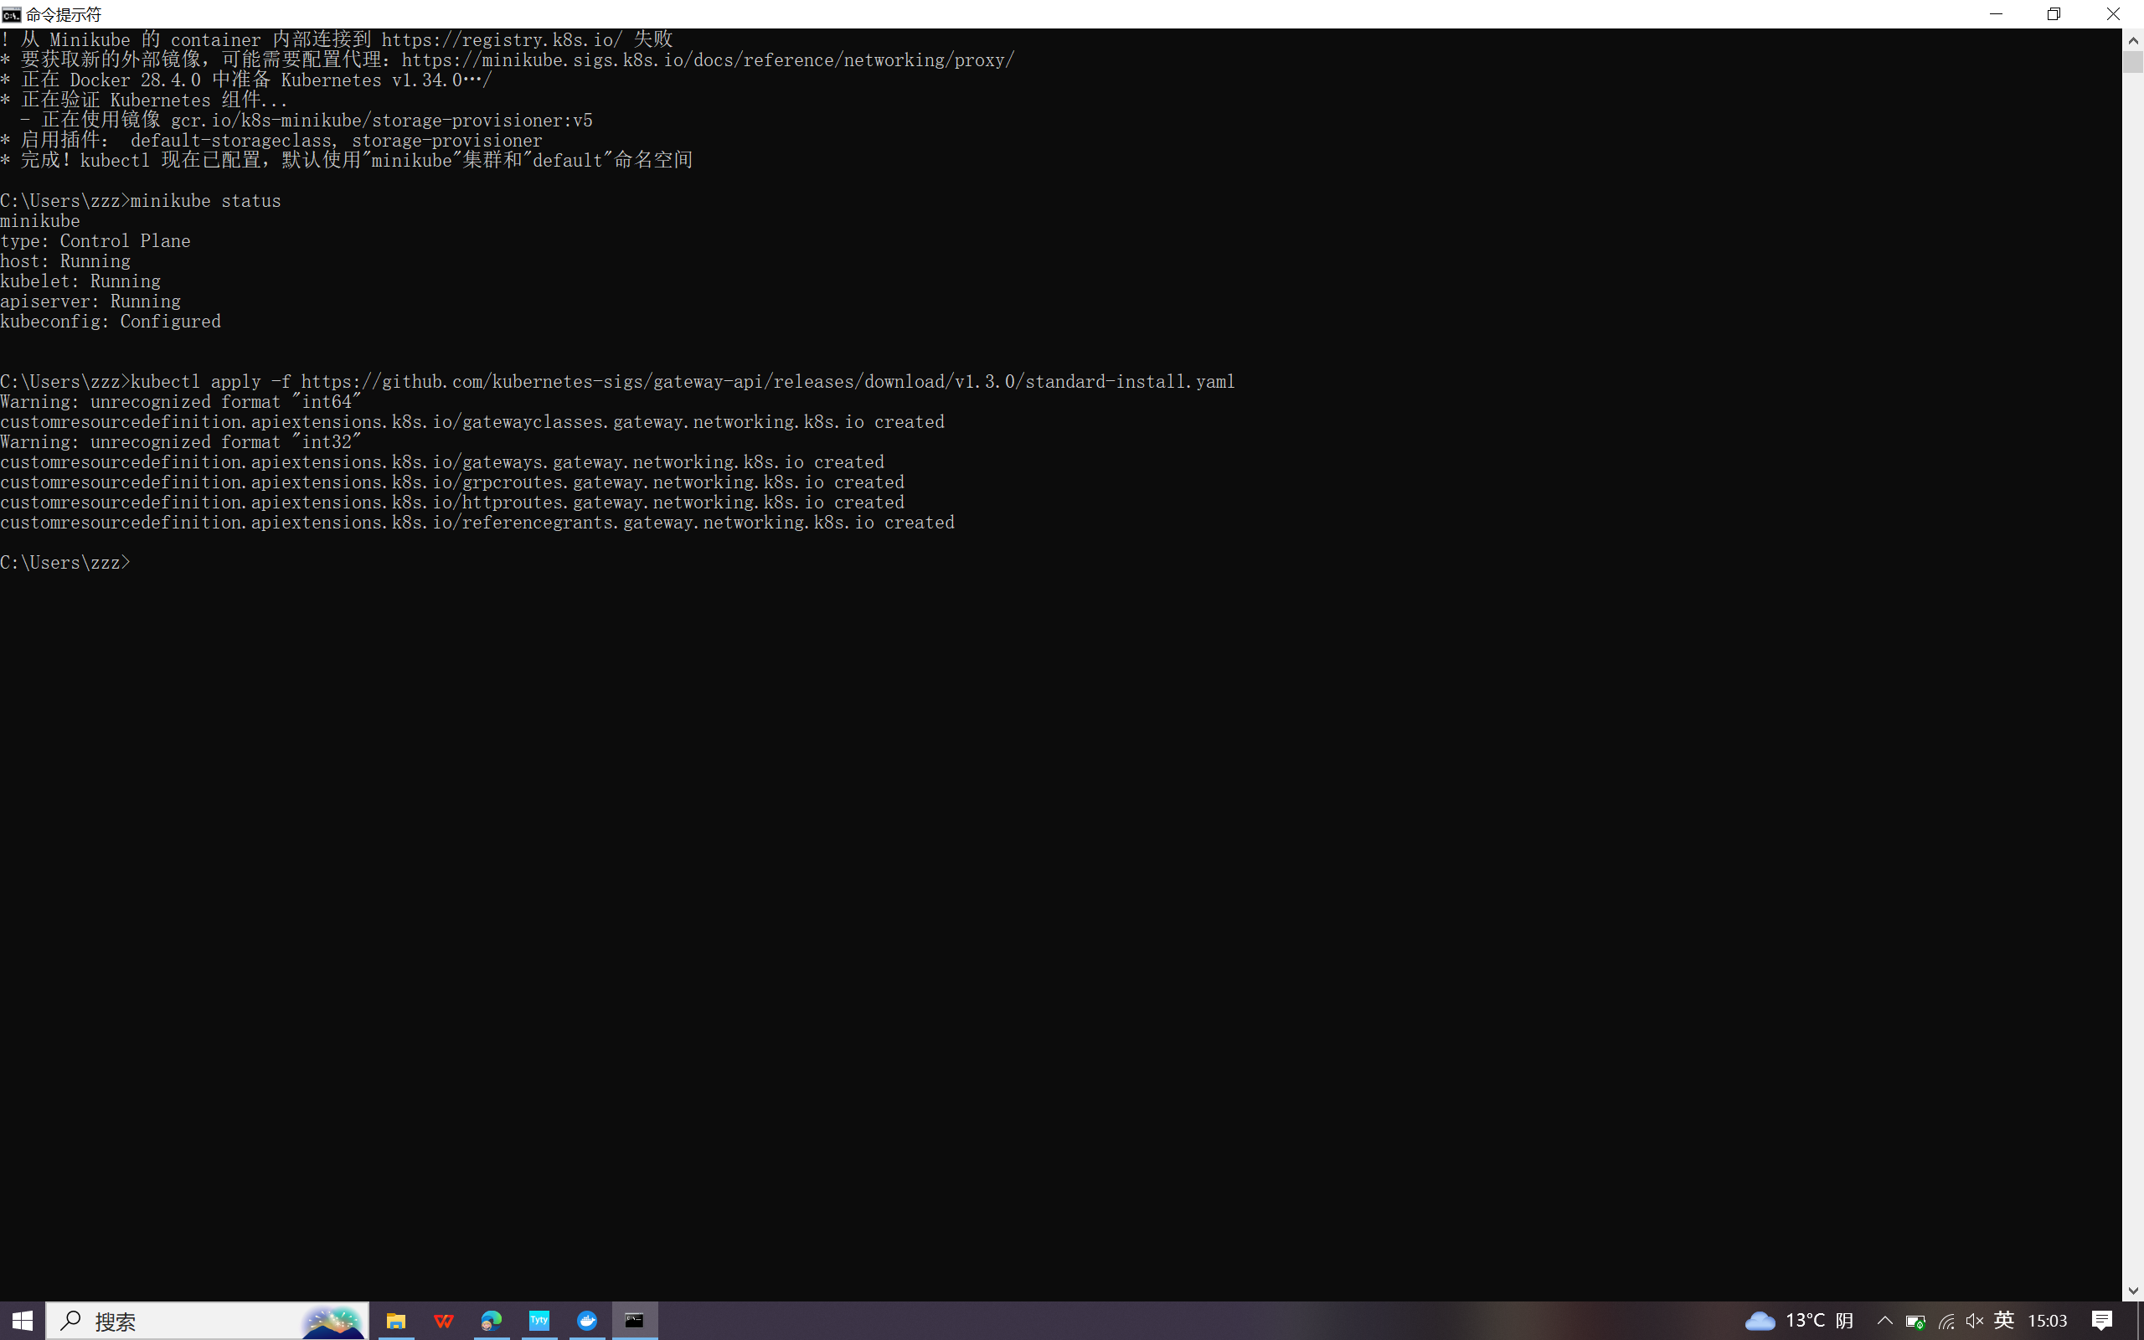

install the Kubernetes Gateway API CRDs
kubectl get crd gateways.gateway.networking.k8s.io &> /dev/null || \
{ kubectl kustomize "github.com/kubernetes-sigs/gateway-api/config/crd?ref=v1.3.0" | kubectl apply -f -; }

Deploy the sample application
kubectl apply -f samples/bookinfo/platform/kube/bookinfo.yaml

kubectl get services
kubectl get pods
Open the application to outside traffic
kubectl apply -f samples/bookinfo/gateway-api/bookinfo-gateway.yaml
kubectl annotate gateway bookinfo-gateway networking.istio.io/service-type=ClusterIP --namespace=default
kubectl get gateway
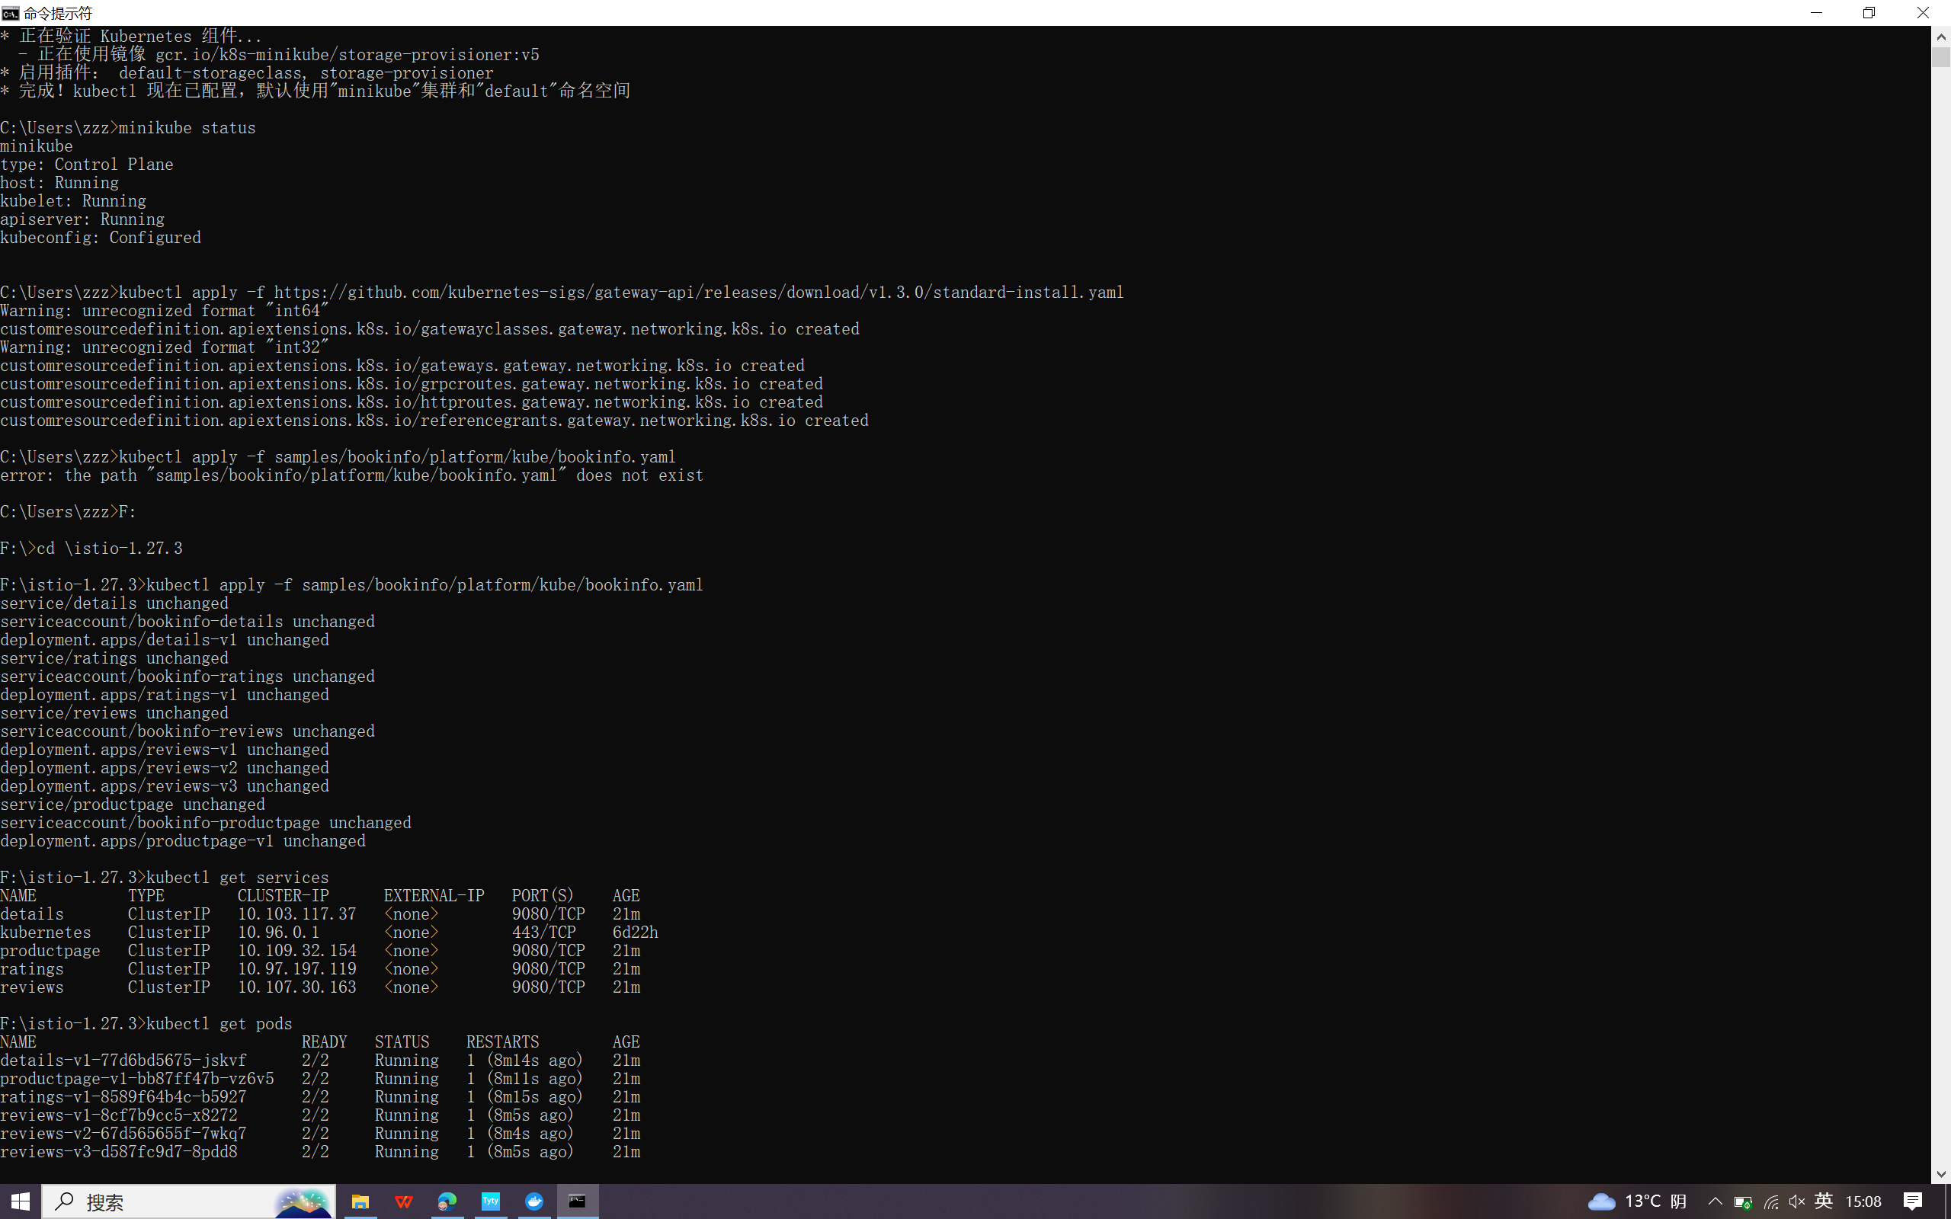

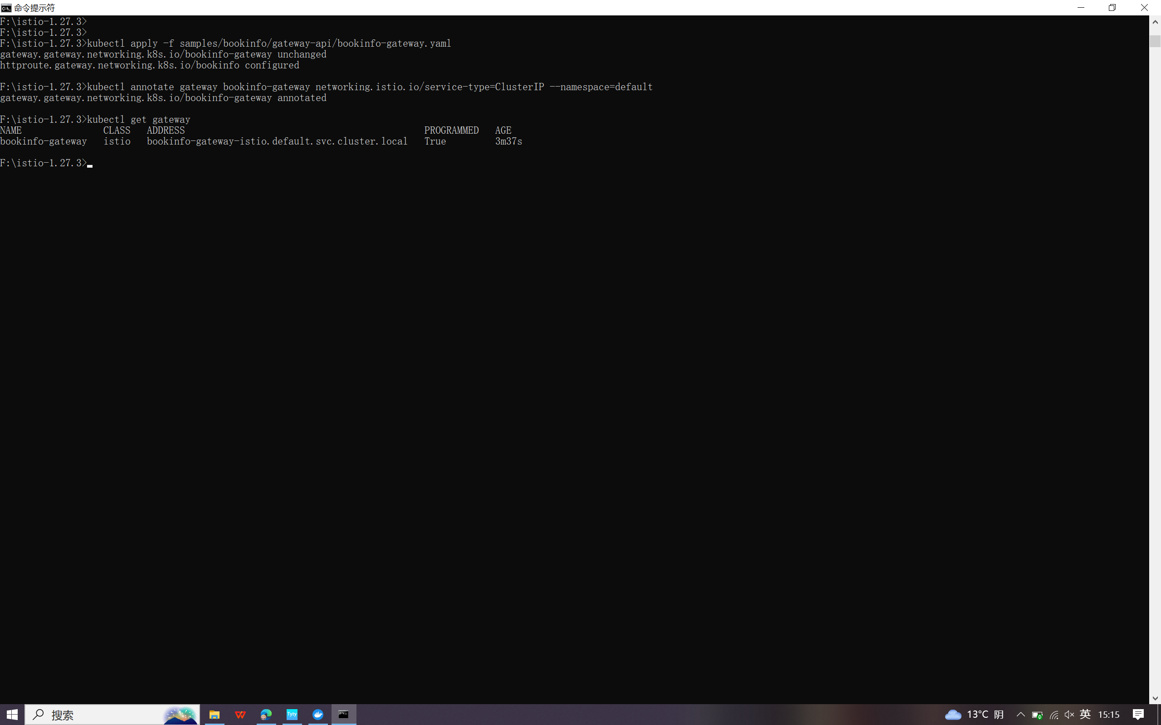

Access the application
kubectl port-forward svc/bookinfo-gateway-istio 8080:80
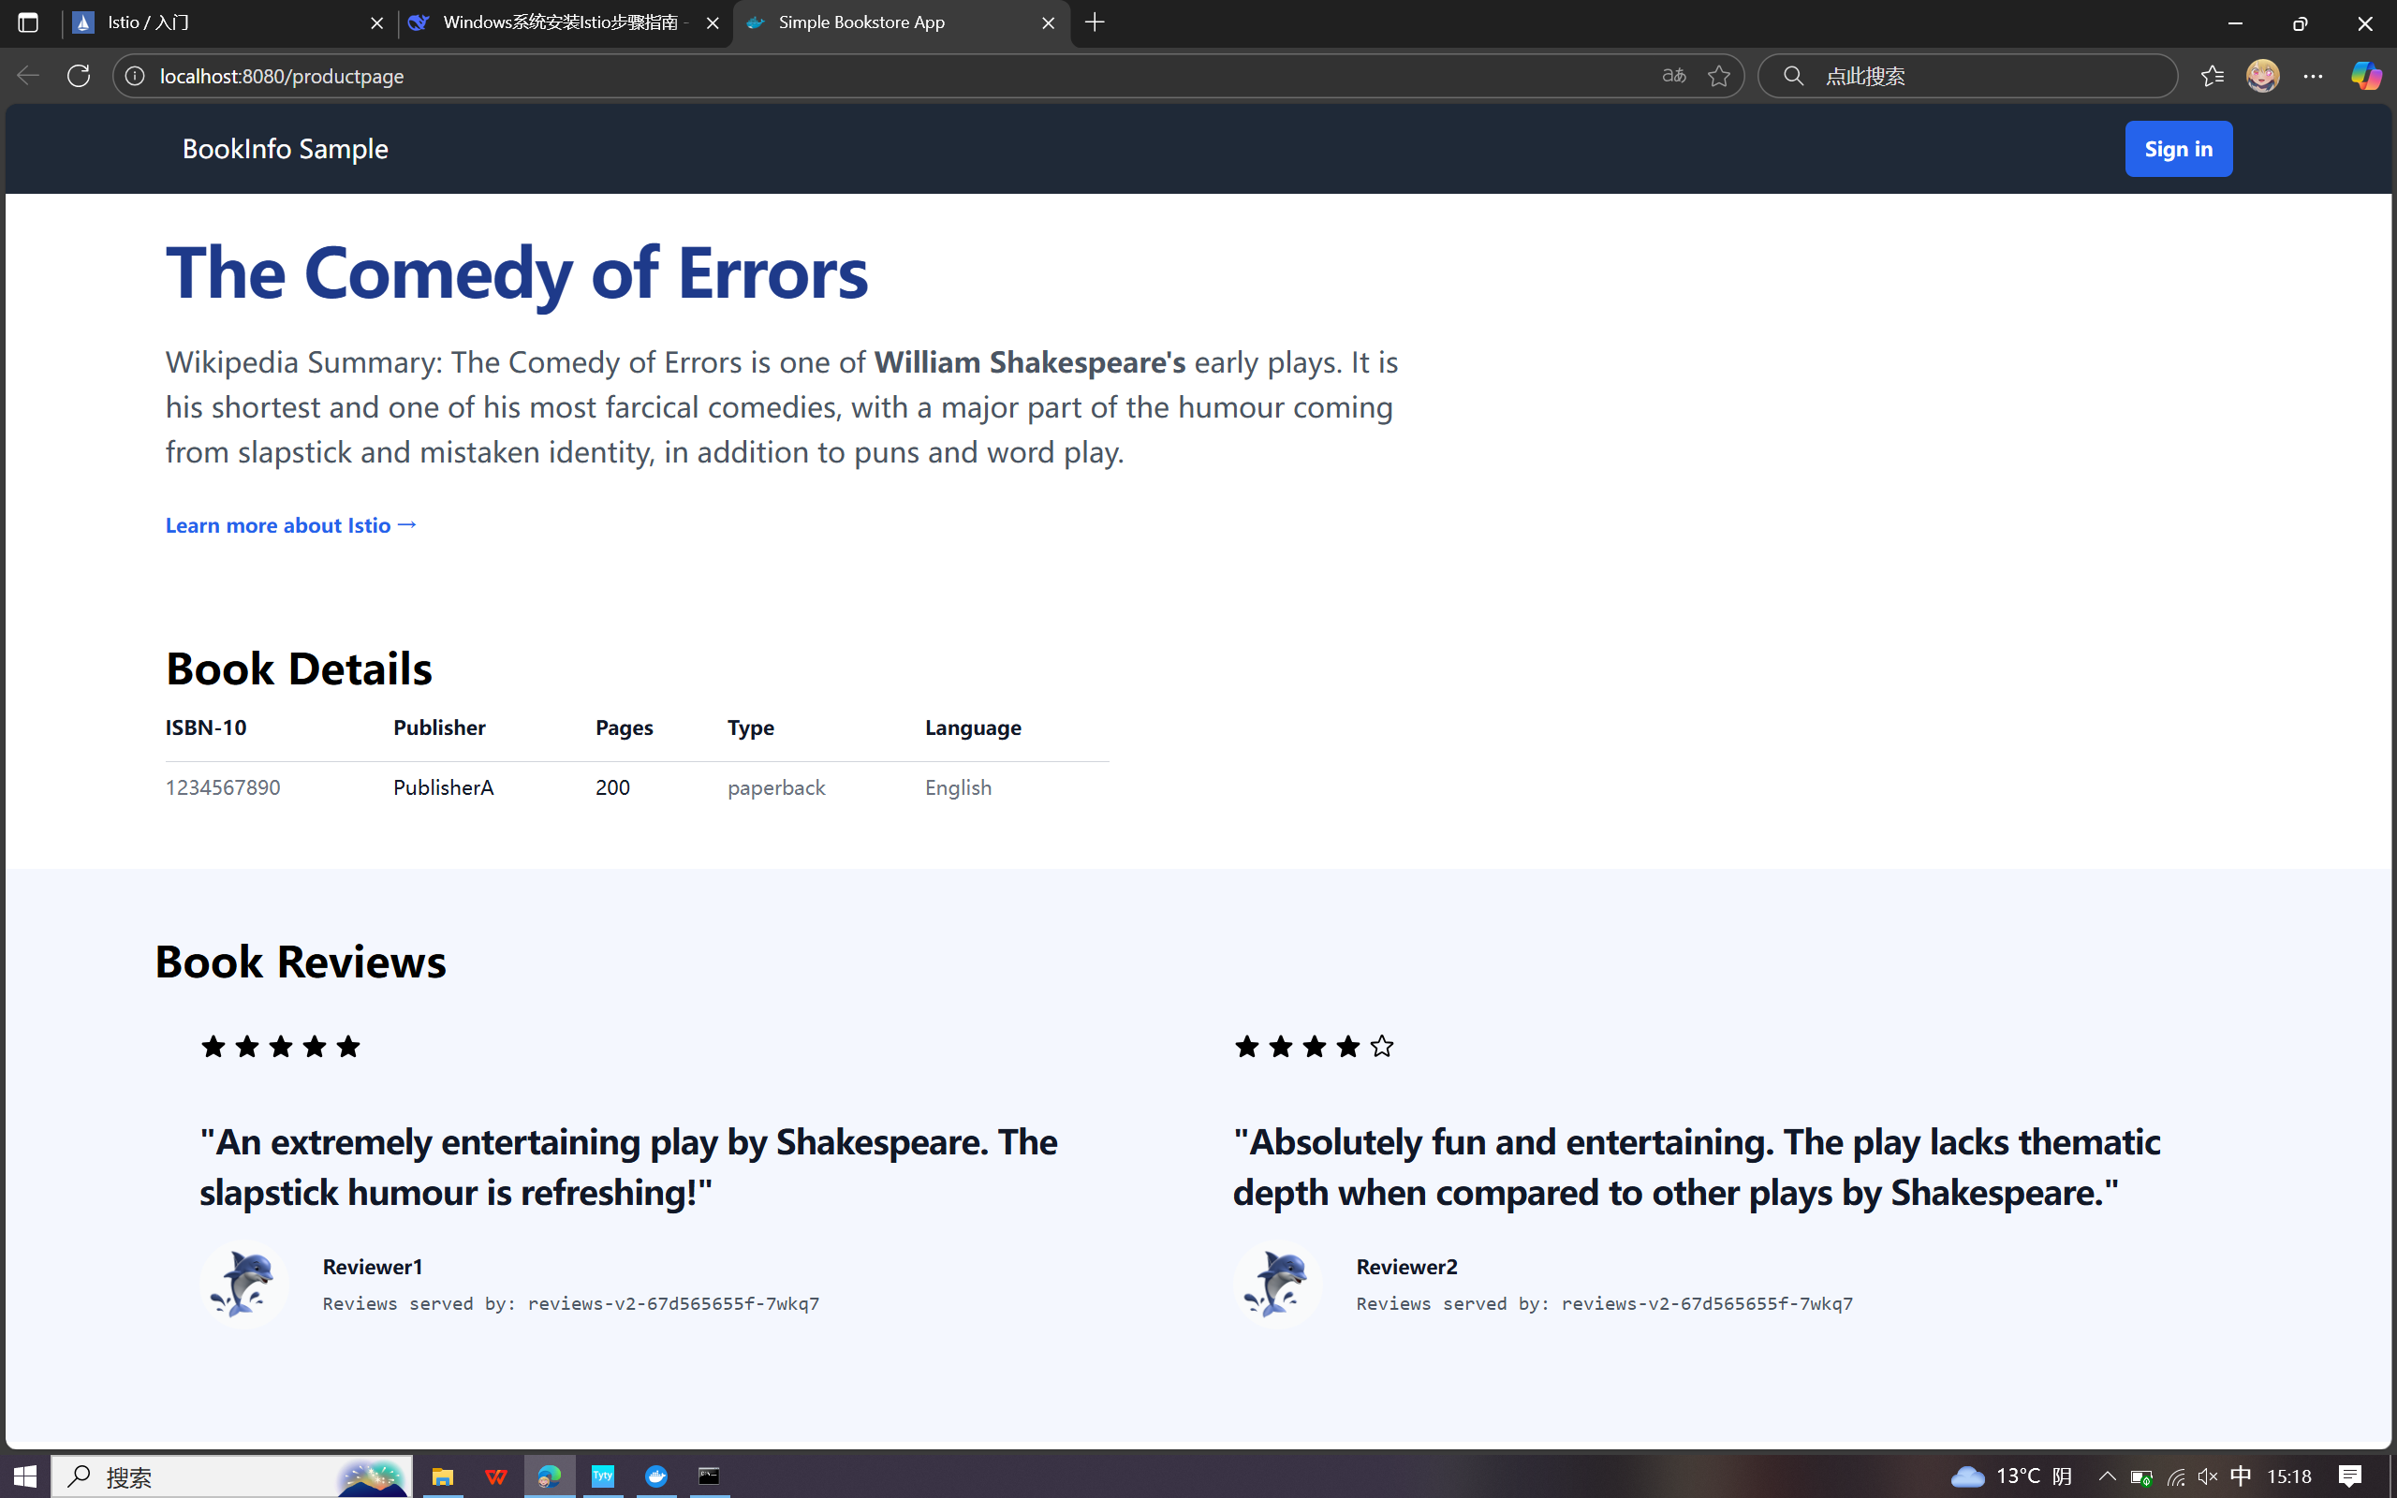

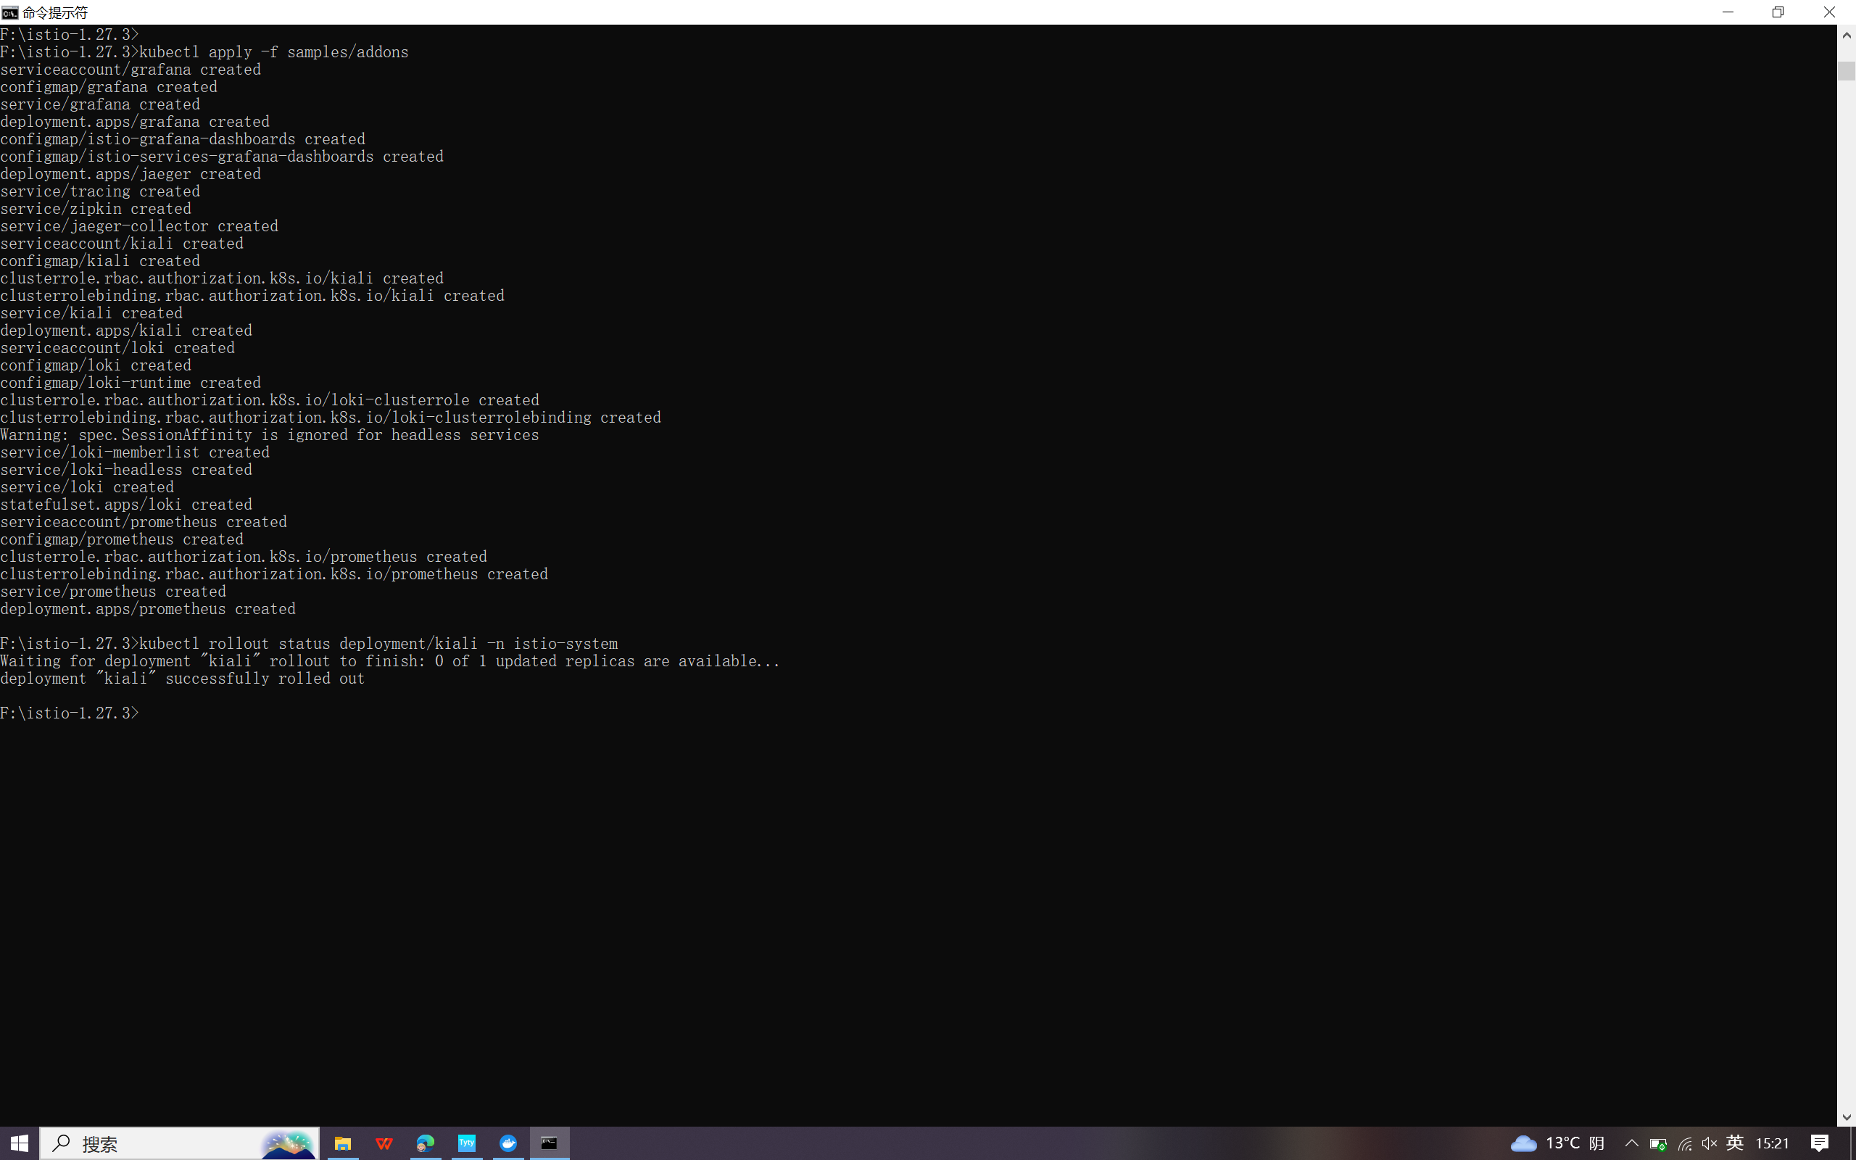

View the dashboard
kubectl apply -f samples/addons
kubectl rollout status deployment/kiali -n istio-system
istioctl dashboard kiali
