Traffic Shifting
kubectl apply -f samples/bookinfo/networking/virtual-service-all-v1.yaml
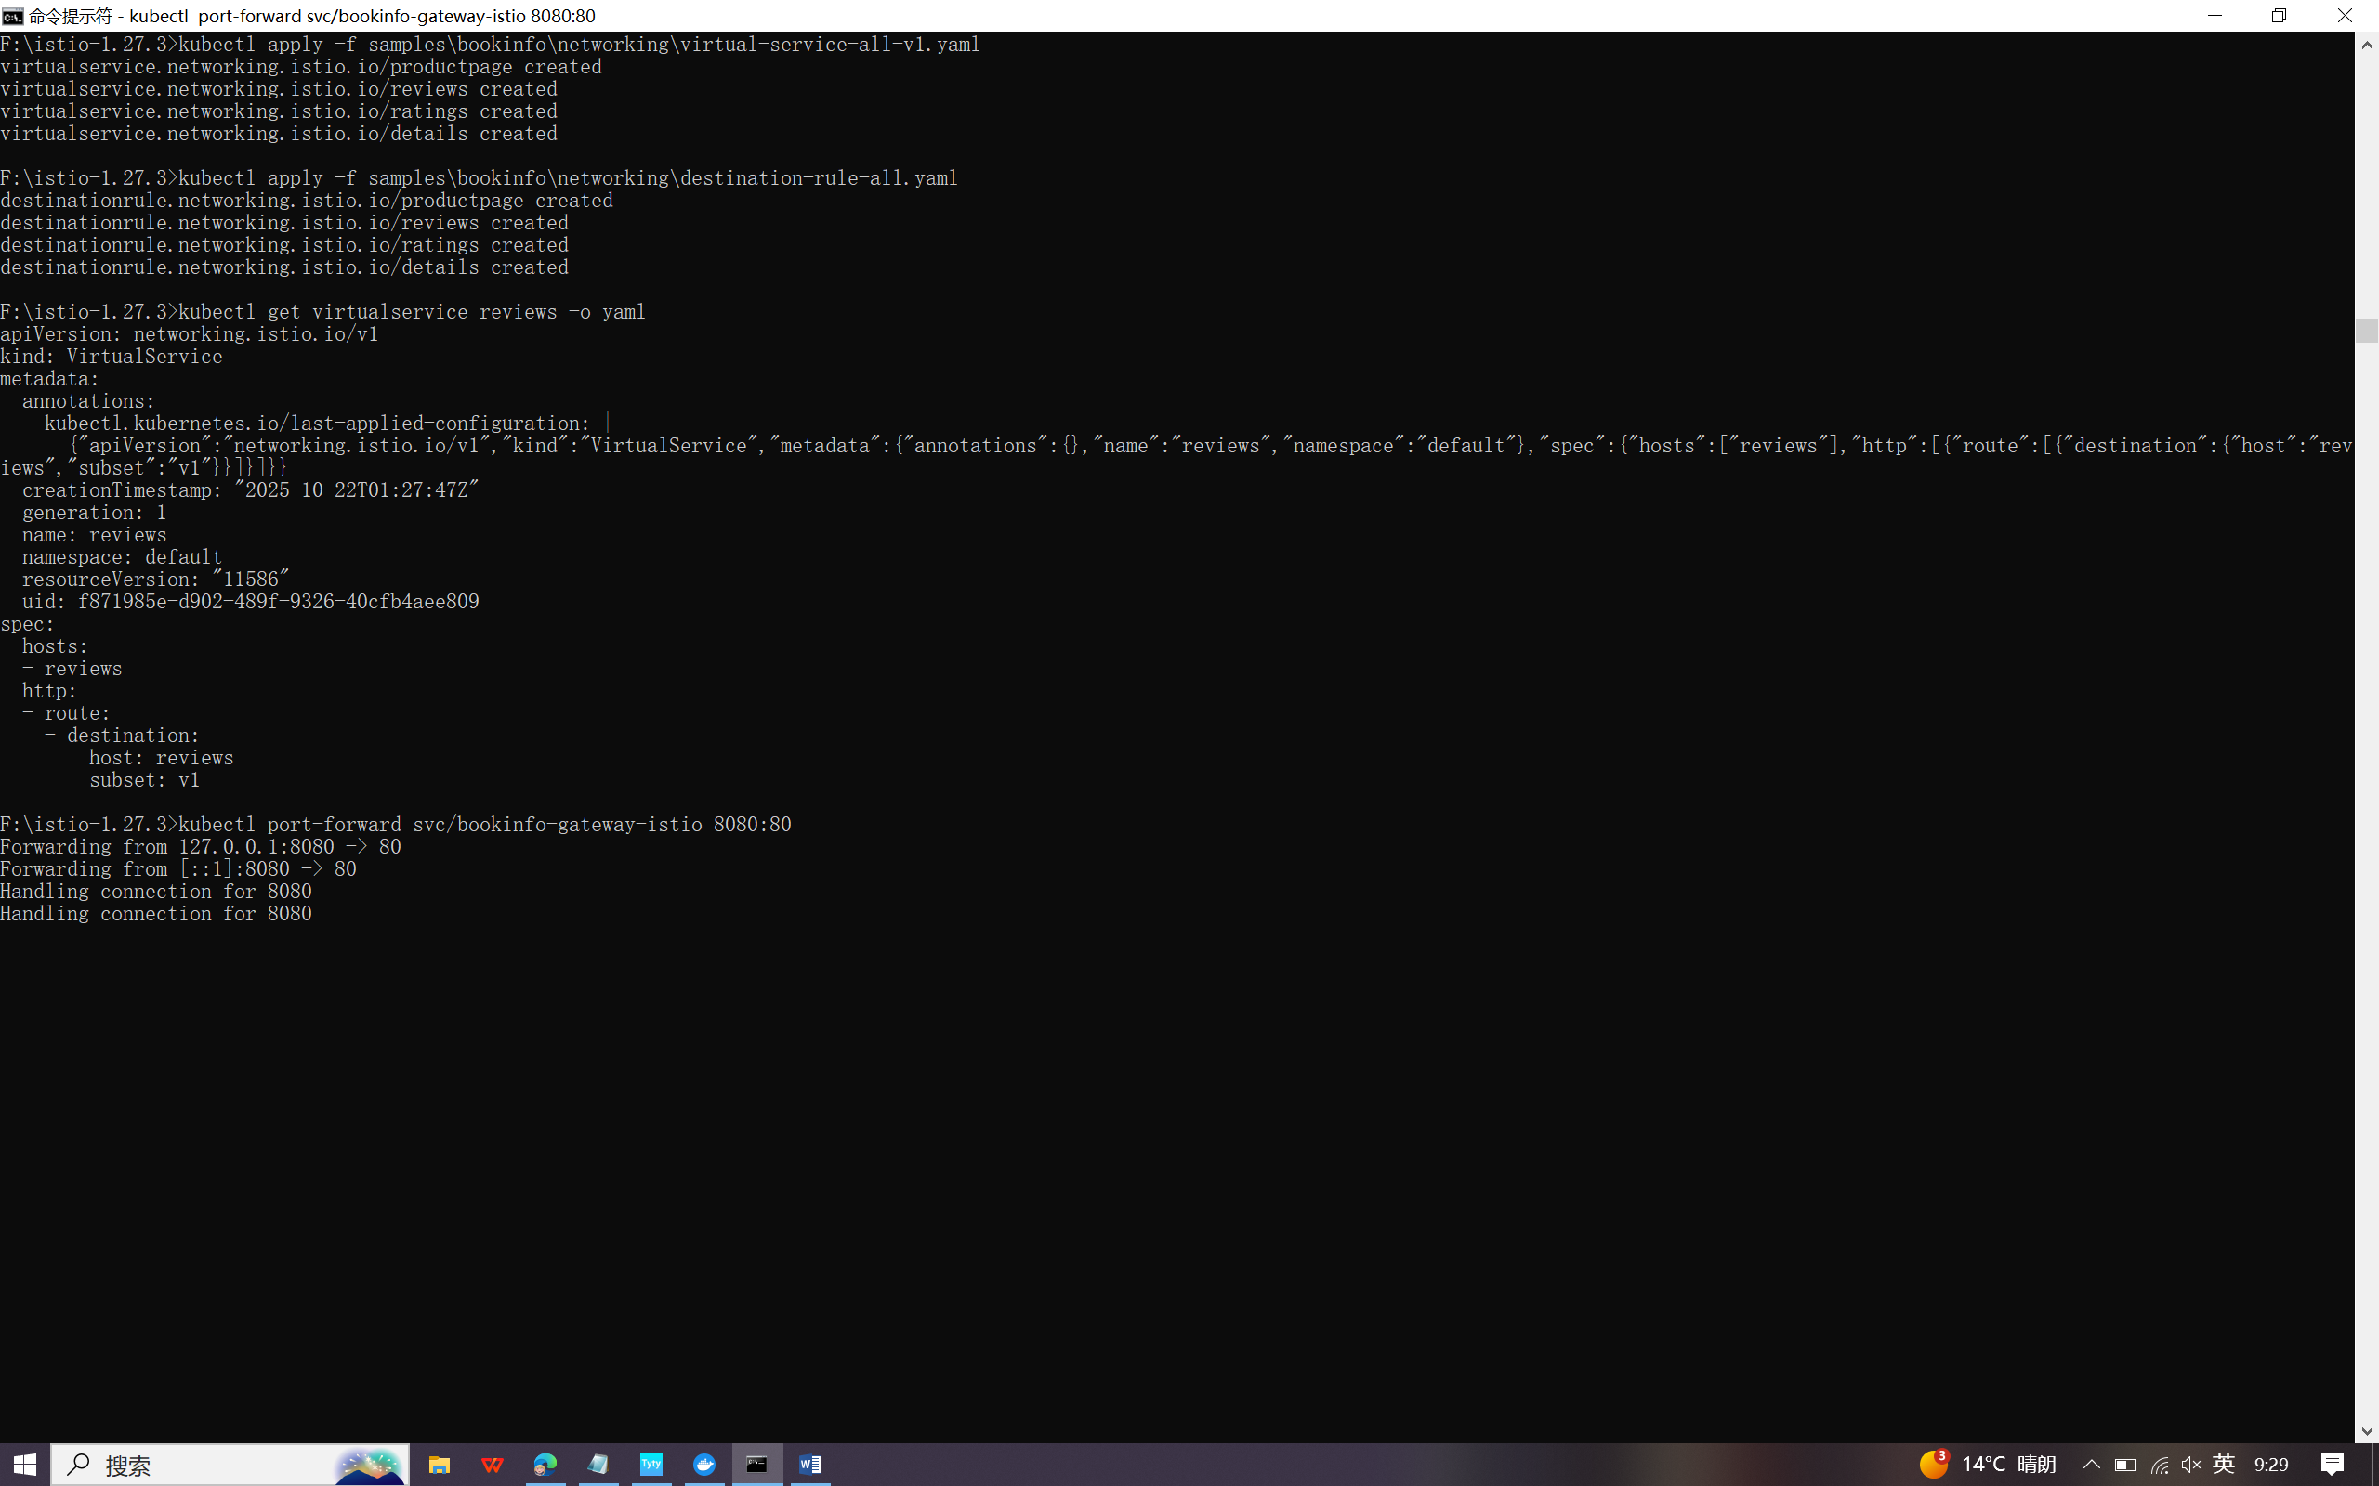



kubectl apply -f samples/bookinfo/networking/virtual-service-reviews-50-v3.yaml



kubectl apply -f samples/bookinfo/networking/virtual-service-reviews-v3.yaml



Request Routing
Istio uses virtual services to define route rules. Run the following command to apply virtual services that will route all traffic to v1 of each microservice:
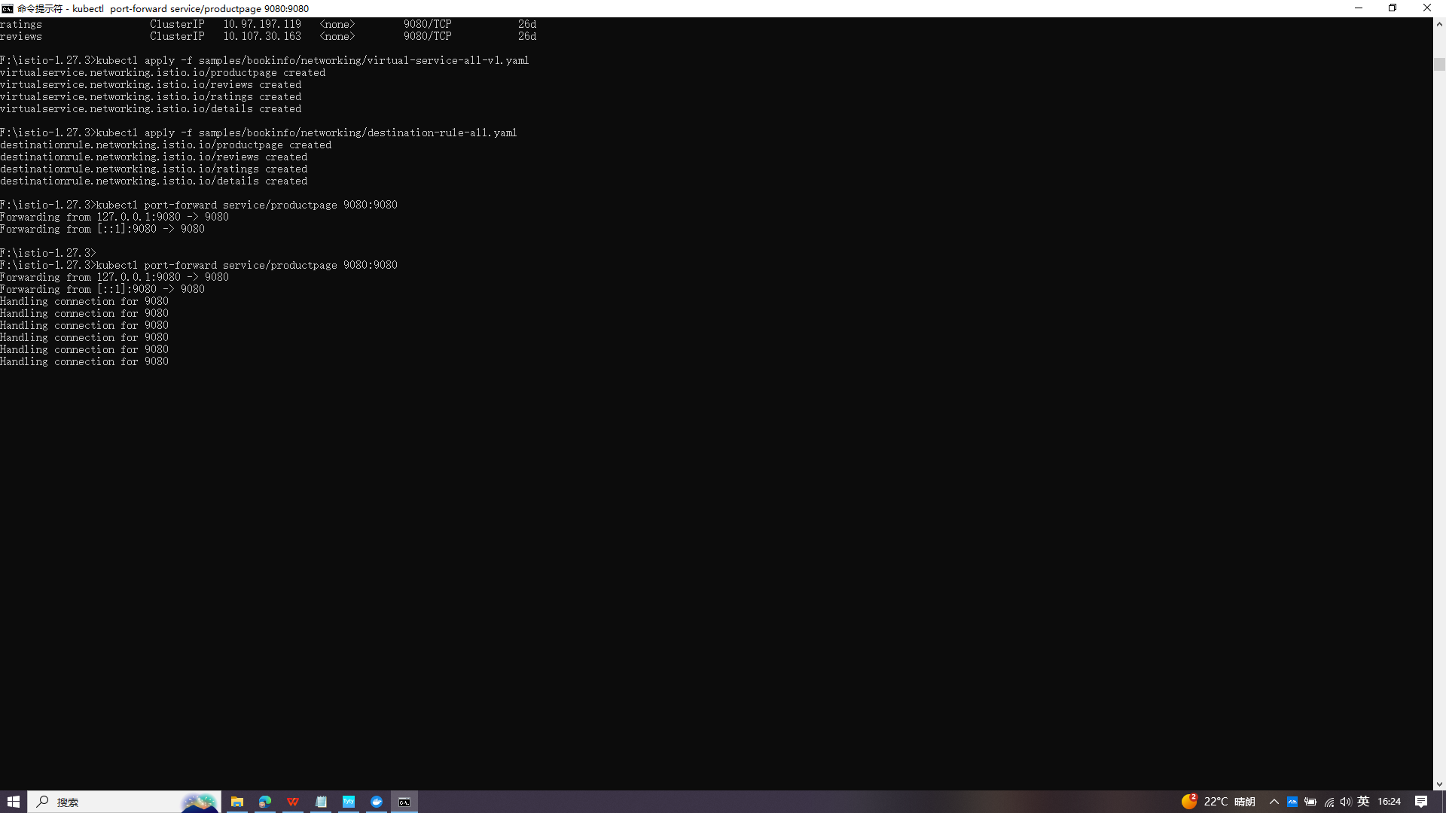

change the route configuration so that all traffic from a specific user is routed to a specific service version. In this case, all traffic from a user named Jason will be routed to the service reviews:v2.
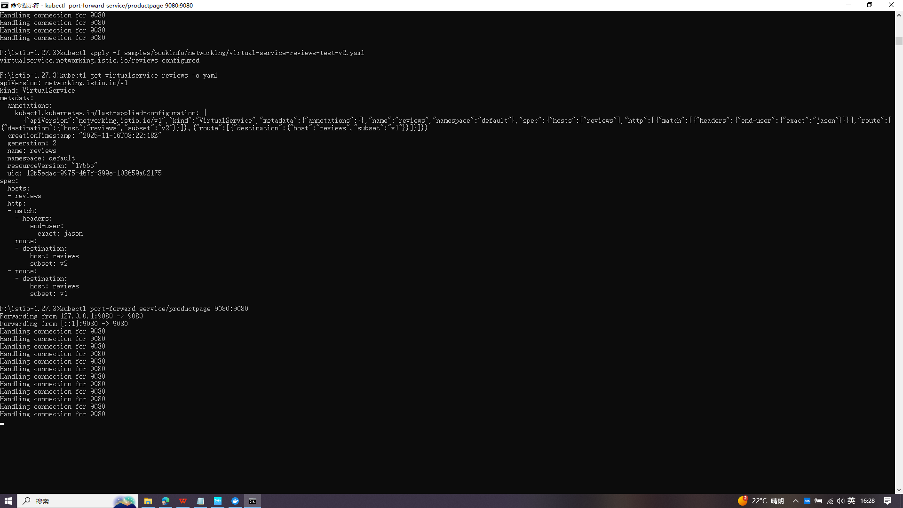

Not sign in and other user
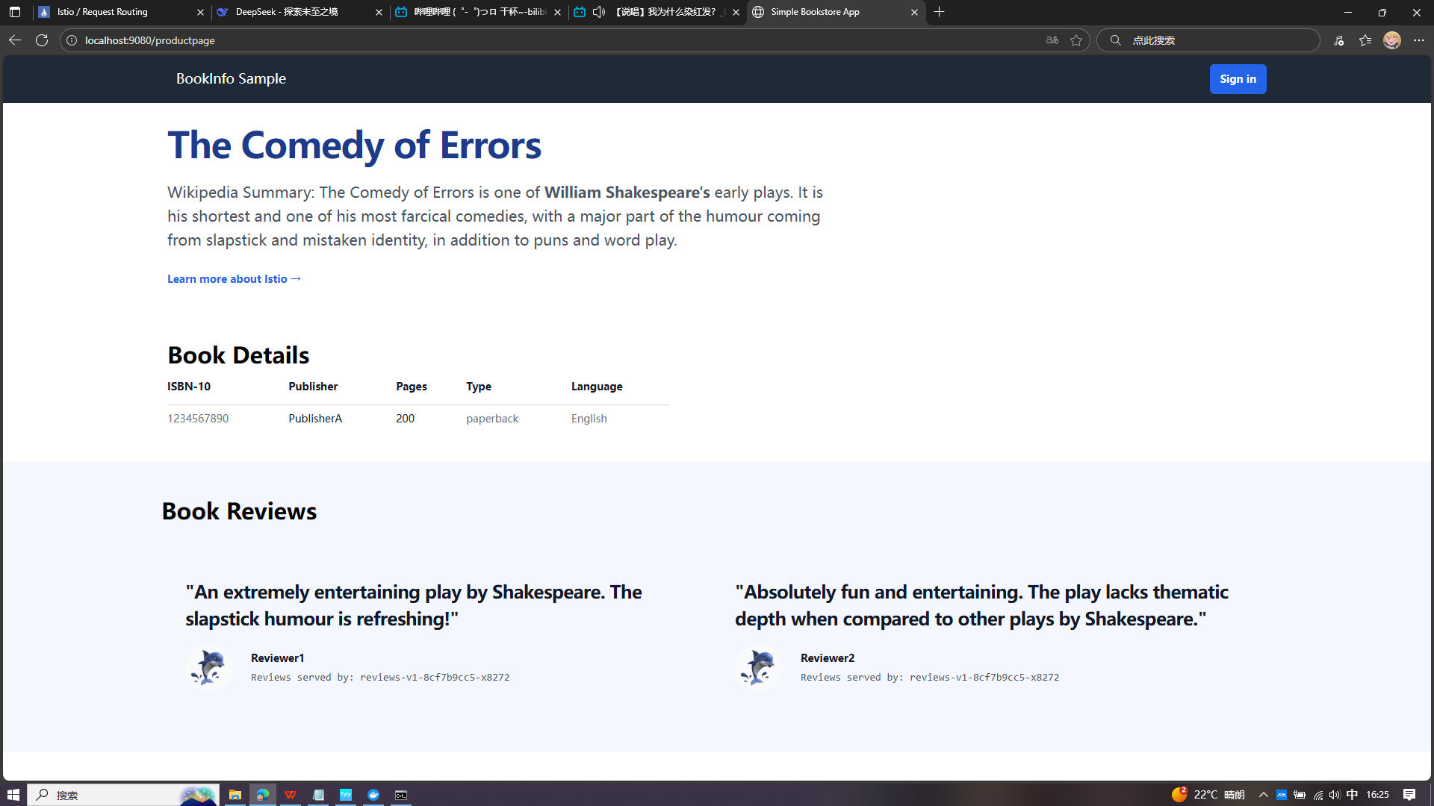

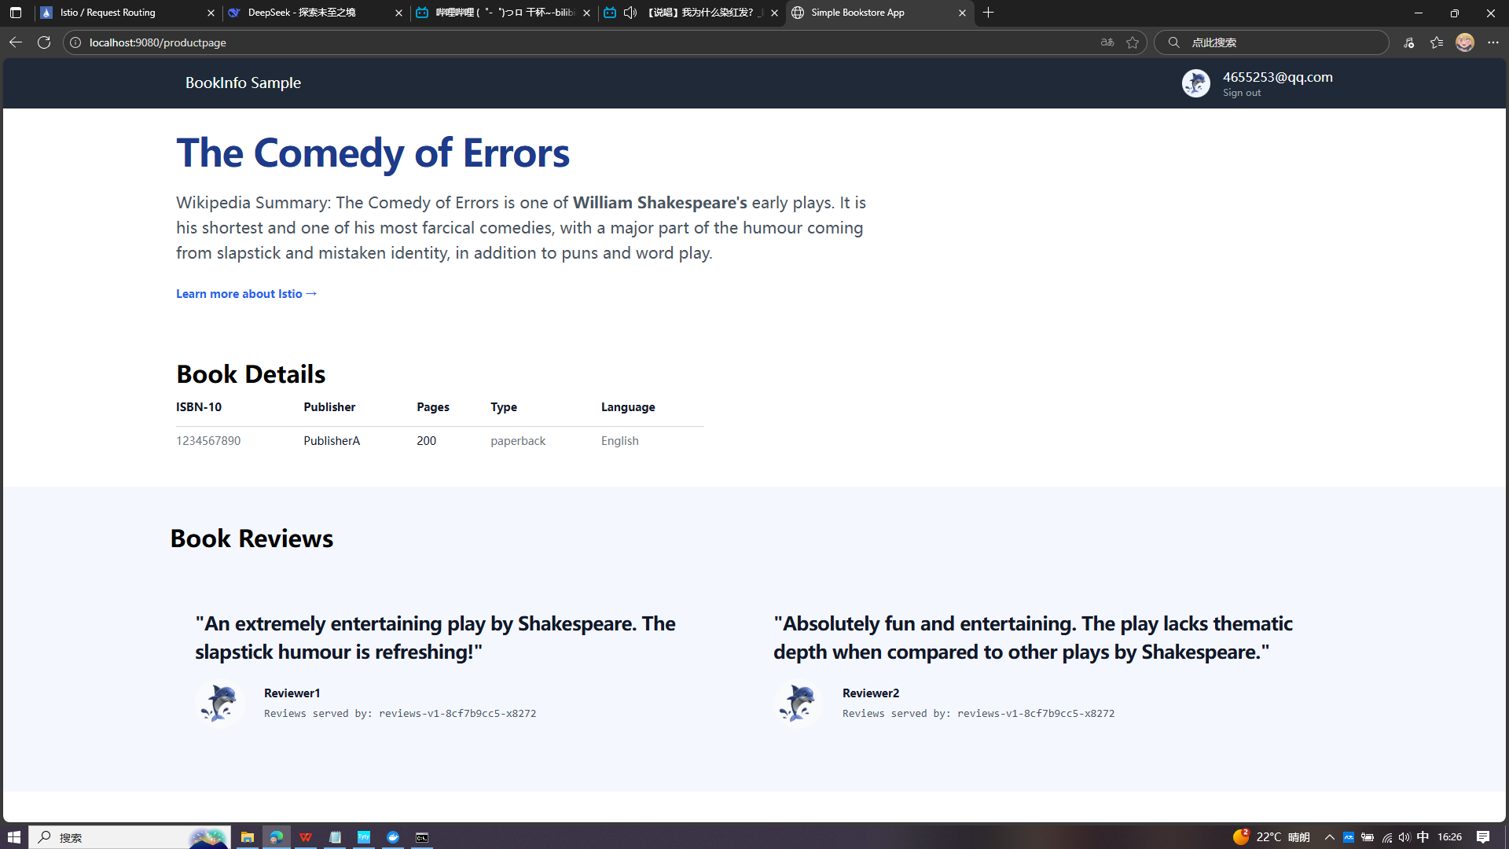

Jason
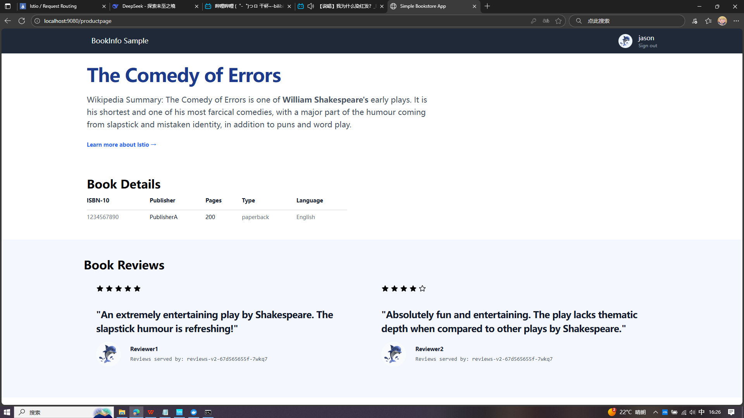

Fault injection
$ kubectl apply -f samples/bookinfo/networking/virtual-service-all-v1.yaml
$ kubectl apply -f samples/bookinfo/networking/virtual-service-reviews-test-v2.yaml

Load becomes slower,use Jason
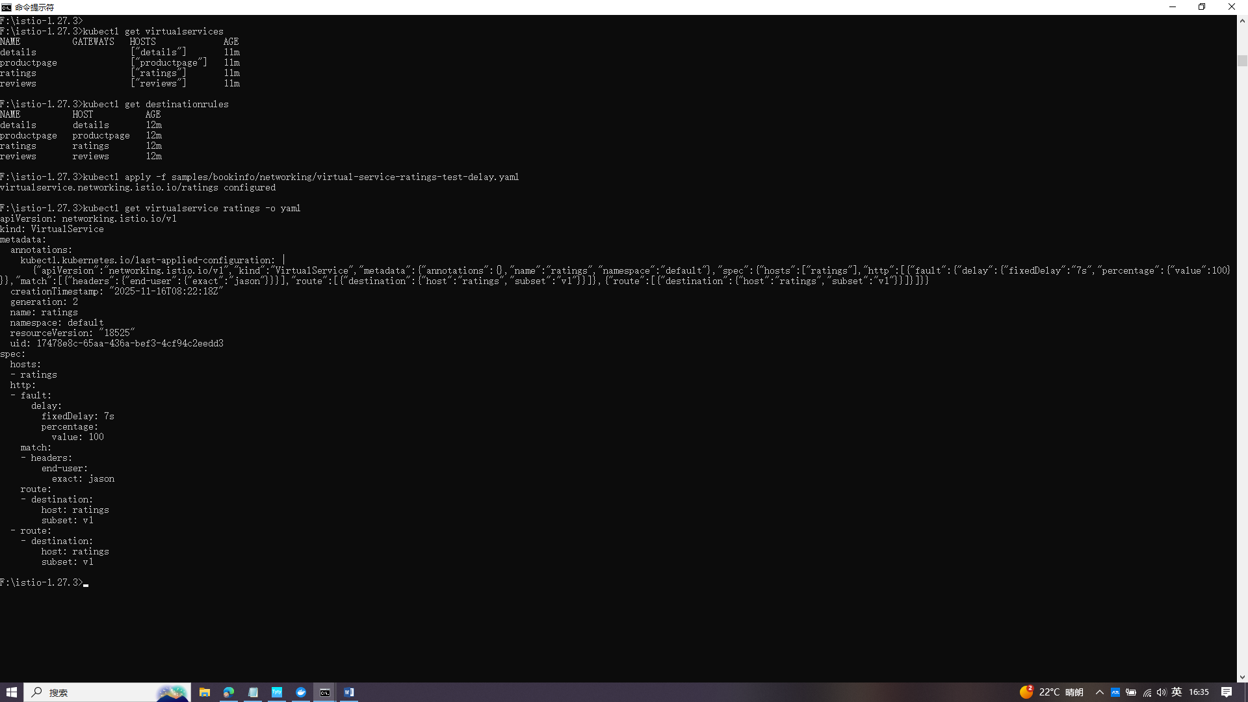

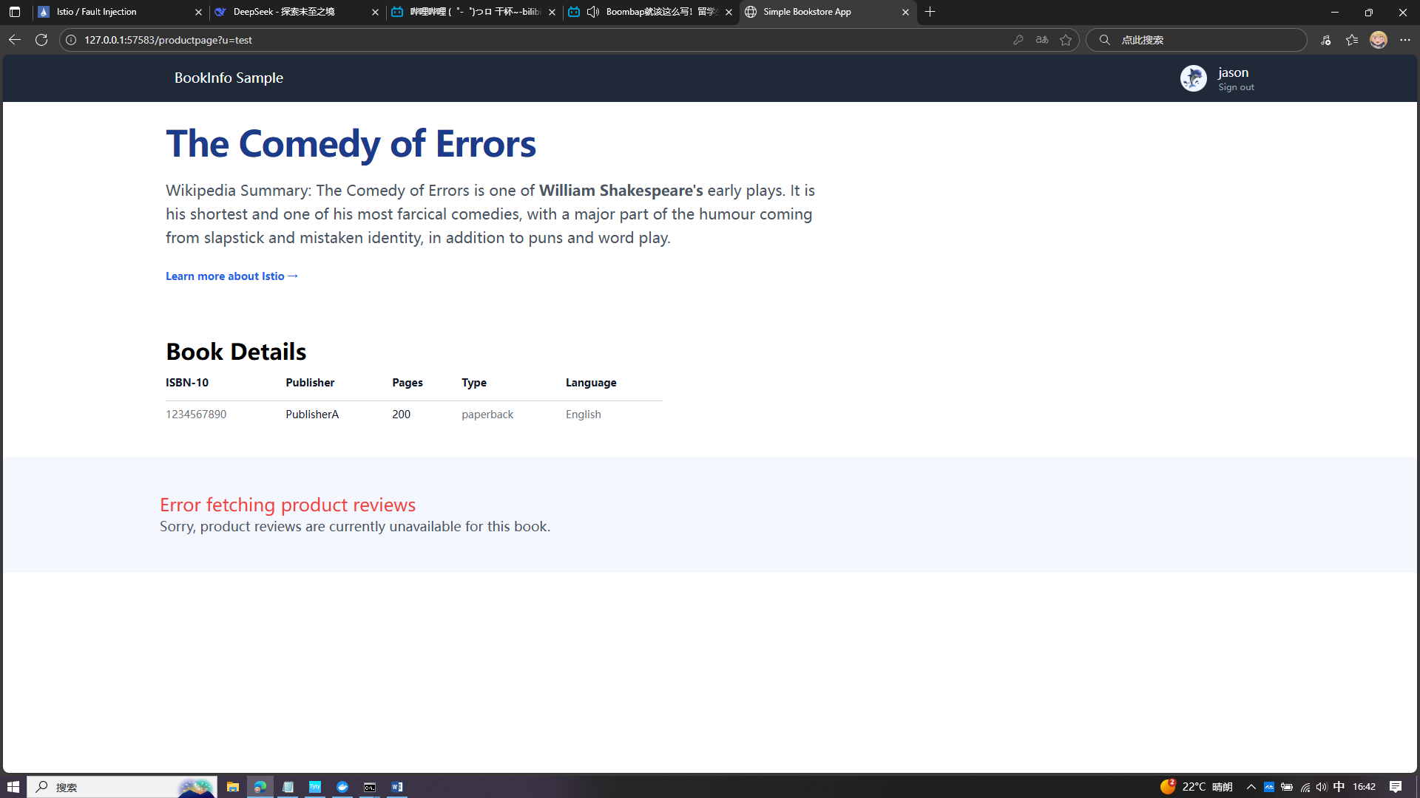

kubectl apply -f samples/bookinfo/networking/virtual-service-ratings-test-delay.yaml
use Jason
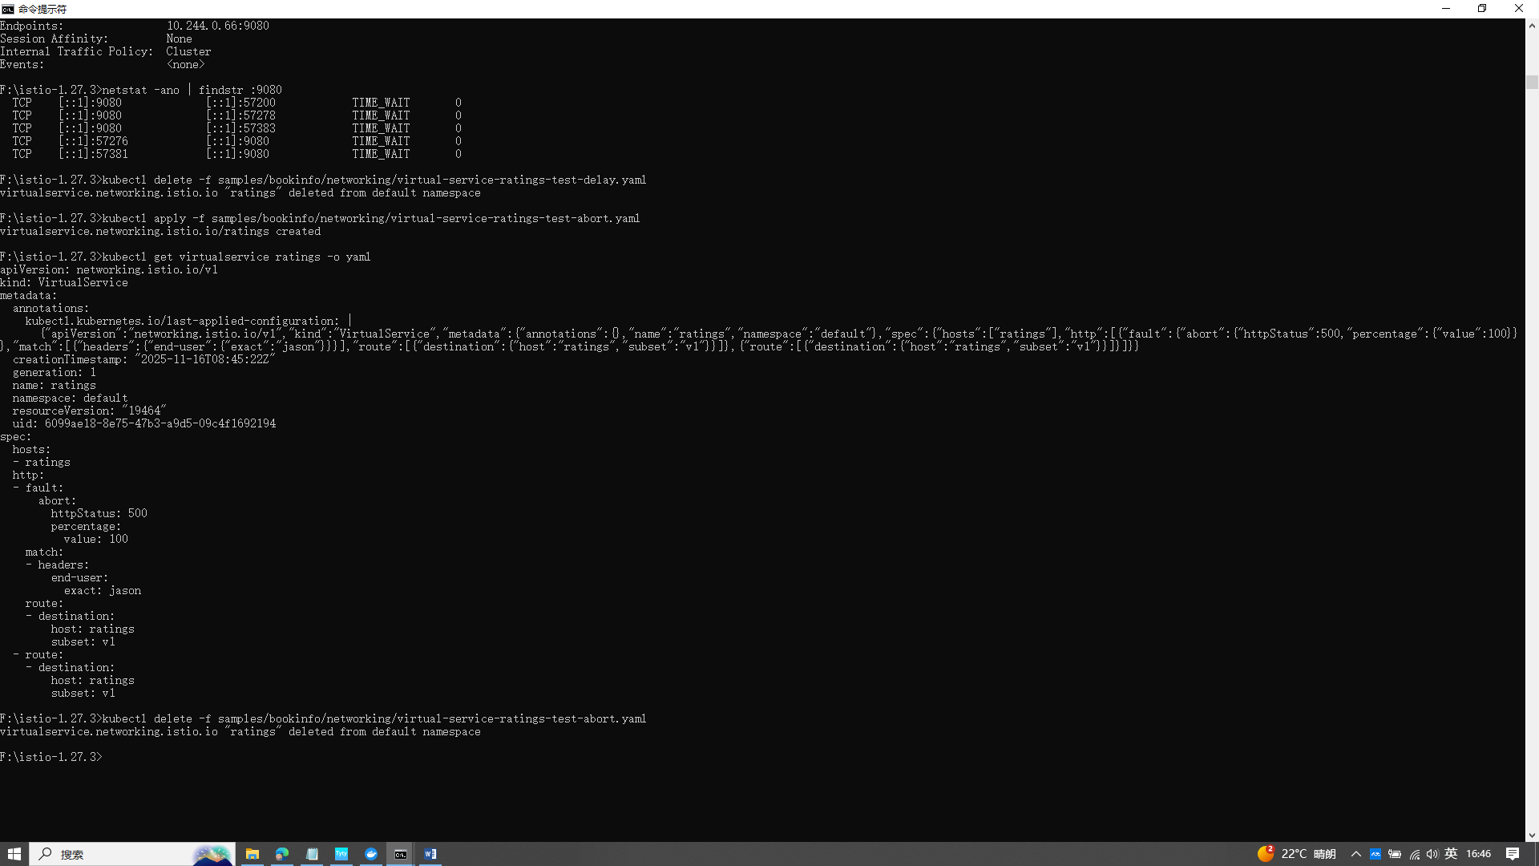

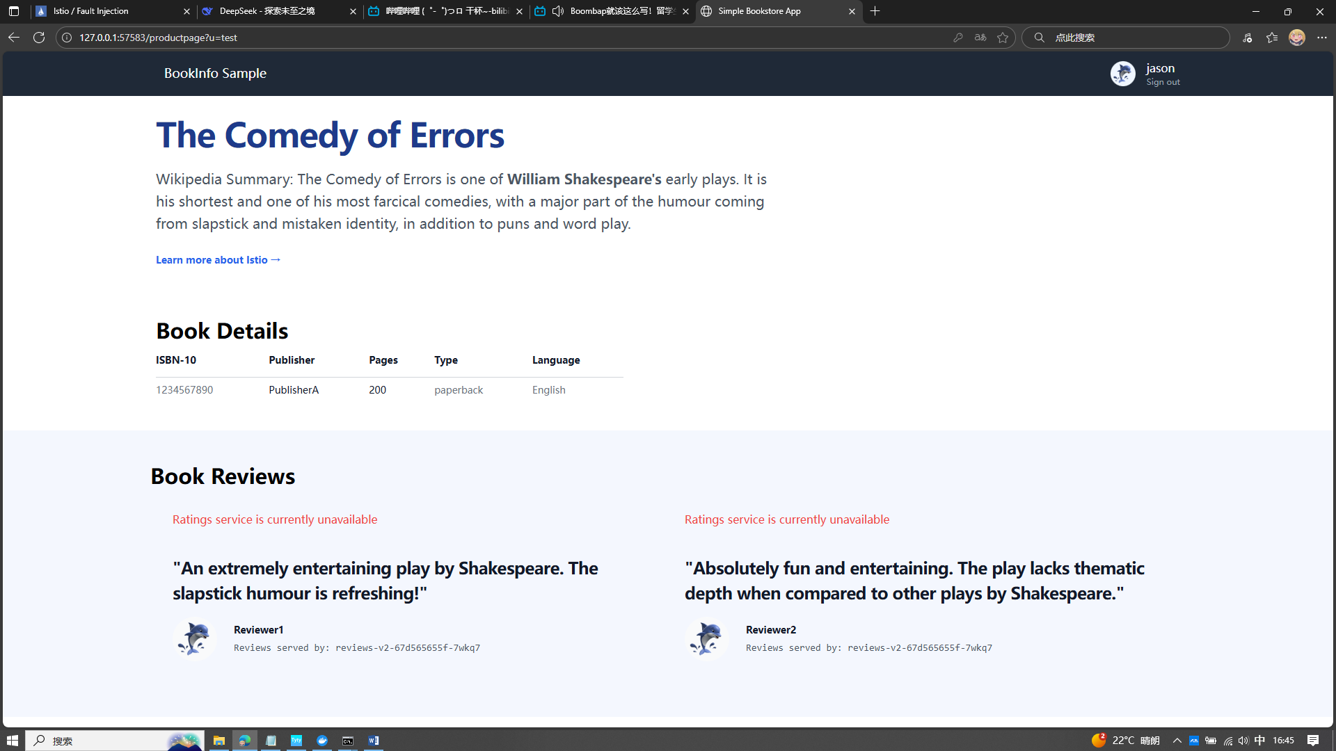

Circuit Breaking

kubectl apply -f samples/httpbin/httpbin.yaml
kubectl apply -f samples/httpbin/sample-client/fortio-deploy.yaml
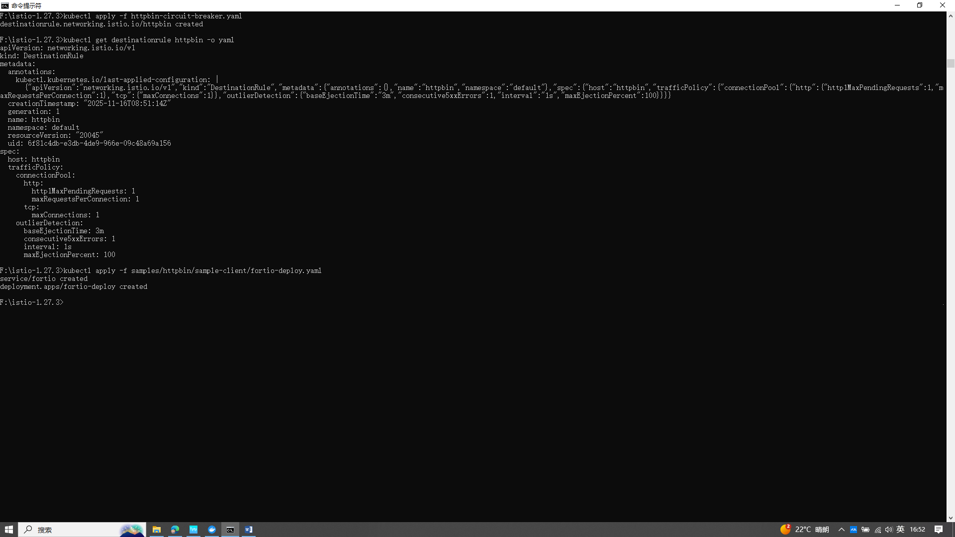
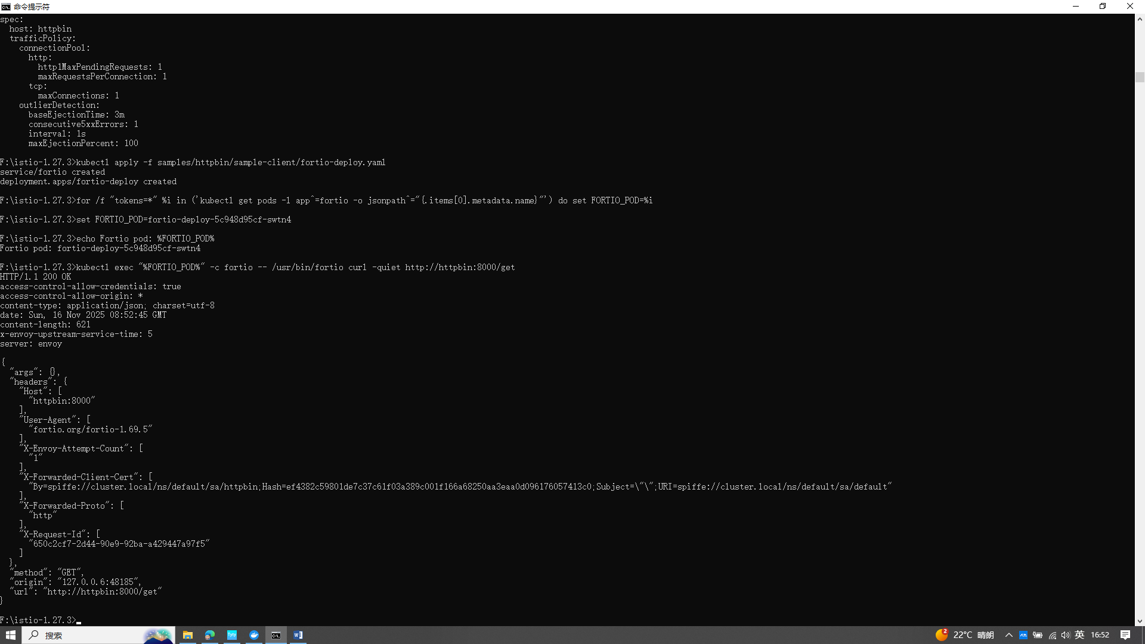

Tripping the circuit breaker
