Install kserves and test
minikube start --memory=4096 --cpus=2
kubectl cluster-info

kubectl create namespace ml-demo
kubectl apply -f sklearn-fixed.yaml

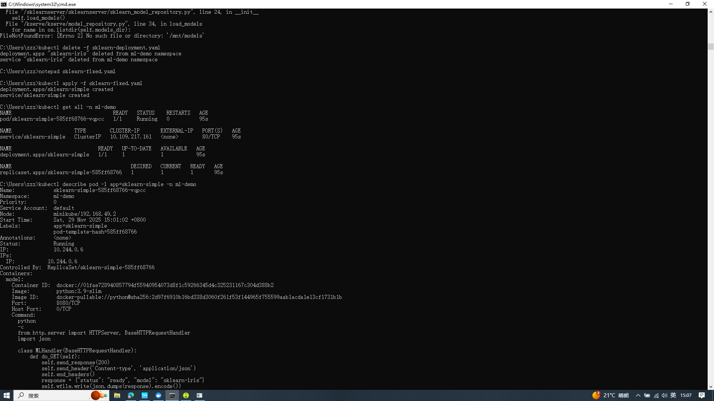

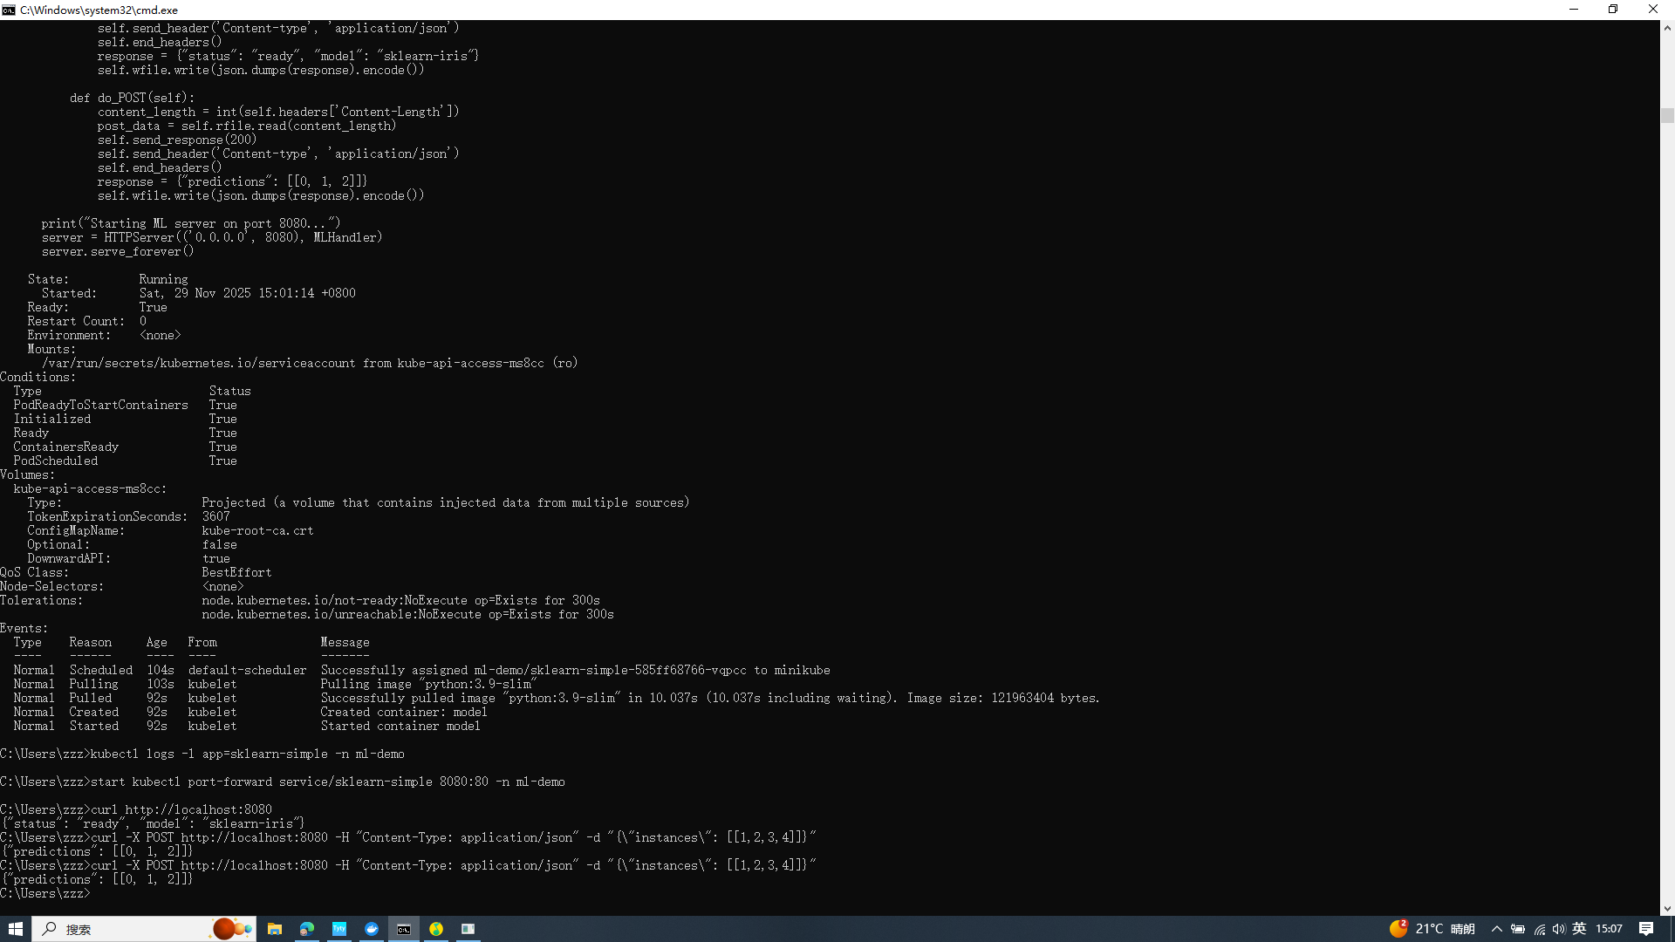 kubectl port-forward service/sklearn-simple 8080:80 -n ml-demo
curl http://localhost:8080
curl -X POST http://localhost:8080 -H "Content-Type: application/json" -d '{"instances": [[1,2,3,4]]}'

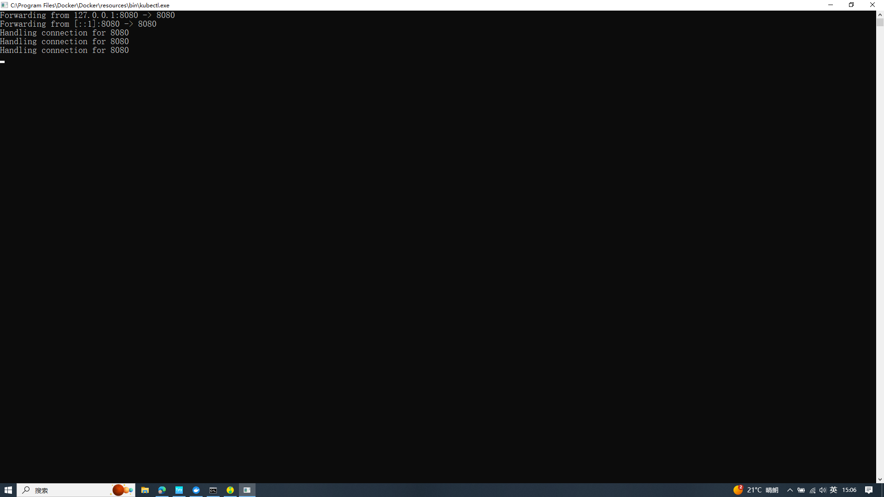

Deploy interface service
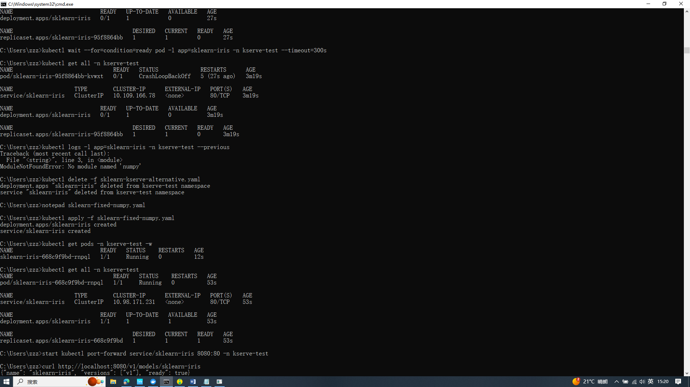

kubectl apply -f sklearn-fixed-numpy.yaml

curl http://localhost:8080/v1/models/sklearn-iris
curl -H "Content-Type: application/json" http://localhost:8080/v1/models/sklearn-iris:predict -d "{\"instances\": [[6.8, 2.8, 4.8, 1.4], [6.0, 3.4, 4.5, 1.6]]}"
