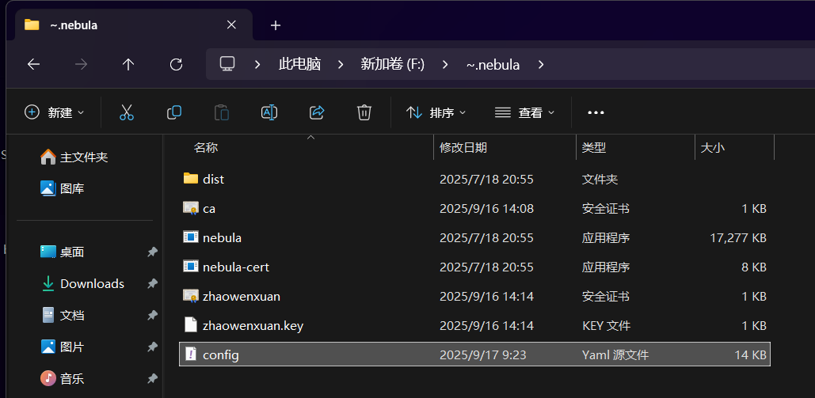

Change config pki:

ca: F:~.nebula\ca.crt

cert: F:~.nebula\zhaowenxuan.crt

key: F:~.nebula\zhaowenxuan.key

cd F:\~.nebula

.\nebula -config config.yaml

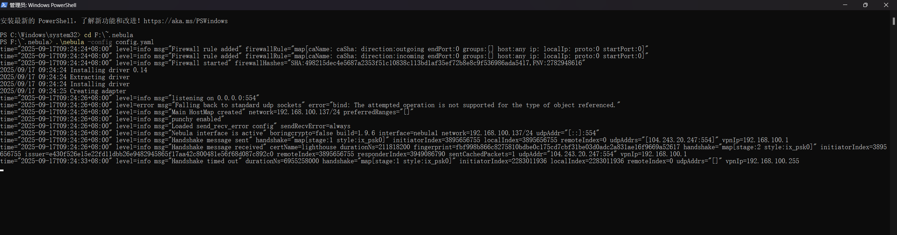

ping 192.168.100.1

