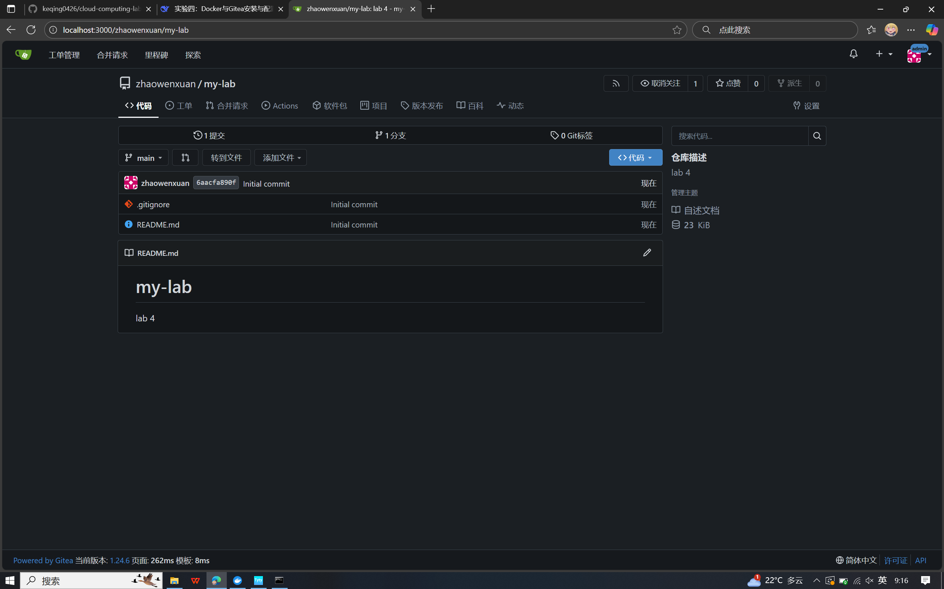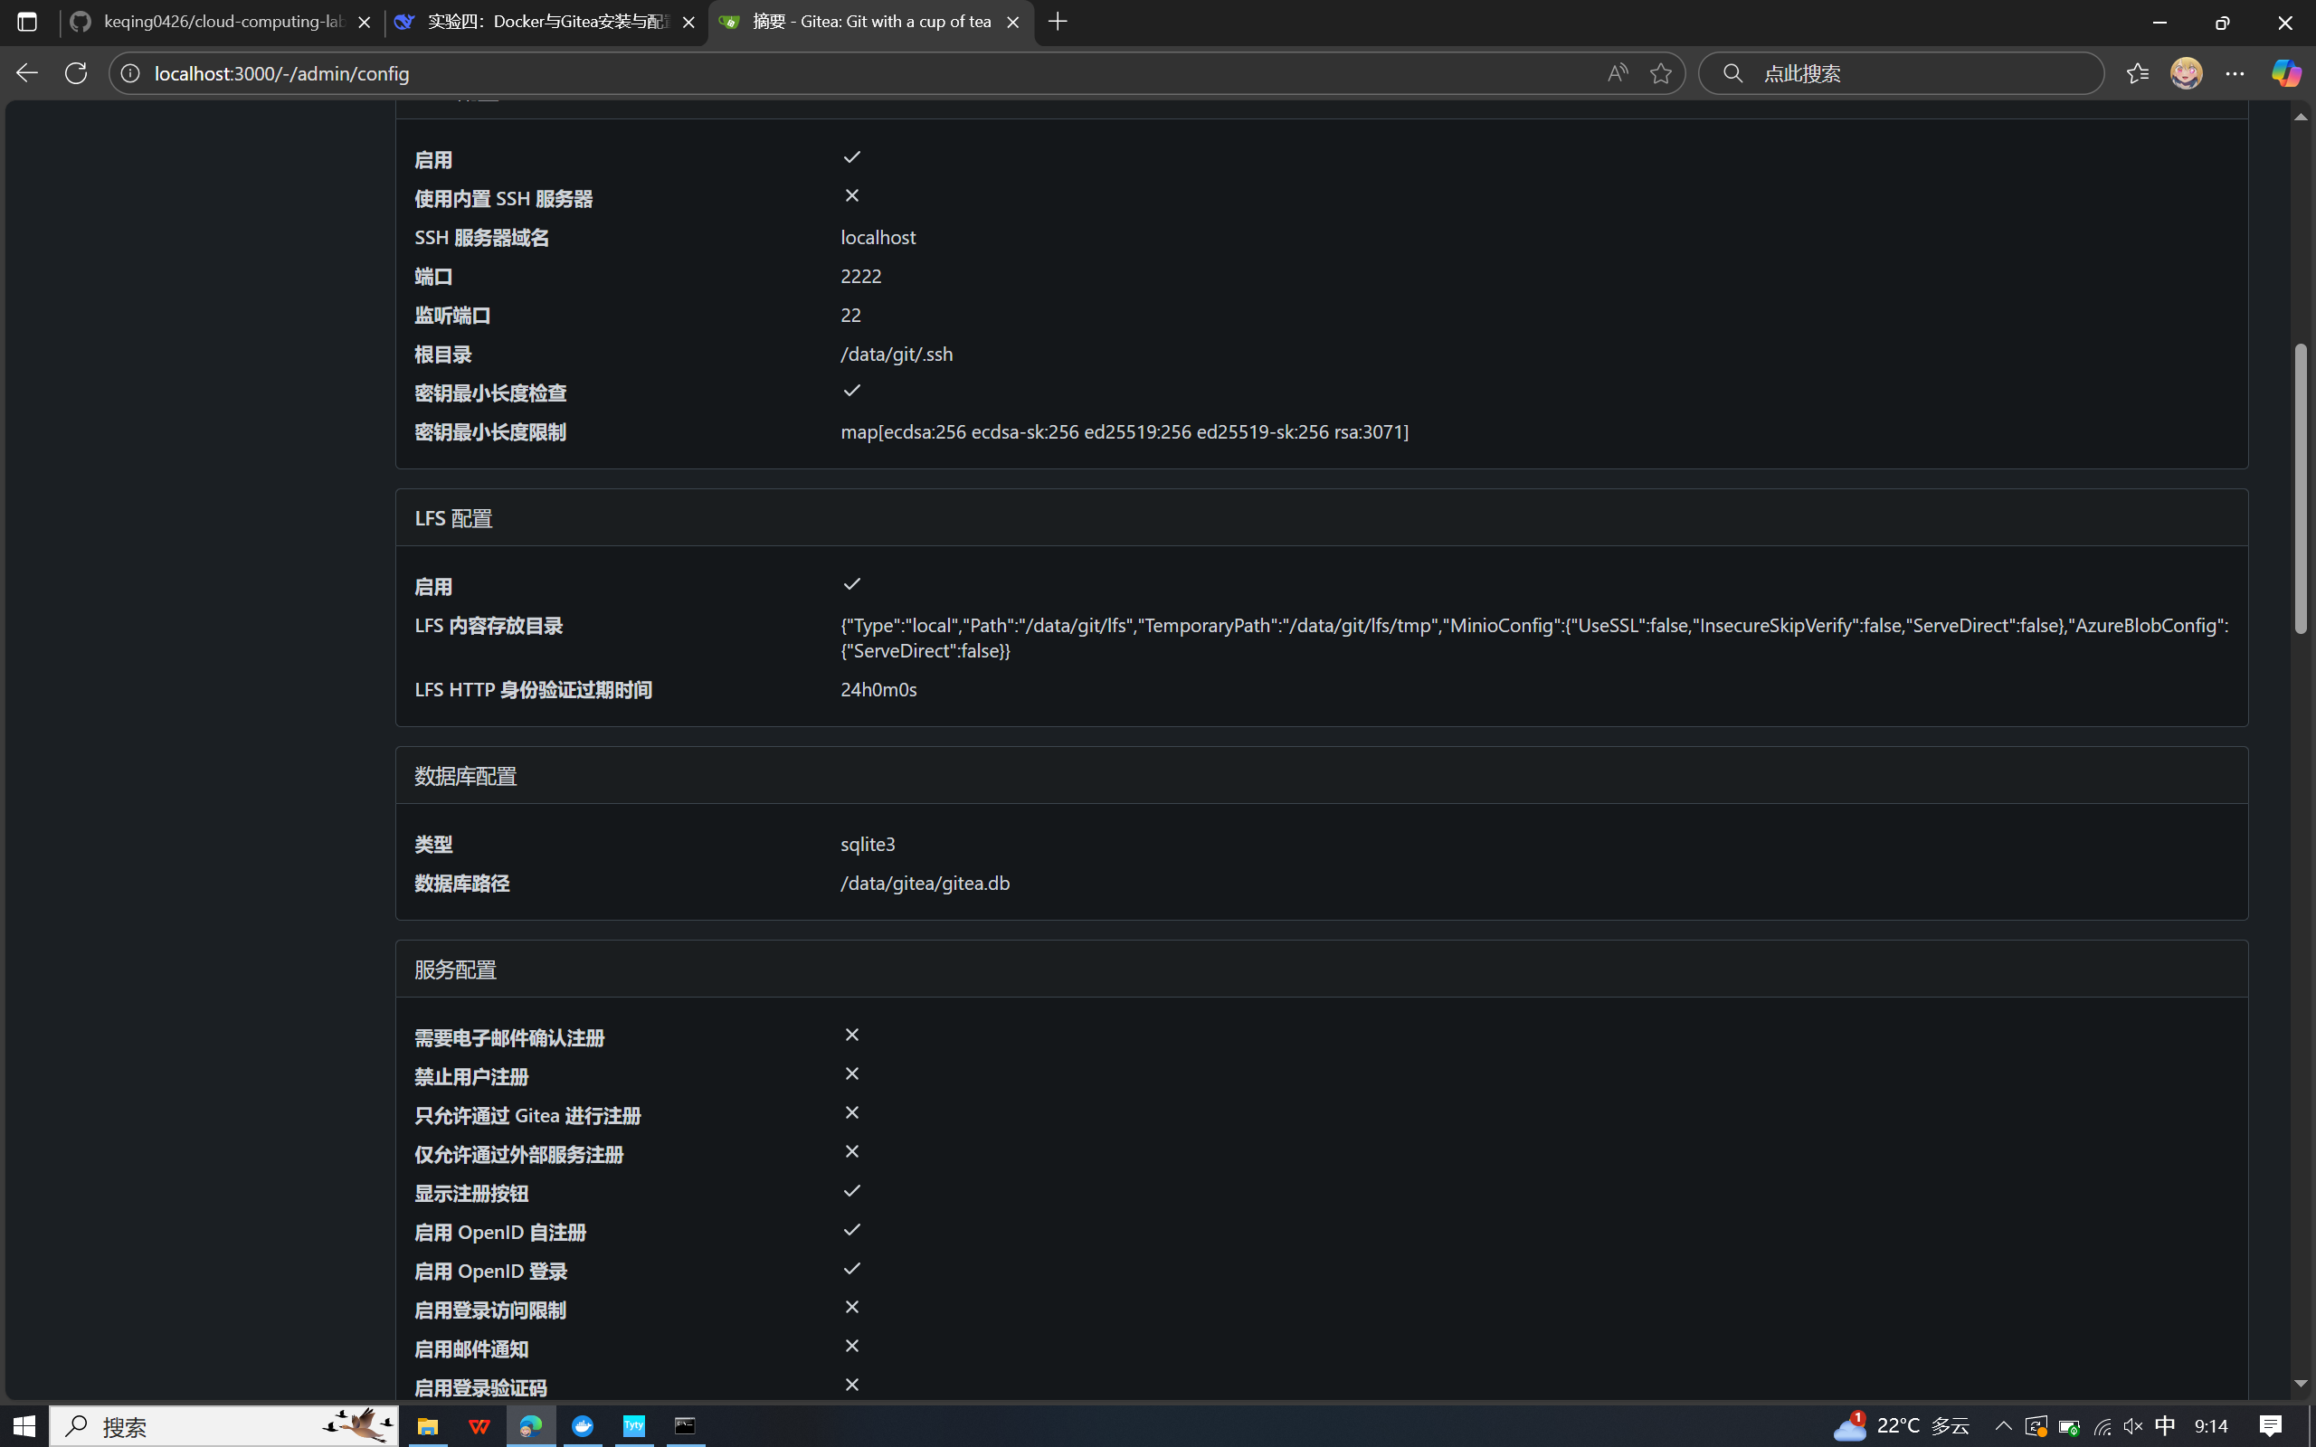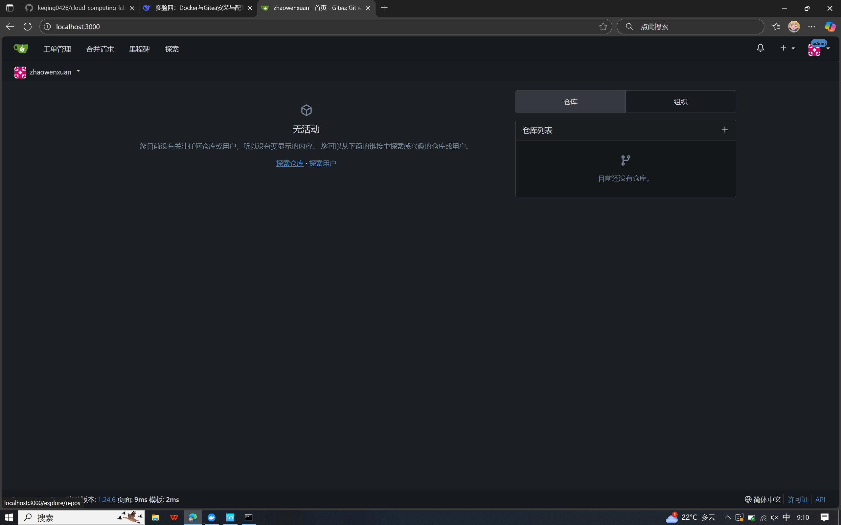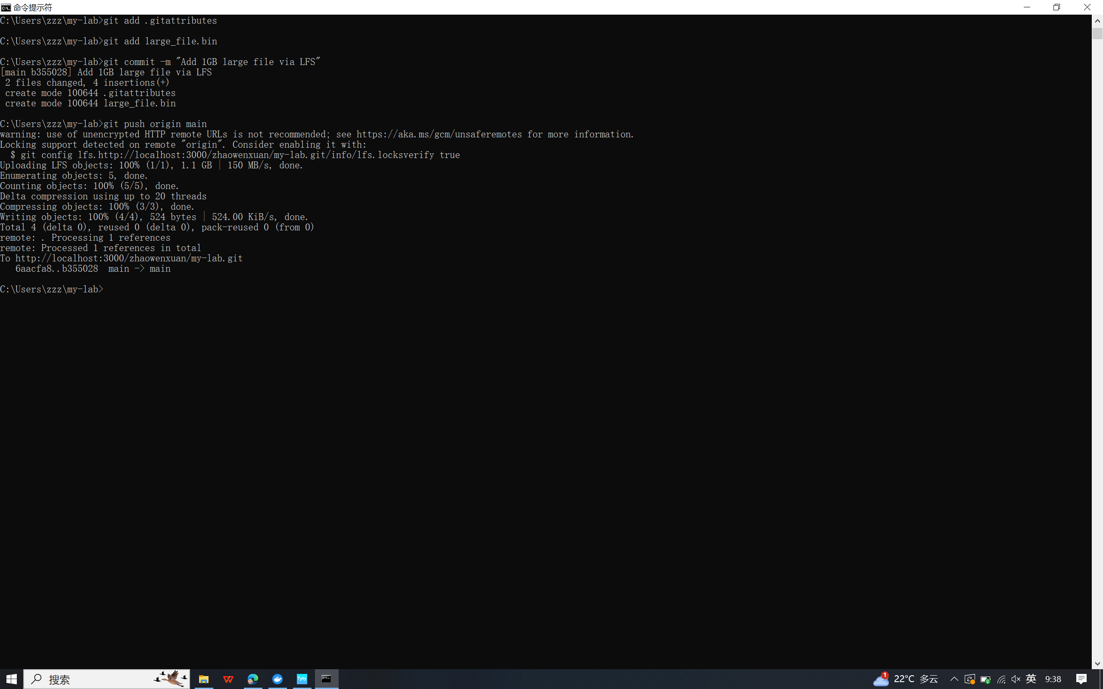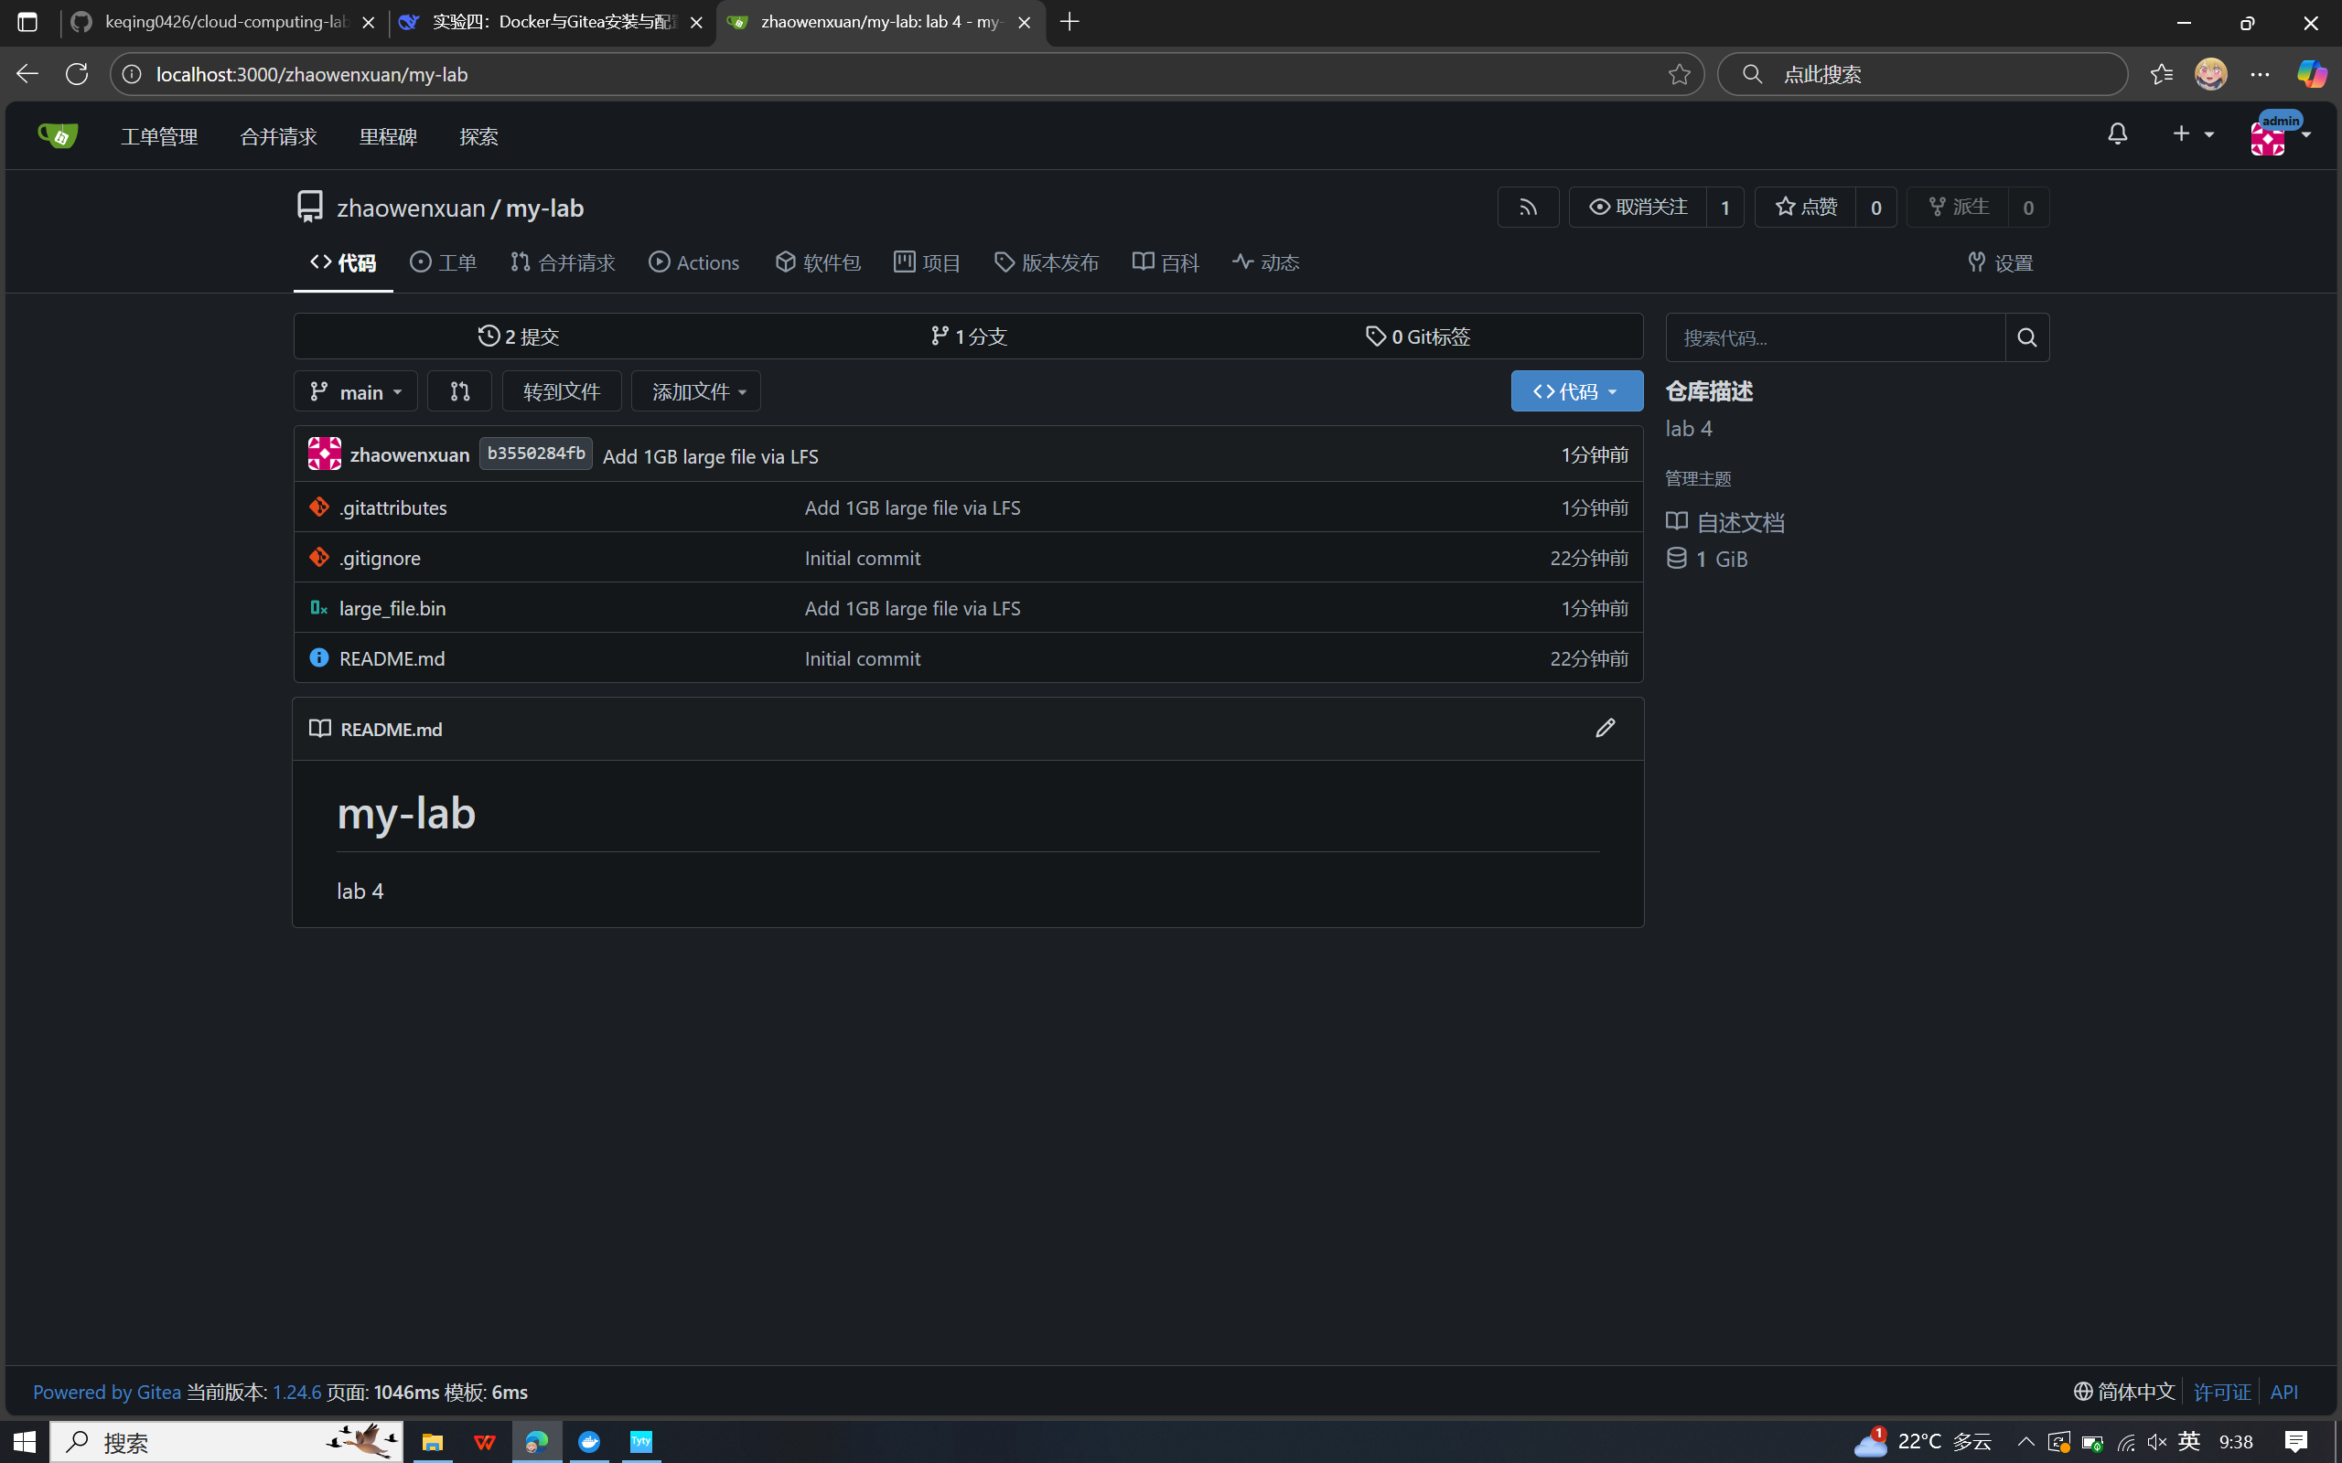

cd my-lab

move ..\large_file.bin .

git lfs install

git lfs track "*.bin"

git add .gitattributes

git add large_file.bin

git commit -m "Add 1GB large file via LFS"

git push origin main