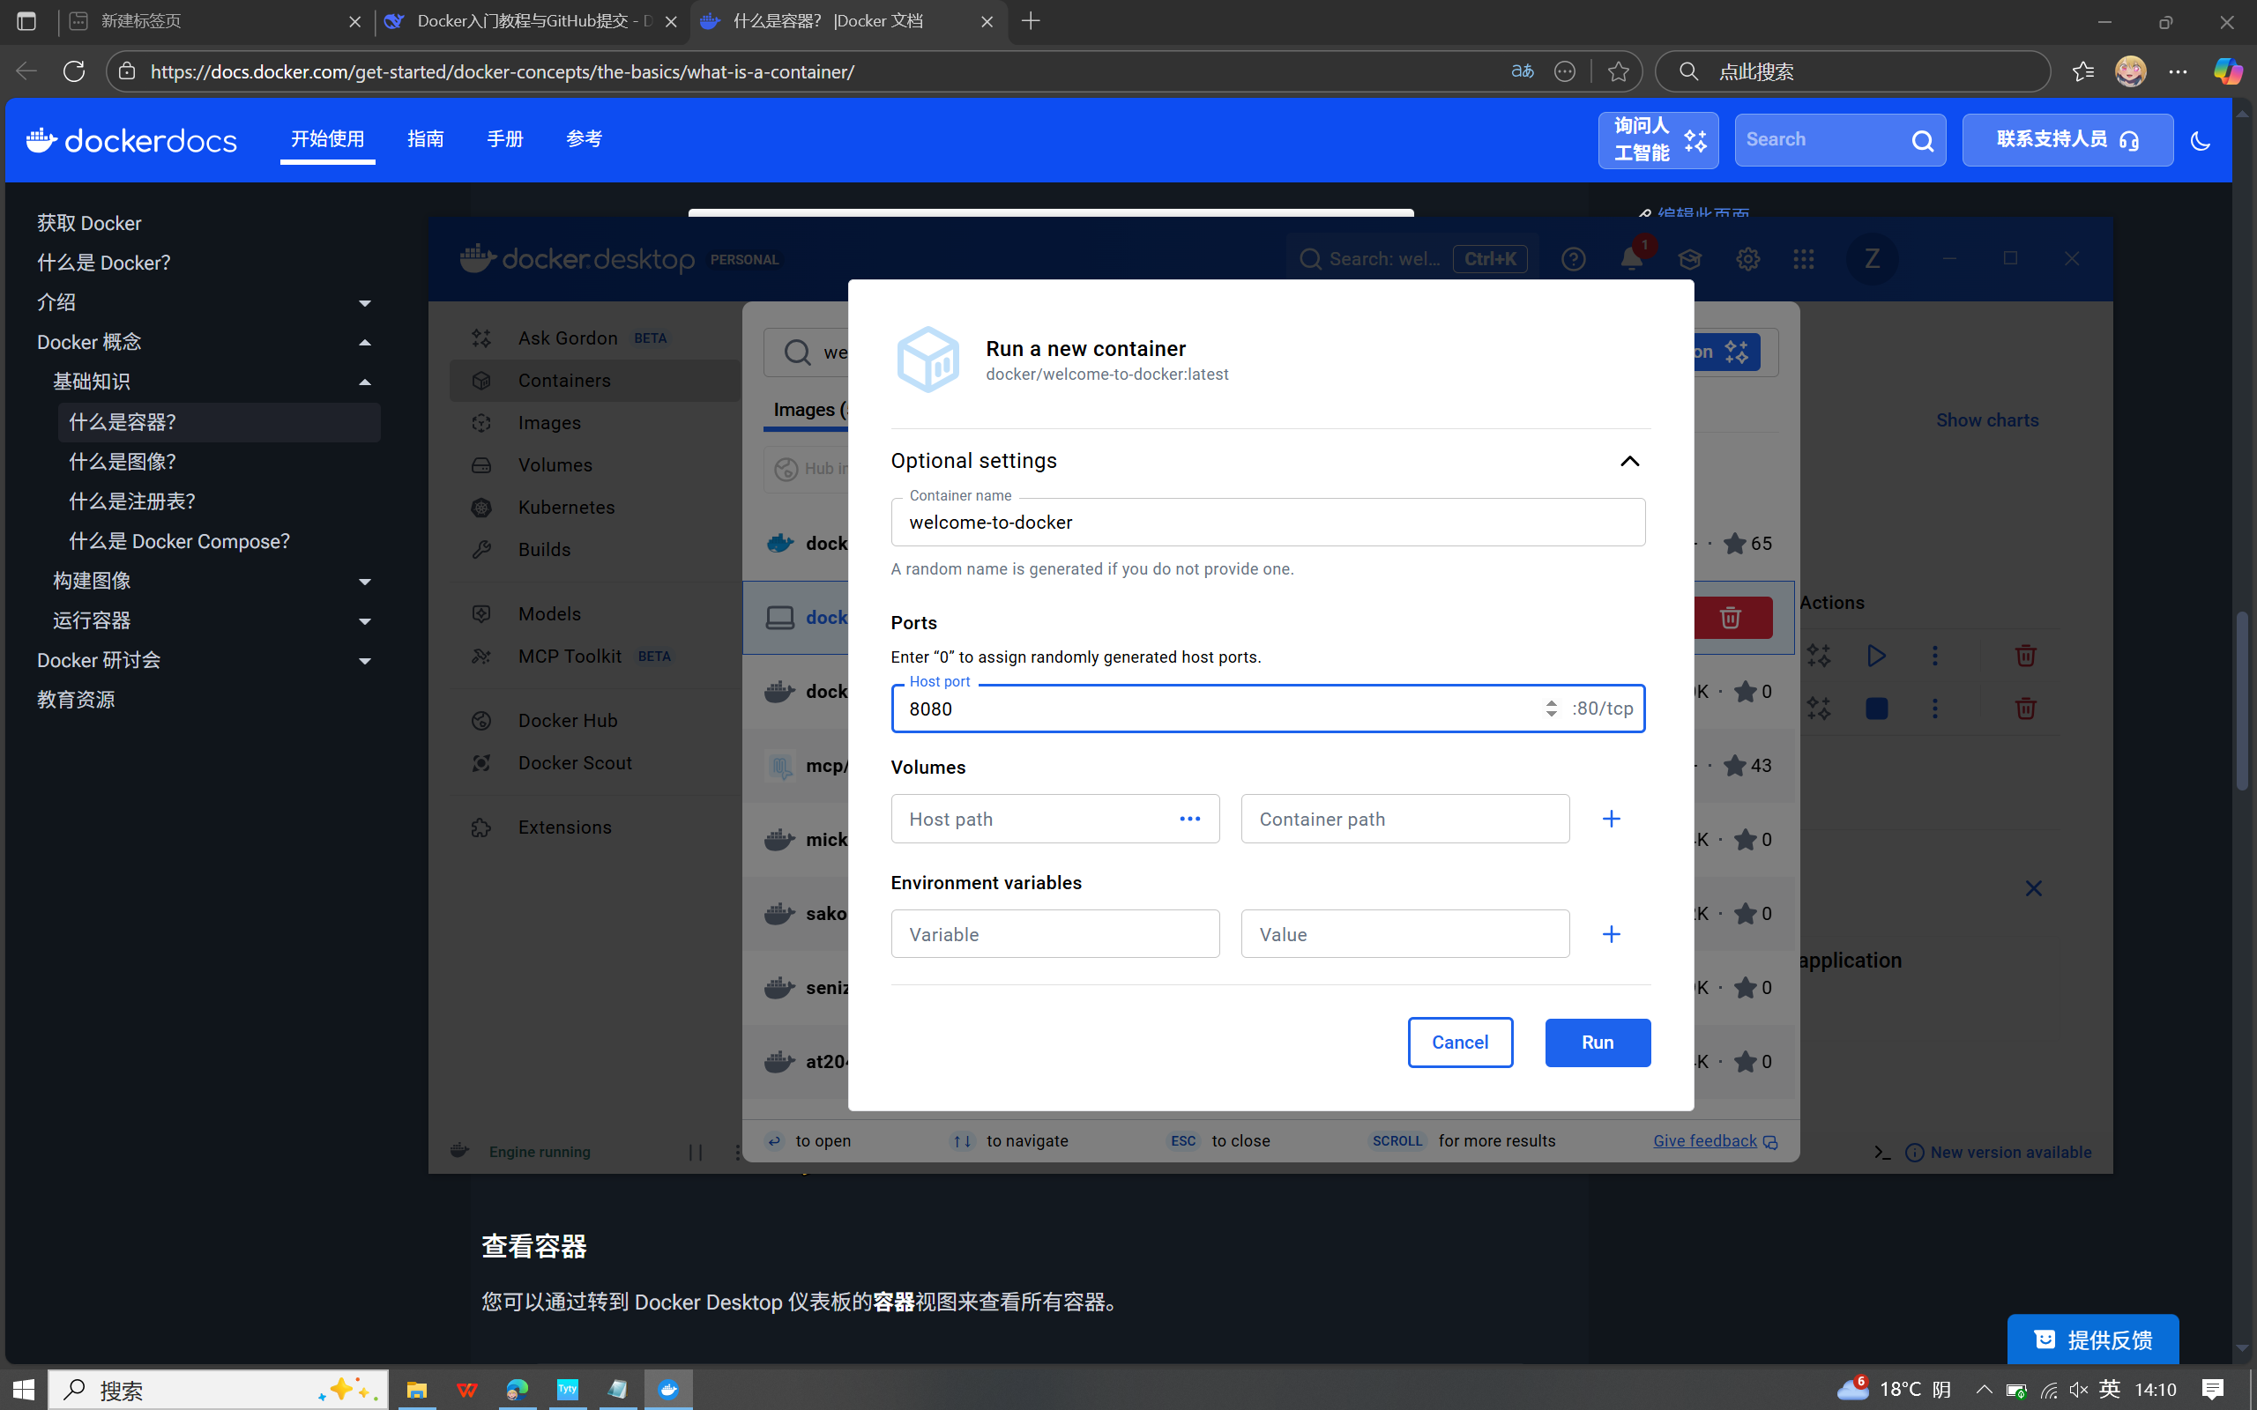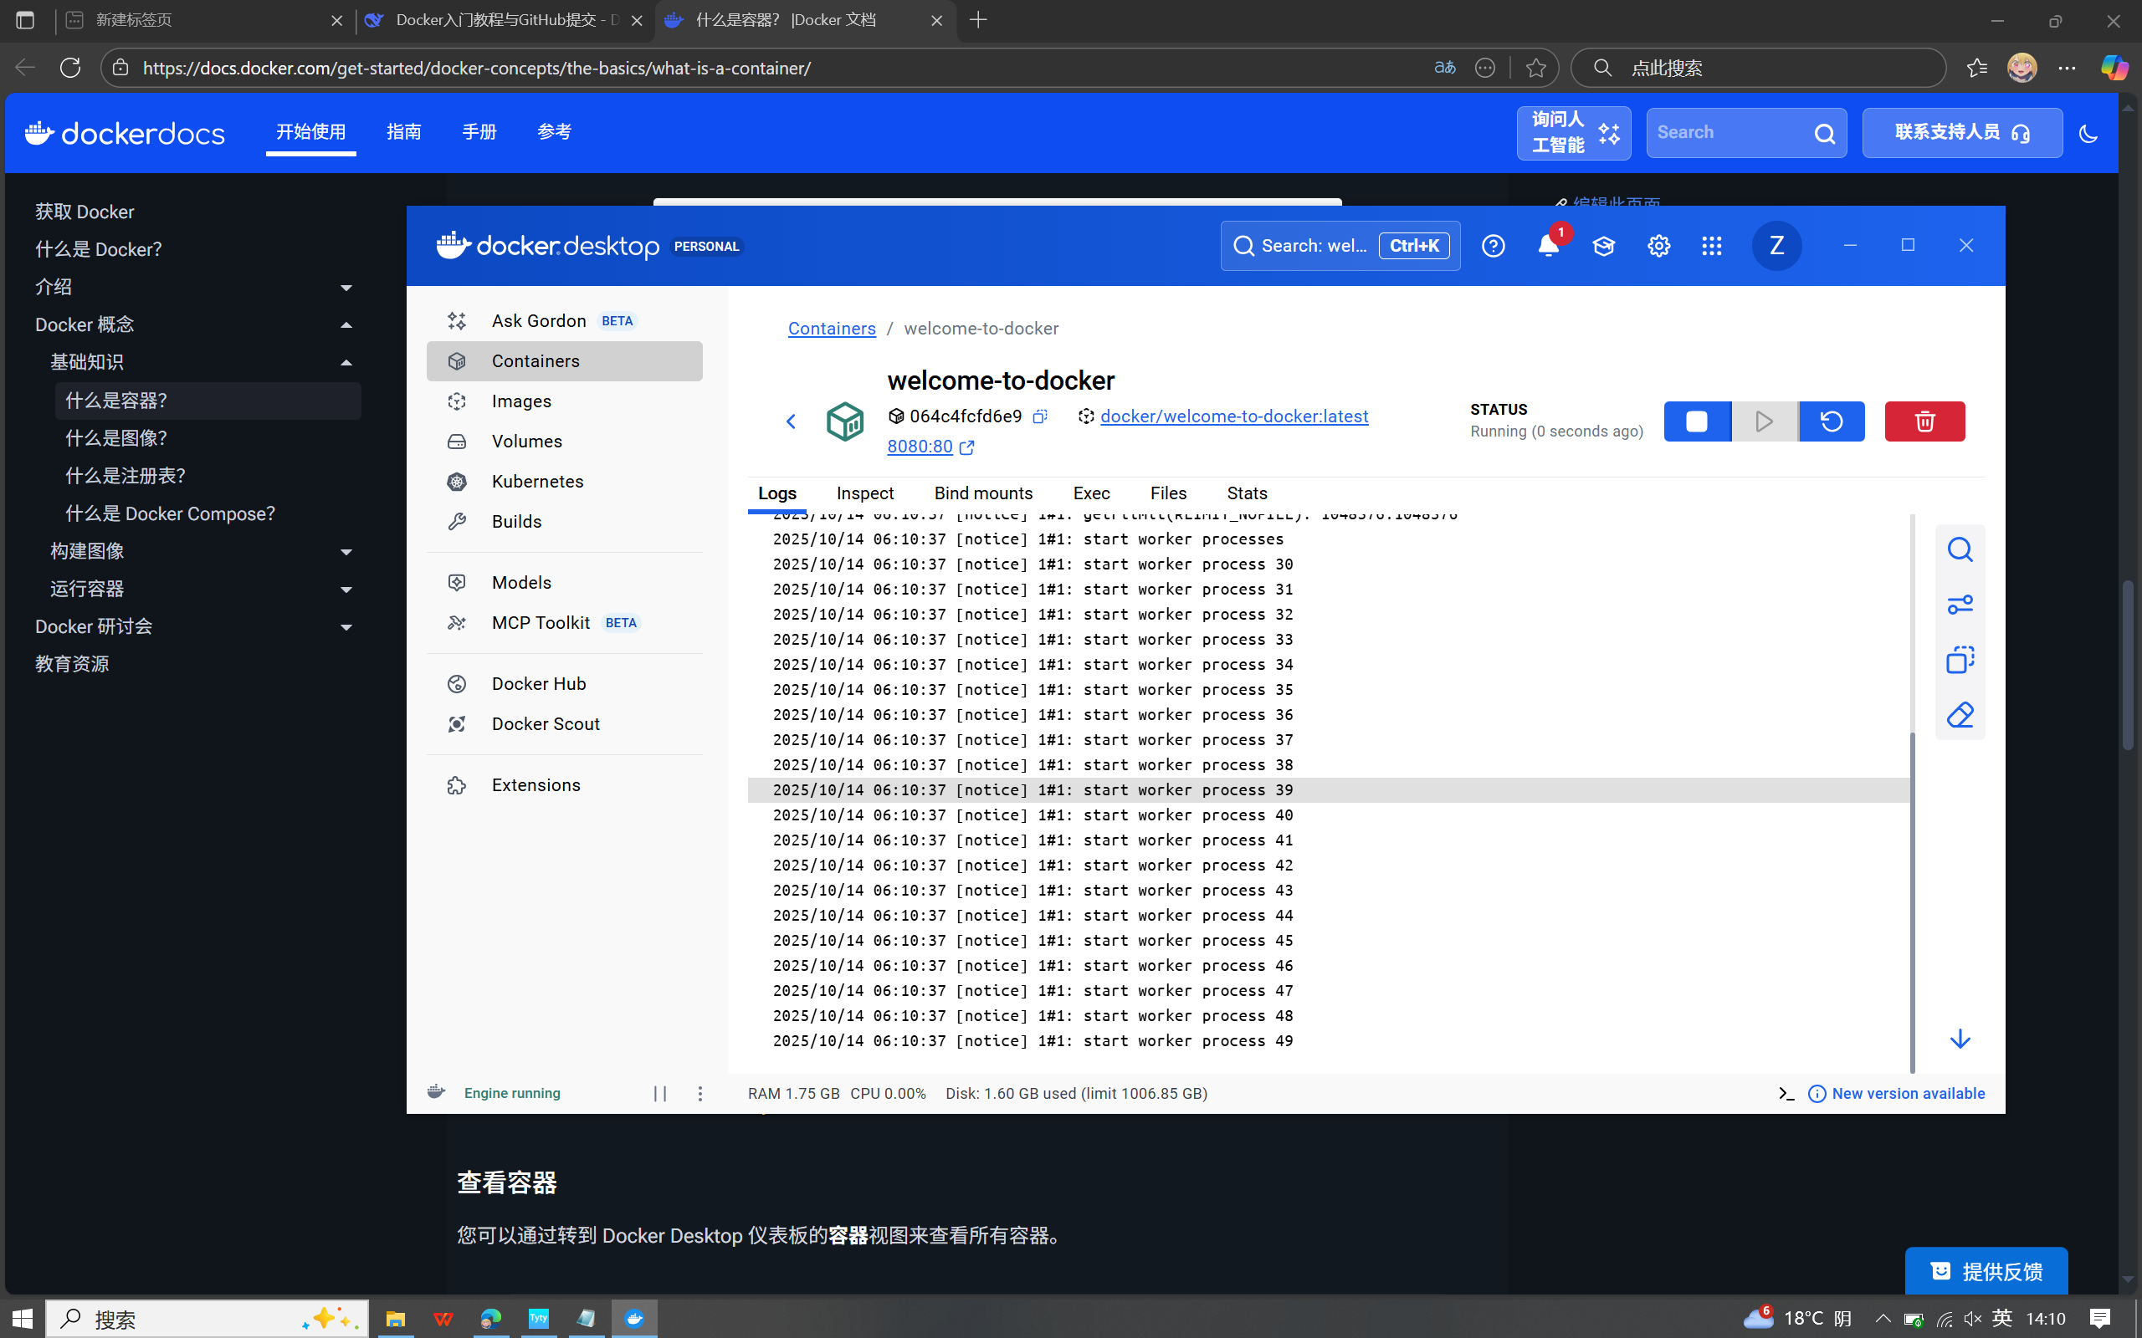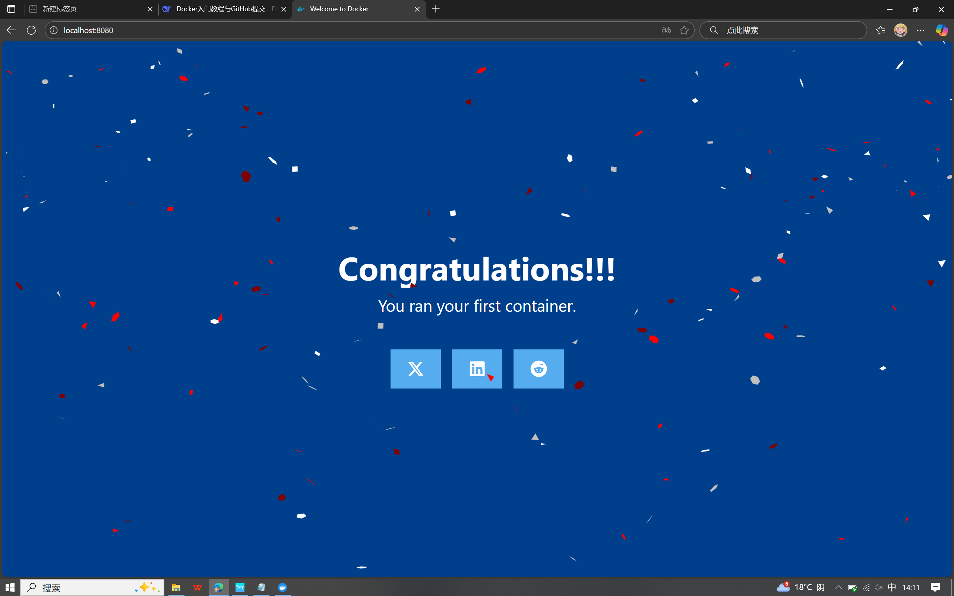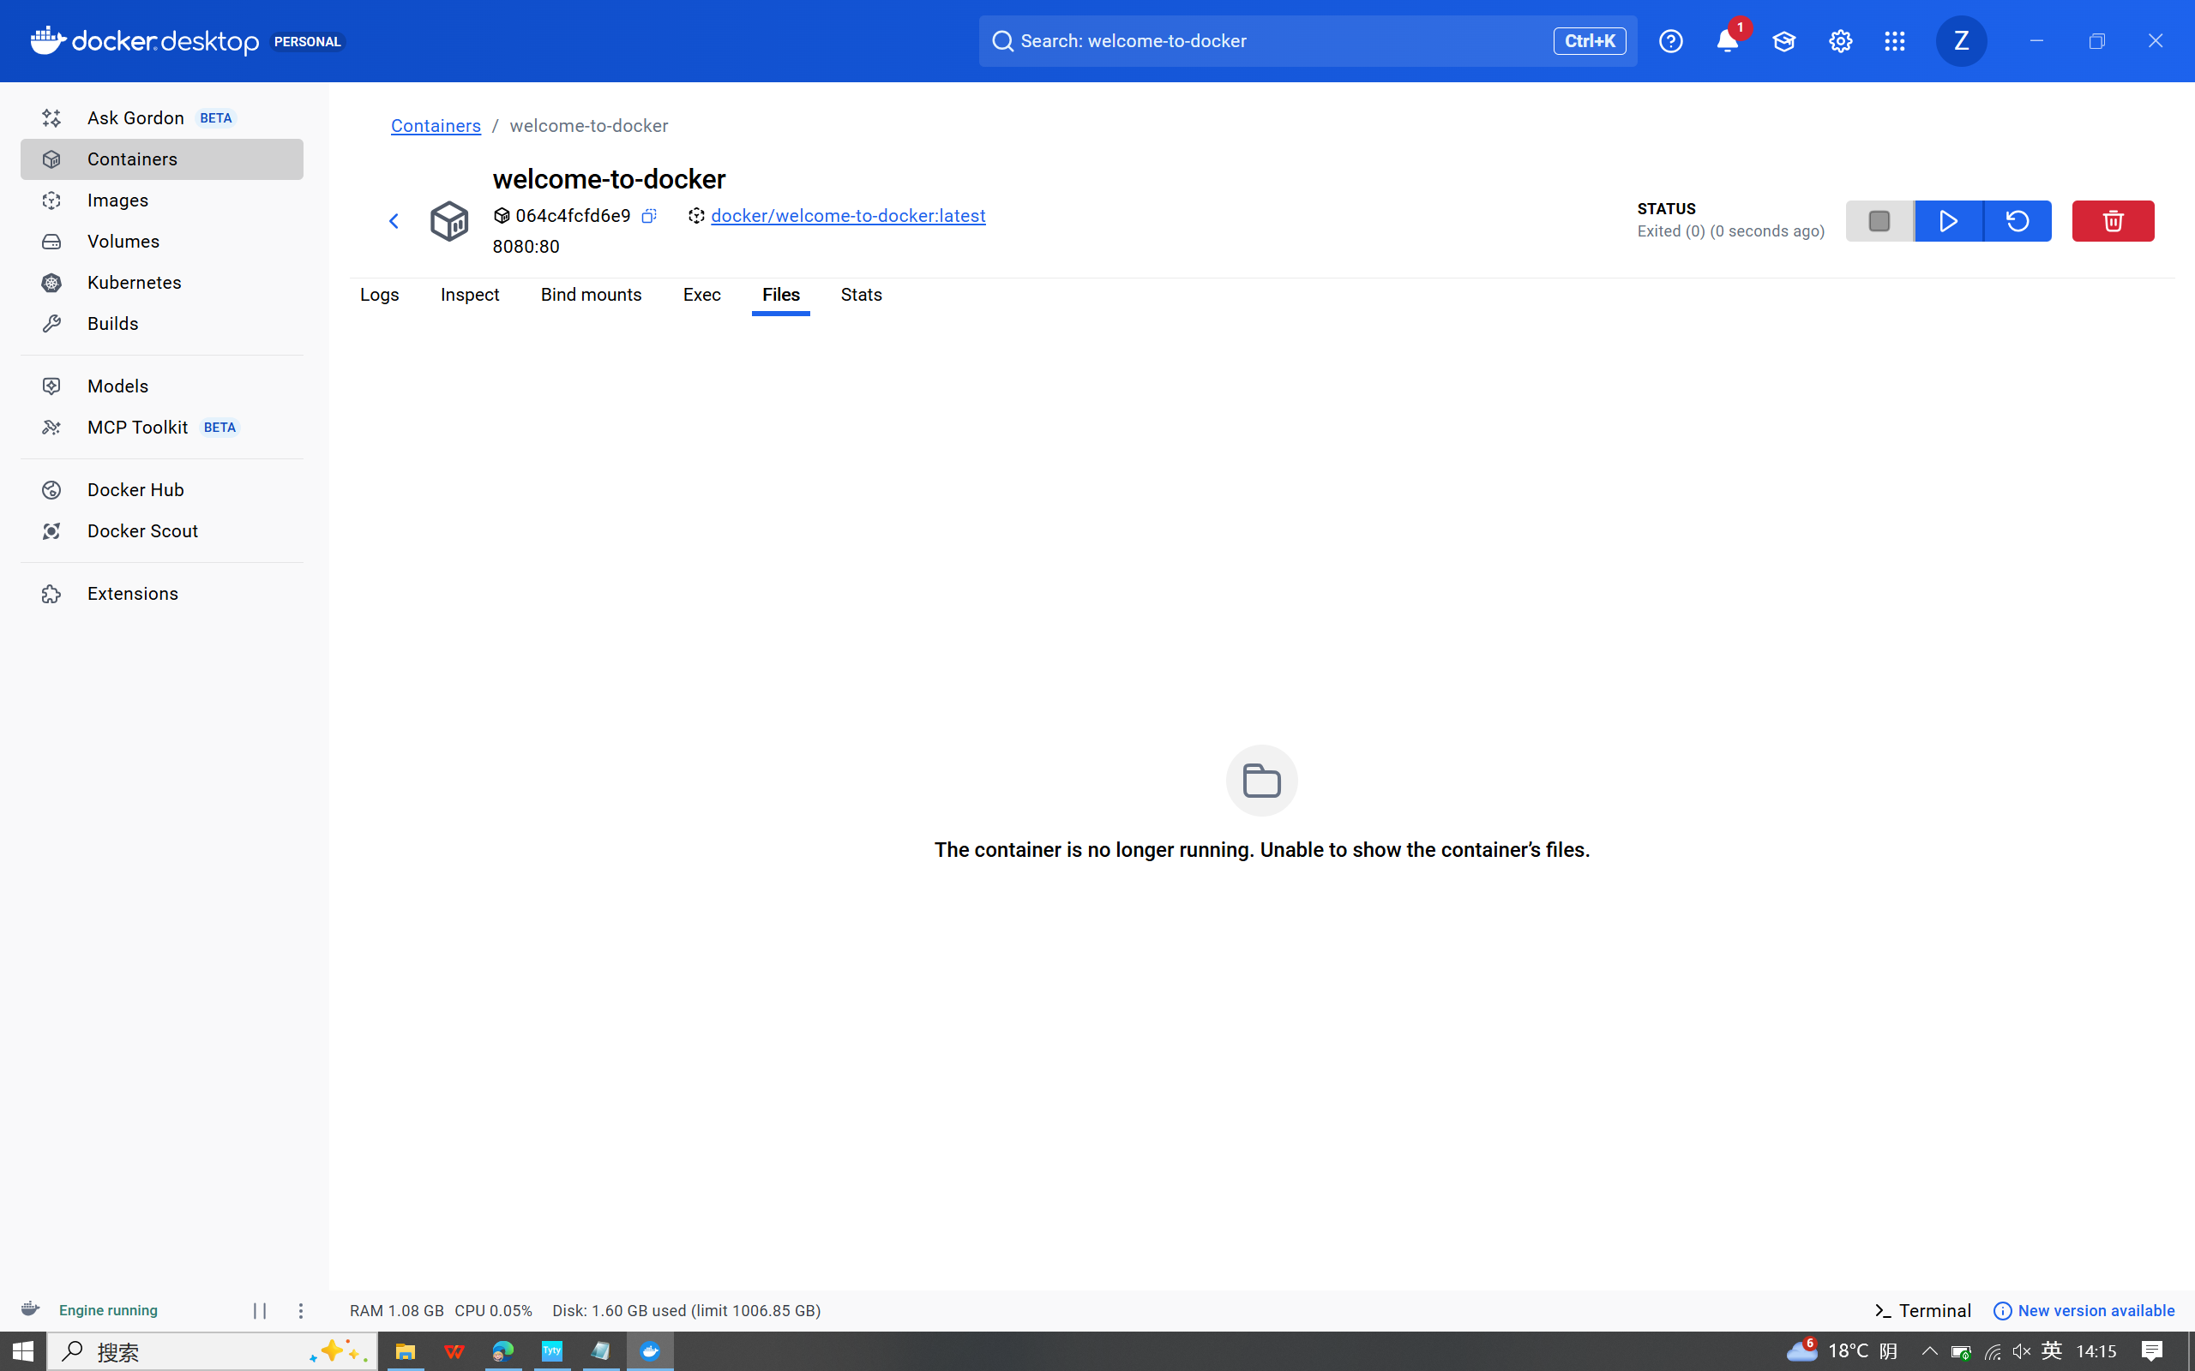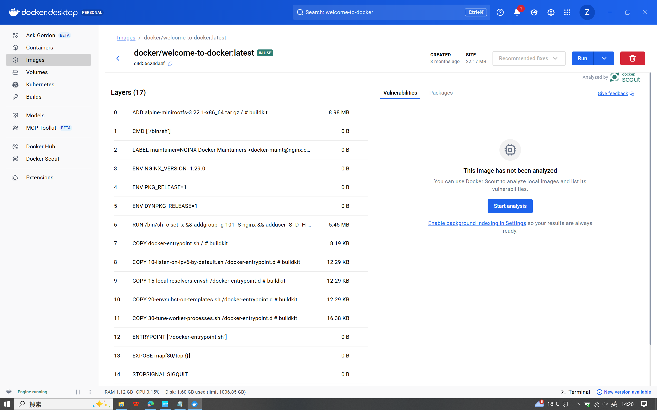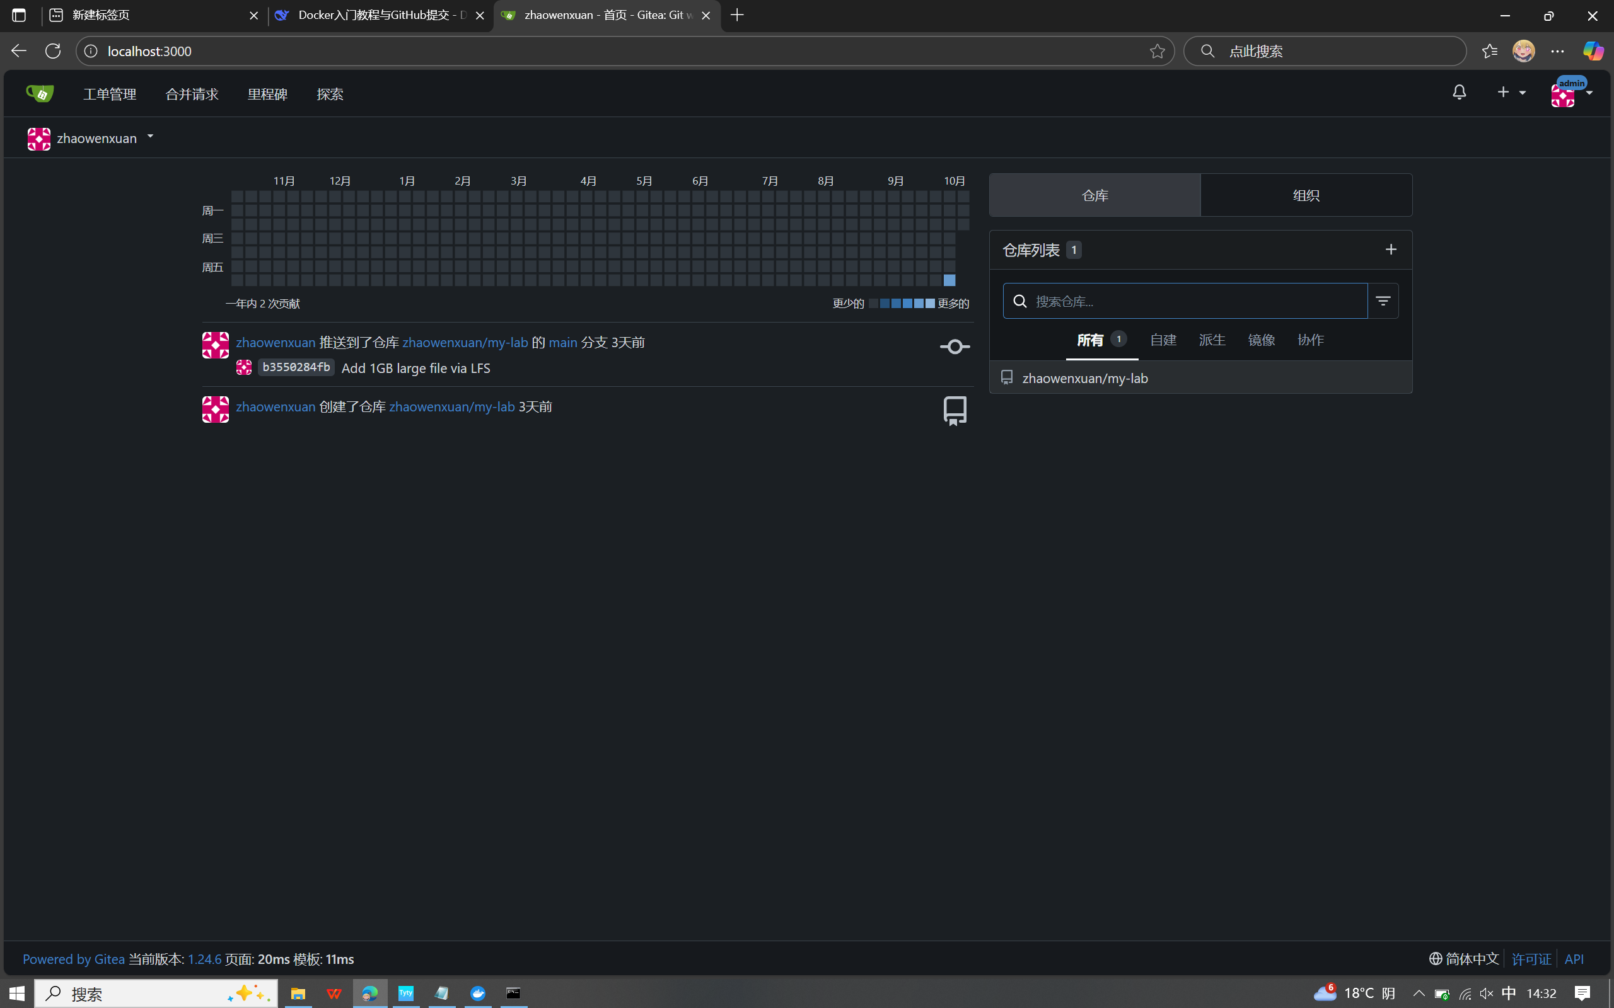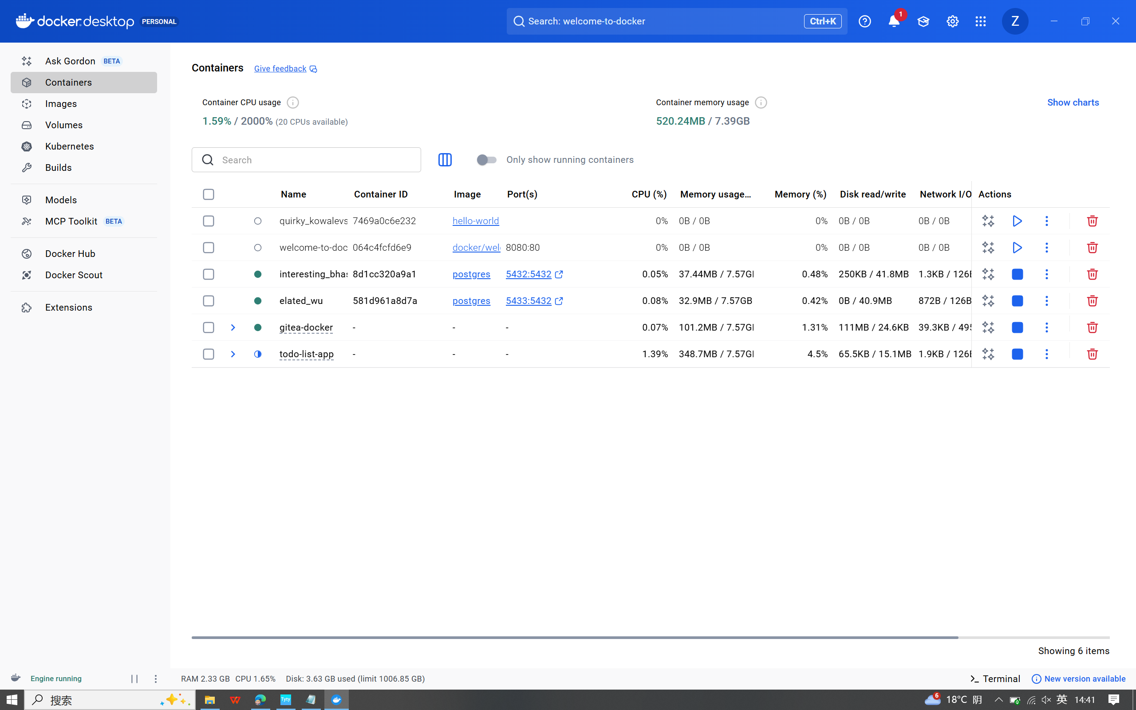

This document comprehensively summarizes my hands-on learning experience with Docker core concepts, following the official Docker documentation tutorial series. The journey covered fundamental Docker concepts, practical operations, and real-world problem solving.

**Core Concepts Mastered**

**1. Container Fundamentals**

* **Containers**: Lightweight, standalone, executable software packages that include everything needed to run an application
* **Images**: Read-only templates with instructions for creating Docker containers
* **Docker Compose**: Tool for defining and running multi-container Docker applications using YAML configuration

**2. Container Operations**

* **Port Publishing**: Mapping container ports to host system ports for external access
* **Overriding Defaults**: Customizing container behavior by overriding default configurations
* **Data Persistence**: Using volumes and bind mounts to maintain data across container lifecycles
* **File Sharing**: Sharing local files and directories with containers
* **Multi-container Apps**: Orchestrating complex applications with multiple interconnected services

**Practical Implementation**

**Project Setup: Todo List Application**

bash

# Cloned the sample project

git clone https://github.com/dockersamples/todo-list-app

# Navigated to project directory

cd todo-list-app

# Built and started the multi-container application

docker compose up -d --build