Create minikube

Minicube start

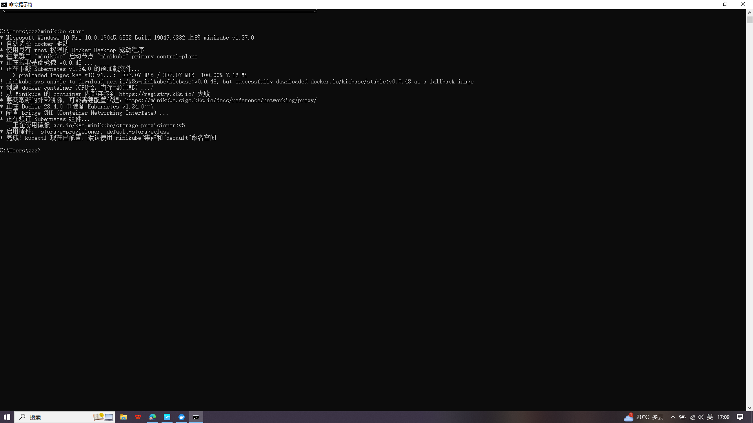

Create deployment

kubectl create deployment hello-node --image=registry.k8s.io/e2e-test-images/agnhost:2.53 -- /agnhost netexec --http-port=8080

kubectl get deployments

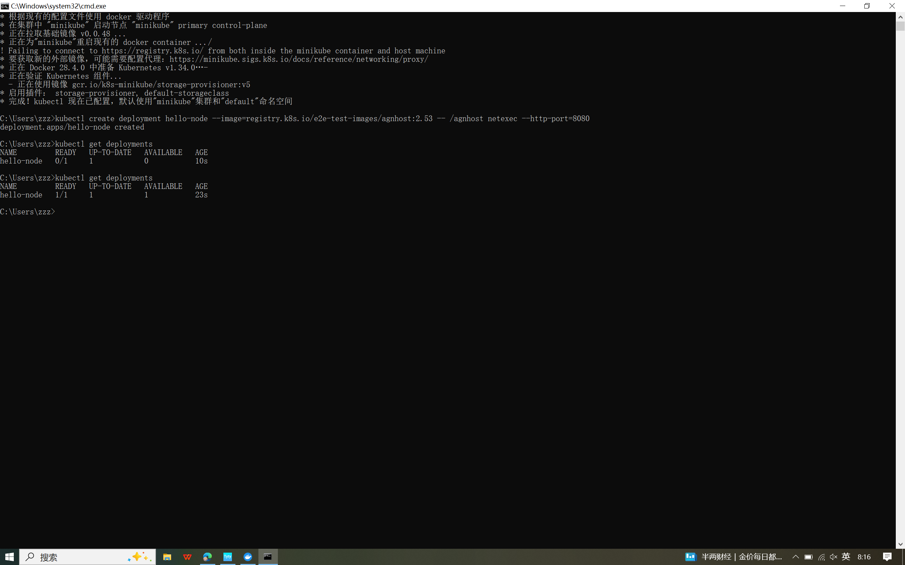

kubectl get pods

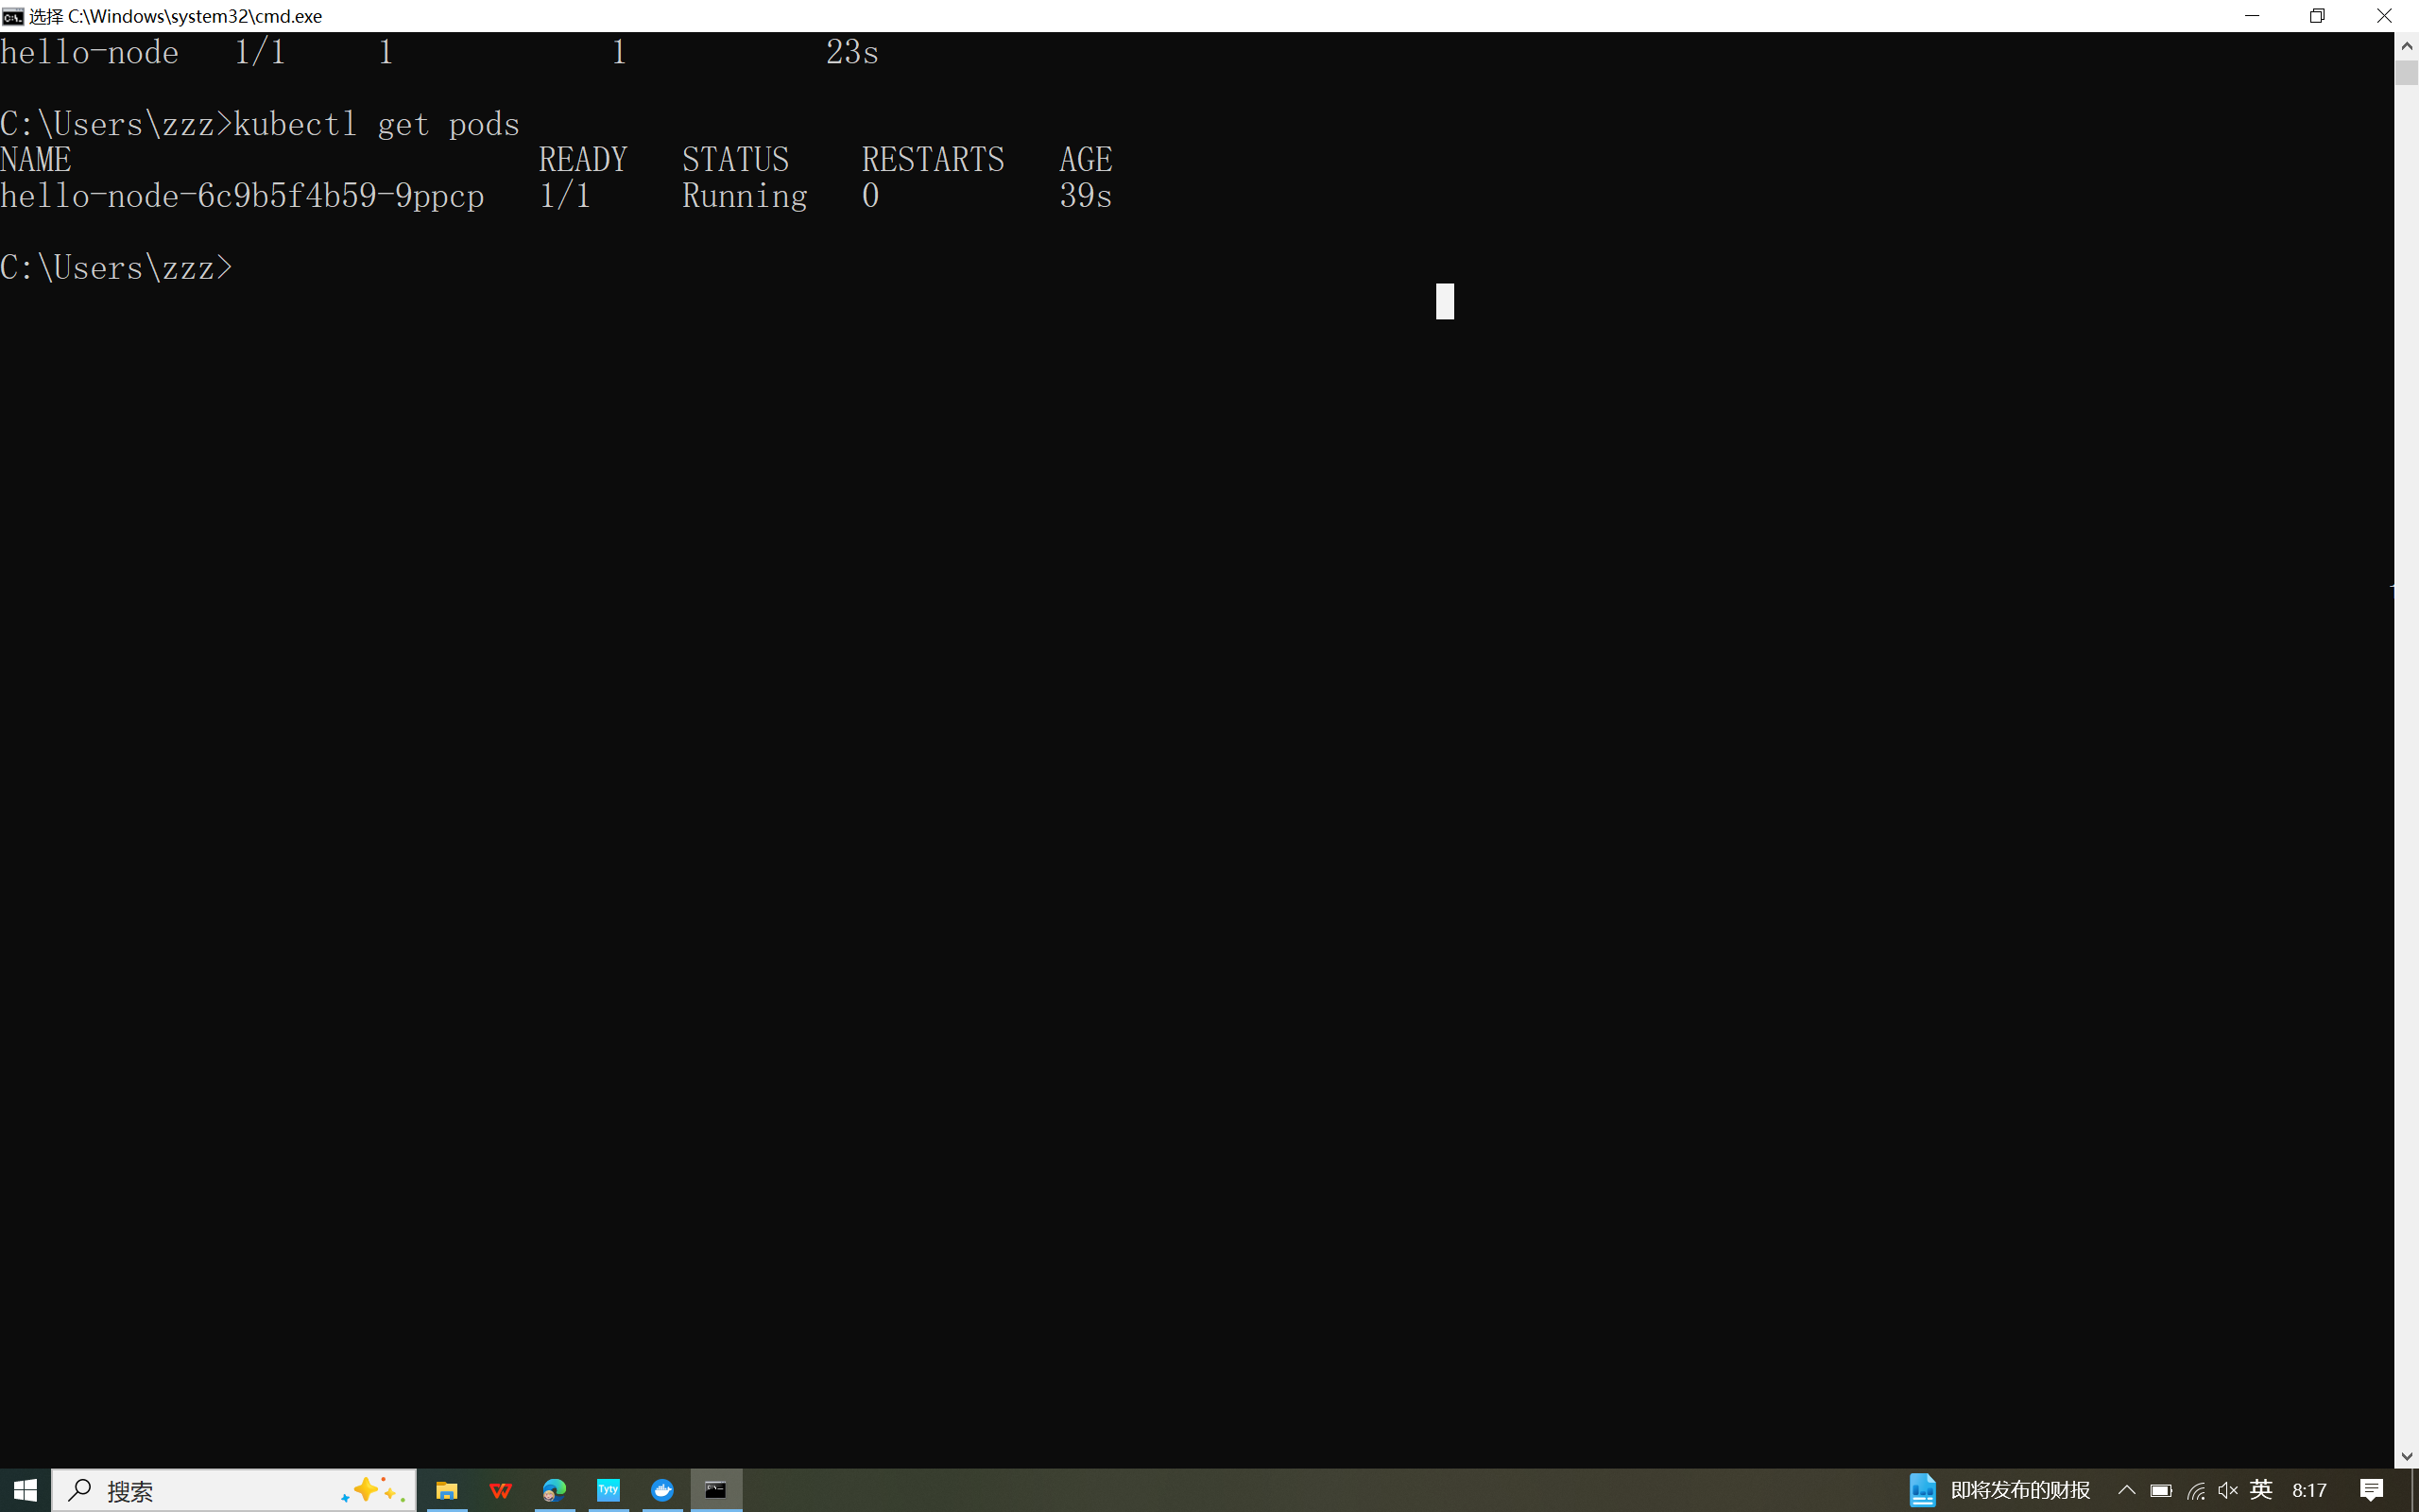

kubectl get events

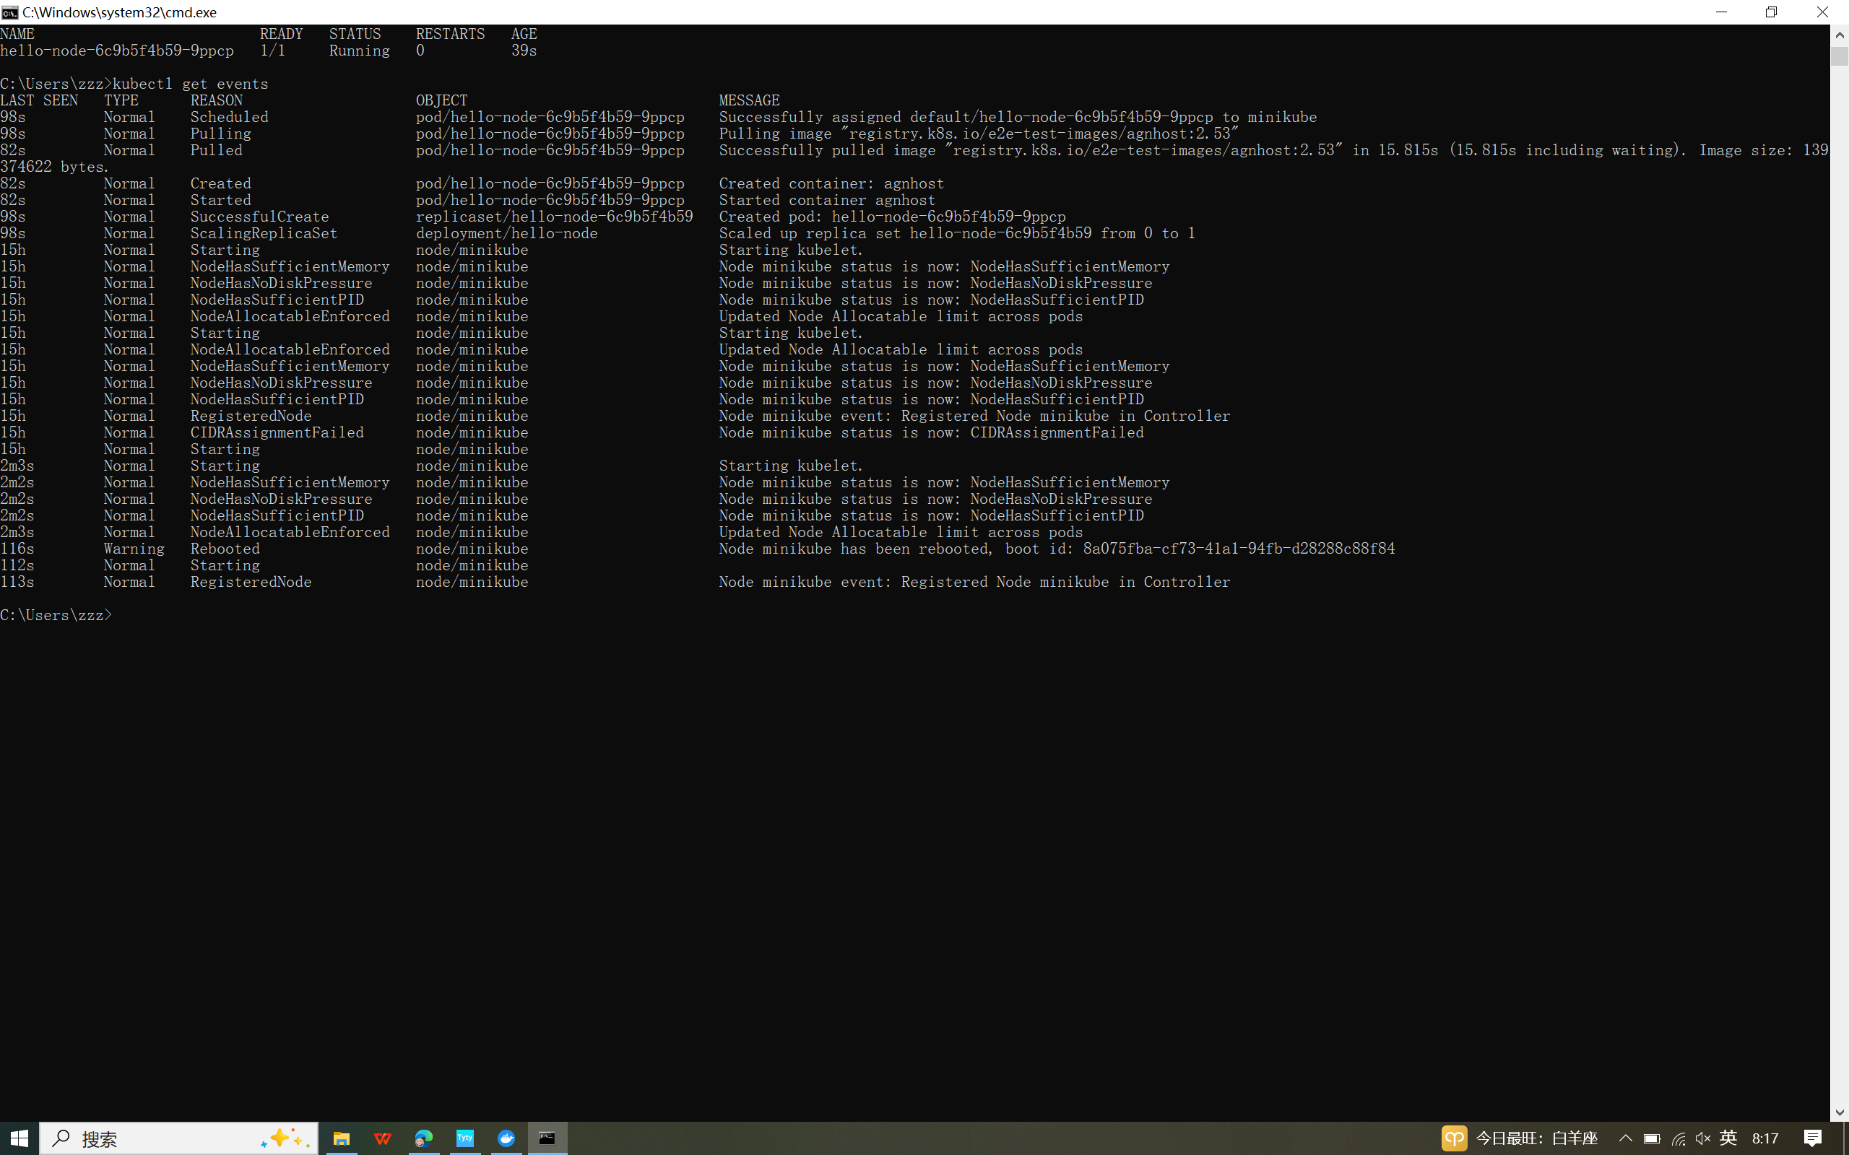

kubectl config view

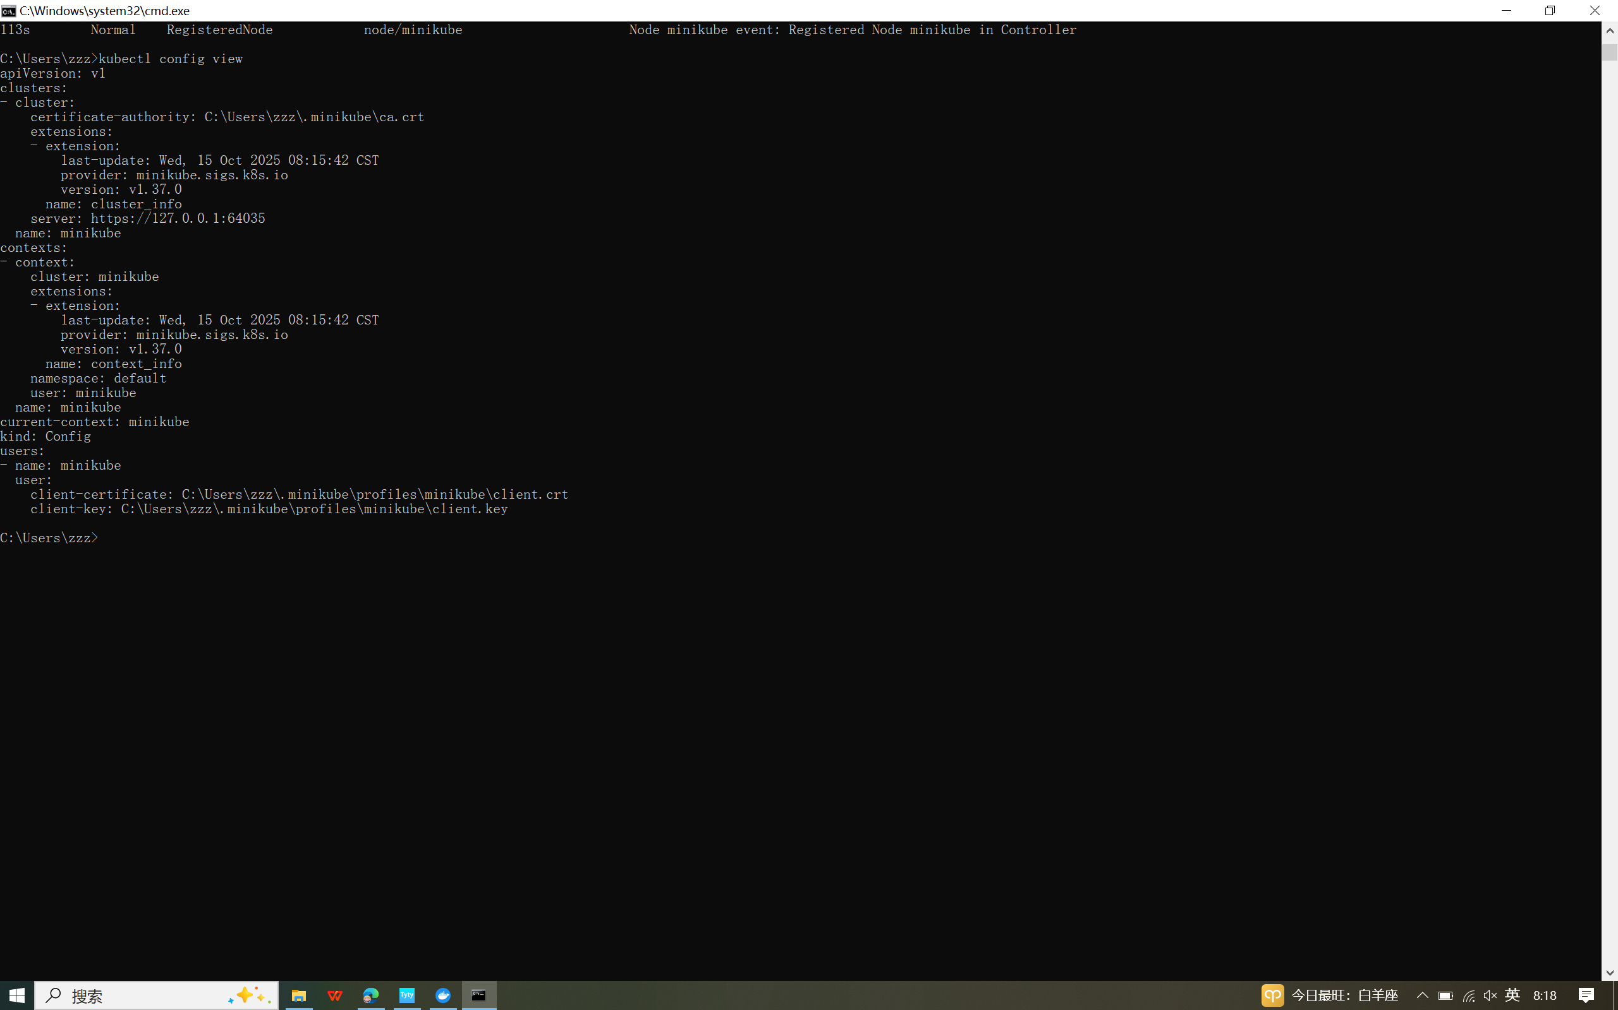

kubectl logs

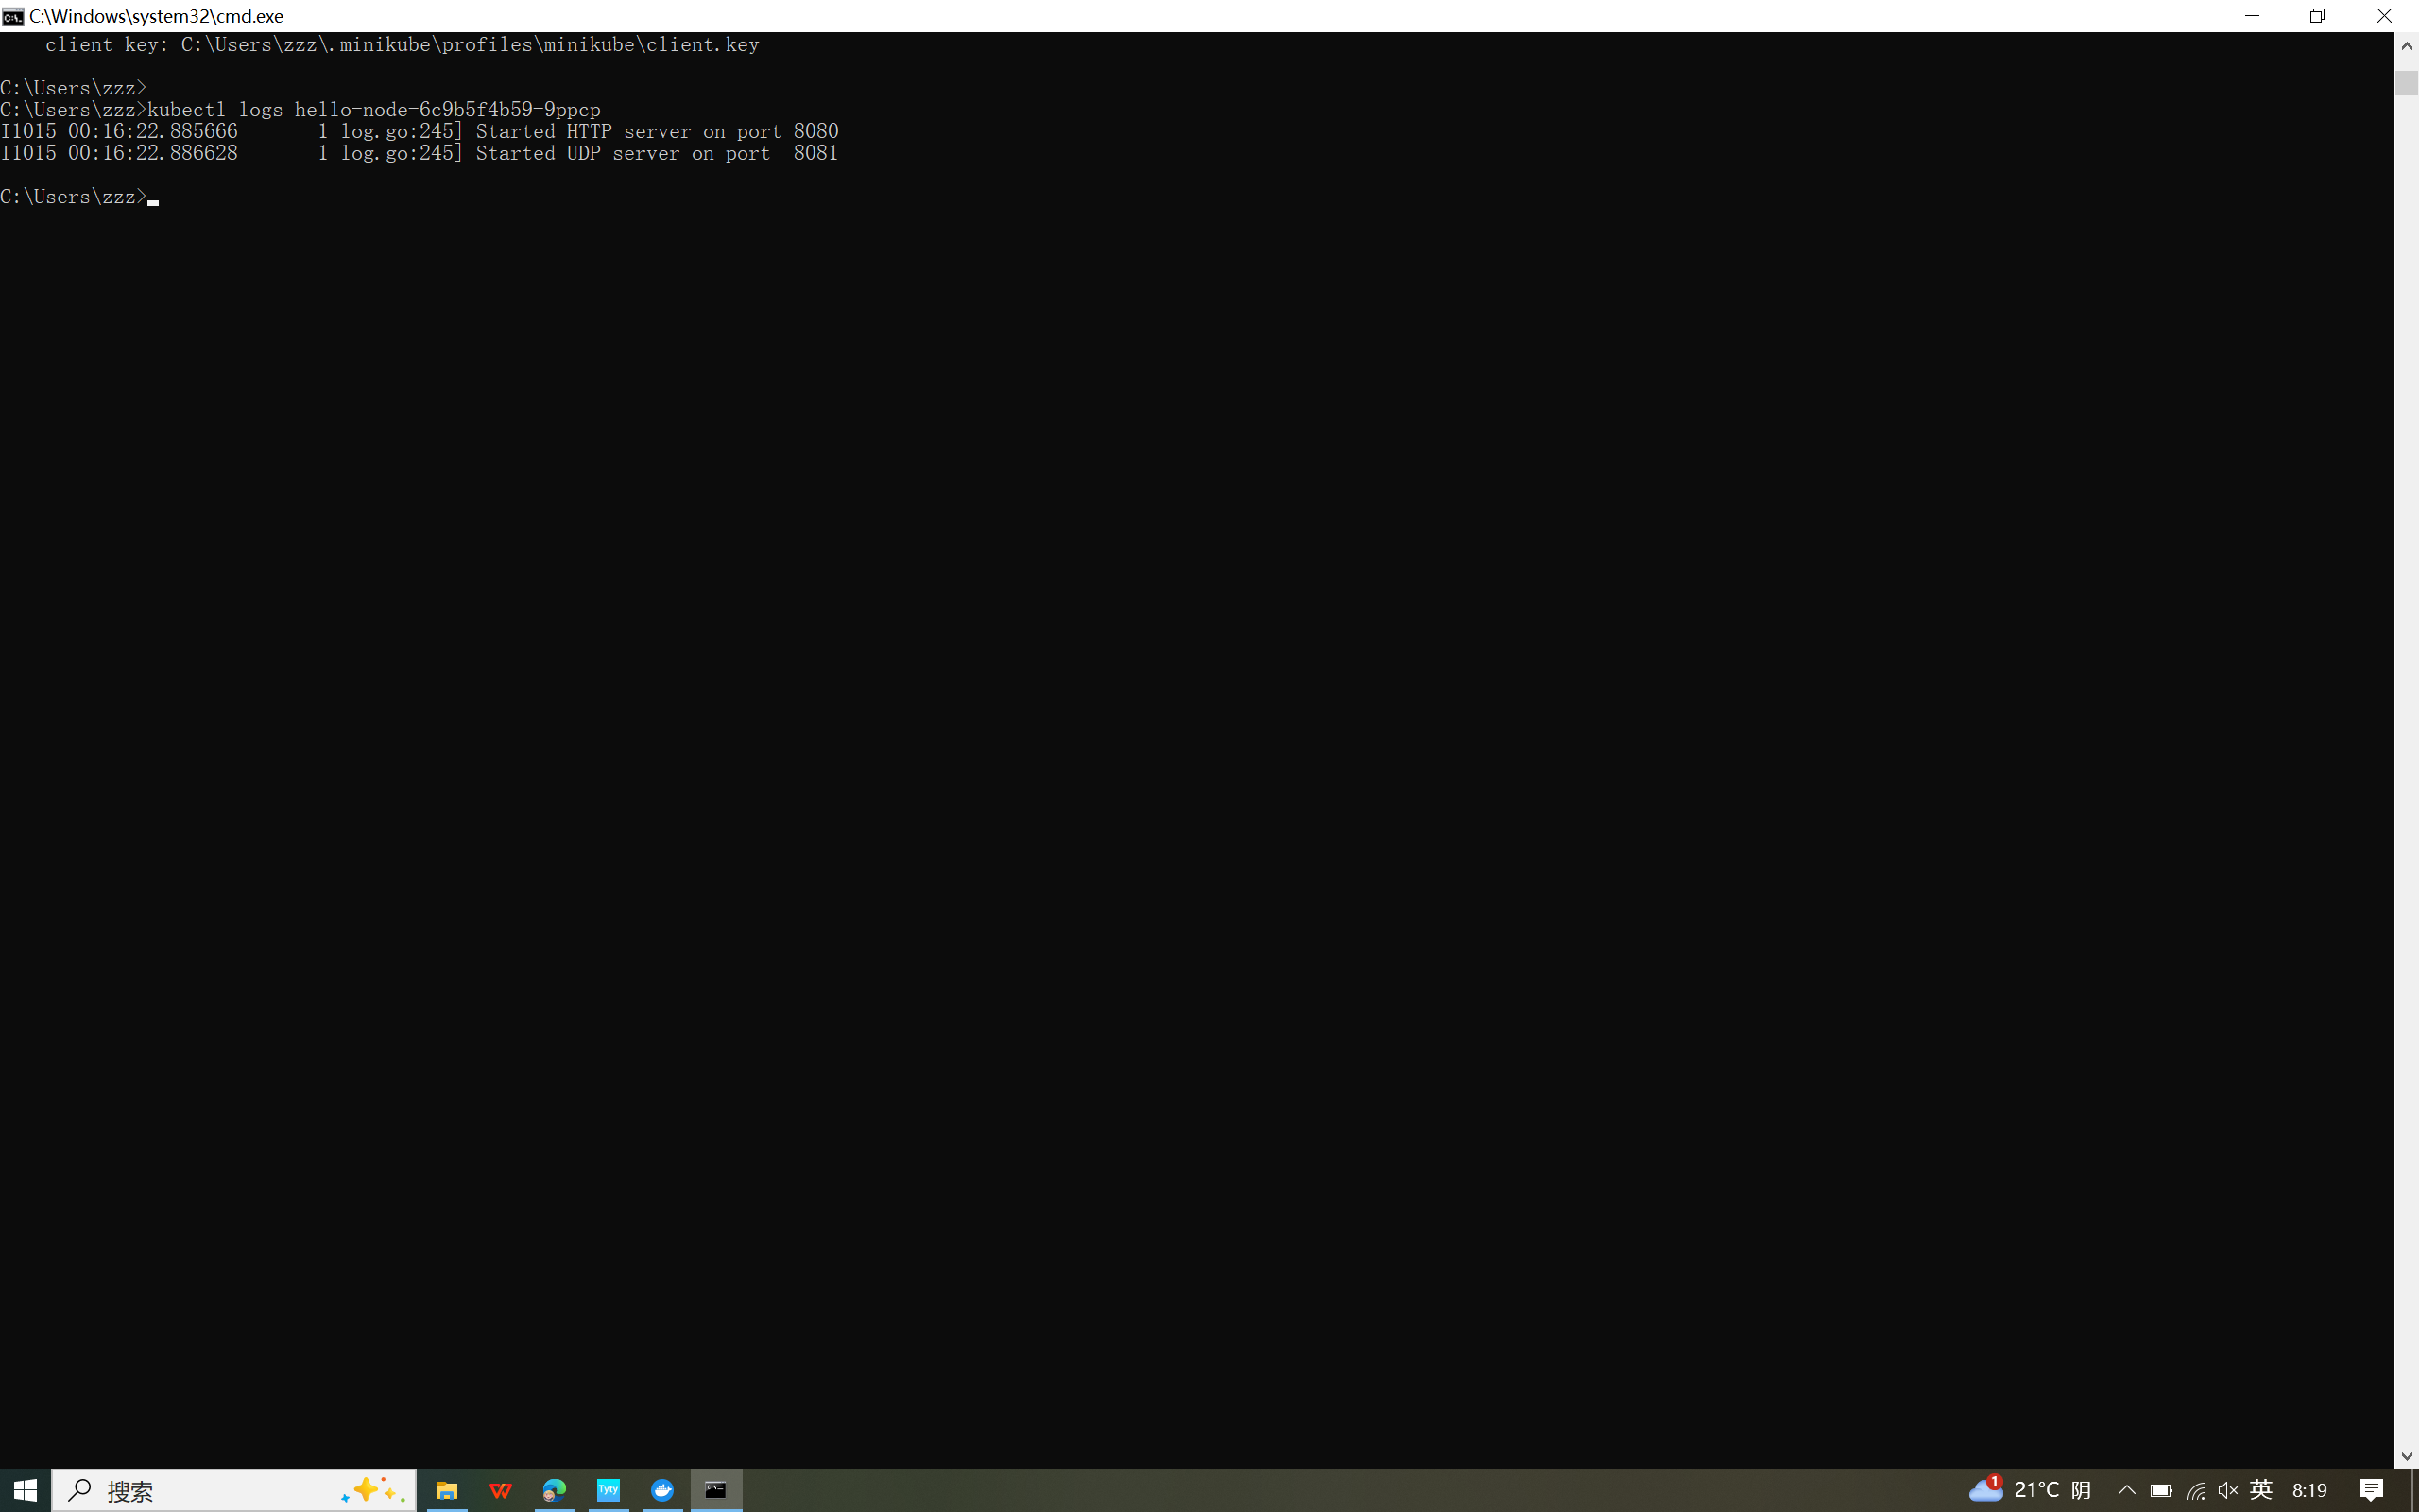

Create service

kubectl expose deployment hello-node --type=LoadBalancer --port=8080

kubectl get services

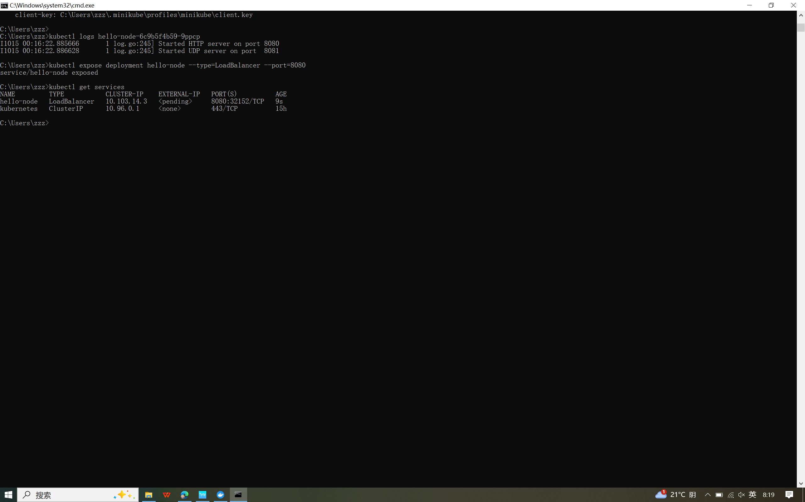

minikube service hello-node

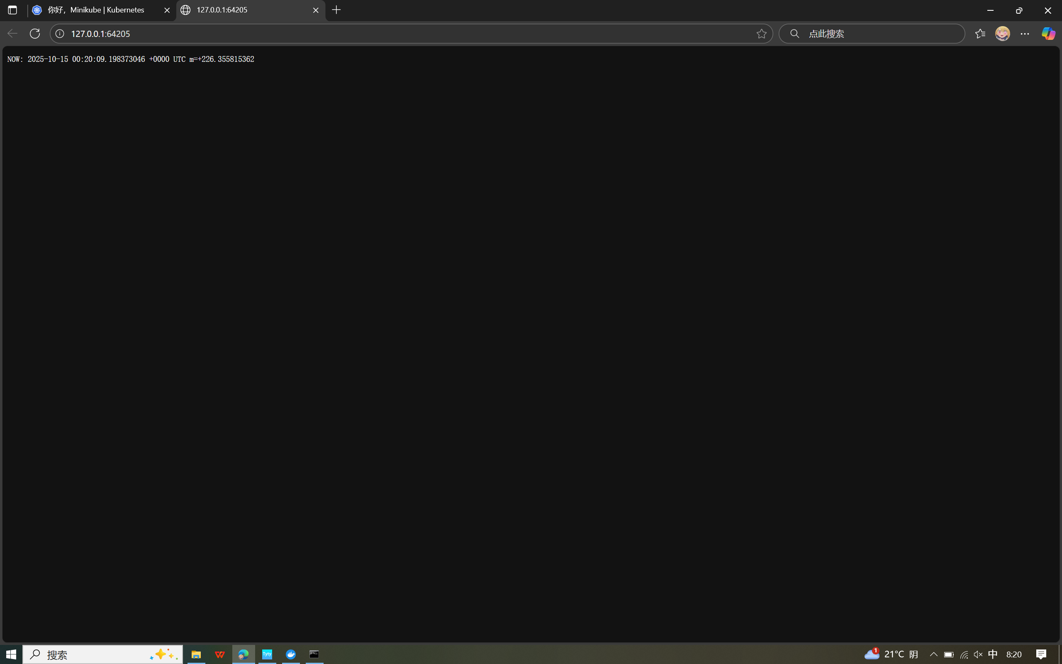

minikube addons list

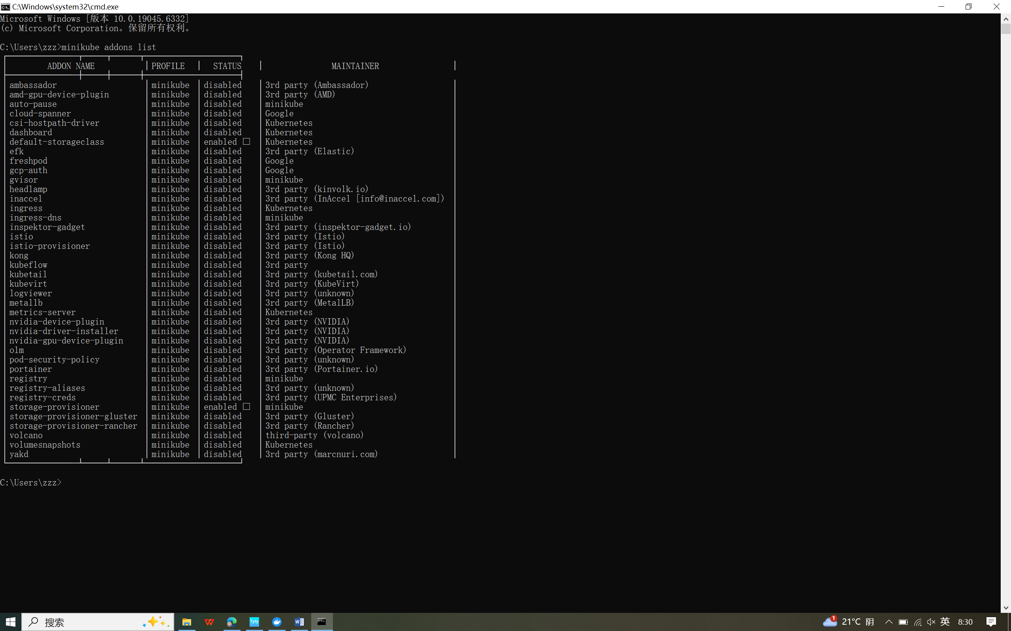

minikube addons enable metrics-server

kubectl get pod,svc -n kube-system

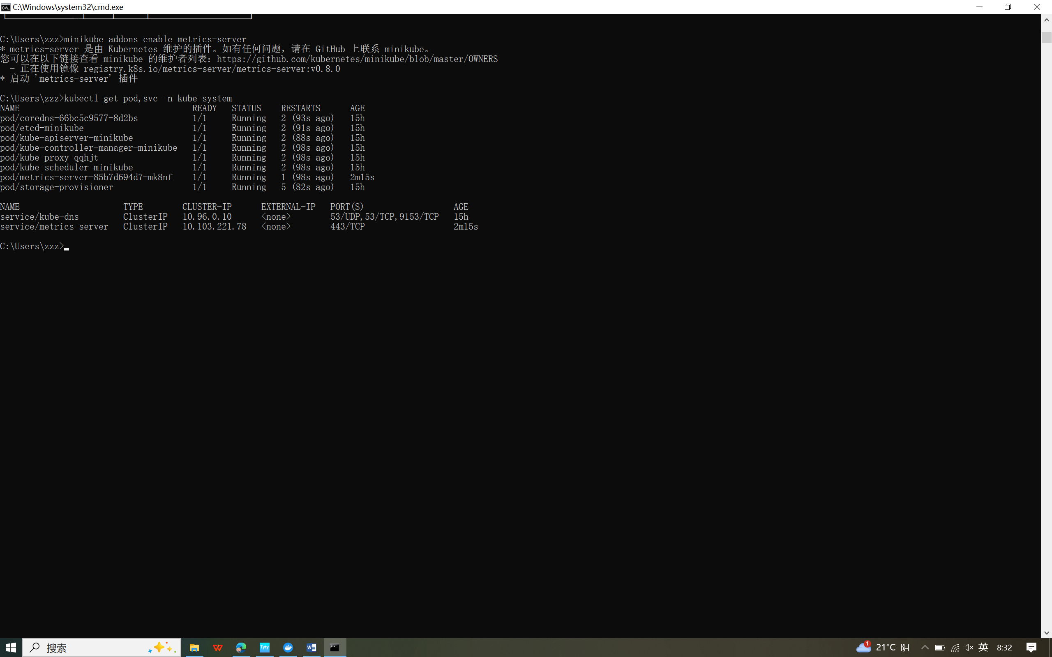

kubectl top pods

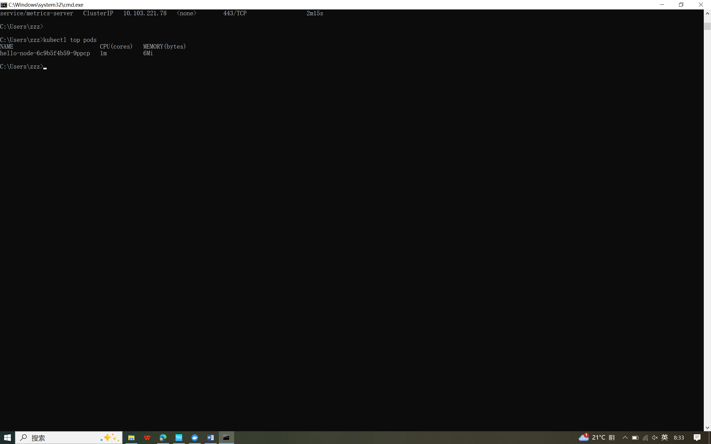

minikube addons disable metrics-server

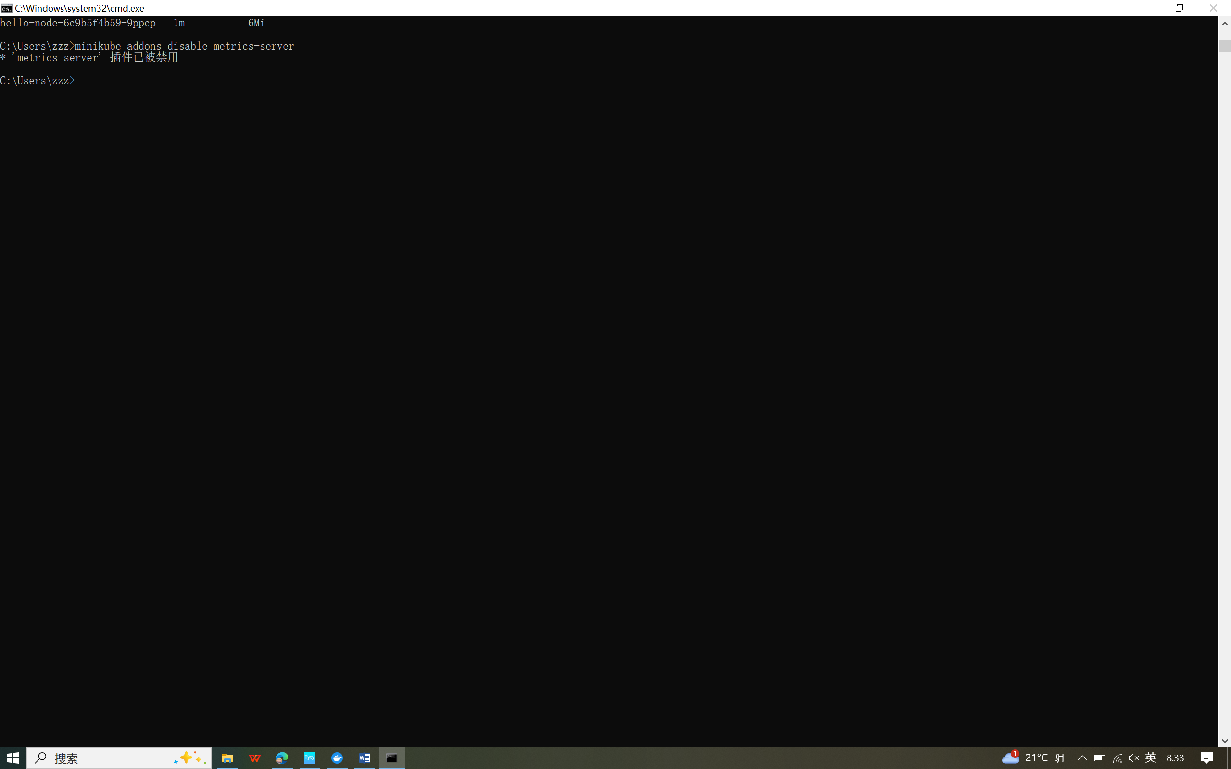

kubectl delete service hello-node

kubectl delete deployment hello-node

minikube stop

